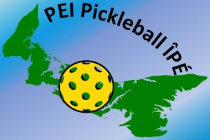 | PEI Pickleball ÎPÉ

Join the Planning Committee – 2026 PEI Provincial Pickleball Championships!
Hello everyone,
We are excited to begin planning for the 2026 PEI Provincial Pickleball Championships, taking place July 17–19 at the new, state-of-the-art indoor pickleball facility — Atlantic Pickleball Club.
As this event continues to grow, we are looking to build a strong and enthusiastic planning committee to help bring it all together. This is a great opportunity to be part of a premier provincial event, connect with the pickleball community, and contribute to an exciting and welcoming championship experience.
We are seeking individuals interested in supporting areas such as:
- Event planning & coordination
- Sponsorship & fundraising
- Marketing & communications
- Volunteer coordination
- Operations & logistics
If you are interested in joining the planning committee or would like to learn more, please reply to peipickleballipe@gmail.com
Thank you for your continued support of pickleball in PEI — we couldn’t do this without our community.
Doris Dunphy President PEI Pickleball ÎPÉ
Adam Arsenault Tournament Co-Director
Marian Grant Tournament Co-Director
Bill Lumley Tournament Co-Director

