Good day everyone:
The first step of the 3-step process is almost complete. We have 1 more rating clinic scheduled for Aug 31st. And before you ask; It is full.
The second step that we need completed before our September 1st deadline, is to have all our members switch over from Team Reach, to the Pickleheads app.
The main reasons for us asking for this are:
- Pickleheads allows limits to be put on sessions, based on skill level IE: 3.0 – 3.49. Please keep in mind that although you cannot play up a level, you are always welcome to play down a level. It also allows limits to be put on attendance levels per session. The most we would ever try to schedule is 2 spares. IE: 2 courts and a 10-player limit. If 4 more players join the waitlist, we can open a 3rd court, but there are still only 2 spares.
- Pickleheads has a waitlist feature.
- Sending group messages to members of the group is much easier. TeamReach has a small character limit, Pickleheads does not. We can upload files or photos easily for everyone to see.
- There will be less chatter because now if you forgot a water bottle or a jacket, you can easily chat with just those members that were in the session, you don’t have to send it out to the whole group.
To help the club members switch-over and to make it as painless as possible, we created a tutorial.
Follow along step by step to 1st, install the app, 2nd, create a profile and finally, join our group: Didsbury PB Club.

Step 1. Go to the App store on your apple device.
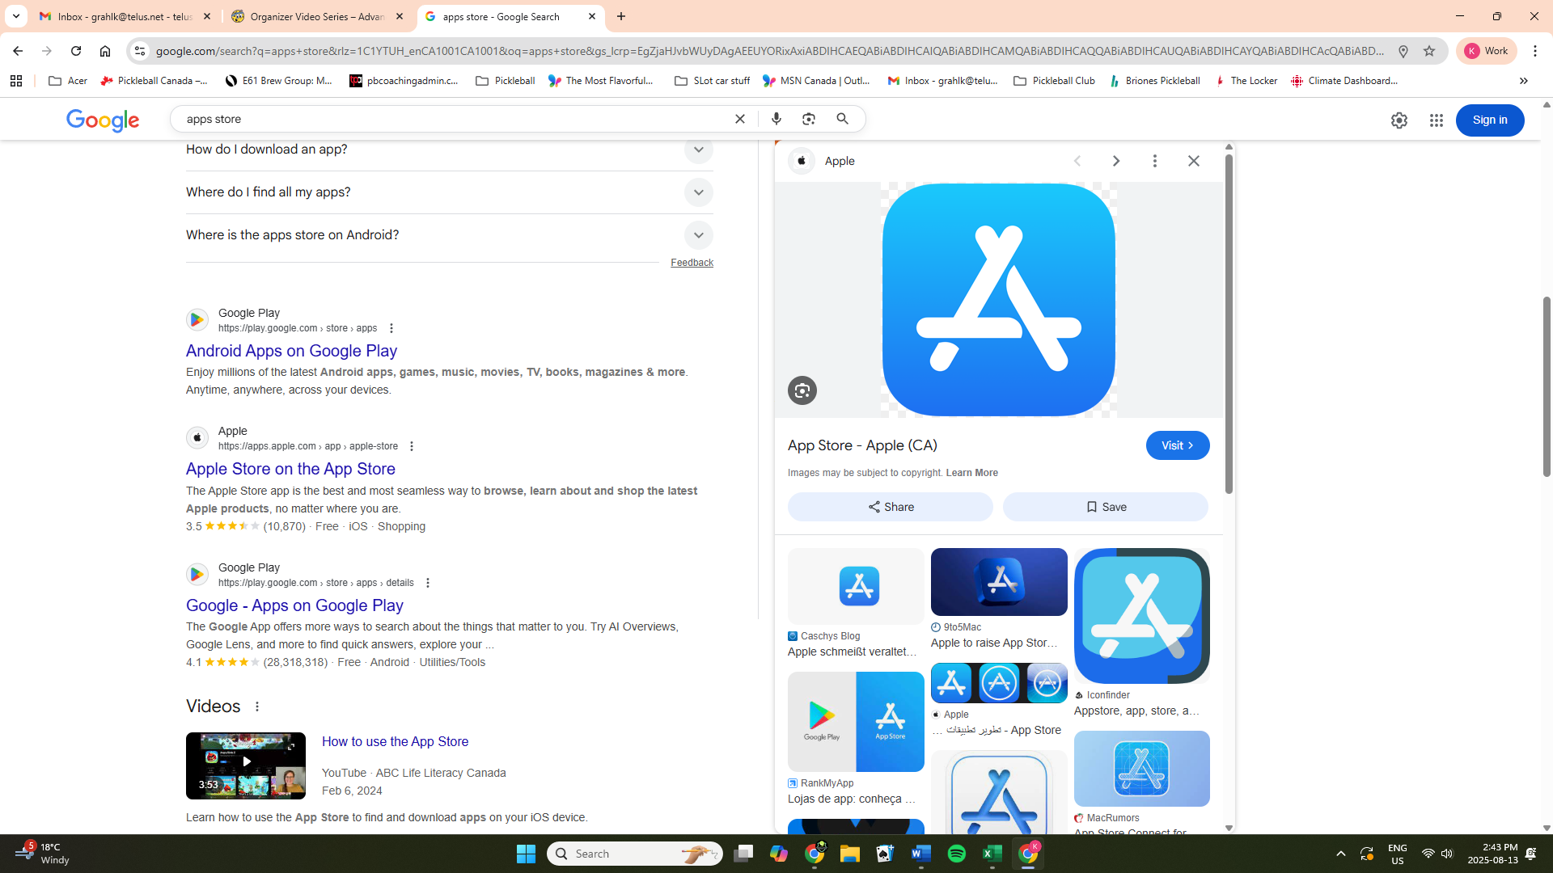
Step 2. Search for app called Pickleheads by following steps 3, 4 and 5.
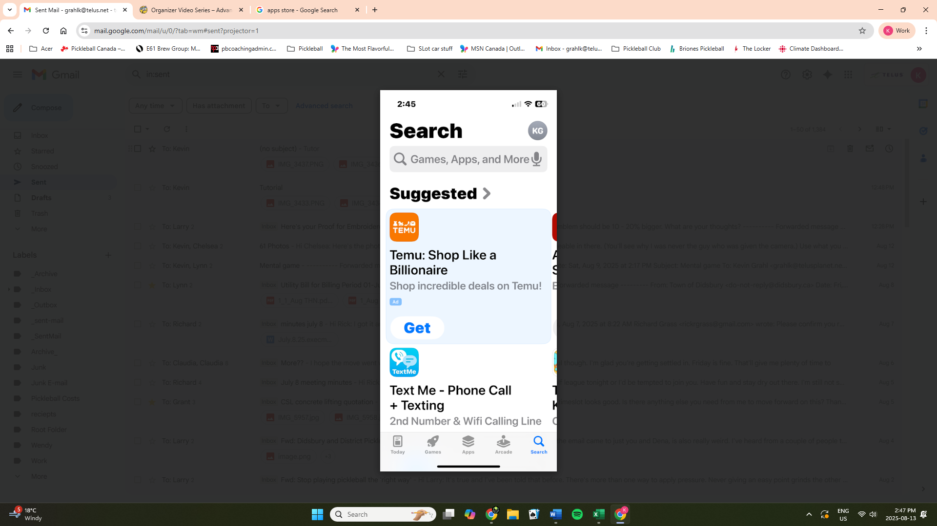
Step 3. Click on the search icon to bring up the search bar.

Step 4. Type “Pickleheads” into the search bar.
Step 5. Tap the GET icon to begin the download process.
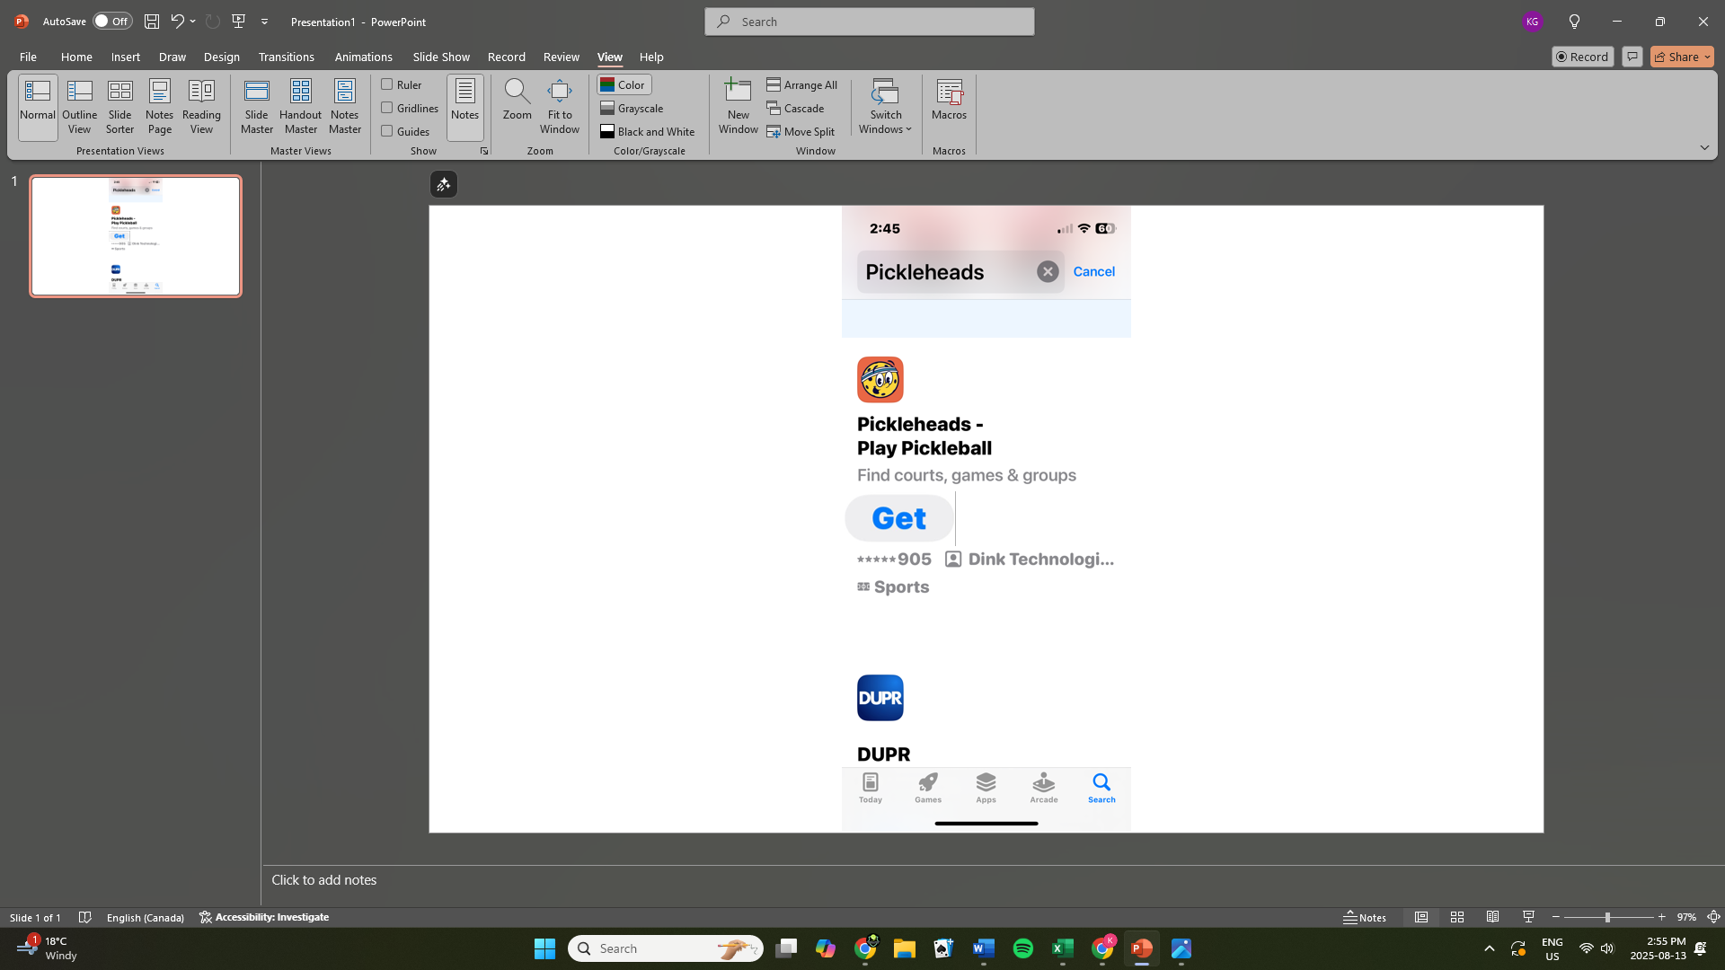
Step 5. Click on the Get icon to start downloading the Pickleheads app.

Once the app is installed on your phone. type in a password and create your own account.


Step 7. Click Create an account to get started.
Step 6. Check the box to verify your age.
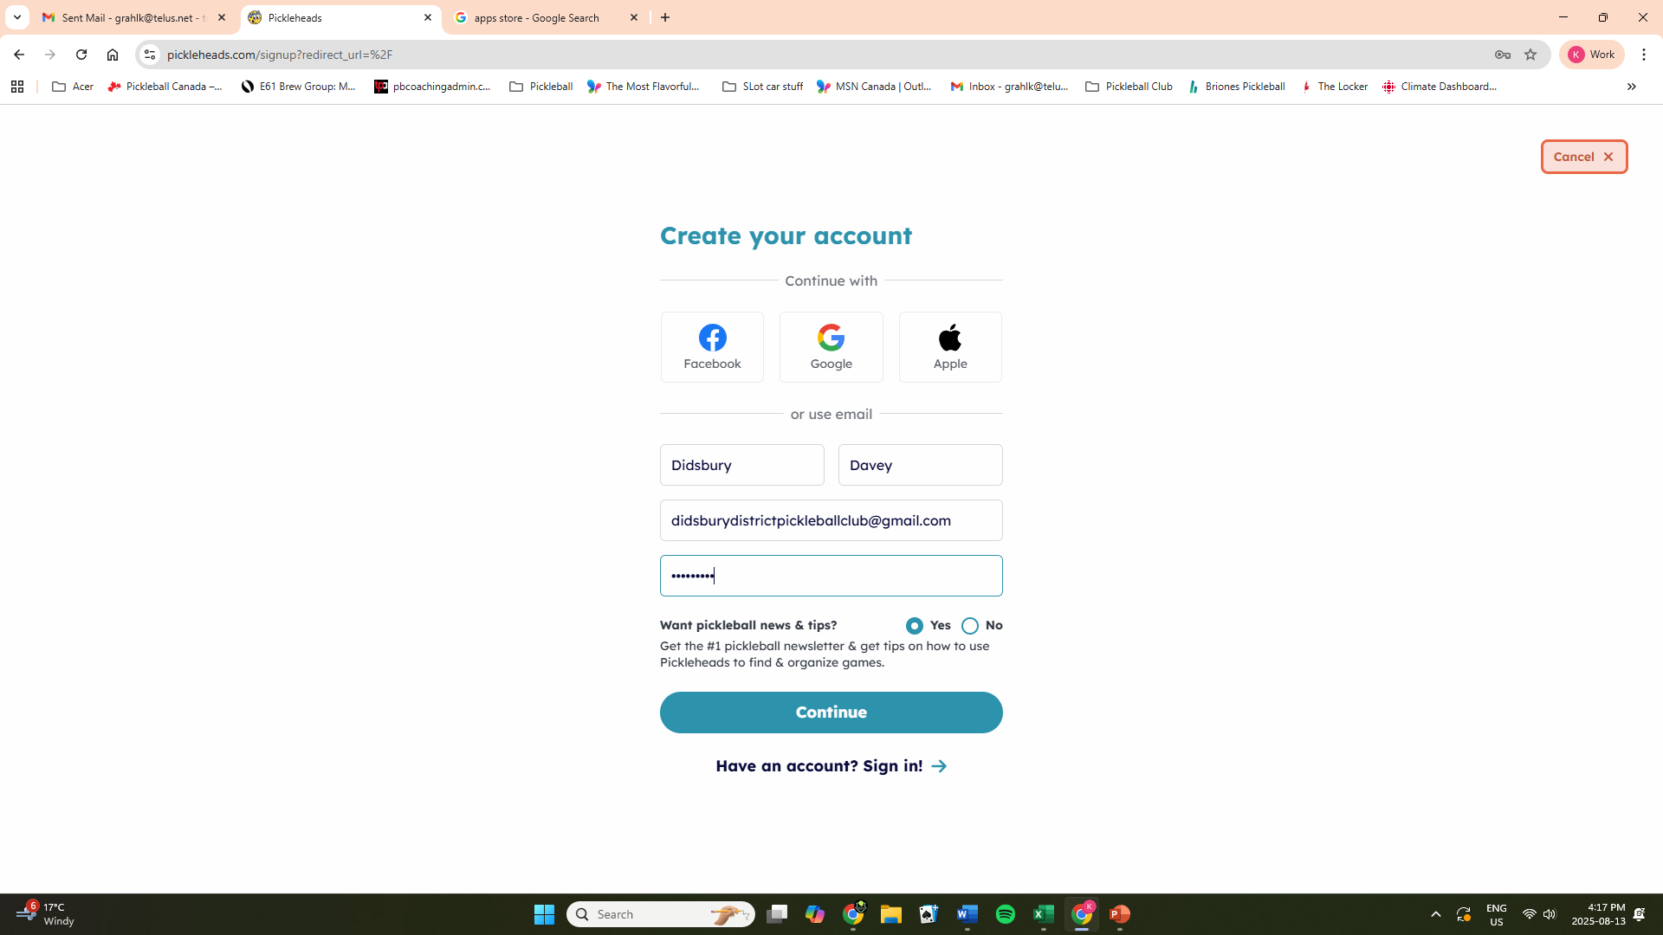
Step 11. Select continue to continue. here.
Step 10. Insert a unique password here.
Step 9. Insert your valid email address here. They will use this address to verify your account.
Step 8. Insert your name here.

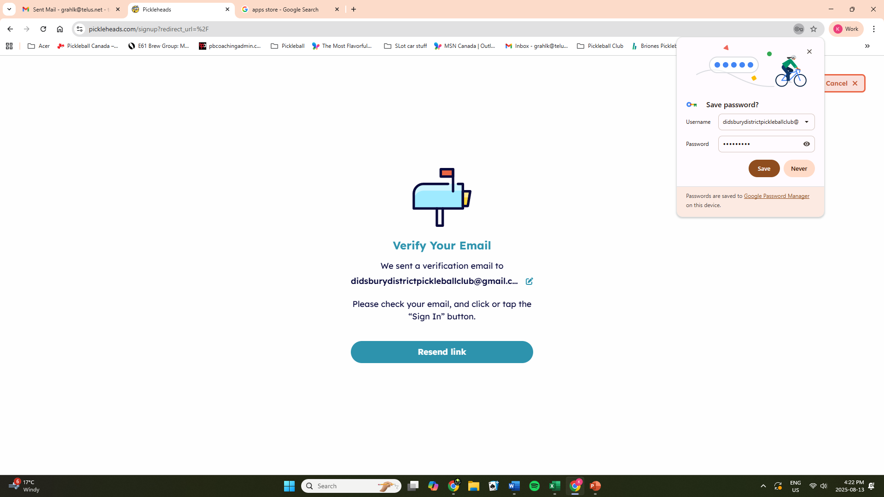
Check the email account that you used on the prior screen for a message from Pickleheads.
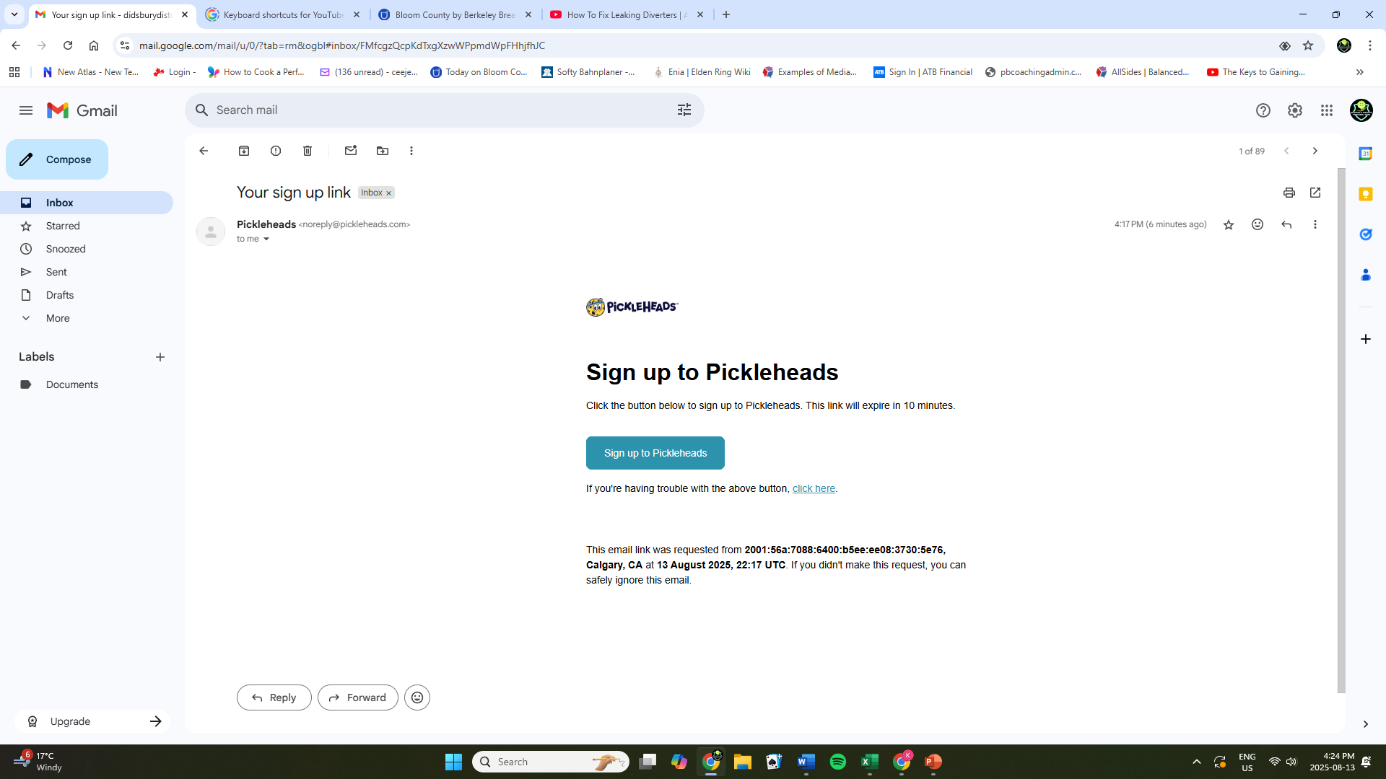
Step 12. Sign up to continue.
.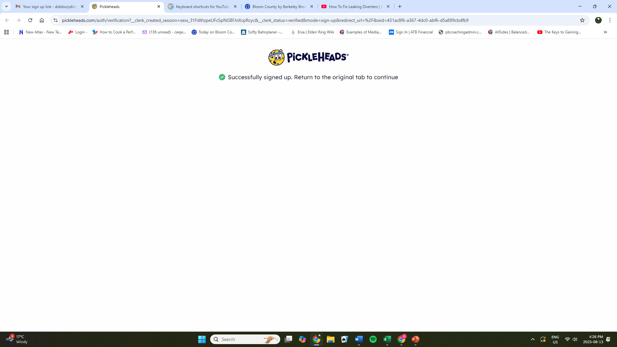
The above screen will show that your account is now verified.
Step 13. Close this window and go back to the original screen that you were on, before you went to check your email. It should now show:

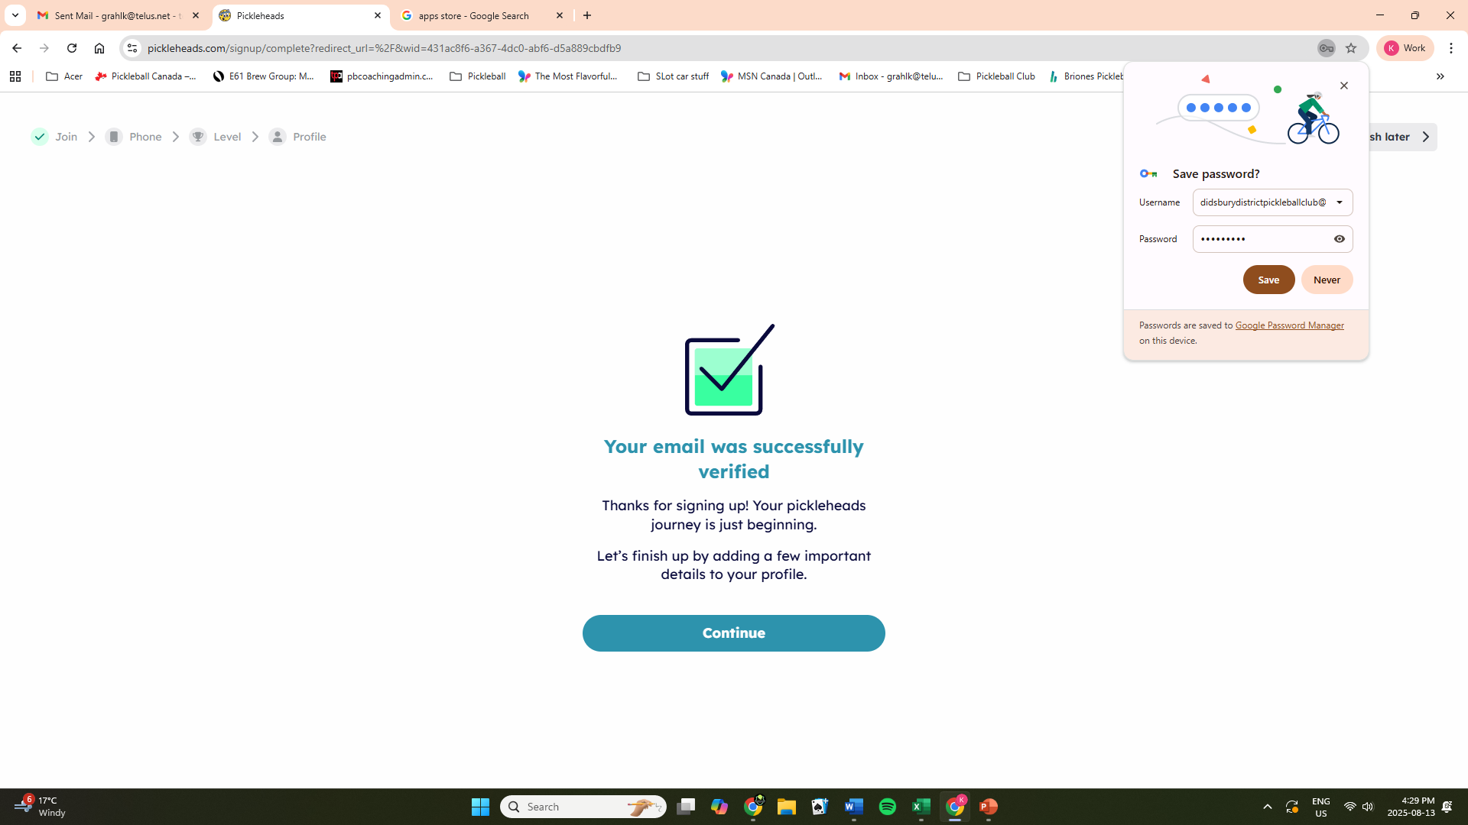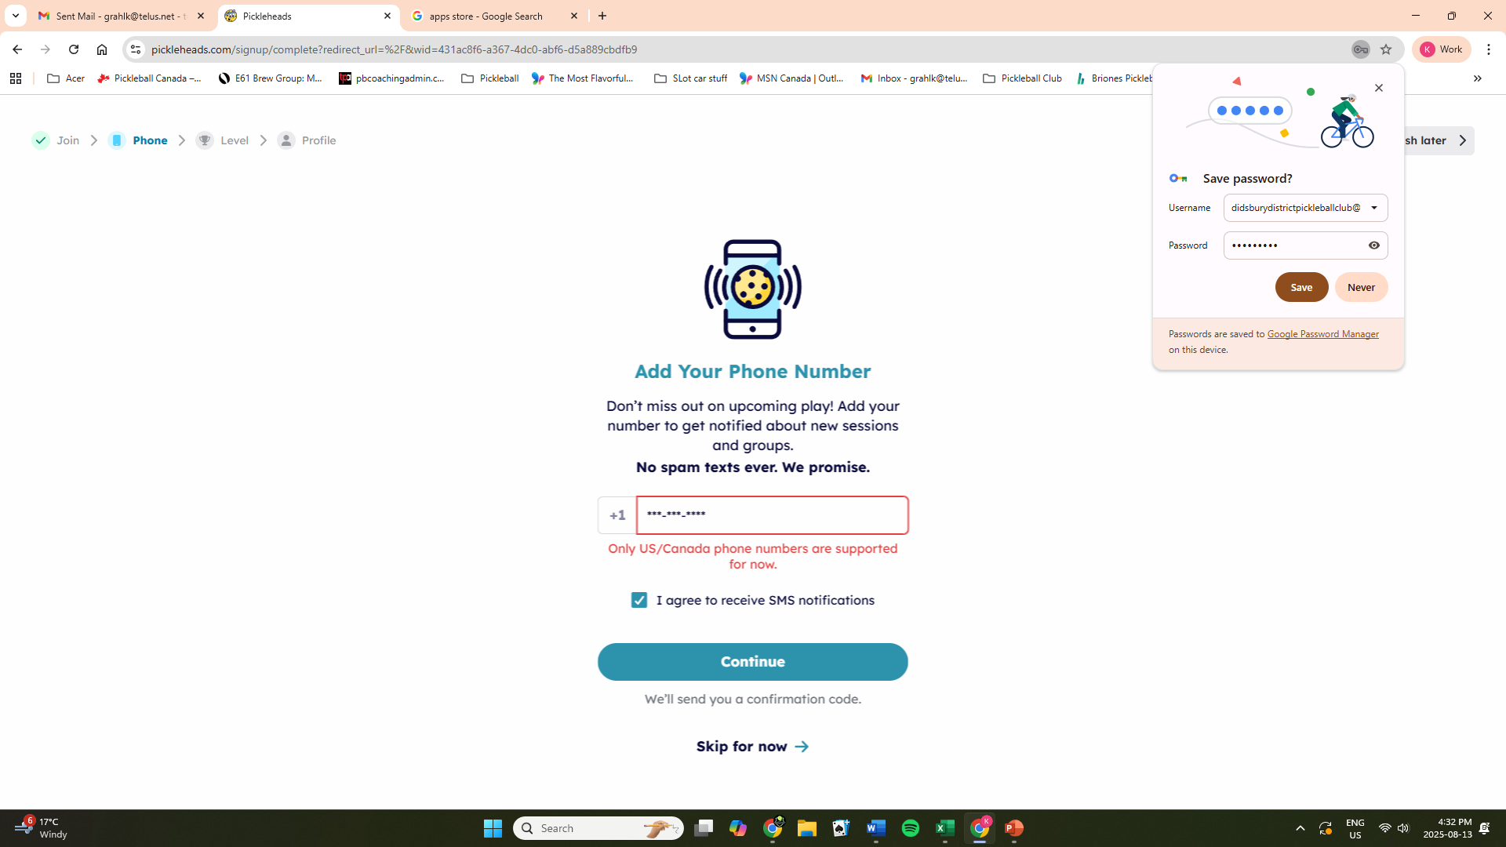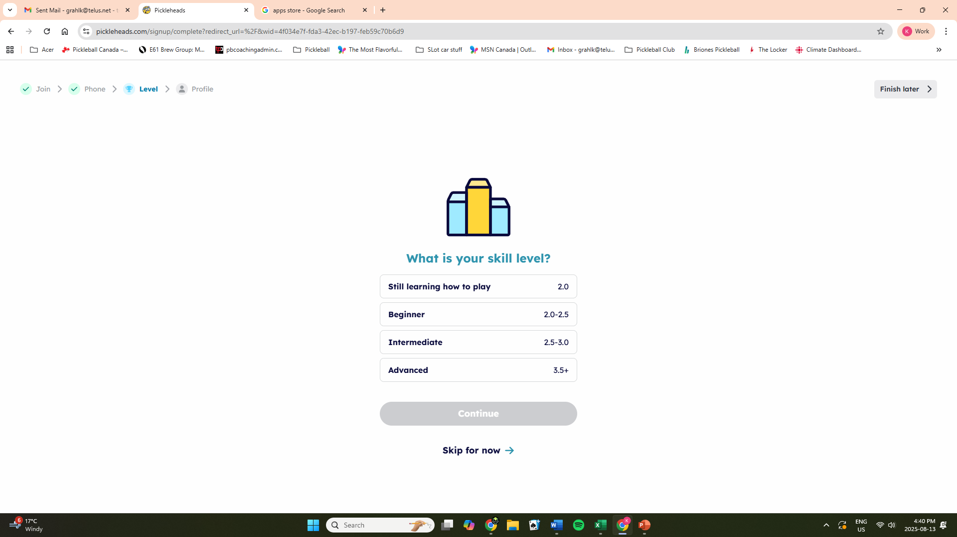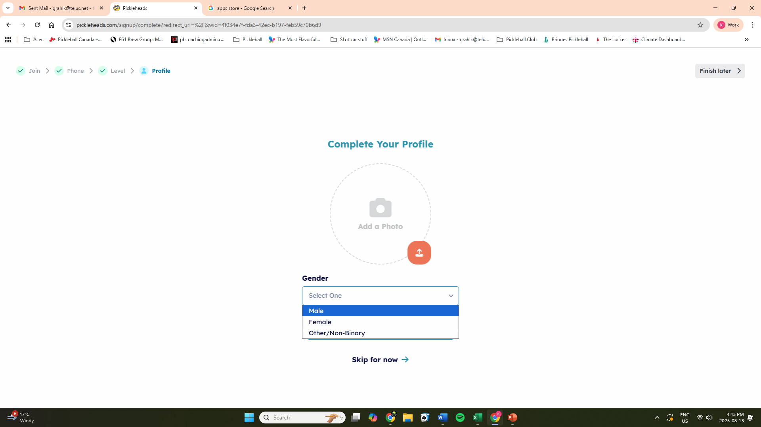
If you do NOT want to receive notifications, choose Skip for now
Step 16. Select continue to set your profile.
Step 15. You have the option to enter your cell phone number and then receive text notifications of invitations to games.
Step 14. Sign up to continue.
Skip for now
Skip for now
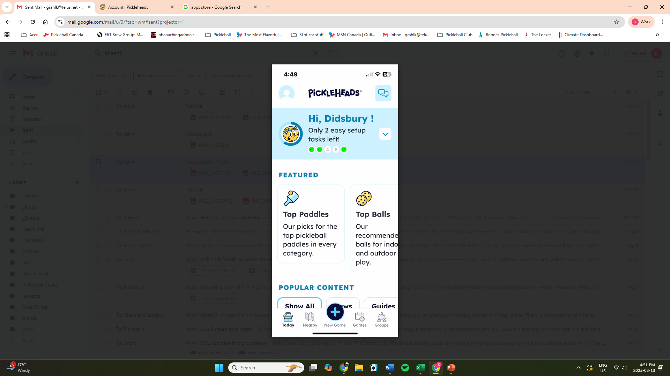
Step 17. Select the profile icon
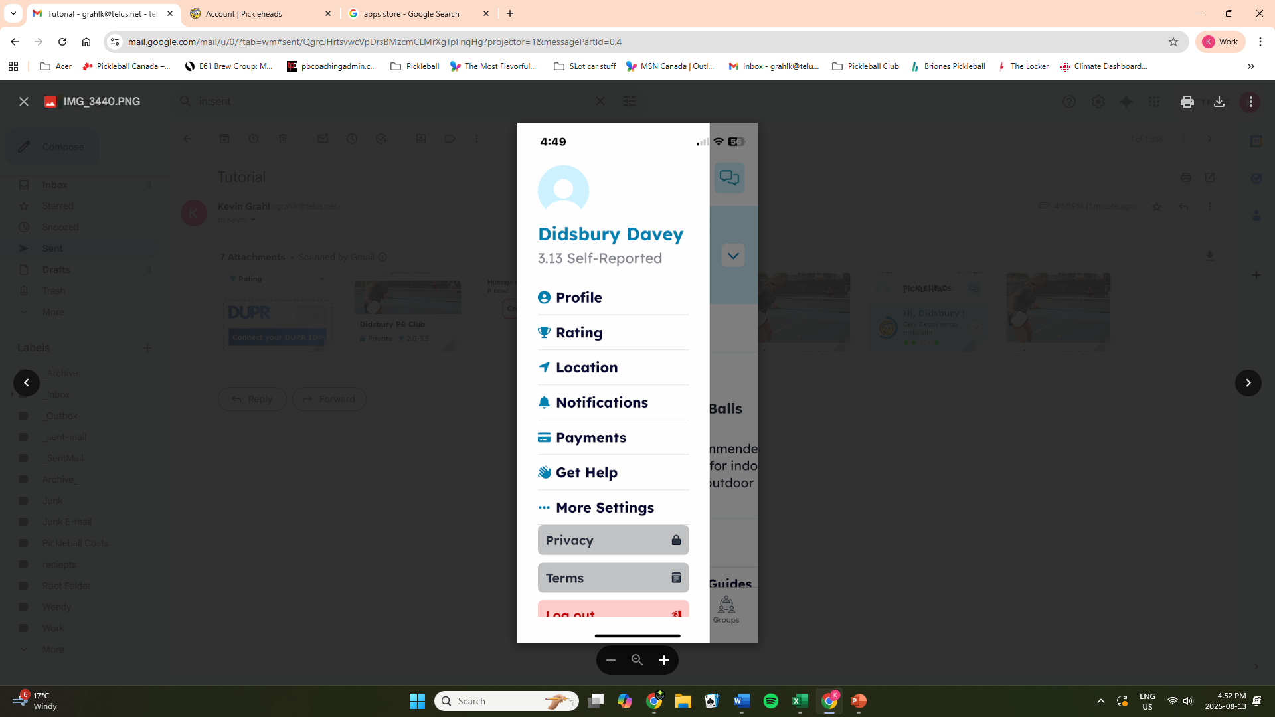
Step 18. Select the Rating icon.

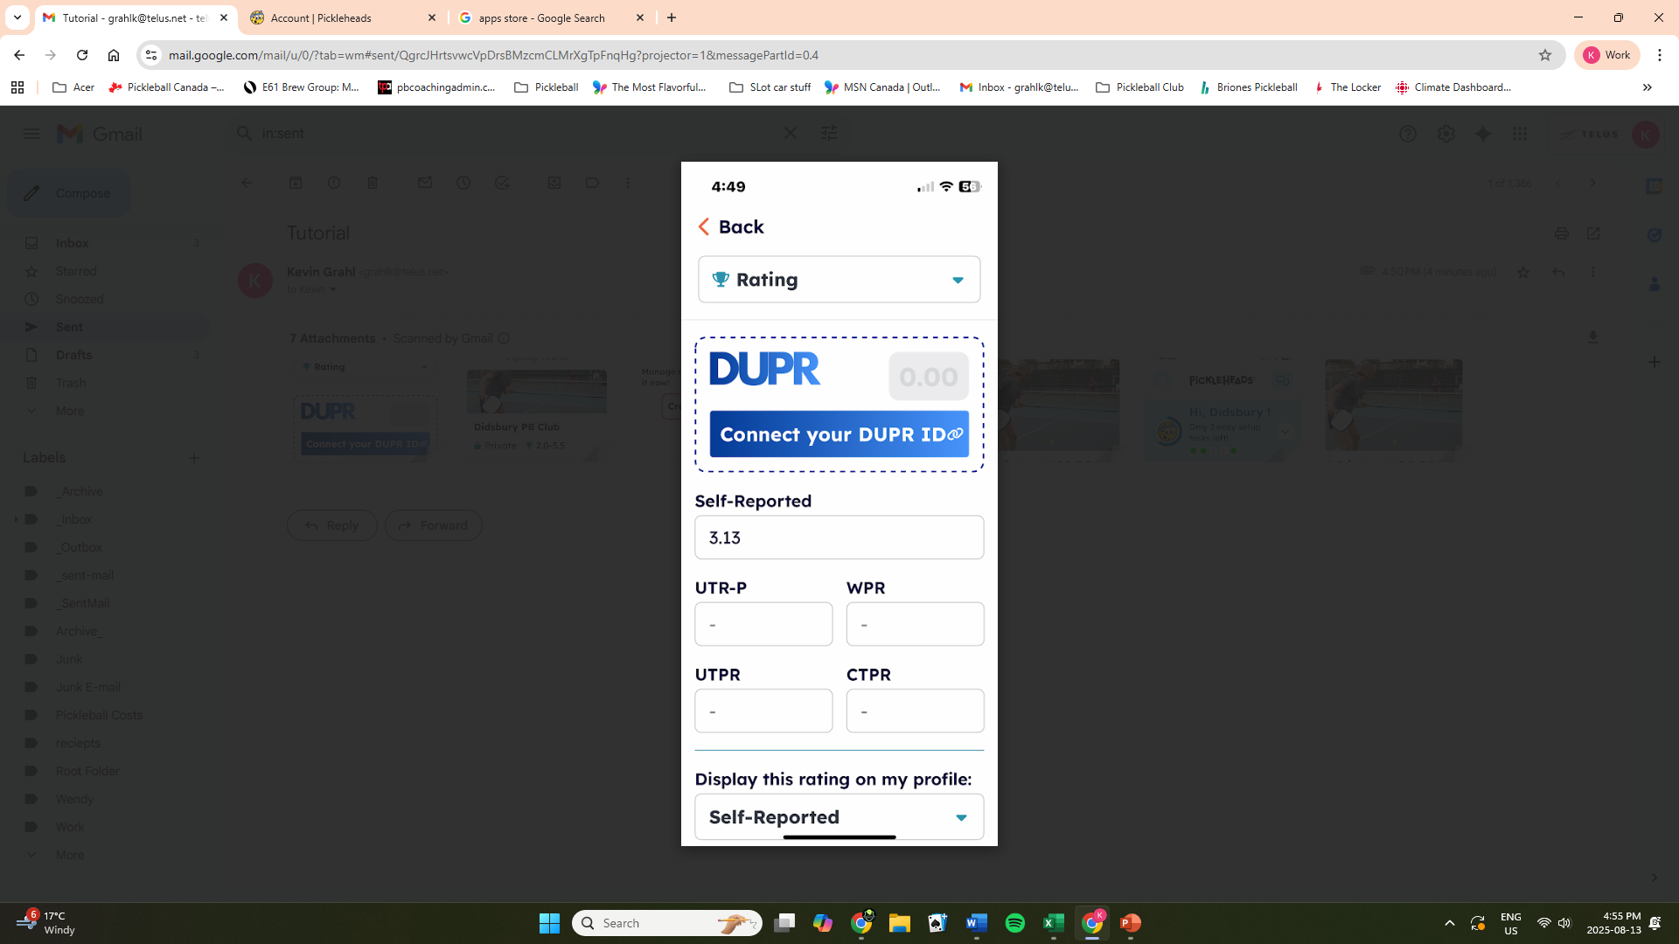
Step 19. Enter your club rating.
Step 20. Go back to main page.

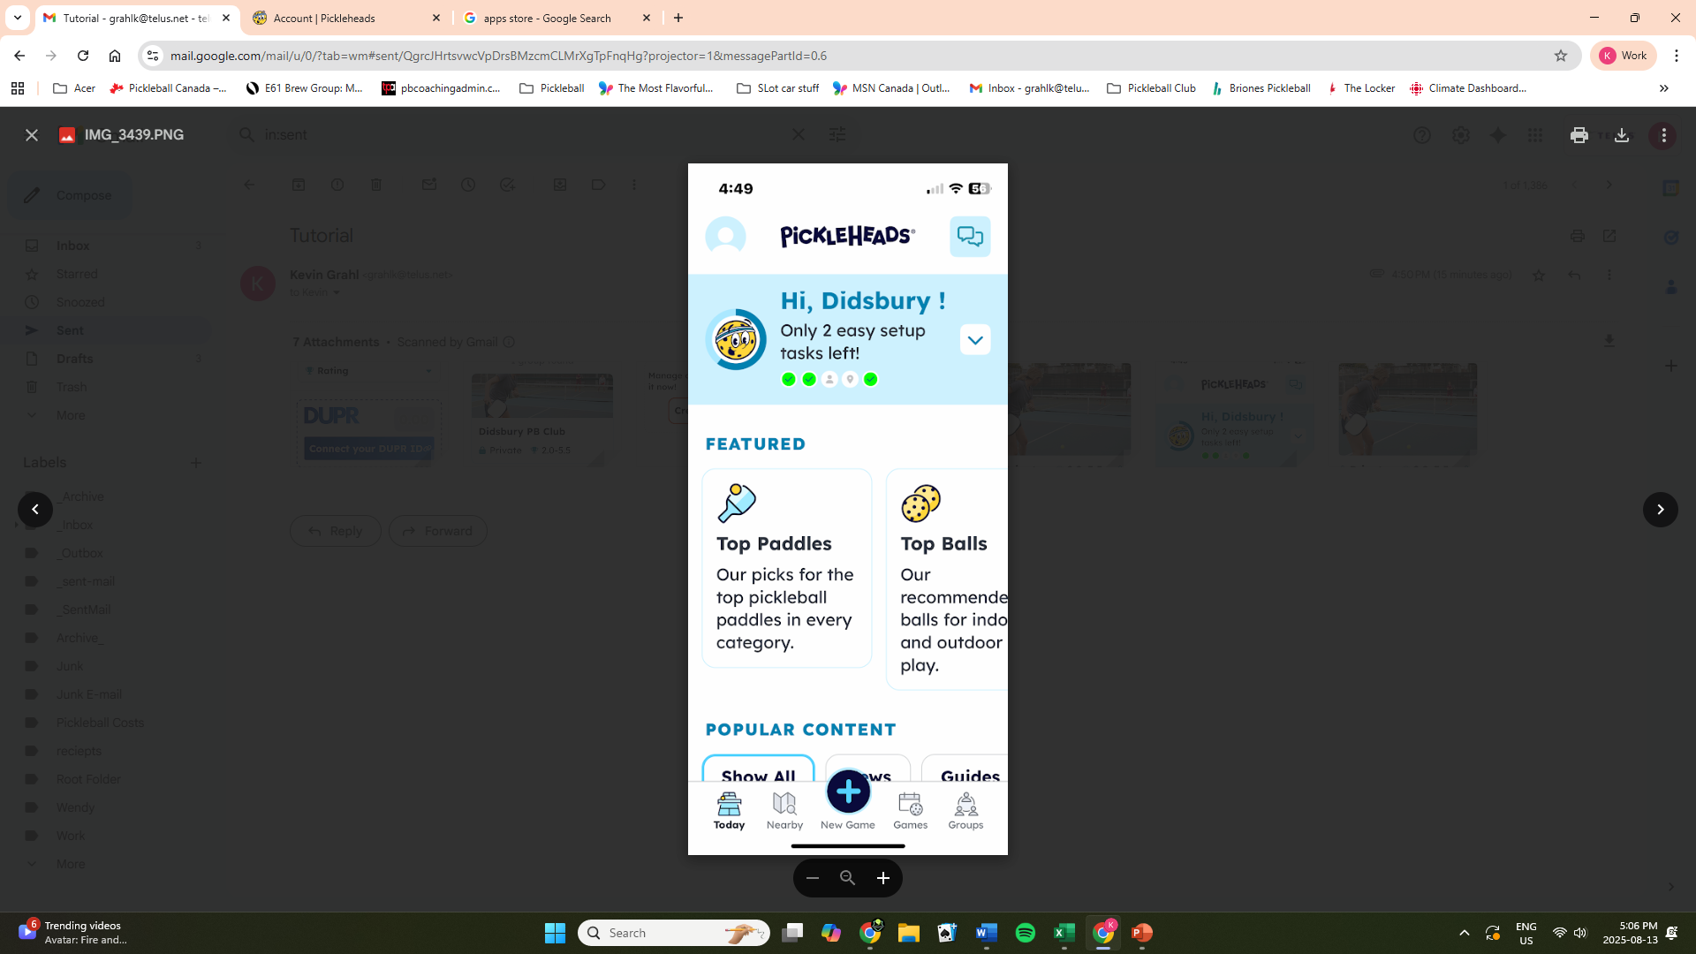
Step 20. Select Groups from the bottom menu bar.

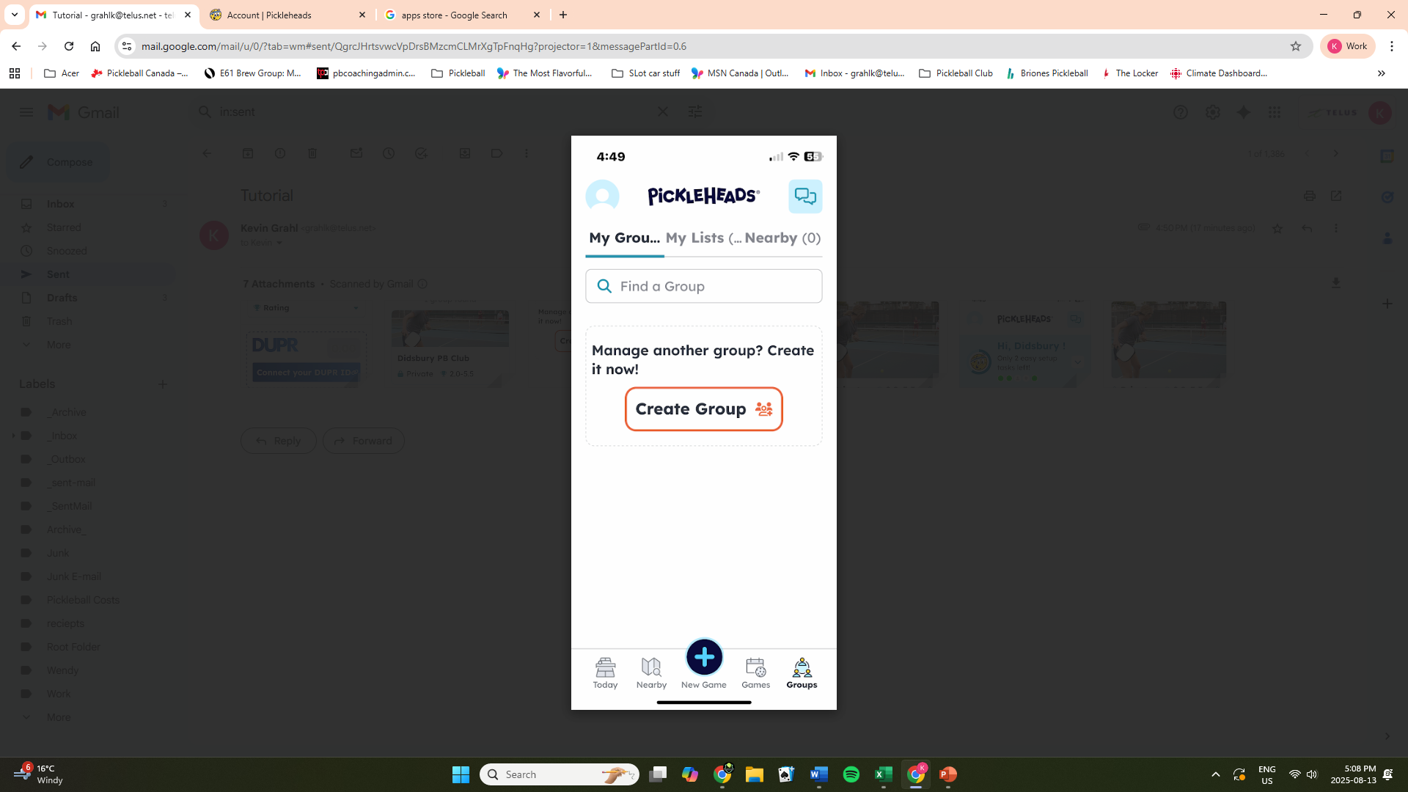
Step 21. Type in Didsbury Pb Club.
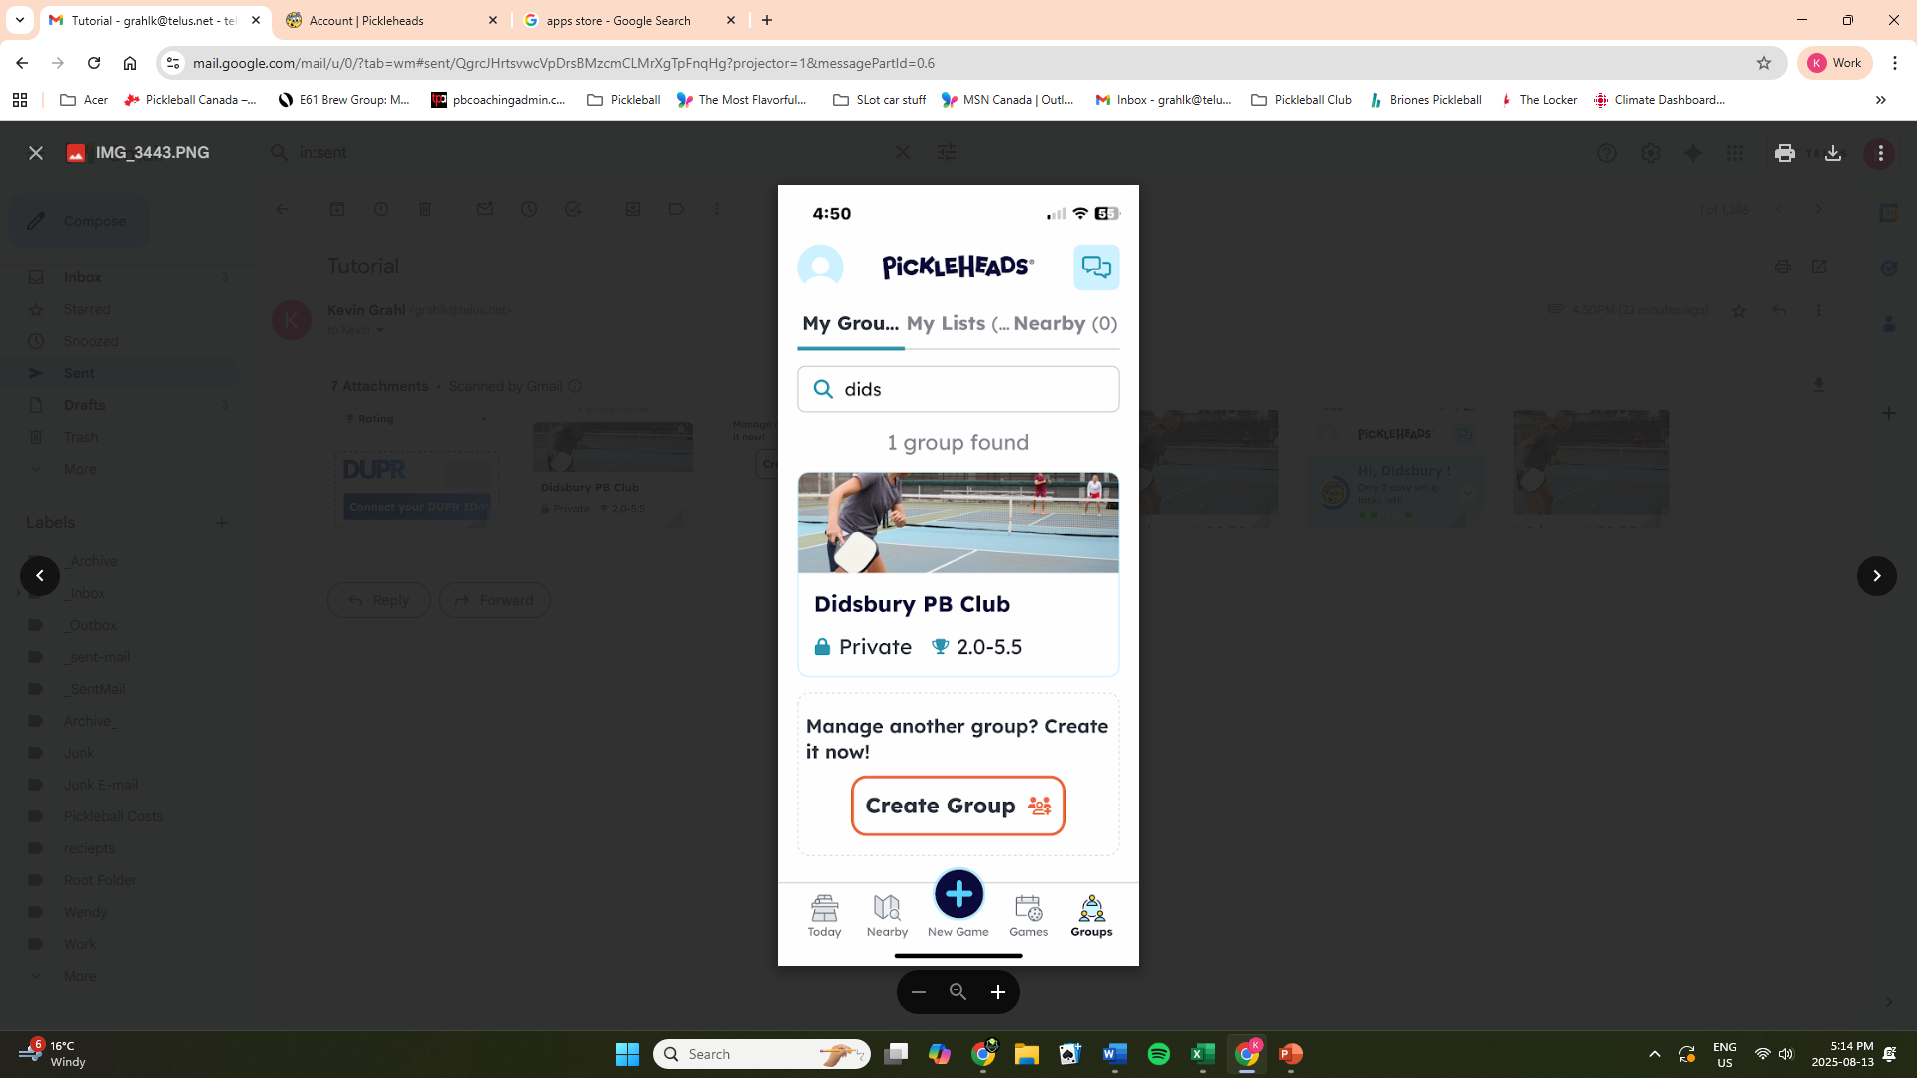
Step 22. Once found, tap the group picture. Didsbury Pb Club.
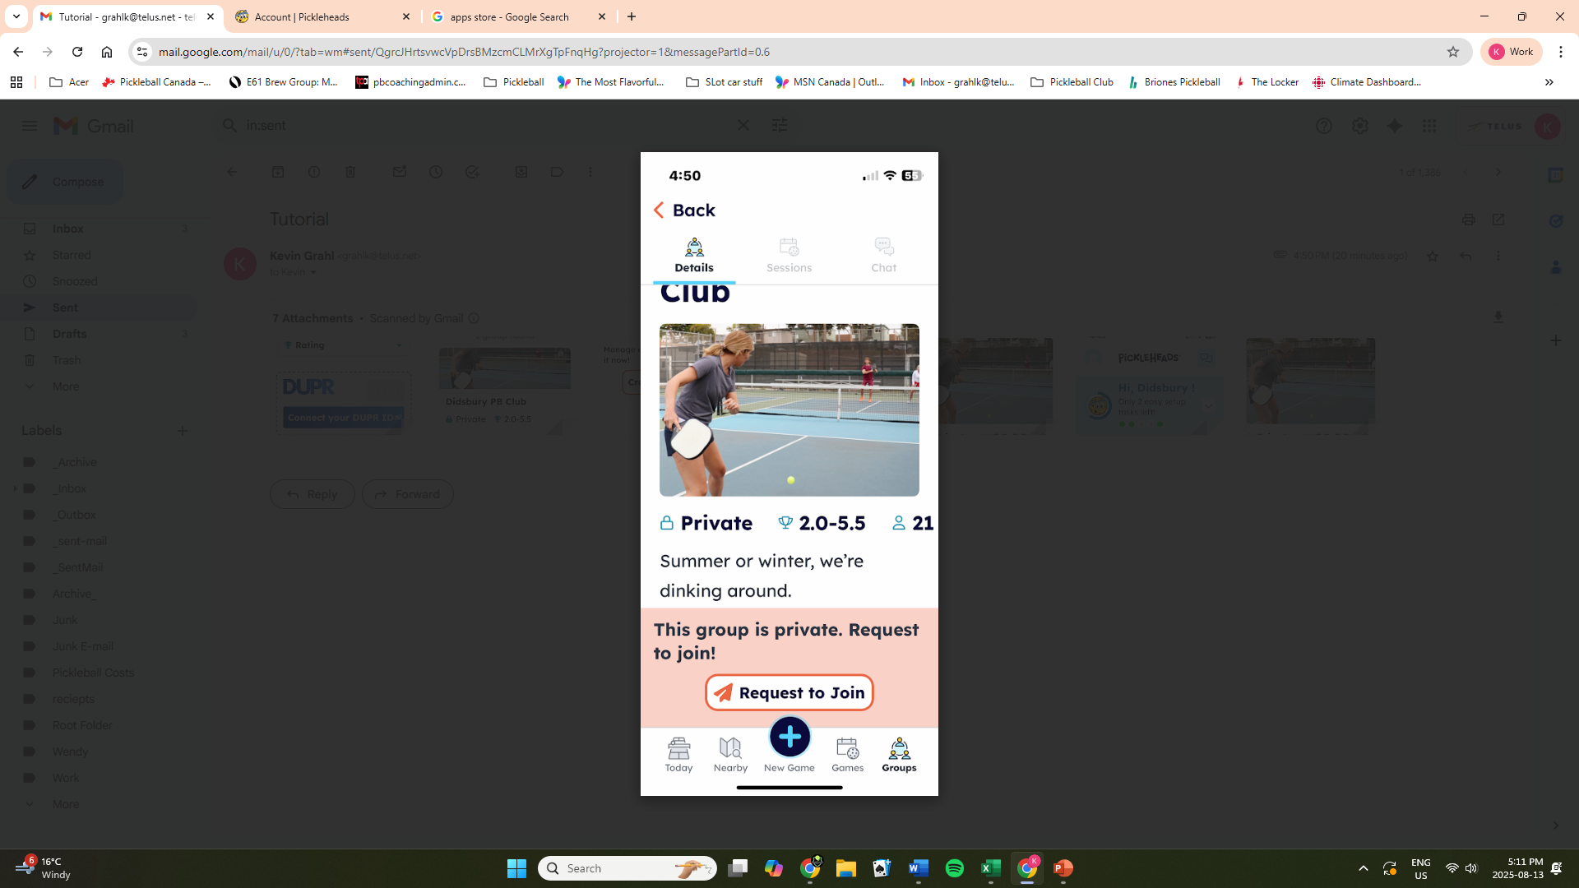
Step 23. Select Request to Join.
Step 24. Go back to your main page.
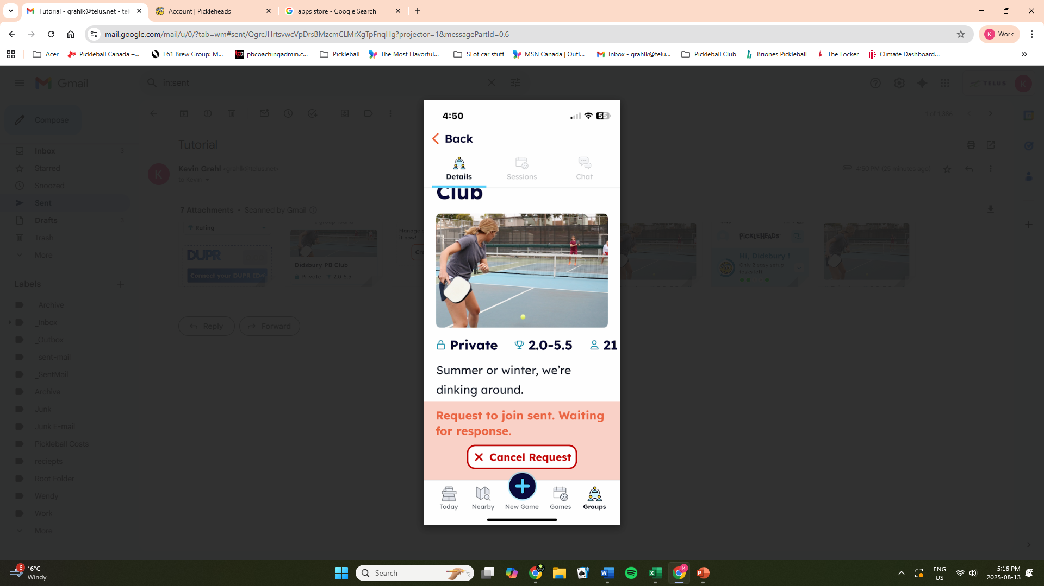

Those are the basic steps to get you started. Check out the app and there is also some great information on the Pickleheads webpage. Thank you for your patience going through these steps. If you still had a problem, one of our installation wizards will try to be at all the Saturday and Sunday sessions, for the remainder of August to assist anyone with the app.
Thanks everyone,
Didsbury and District Pickleball Club

