Welcome to the November 2023 Newsletter
Here we are in November already! Time flies when you’re having fun playing pickleball!!
We have had a busy couple of months getting back into our regular fall play sessions and organizing, and running, our Fall Tournament. We also continue to grow as a club, and we would like to extend a very warm welcome to all of the new members that have joined us over the last couple of months. We aim to provide you with a fun, inviting place to come and grow your pickleball skills, and hope that you are meeting friendly faces and enjoying this great sport that we all have come to love! (Yes…..the addiction is real……try to pace yourselves!!!)

CPC Board of Directors
We have many new members and faces at our club, so for those of you who may not recognize, or know, the people who are at the helm, here is a current photo of our current board members.

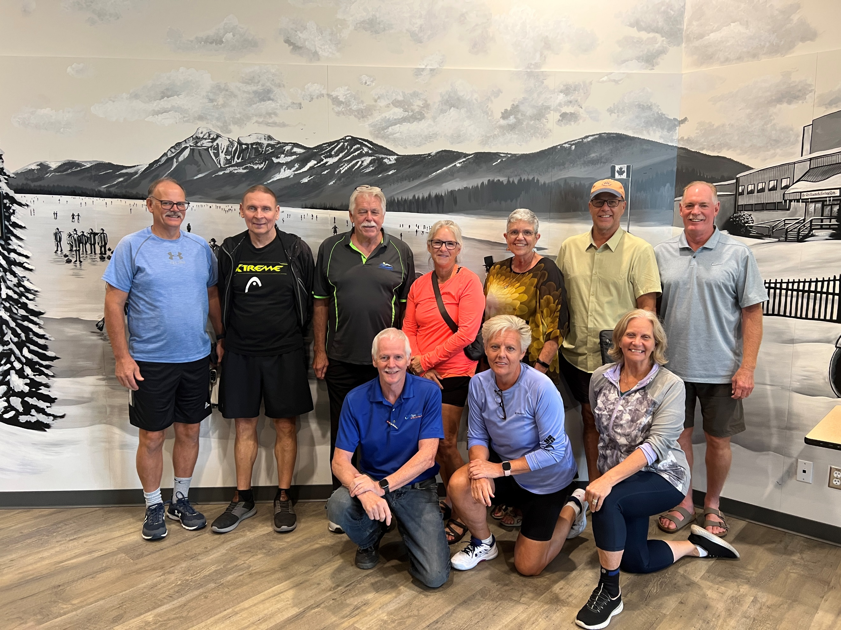
Back Row: Dave Barham, Gerry Rostek, Lyle Simpson, Sheila Armstrong, Cathie Sessions, Fred Meyerink, Brett Lovely
Front Row: Raymond Hart, Kathy Isaac, Carol Hart
Missing: Donna Hutchinson

November Play Schedule and Events

November is here, and along with it, the fall weather, so daily play schedules are filling up more quickly once again. Please note that registration on Pickleball Brackets will now be ‘locked out’ 2 hours prior to the session starting (not 1 ½ hours as was the case before). This gives your busy hosts more time to finalize court assignments and make sure the Landing is all set up and ready to go for your daily play. For Skills and Drills, registration will now be ‘locked’ at 8 pm the evening before the session. This is required to make sure the proper number of instructors can be confirmed in order to run the sessions the following day. Please be respectful of your hosts and fellow players, and make sure you are only signing up for sessions you are certain you will be attending. (Of course, we realize emergencies arise, if this happens please contact us soon as possible so we can make the needed changes).

The November calendar is now up on our website and you can also find a copy attached to end of this newsletter. Most of our regular weekday hours will remain the same for this month, however there are some notable cancellations that the city has made for other events at the Landing. There will be NO PLAY on Saturdays or Sundays during the month of November, and Friday, Nov. 3rd and 17th have also been cancelled. Along with our regular Mixers, Comp/Rec play, Beginners, and Skills and Drills, here are some of the other sessions that we will be running over the next couple of months. Please take a good look at all the options, lots of fun events to get involved with!!!!!

7 Week Men’s Fall Ladder League/Women’s Fall Ladder League

Where: The Landing

When: November 7th – Dec 19th, 2023

Time: Tuesday’s, 12.30pm-2.45pm

Cost: Players will Fob in as usual.
[Grab your reader’s attention with a great quote from the document or use this space to emphasize a key point. To place this text box anywhere on the page, just drag it.]

Opt-In on Pickleball Brackets one week in advance.

6 Week Winter Ladder Play for all Members

Where: The Landing

When: January 6th – February 24th (No Games Feb 3rd & 17th)

Time: Saturday Mornings, 10.15am-12.15pm

Cost: Players will Fob in as usual (as per normal play) and also pay a one off $10.00 entry fee to go toward door prizes.)
[Grab your reader’s attention with a great quote from the document or use this space to emphasize a key point. To place this text box anywhere on the page, just drag it.]
Register on Pickleball Brackets:-
https://pickleballbrackets.com/lgd.aspx?lid=127844a3-e0c7-4371-9d49-58a513f40f00

General Information for Ladder Leagues
The format of play is designed so that players play mostly with others of similar skill levels therefore players will be seeded before commencement. Each week in each grouping the top two players in the group will move up and the bottom two players will move down.
Each week, players will be placed in groups of 4, 5 or 6 in the order of their ranking on the ladder for match play. You are expected to play every week unless you “Opt Out”. All players will play three or four doubles games in a round robin fashion with the other players in the group. At the start of the game, players will decide who starts serving first and choice of side.
After your games have been played, players record their scores on the score sheet and the ladder captain will then enter them into the pickleball brackets program.
Scores will not affect your club ratings unless a grouping decides that they would like their scores recorded. All players in the group must be in agreeance and be within .5 in skill level.
NB: Fall Ladder League winners will be determined by most wins. In the event of a tie then it will go to point differential.
Winter Ladder League’s winner will be determined by the player who finishes at the top of the ladder.
Partner Drills – 3.0 and Over
Partner Drills will continue to run on Monday’s. Come on out and drill with your partner. You can practice your own drills or follow along with Raymond and Carol Hart. (No games allowed)!!! Only one partner needs to OPT IN.
See the calendar for times.
(You need to register for the session before you will see it listed under your “My Schedule”)

Half Court Singles
Playing Half Court Singles will improve your accuracy, skills and endurance not to mention it is lots of fun. Join us on Thursday’s, 3.00-4.30pm. Opt In on Pickleball Brackets.

Challenge Court
We are going to experiment with a Challenge Court on Thursday Nov 16th. Two TOP DOGS and two Challengers will be chosen to start off the day. The Winners can only stay on the challenge court for 3 games in a row. Fancy your chances, then grab a partner and head on down!!!
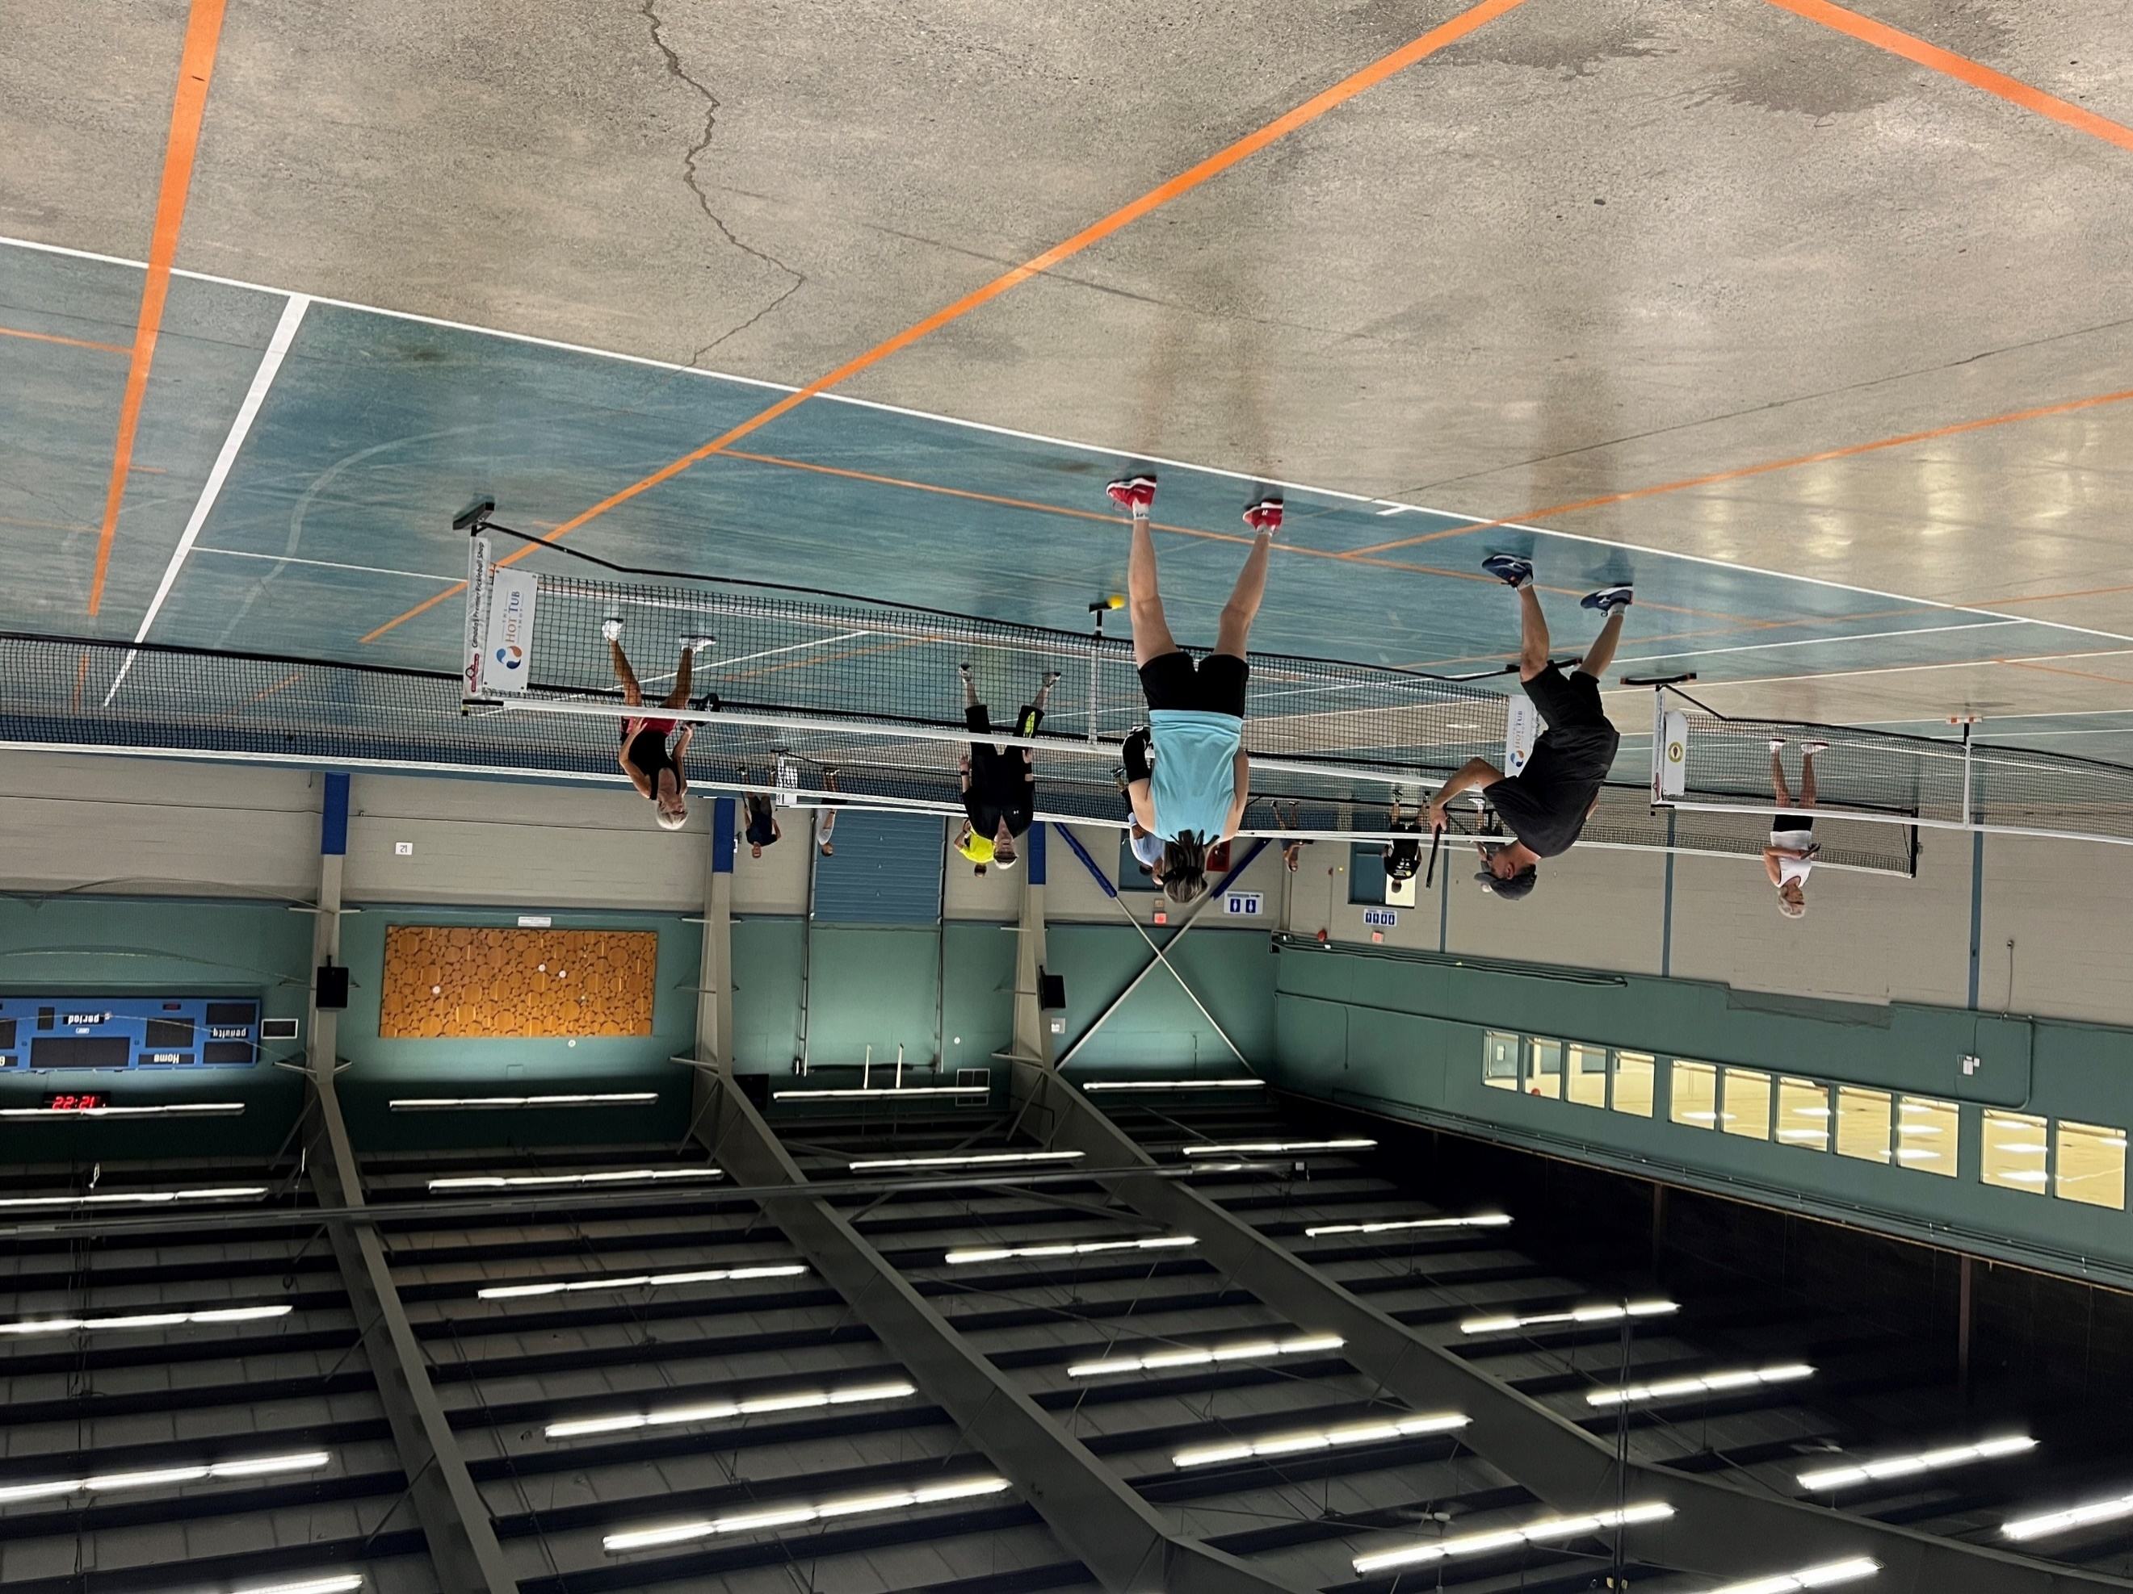
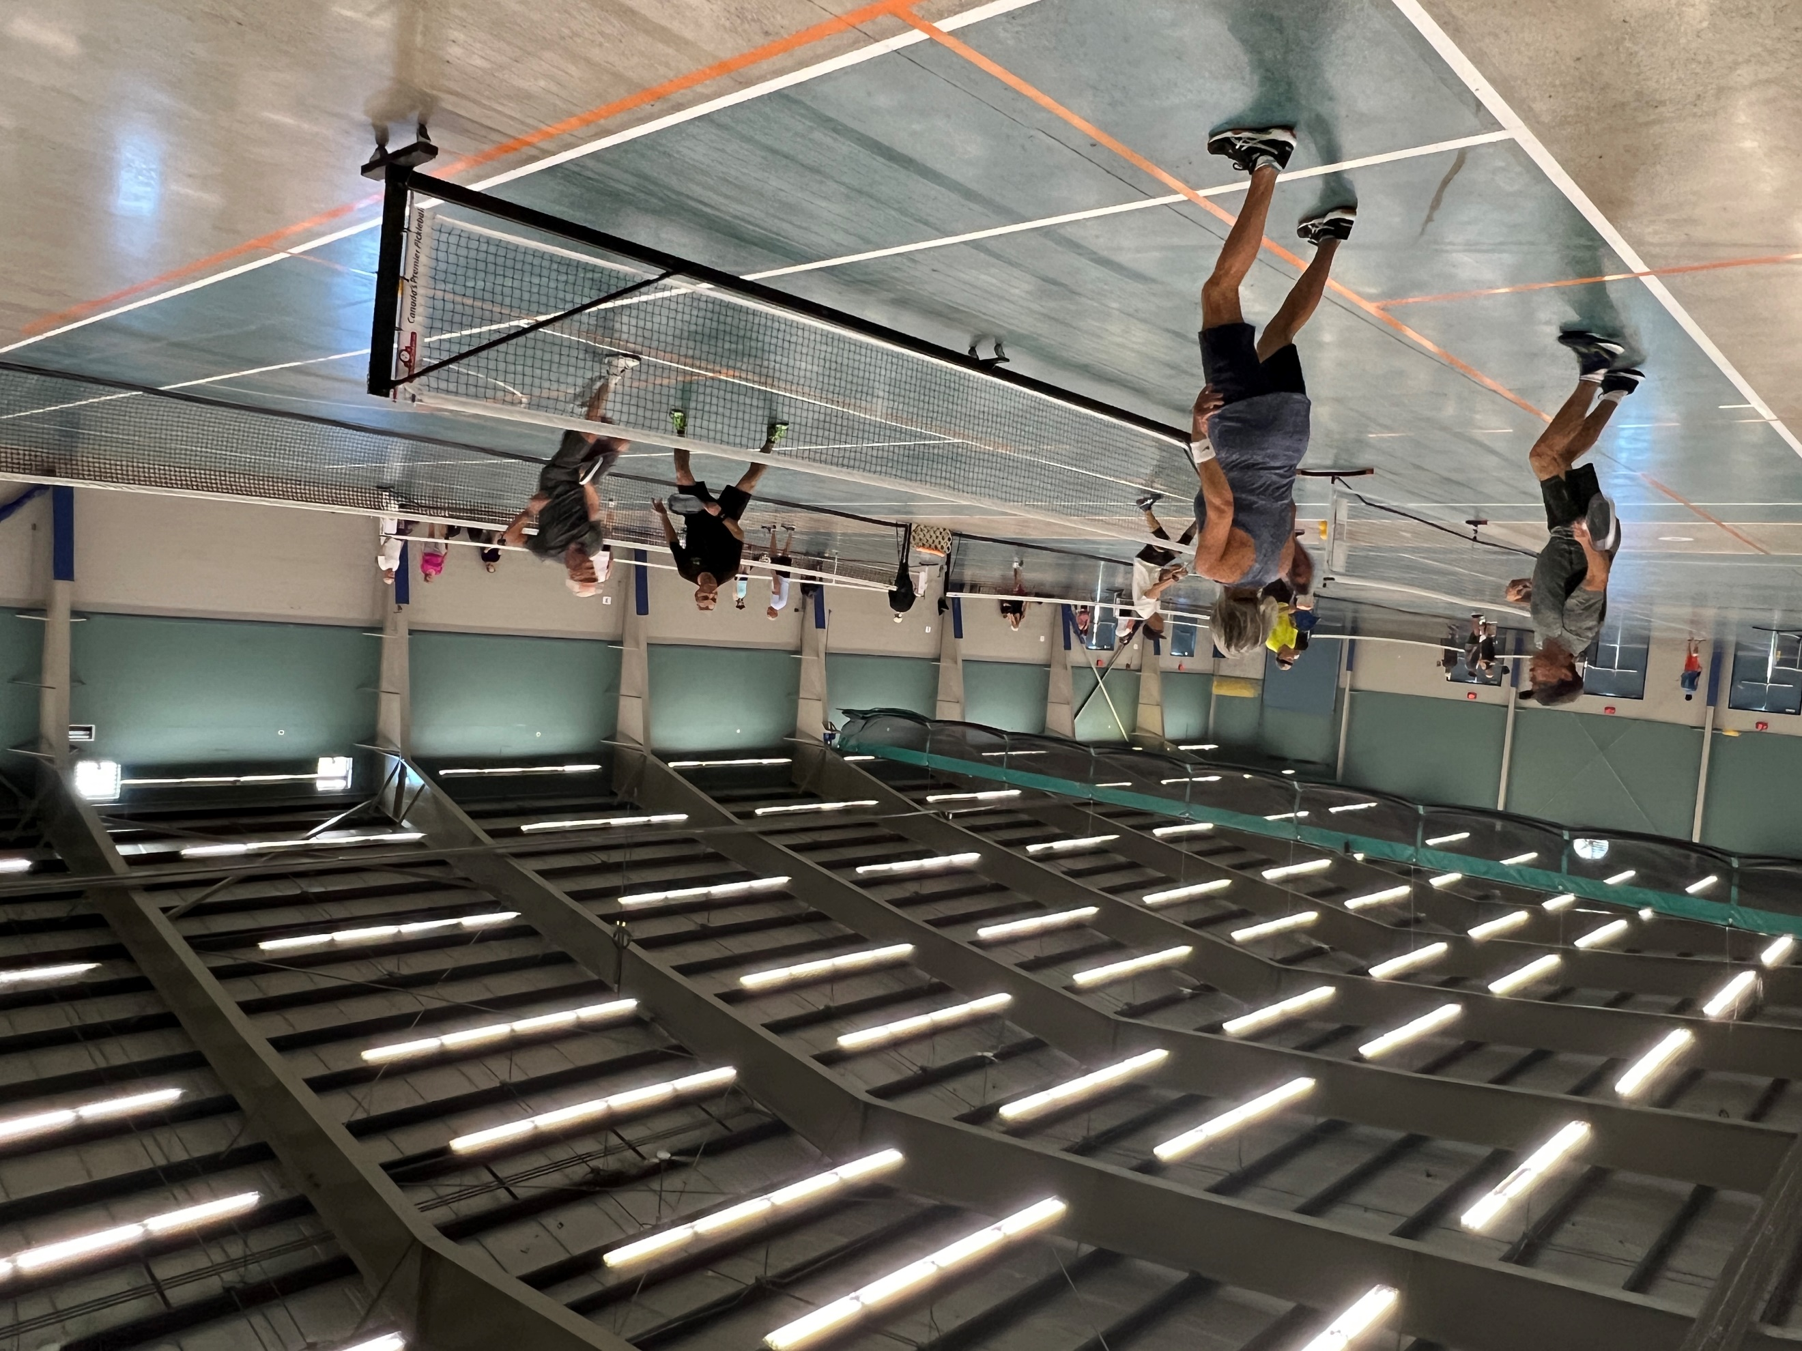
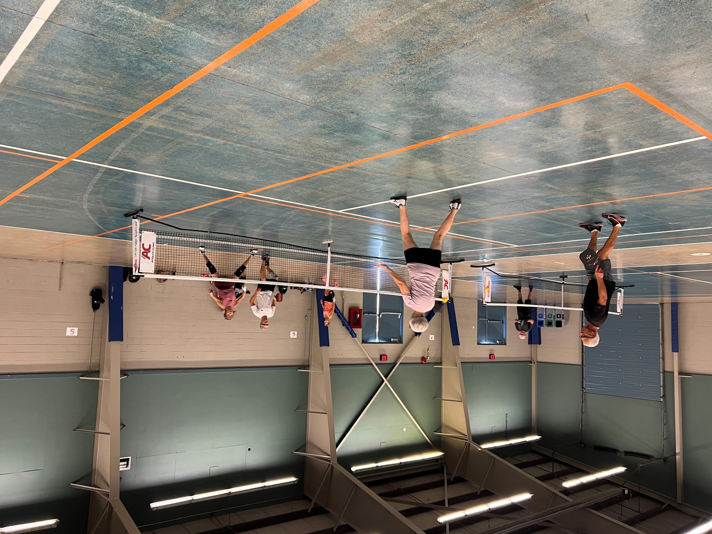

Elder College Sessions
Lyle, and his wonderful volunteer coaches, finished up another round of Elder College pickleball classes. Participants spend one day in a classroom setting learning the basic rules and strategies of the game, and then participate in a second session at the Landing where they put all their great learning into practice. Lyle and his crew make sure that everyone gets a solid introduction to this wonderful sport, and everyone has a great time! At the end of the course a lucky winner is also chosen to receive a brand new paddle. The next Elder College sessions will be held next February.

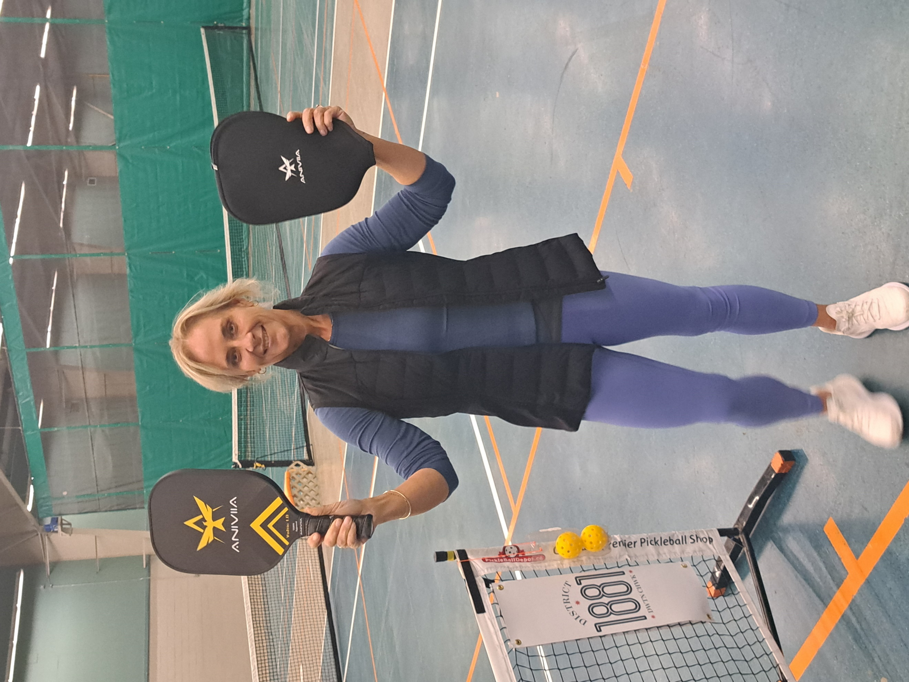
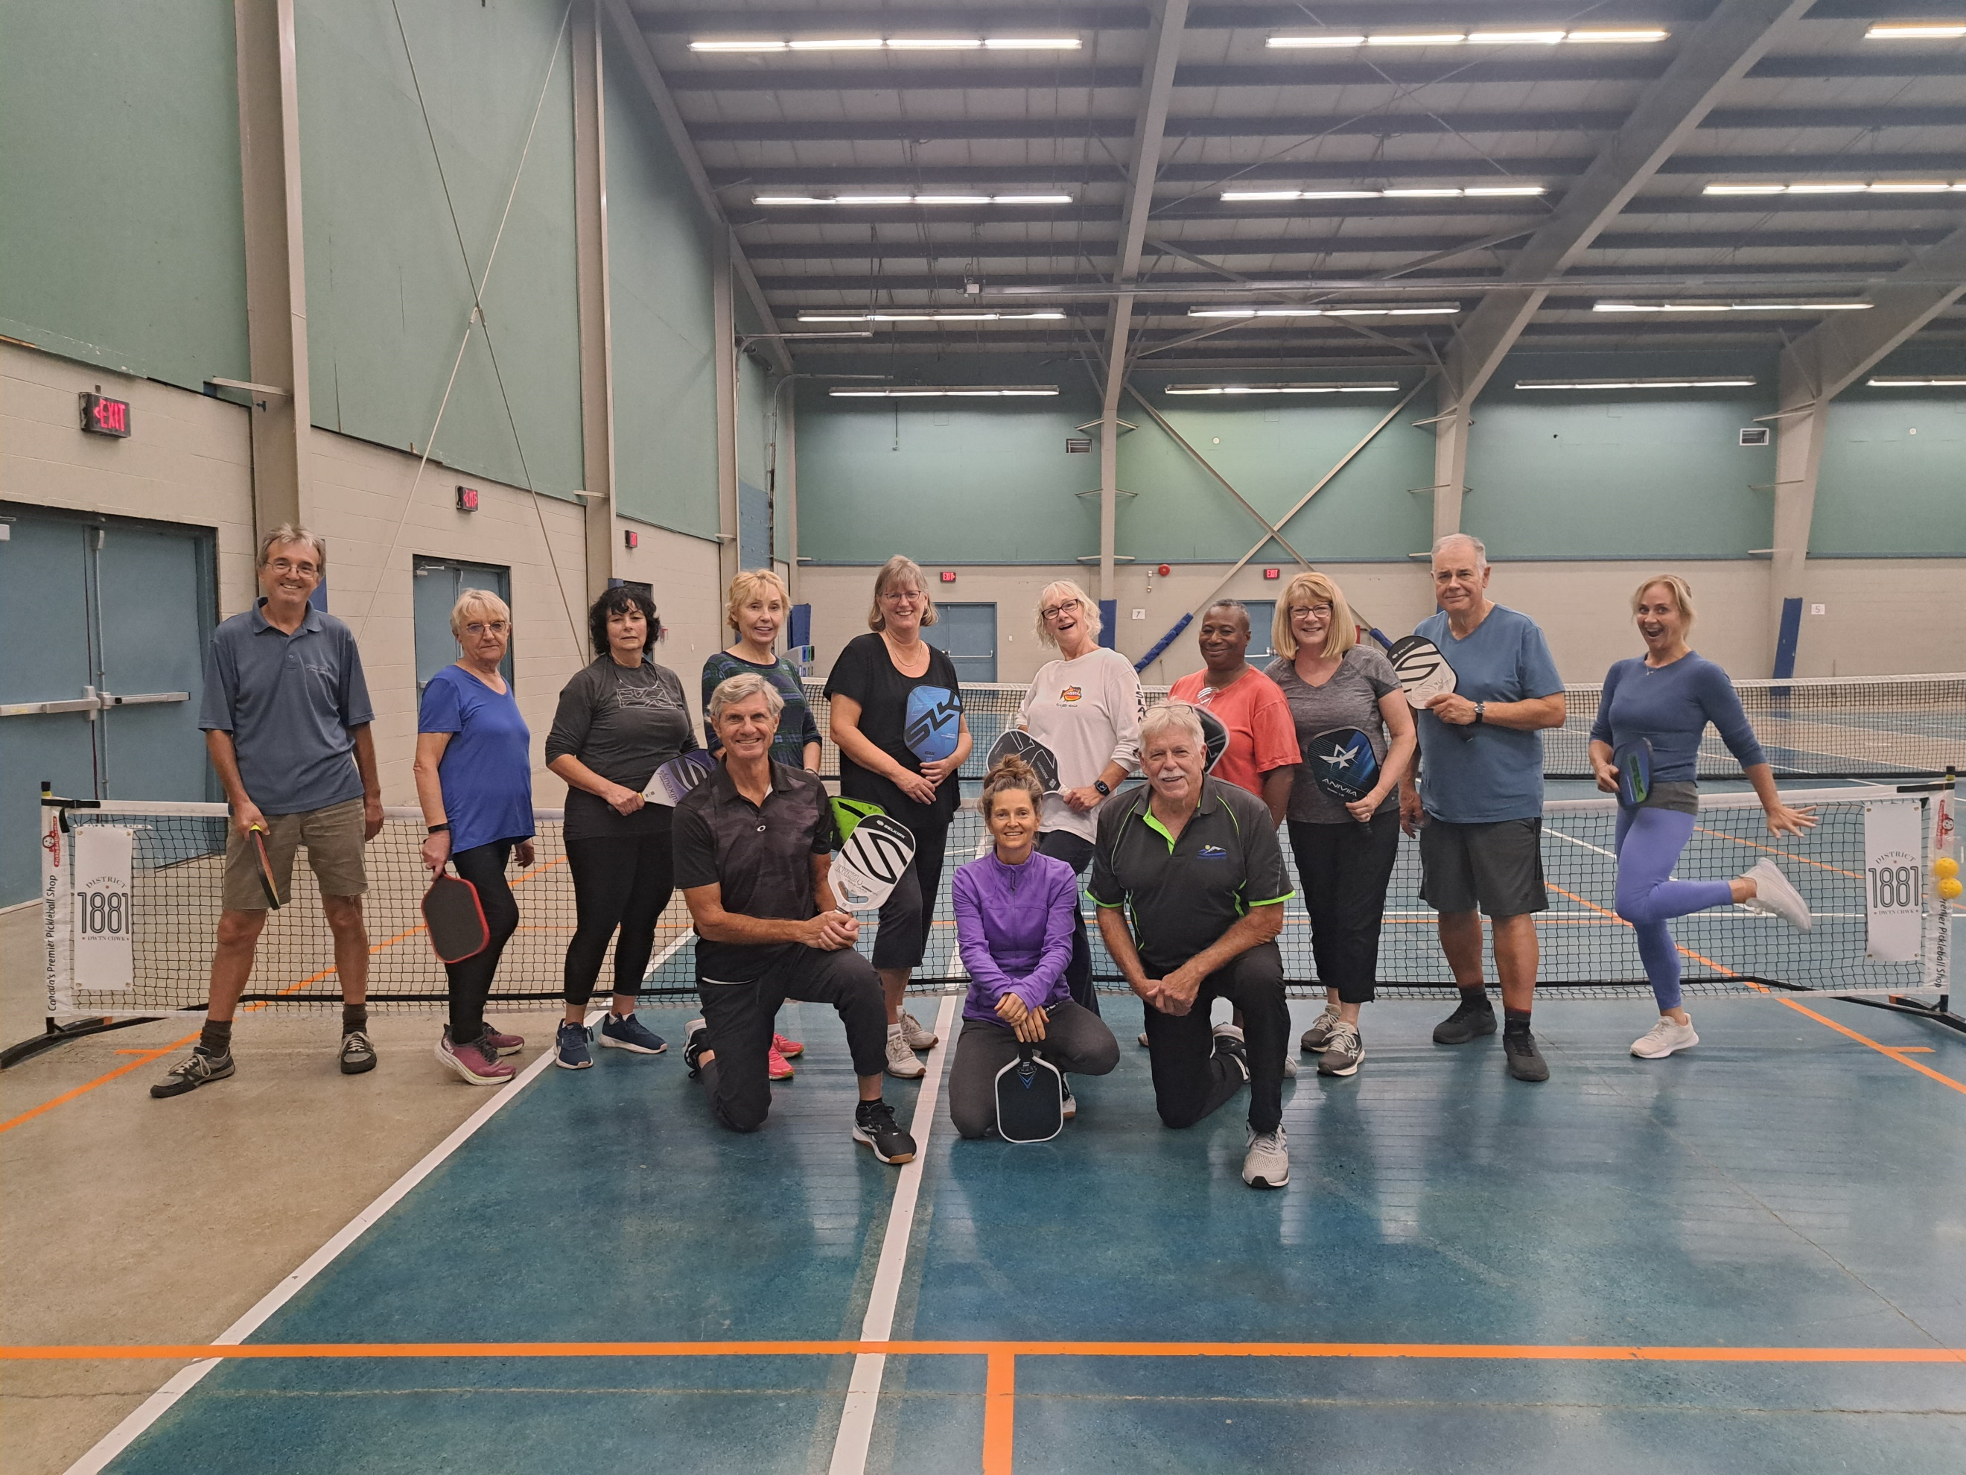

CPC Fall Tournament
Oct 20-22nd
Well, another successful Chilliwack Pickleball Tournament is in the books!!! Last weekend we hosted over 280 enthusiastic participants who enjoyed three days of great competition and camaraderie. Our club is quickly becoming known for our well run, welcoming tournaments, and if you haven’t ventured into the tournament arena yet, make sure you make plans to join us for our upcoming tournament in February 2024!
Congratulations to all the members (and their partners) that were able to make it to the podium in last weekend’s tournament!!! (It’s an extensive list, so please forgive any errors or omissions!!)
Bruce Holbrook/Stephan Holbrook GOLD Men’s Doubles 2.5 Age: Any
Dan Norman/Remmert Hinlopen GOLD Men’s Doubles 3.0 Age: 50+
Shawn Wilson/Jason Dueck SILVER Men’s Doubles 3.0 Age 50+
Harry Hubner/Randy Orford GOLD Men’s Doubles 3.5 Age: 50+
Shawn Iversen/Wade Rathgeber SILVER Men’s Doubles 3.5 Age 50+
Raymond Dear/Tim Cowley GOLD Men’s Doubles 4.0-4.5 Age: Any
Stephane Hamel/Tim Mallach BRONZE Men’s Doubles 4.0-4.5 Age: Any
JD Fredette GOLD Men’s Scramble 2.5 and under Age: Any
Chris Brown-John GOLD Men’s Scramble 3.0 Age: Any
Ed Nicholl SILVER Men’s Scramble 3.0 Age: Any
Glen Marcotte BRONZE Men’s Scramble 3.0 Age: Any
Wade Rathgerber BRONZE Men’s Scramble 3.5 Age: Any
Stephane Hamel GOLD Men’s Scramble 4.0 and above Age: Any
Ray Dear SILVER Men’s Scramble 4.0 and above Age: Any
Robynn Macpherson/Lara VanDerMerwe GOLD Women’s Doubles 2.0 and under Age: Any
Judy Redekop/Katheryne Robbins SILVER Women’s Doubles 2.0 and under Age: Any
Michele Raye/Penny Holbrook BRONZE Women’s Doubles 2.0 and under Age: Any
Penny Holbrook/Michele Raye BRONZE Women’s Doubles 2.0 and under Age: 50+ Tara Lyon/Samantha Johnson GOLD Women’s Doubles 2.5 Age: Any
Lili Blackwell/Terry Aleksic SILVER Women’s Doubles 3.0 Age: Any
Carrie Klassen/April Gardener BRONZE Women’s Doubles 3.0 Age: Any
Sheila Armstrong/Sandra Verschuur SILVER Women’s Doubles 3.5-4.0 Age: Any
Jeannie Korytko/Kim Forsythe BRONZE Women’s Doubles 3.5 Age: 50+
Samantha Johnson/Lara VanDerMerwe GOLD Women’s Scramble 2.0 and under Age: Any
Judy Redekop/Michelle Raye SILVER Women’s Scramble 2.0 and under Age: Any
Trish Cochrane/Kelly Joiner BRONZE Women’s Scramble 2.0 and under Age: Any
Julie Fredette/Bev Burnet GOLD Women’s Scramble 3.0 Age: Any
Suzi Inkman/Cigdem Celik BRONZE Women’s Scramble 3.0 Age: Any
Jeannie Korytko SILVER Women’s Scramble 3.5 Age: Any
TJ Jones BRONZE Women’s Scramble 3.5 Age: Any
Kathy Isaac GOLD Women’s Scramble 4.0 and above Age: Any
Kas Ingwersen BRONZE Women’s Scramble 4.0 and above Age: Any
Samantha Johnson/Mike Johnson GOLD Mixed Doubles 2.0 and under Age: Any
Lara VanDerMerwe/Philip Weatherston SILVER Mixed Doubles 2.0 and under Age: Any
Jennifer Ware/Doug Ware GOLD Mixed Doubles 2.5 Age: 50+
Sue Iversen/Shawn Iversen SILVER Mixed Doubles 2.5 Age: 50+
April Gardener/Remmert Hinlopen GOLD Mixed Doubles 3.0 Age: 50+

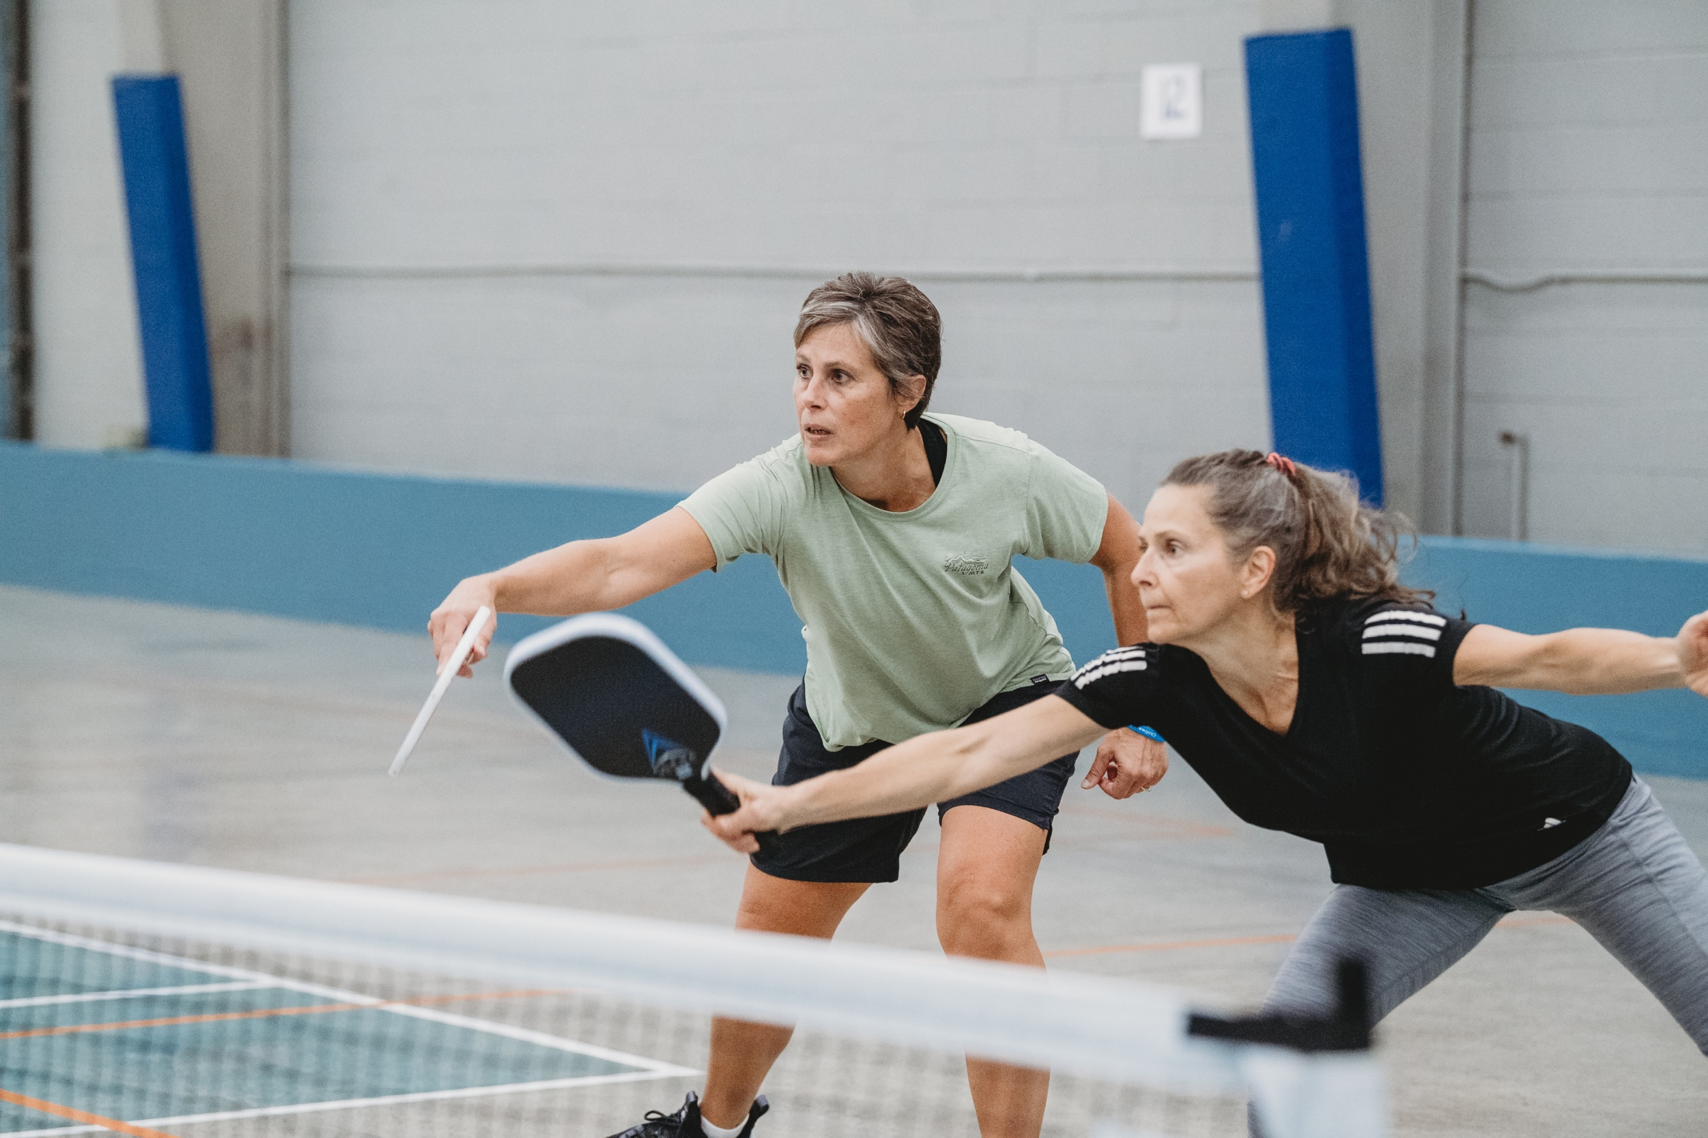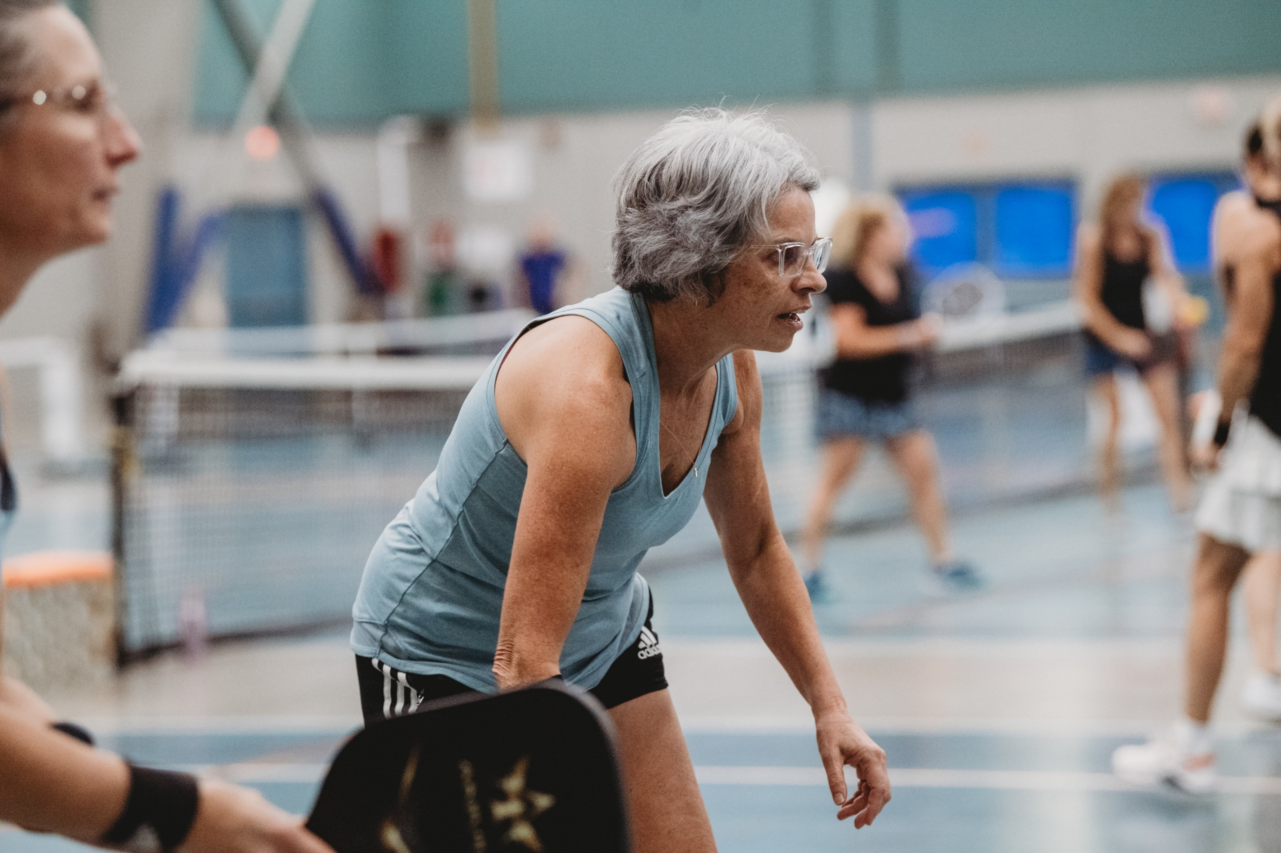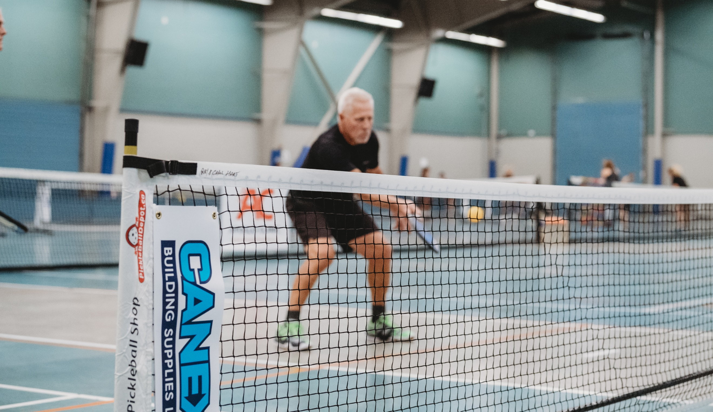

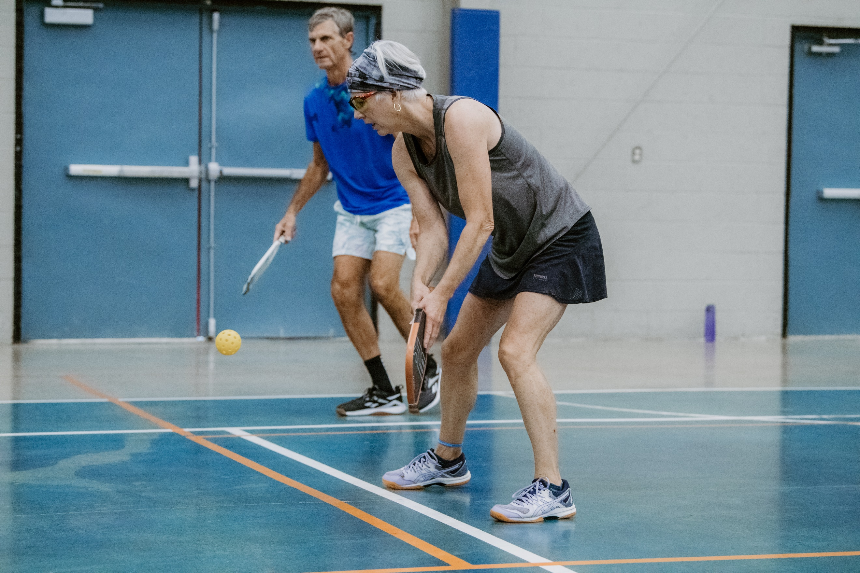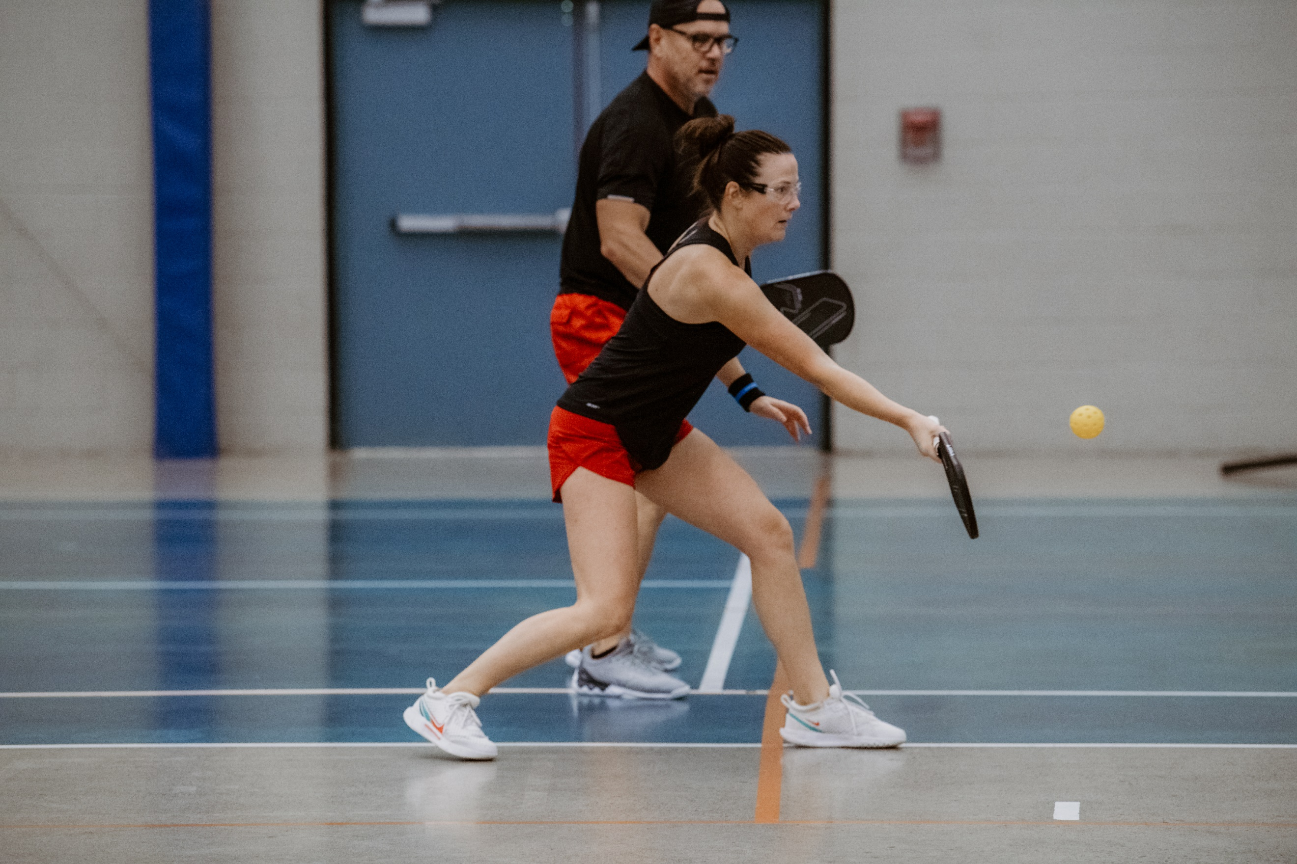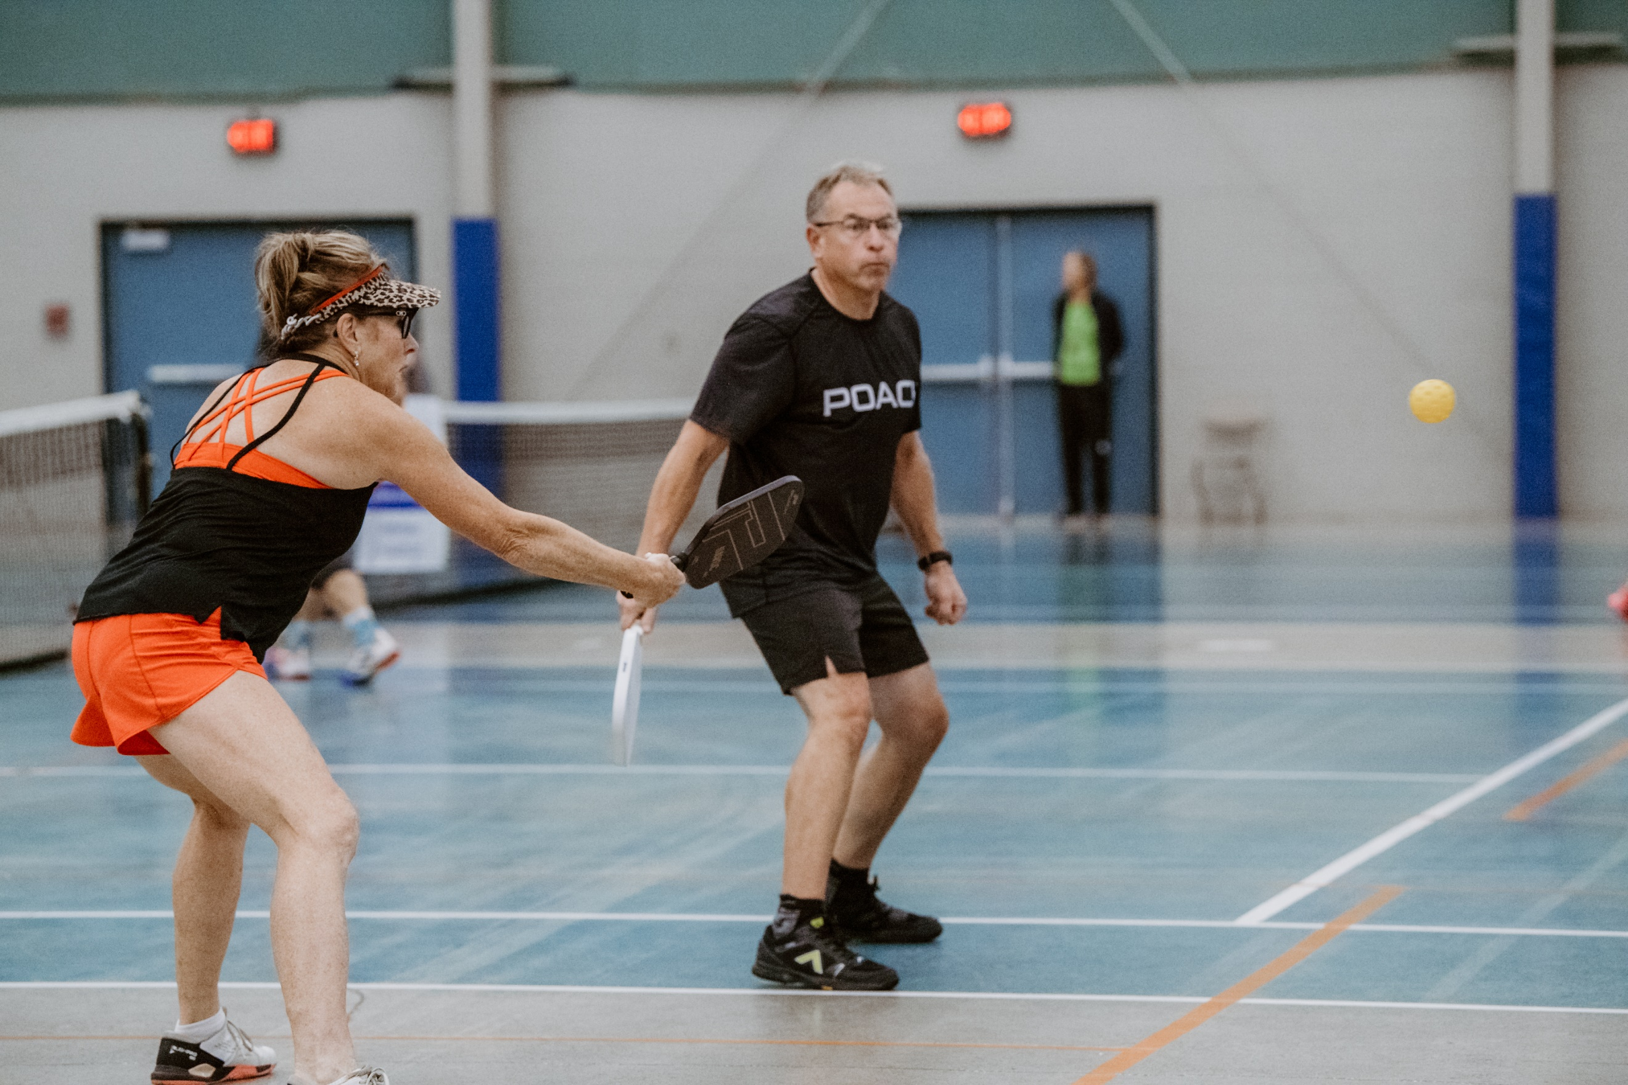

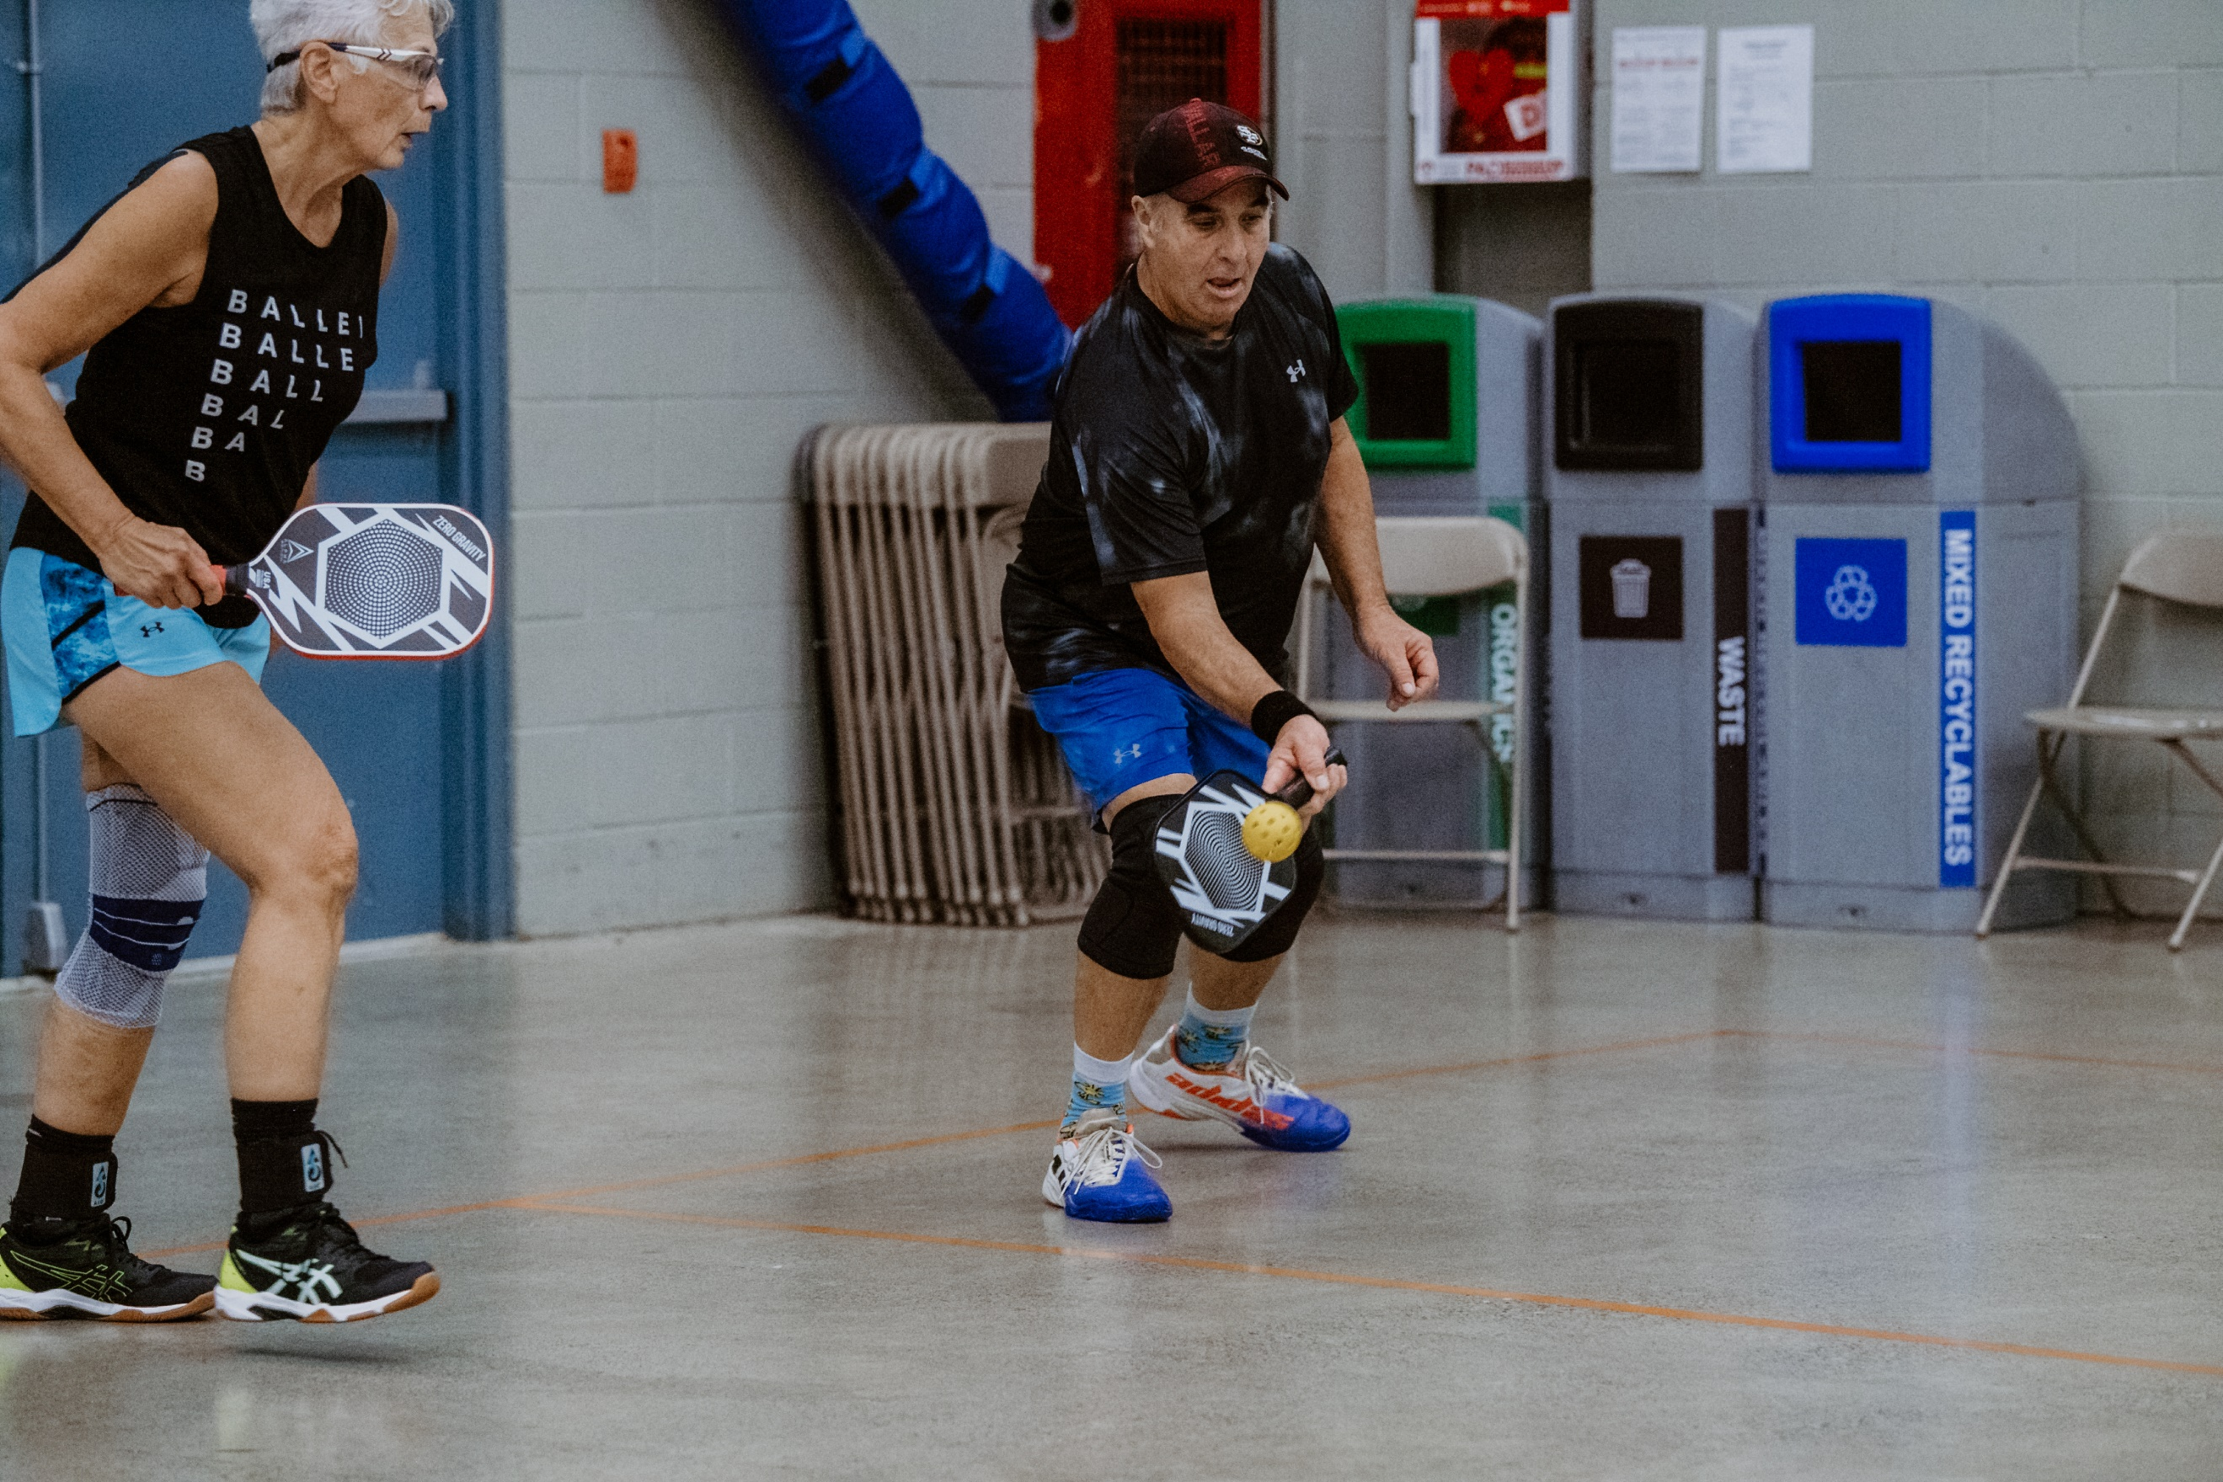

THANK YOU VOLUNTEERS, THANK YOU !!!!!!!!
A huge THANK YOU goes out to all the volunteers that worked to make our Fall tournament such a great success!
The first thank you must go out to the tournament organizers. Our tournament leader, Carol Hart, spends endless hours behind the scene getting the tournament set up on Pickleball brackets and then for 3 days makes sure everything runs smoothly and on time!! Lyle Simpson, our tournament MC, makes sure that everyone that comes to our tournament meets up with a friendly face, has some laughs, and gets to their courts on time to play their games. Ray Hart is in charge of the playing floor and makes sure his Court Monitors keep everything running along on time, and he is always the go-to guy when there are any rule disputes or questions. The rest of the team consisted of Sandra Vershuur and myself helping Carol at the computers, Betty Meiszner, Linda Huffman, and Sue Johnston, who checked in players and made sure games were recorded on paper, Gerry Rostek who set up and manned the game monitors, Dave Barnham who helped on the playing floor and refed some matches, and of course, last but not least, Helen and Ken Janzen who organized all the food and goodies and spent 3 days at the tournament making sure everyone was happy and fed!
But a big tournament with over 280 players can not run without many other volunteers! Below is a list of everyone who offered their time to help out our club!

Bunny Duffy Heather Turner Hamel Angelika Stephan Lori Barden
Holly McMillan Liz Carey Sam Barieh Debbie Golden
Diana Manuel Joti Kapdee Branda Pare Brian Bruinink
Ken Witt Brenda Jones Rob Forde Teri West
Brenda Rattray Cheryl May Dianne Ellis Don Beer
Ray Dear Don Barden Bob McMillan Karen Ng
Rod Comeau Moni Bhavra Janet Erwood Lowell Ritchie
Candy Clouthier Tania Symons John DeGlopper Charlene DeGlopper
Mary Adamson Dan Miles Lynda Mundstock Michele Godfrey

(I’m sure there were also some last minute fill-ins, or other helpers that contributed this weekend, so if you are not on this list….Thank you and sorry for the omission!)

Tournament Raffle Table
As usual our tournament provided players, and guests, the opportunity to win wonderful raffle prizes, and a big thank you goes out to Christina Garson for securing such wonderful gifts! We would like to thank those businesses, and individuals that donated product:
Zach Russell IGWealth management/Molsons
Save On Foods
Thrifty Boutique
Lily Blackwell Realty
Dan Norman
Christina Garson and friends
Proceeds raised at the raffle table will be donated to the Chilliwack Senior’s Society.

CHRISTMAS HAMPER FUNDRAISER
Yes…..it is that time of year again!!! Our club will once again be running our Christmas Hamper fundraiser to help out some Chilliwack families in need. Last year we worked with some local schools to provide two families with Christmas hampers filled with food and goodies. I know first-hand that these families were extremely grateful and touched by our club’s generosity, and it provided them with the help they needed to get through, what for some families, is often a challenging time of year.
We will be putting out the donation box by the sign in table, so when you see it, please remember how fortunate we all are, and open your hearts and wallets! If you don’t carry cash you can also make a donation at pay@chillpb.com. (please make a note that it is for the Christmas Hampers). Thank you!

Club Sponsors Program

We continue to have some wonderful club Sponsors so please don’t forget to check them out when you are looking for great service and/or products! Also, if you looking for information on how to become a sponsor, or know of a local business that may want to join our team, please contact our Vice-President, Ray Hart.

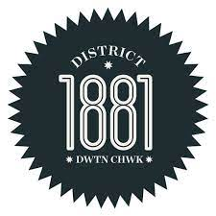

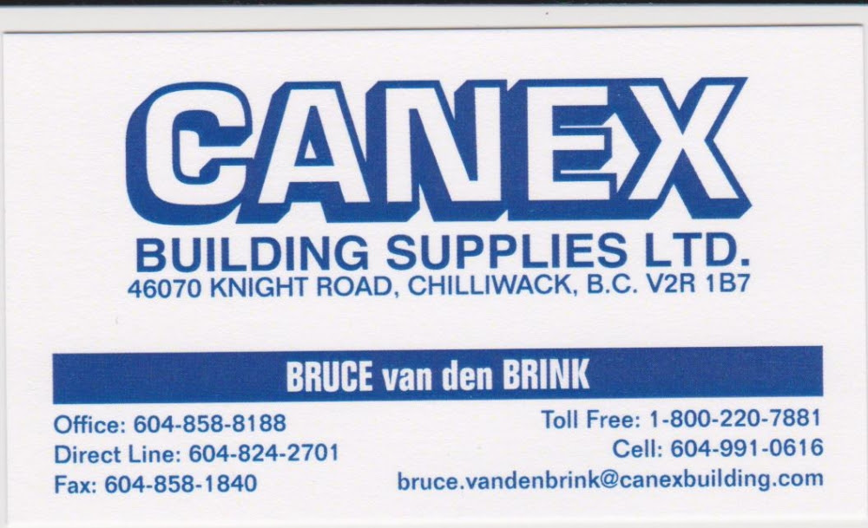

Saturday, November 11th, 2023

Nov2023
Sun | mon | tue | wed | thu | fri | sat
 |  |  | 01 | 02 | 03 | 04
 |  |  | 10.30-1.00pm  Competitive &  Rec Social | 12.30-2.45pm  Skills & Drills,  Rec Social  3.00-4.30pm  Half Court Singles | Cancelled | Cancelled
05 | 06 | 07 | 08 | 09 | 10 | 11
 | 10.30-1.00pm  Mixer  1.15-3.15pm  Partner Drills  3.30-4.30pm  Jr Program  4.30-6.00pm  BYOC | 12.30-2.45pm  Women’s & Men’s Ladder League  3.00-5.00pm  Beginner’s | 10.30-1.00pm  Competitive &  Rec Social | 12.30-2.45pm  Skills & Drills,  Rec Social  3.00-4.30pm  Half Court Singles | 12.30-2.45pm  Mixer  3.00-5.30pm  BYOC | Cancelled
12 | 13 | 14 | 15 | 16 | 17 | 18
Cancelled | 10.30-1.00pm  Competitive & Rec Social  1.15-3.15pm  Partner Drills  3.30-4.30pm  Jr Program  4.30-6.00pm  BYOC | 12.30-2.45pm  Women’s & Men’s Ladder League  3.00-5.00pm  Beginner’s | 10.30-1.00pm  Mixer | 12.30-2.45pm  Skills & Drills,  Rec Social with Challenge Court  3.00-4.30pm  Half Court Singles | Cancelled | Cancelled
19 | 20 | 21 | 22 | 23 | 24 | 25
Cancelled | 10.30-1.00pm  Mixer  3.30-5.30pm  Partner Drills | 12.30-2.45pm  Women’s & Men’s Ladder League  3.00-5.00pm  Beginner’s
26 | 27 | 28 | 29 | 30
Cancelled | 10.30-1.00pm  Competitive & Rec Social  3.30-5.30pm  Partner Drills | 12.30-2.45pm  Women’s & Men’s Ladder League  3.00-5.00pm  Beginner’s | 10.30-1.00pm  Mixer | 12.30-2.45pm  Skills & Drills,  Rec Social  3.00-4.30pm  Half Court Singles

