Welcome to the September 2023 Fall Newsletter

How is it possible that it is September already????! Time flies when your having fun playing pickleball, I guess? I hope that everyone has been enjoying this gorgeous weather we have had, (although it’s a little toasty for some!) and have found time to relax and enjoy time with family and friends. As many are getting ready to get back into the regular routine of school, or work, the club is also returning to our more regular play times and sessions.

A.G.M. and the new CPC Board of Directors

Thank you to all of our members that attended the July AGM meeting. We were able to pass some new important resolutions and elect our new Board of Directors. (A copy of the AGM meeting minutes are accessible on the CPC website, and attached to this newsletter as well.)

The following are your current Board of Directors:
Lyle Simpson , President Cathie Session, Director at Large
Raymond Hard, Vice-President Gerry Rostek, Director at Large
Carol Hart, Treasurer Dave Barham, Director at Large
Kathy Isaac, Secretary Sheila Armstrong, Director at Large
Fred Meyerink, Registrar Brett Lovely, Director at Large
Donna Hutchinson, Director at Large

We would also like to once again thank our outgoing board members, Ray Dear, Dean Johnson, Tim Alsop, and Doug Gascon for their time and contributions to our executive team. Thank you for your dedication and commitment to our club, and although no longer serving as board members, we know that we can always rely on you to lend a helping hand where needed, and are thankful to have you continue as active, productive members of our club!

(PS: On a personal note, I would just like to thank Ray Dear for all his help preparing me to take over the job of producing our club’s monthly newsletter. He did an amazing job and his shoes will be hard to fill…..so please be patient as I muddle through!!)

September Play Schedule and Events

September is seeing a return to our more regular Fall hours, as you will see in the new September Landing schedule attached to the end of this email. (You can also find a copy of the September schedule on our website page). Along with daily play times, please find below many other great activities that will be offered during our fall sessions:

Half Court Singles:
We are thrilled to be offering Half Court Singles sessions again commencing in September. If you like the idea of playing singles but find the thought of playing the full court daunting, then this is for you. It is a great game and easier on the body for sure. It will be played in a round robin format, so you get a chance to play with most everyone.
Dates: Thurs Sept 7th & 14th, 3.00-5.00pm
Cost: One playing credit.

Book Your Own Court
Book Your Own Court remains very popular. Book a court and organise your own group of players. Only one player needs to book the court. The cost is $15 for the court. The courts can be booked one week in advance. See the schedule for dates and times.

Partner Drills
Raymond & Carol Hart will be available during this session to suggest drills that you can practice, to improve your pickleball skills. Please note this is not an instructional session. You may follow along with the suggested drills or work on your own drills. Absolutely no games will be allowed during this session as there will be balls flying around everywhere. Only one partner needs to register and Opt-In, but you must bring your own partner to drill with.
NB: This session is for players at a 3.0 and over club rating.
Cost: $10 for the court.
Dates: Monday Sept 11th, 18th, 25th, 1.15pm-3.15pm.

Junior Fall Program
Registration is now open for our Junior Fall Program. Get the kids/grandkids out to play this fun sport of Pickleball. Coach Alistair will teach the fundamentals of pickleball to Level 1 participants. Level 2 participants are by invitation only and will work on more advanced skills and game play.
Monday Sept 11th - Oct 2nd, 3.30-4.30pm
Cost: $40
Click this link to register: Junior Level 1 Pickleball
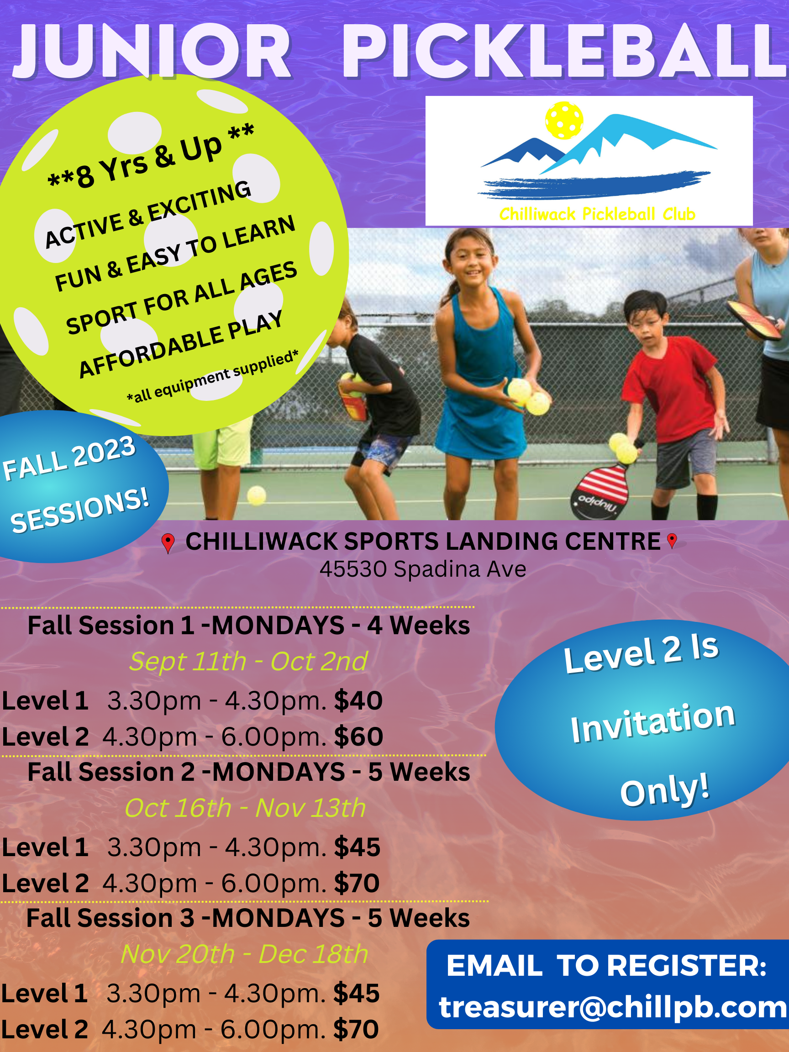
Beginner Sessions
Our beginner sessions will continue to run on Tuesday's 3.00-5.00pm. A great place to come meet and play with other players at your skill level. Donna Hutchinson, who has recently joined our executive, will be in attendance to help guide you and help with any questions you may have.

Evening Hours
For the month of September, we were able to snatch a few extra evening hours at the Landing. Great for our members who are working! There will be a mix of Book Your Own Court sessions, the popular "Mixers", and some Recreational Social Play as well. Please refer to the calendar for dates and times. Please take advantage of these times in September because in October we can no longer secure these times from the city.

President's Invitational Round Robin Social
Your President Lyle Simpson invites all players who are club rated at 2.499 and under to come out on Weds. Oct. 4th, to play in his Round Robin Social. A great way to meet new friends, play lots of fun games with other players of a similar skill level. The format will be a round robin. Prizes for the lucky players who come out on top.
We will also be spoiling you with some coffee and goodies whilst you recap all your amazing moves and winning points.
Registration is now open for this event, in pickleball brackets, under ‘Leagues’.

Tier 3 Team Event
The Tier # Team Event will take place on Friday Oct 6th, 3.00-8.00pm. Eligible players will be receiving their invitations soon and I hope we can field 4 teams of 6 players. Each team will consist of 3 male and 3 female players. This is really a fun event and everyone always has a great time playing this format. We invite everyone out to watch and support the teams as they jockey for the ultimate prize of $100 each.

Chilliwack Fall Tournament
Registration is now open on Pickleball Brackets for our Fall Tournament. Divisions are filling up quickly so don't delay or you may risk not getting a spot. We have events for everyone. Men's Doubles, Women's Doubles, Mixed Doubles, as well as Men’s and Women’s Scrambles (no partner needed), which are very popular. Remember if you do not have a partner and wish to play in the Set Double events you can state you are looking for a partner when you register on pickleball brackets.

CPC Fall Tournament
Oct 20-22nd
Divisions: 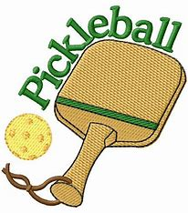
Men’s Set Doubles & Women’s Set Doubles (Age Divisions)
Mixed Set Doubles (Age Divisions)
Men’s & Women’s Scrambles (Any Age)- No Partner Needed

Skill Levels for most divisions: 2.0, 2.5, 3.0, 3.5, 4.0 & 4.5 & Over
Register: www.pickleballbrackets.com
Volunteers needed. Please inform Cathie Sessions or your host if you can volunteer a
few hours to help.

Exciting Summer Tournament Results!

This past June and July, many of our club members participated in tournaments all over the province, and out of the province as well. The CPC was well represented, and we had an amazing amount of podium finishes by our members! Congratulations to everyone who participated !!! No matter how you finish, the tournaments are a wonderful time to push yourself and your skills, and to enjoy the friendships and camaraderie that are inherent in tournament settings.
Unfortunately (or I suppose, fortunately!!), we had SO MANY MEMBERS make it on to medal podiums this summer, that it is impossible to include all of the photos in this newsletter. However, many photos of medal winners have been continually posted on our Chilliwack Pickleball Club Facebook page, and you can scroll through yourself to view them at your leisure.
Suffice to say that there were about 40 different CPC members that won at least 1 medal this summer!!! (and many of those 40 also medaled numerous times!)
Our wonderful results are obviously a testament to not only great skill levels, but also what a wonderful club and organization we have here in Chilliwack, and a HUGE THANK YOU goes out to all of our Player Development people, who constantly give up their own playing time and are committed to helping everyone in our club be the best they can be! (You know who you are….Thank you!)

Other news

Portage Courts: Please take note of the new play hours allowed at Portage Courts.
Weekdays from 9:00 am to 6:00 pm. and weekends from 10:00 to 4:00. The city
has locked the gates in order to encourage people to adhere to these times, and
Lyle has also requested that club members please be respectful of these new
requirements.
New facility: Although it’s terribly hard to wait, we need to remain patient in regards
to our new facility. Lyle is staying on top of it as best he can and has recently
had some contact with the city in this regard. As the old adage goes ‘Good things
come to those who wait’, so hopefully that will be the case for us!
Elder College: We will be running two more Elder College classes this fall. Two
classroom sessions (Sept 14 and Oct 3) and then play sessions at the Landing (Sept.
21/28 and Oct. 10/17). Lyle will again be looking for instructors to help out
during the play dates at the Landing.

Club Sponsors Program

We continue to have some wonderful club Sponsors so please don’t forget to check them out when you are looking for great service and/or products!

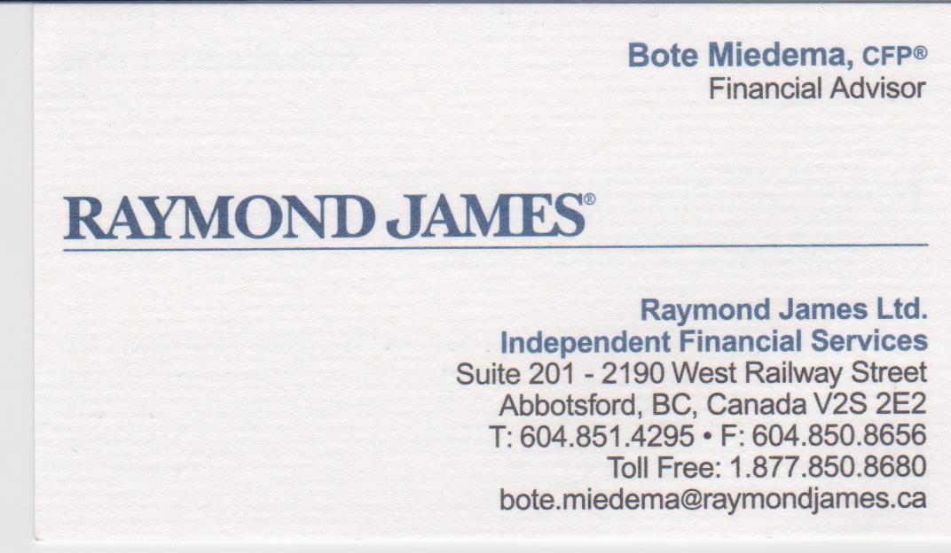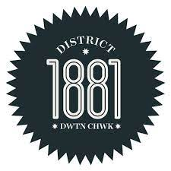

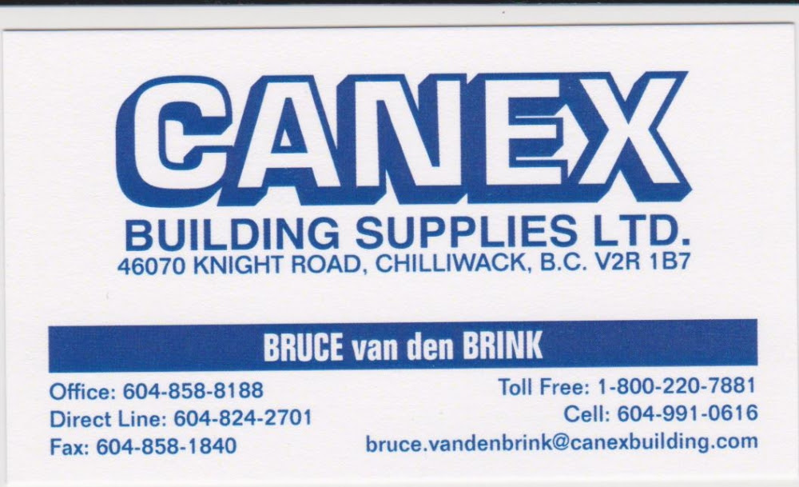

Sep2023
Sun | mon | tue | wed | thu | fri | sat
 |  |  |  |  | 01 | 02
 |  |  |  |  | 10.30-1.00pm  Competitive & Recreational Social Play | Cancelled
03 | 04 | 05 | 06 | 07 | 08 | 09
8.00am-10.30am  BYOC | 10.30-1.00pm  Mixer | 12.30-2.45pm  Men’s Rec & Women’s Comp  3.00-5.00pm  Beginners Play  6.30-9.00pm  Mixer | 10.30-1.00pm  Mixer | 12.30-2.45pm  Skills & Drills &  Rec Social play  3.00-5.00pm  Half Court Singles  6.30-9.00pm  Mixer | 12.30-2.45pm  Competitive & Rec Social Play  3.00-5.00pm  BYOC  5.00-7.00pm  BYOC | 9.30-12.00pm  Mixer
10 | 11 | 12 | 13 | 14 | 15 | 16
7.30-9.45am  BYOC | 10.30-1.00pm  Competitive & Rec Social Play  1.15-3.15pm  Partner Drills  3.30-6.00pm  Jr Program  6.00-9.00pm  Rec Social Play | 12.30-2.45pm  Women’s Rec & Men’s Competitive  3.00-5.00pm  Beginner’s Play  6.30-9.00pm  BYOC | 10.30-1.00pm  Mixer | 12.30-2.45pm  Skills & Drills &  Rec Social Play  3.00-5.00pm  Partner Drills | 12.30-2.45pm  Mixer  3.00-5.00pm  BYOC  5.00-7.00pm  BYOC | 9.30-12.00pm  Competitive & Rec Social Play
17 | 18 | 19 | 20 | 21 | 22 | 23
Cancelled | 10.30-1.00pm  Competitive & Rec Social Play  1.15-3.15pm  Partner Drills  3.30-6.00pm  Jr Program  6.00-9.00pm  Rec Social Play | 12.30-2.45pm  Men’s Rec & Women’s Competitive  3.00-5.00pm  Beginner’s Play  6.30-9.00pm  BYOC | 10.30-1.00pm  Mixer | 12.30-2.45pm  Skills & Drills &  Rec Social Play  3.00-5.00pm  Elder College | 12.30-2.45pm  Competitive & Rec Social Play  3.00-4.45pm  BYOC  4.45-6.30pm  BYOC | Cancelled
24 | 25 | 26 | 27 | 28 | 29 | 30
7.30-9.45am  BYOC | 10.30-1.00pm  Mixer  1.15-3.15pm  Partner Drills  3.30-6.00pm  Jr Program  6.00-9.00pm  BYOC | 12.30-2.45pm  Women’s Rec & Men’s Competitive  3.00-5.00pm  Beginner’s Play | 10.30-1.00pm  Competitive & Rec Social | 12.30-2.45pm  Skills & Drills &  Rec Social Play  3.00-5.00pm  Elder College | 12.30-2.45pm  Mixer  3.00-4.45pm  BYOC  4.45-6.30pm  BYOC | Cancelled

Here is the link to our July 2023 AGM minutes:
https://files.trackie.com/uploads/redactor/2023-08-13-21-57-37-1817038656-315.pdf

