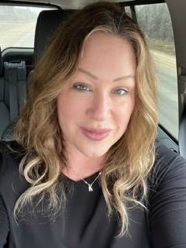

Kim Ezzard is a 3.5/4.0 competitive tournament player from the Selkirk Interlake area. She is a Level 1 NCCP certified Instructor.

She will be able to teach you the basic fundamentals of Pickleball so you will be comfortable enough to sign up and play recreational Pickleball in any gymnasium or group setting. She has paddles and balls so you can try it out without buying any equipment! All you need is runners and athletic attire.

You will learn the rules of the game with a fun, enthusiastic Instructor who loves the game! Can teach adults or children!

Contact her for group or private lessons, pricing, and available dates.

Kim Ezzard

[kimsimpson@shaw.ca](mailto:kimsimpson@shaw.ca)

204-795-3479