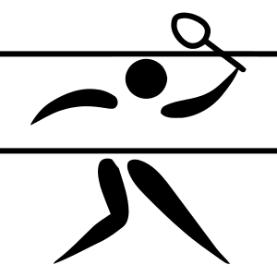
Pickleball Referee Clinic
Winakwa Community Center
Wednesday, November 17th, 2021
Classroom Session 9am – 12pm
Practical Session 12pm-2pm
Knowledge of 2021 USAPA Official Rulebook required!
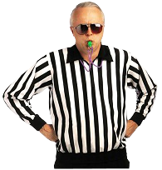

Instructor: Paul Aquin
Maximum 12 students
Cost: $30 (payment by E-transfer)
To register: Email Rose Sawatzky at r-sawatzky@hotmail.com ASAP to secure your spot

