Date: Saturday January 7th, 2017
Location: University of Toronto Field House
Faculty of Kinesiology & Physical Education
55 Harbord Street

Start Time: Saturday 9:30 am
Sanctioned by: Ontario University Association (OUA)
Hosted By: Faculty of Kinesiology & Physical Education
University of Toronto Track and Field Club

Meet Director: Bob Westman – bob.westman@utoronto.ca

Eligibility: University, College, and AO athletes

Entries: Must be submitted on-line by Thursday Jan 5th, 2016(noon)

http://www.trackie.com/online-registration/

Cheques: Cheque Payable to: University of Toronto
Facility: 200m flat Mondo - rubber 5-lane track with 8 sprint lanes. All runways Mondo - rubber; shot put circle concrete.
Spikes: MAXIMUM 6mm.
Timing: Fully electric timing.
Changing facility: Locker rooms are available for men and women. Please bring your own locks and towels.
Entry Fee: $20.00 per athlete per event
Cost limit $400 per team
Late Entry: Late entries will be accepted at $40.00 per athletes per events.
Entries will not be accepted after 6:00PM the night before the meet.
SCRATCHES: Please make all scratches online or upon arrival to the Field House registration desk (top of the stairs).

Track Events | Draft  Meet Schedule  SATURDAY January 7th, 2017
11:00 AM | 4x200m relay | Women
11:05 AM | 4x200m relay | Men
11:10 AM | 1200M timed section | Girls
11:20 AM | 1200M timed section | Boys
11:30 AM | 1000m timed section | Women
11:40 AM | 1000m timed section | Men
12:00 AM | 60m hurdles heats | Women
12:15 AM | 60m hurdles heats | Men
12:30 AM | 60m heats | Women
12:50 PM | 60m heats | Men
1:10 PM | 1500m times sections | Women
1:30 PM | 1500m times sections | Men
 | Track Break
2:00 PM | 60m hurdles final | Men
2:10 PM | 60m hurdles final | Women
2:20 PM | 60m final | Men
2:25 PM | 60m final | Women
2:40 PM | 600m timed sections | Women
2:50 PM | 600m timed sections | Men
3:00 PM | 300m timed sections | Women
3:20 PM | 300m timed sections | Men
3:40 PM | 3000m times sections | Women
4:00 PM | 3000m times sections | Men
4:20 PM | 4x800m timed sections | Women
4:30 PM | 4x800m timed sections | Men
4:40 PM | 4x400m timed sections | Women
4:50 PM | 4x400m timed sections | Men

Field Events | Draft  Meet Schedule  SATURDAY January 7th, 2017
8:00 AM | Weight Throw | Mens + Womens
8:45 AM | Shot Put | Mens + Womens
9:45 AM | Beginners Pole Vault | Mens + Womens
11:00 AM | Long Jump | Men
12:00 PM | Pole Vault (seeds above 2.75M) | Women
12:30 PM | High Jump | Men
12:30 PM | Long Jump | Women
2:00 PM | Triple Jump | Men
2:30 PM | Pole Vault (seeds above 3.50M) | Men
2:30 PM | High Jump | Women
3:00 PM | Triple Jump | Women

NEW For the University of Toronto Athletic Centre Field House
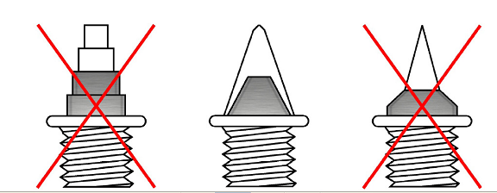

SPIKES
- All spikes must be presented to be checked at the spike check in table (where you receive your hip numbers)
- Athletes will not be allowed to compete without having their spikes
checked and cleared .
- Acceptable spikes: 6mm pyramids / cones – same size
- Any athletes competing with longer than 7mm spikes will be disqualified.
- Water is the only permitted drink allowed on the track facility.

