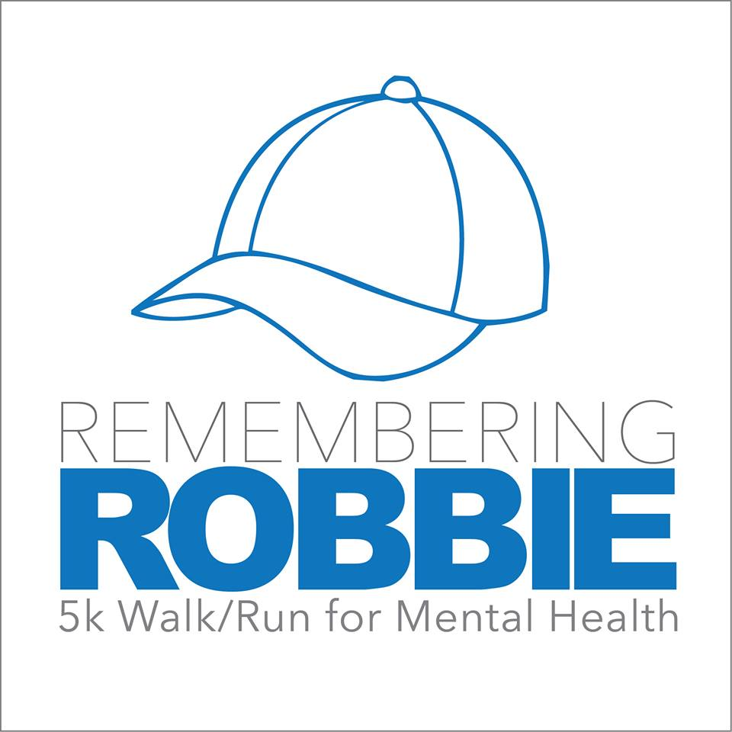

**When**: July 16, 2016

**Time:** 8:30 am Check In (pick up participant packs, bibs and t-shirts)

9:00 am Start Time

**Where**: Hospital Pond Gazebo for Check in. Walk/Run will take place through the community and end up back at the pond.

**Who**: Anyone and Everyone, walk, run, or strollers (no bikes)

**Why**: To increase awareness of mental health and donate proceeds to the NL Division of the Mental Health Association.

**How to Register:**

Visit [www.rememberingrobbie.ca](http://www.rememberingrobbie.ca) and fill out online registration form or form provided, pay online or day of event at registration table.

**Registration Fee**: $25.00 with T-shirt and $15.00 without. Register by July 5th to get a t-shirt

We would like to encourage everyone to take a pledge sheet and gather donations that will also go to the NL Division of the Mental Health Association.

Twillingate Recreation

2nd Annual



Name: _____________________________________________

**Pledge Sheet**

|  |  |  |  |
| --- | --- | --- | --- |
| Name and Address (if tax receipt is required) | Amount | Paid | Receipt Requested |
|  |  |  |  |
|  |  |  |  |
|  |  |  |  |
|  |  |  |  |
|  |  |  |  |
|  |  |  |  |
|  |  |  |  |
|  |  |  |  |