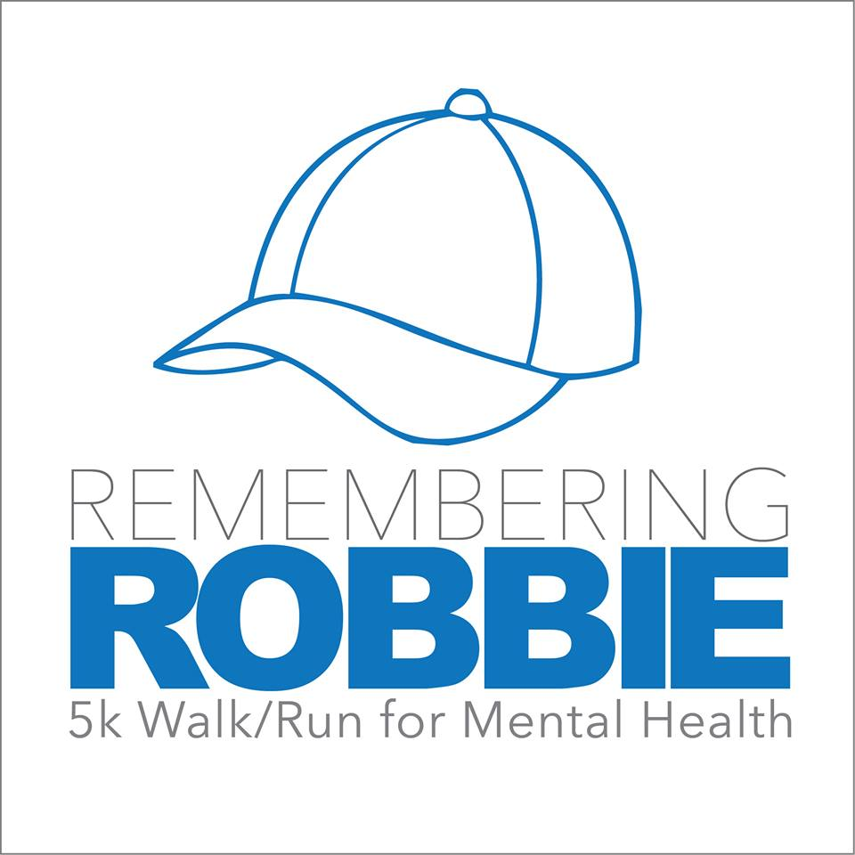

When: July 16, 2016

Time: 8:30 am Check In (pick up participant packs, bibs and t-shirts)

9:00 am Start Time

Where: Hospital Pond Gazebo for Check in. Walk/Run will take place through the community and end up back at the pond.

Who: Anyone and Everyone, walk, run, or strollers (no bikes)

Why: To increase awareness of mental health and donate proceeds to the NL Division of the Mental Health Association.

How to Register:
Visit www.rememberingrobbie.ca and fill out online registration form or form provided, pay online or day of event at registration table.

Registration Fee: $25.00 with T-shirt and $15.00 without. Register by July 5th to get a t-shirt

We would like to encourage everyone to take a pledge sheet and gather donations that will also go to the NL Division of the Mental Health Association.

Twillingate Recreation
2nd Annual

Name: _____________________________________________

Pledge Sheet

Name and Address (if tax receipt is required) | Amount | Paid | Receipt Requested

