
Race details
We sincerely appreciate you joining us at this very special event in memory of Rowan Dean. 100% of proceeds raised will go directly to the Rowan Dean Passion for Sports Scholarship. We hope you have a wonderful time and thank you for attending.
Date: Saturday, October 10, 2026
Check in time: 9-9:45 am. There will be a table where you will pick up your BIB and receive a bracelet in honor of Rowan.
Events: 1) 5 km competitive timed race
2) 5 km leisure run and walk
3) 2 km fun run
** If your child is under 10 and will be running the 5km, we kindly ask that a parent/accompanying adult always be near them on the course.

Start Location: St Michael High School Soccer pitch adjacent to the Ferguson Forest Centre.
Link to Google Maps:
https://www.google.com/maps/search/google+maps+ferguson+forest+north+grenville/@45.0296102,-75.6591952,1081m/data=!3m1!1e3?entry=ttu&g_ep=EgoyMDI1MDkxNS4wIKXMDSoASAFQAw%3D%3D

Start Times: Approximately 10 am after opening remarks
Grouped sections at start line:
1st event: 5 km competitive (timed)
2nd event: 5 km leisure (runners at front, walkers nearer to back,
stroller are allowed)
3rd event: 2 km fun run

5km competitive race and leisure walk/run ROUTE
Starts and finishes at the soccer pitch in a large loop that uses grass, gravel road surface, fields and forest trails. No paved surfaces. See map below. Route will be clearly marked, and volunteers posted throughout route at key turn points. Start and finish flags will be visible.

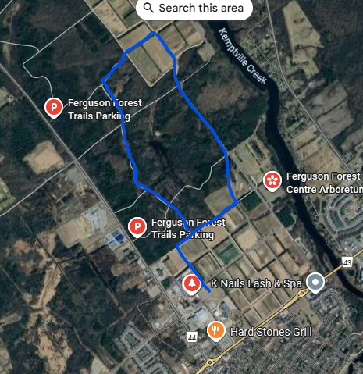

2 km fun run ROUTE:
Starts and finishes at soccer pitch in a small loop that uses grass and gravel road surface. See map below. Route will be clearly marked, and volunteers posted throughout route at key turn points. Start and finish flags will be visible.
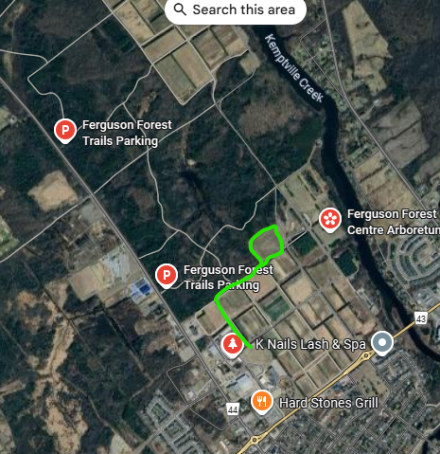

Toilets: Porta potties on site and indoor washrooms available at Municipal Centre (another event is taking place at Municipal centre so those washrooms may be very busy)
First Aid: Volunteer Fire Fighters on site, call 911 if there is an emergency
Water: We encourage everyone to bring a reusable water bottle. Filling station available at Municipal Centre
Food: Rowan’s favourite treats will be offered as you cross the finish line.

NB: 1) There are no water stations on the race route
2) After-run clean up and route check: As the run/walk comes to conclusion, the route will be checked for any remaining participants. Please help us keep the run/walk routes and soccer pitch clean by using garbage and recycling bins available on site or bring waste home.

