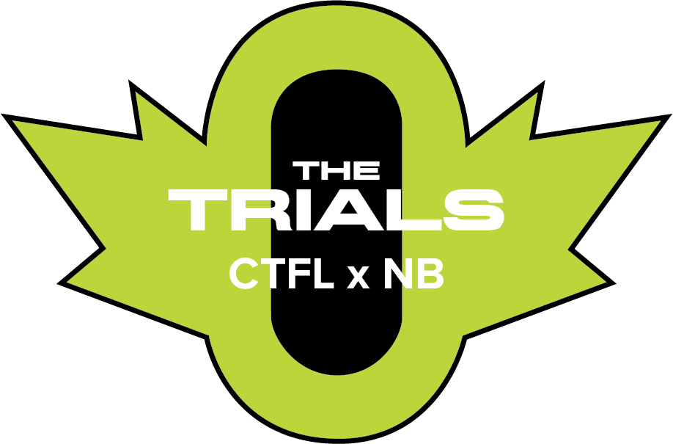

CTFL X NB Trials
PRESENTED BY OTTAWA LIONS

Date: Sunday, June 27-28th, 2026
Location: Terry Fox Athletic Facility, 2960 Riverside Dr. Ottawa, ON K1V 8N4
Sanctioned by: Athletics Ontario
Age Categories: U20, U18 & U16
Early Entry Deadline: Sunday, June 7th @11:59pm
Open Entry Deadline: Sunday, June 21st @11:59pm
Declaration: CTFL.ca
Fees: Online Early Entry - $130.00 + $40 for additional events
Online Open Entry - $160.00 + $50 for additional events
Admission: $10.00 (Day 1) - on site or pre order
Coach Registration: Coaches are to register for a pass. – Coaches Pass
Implements: Athletes are asked to bring their own implements. A limited number of implements may be
available, but requests must be made with plenty of time.
Check-in: Athletes are asked to marshal at the check in desk located at the gate of the warm-up field for their respective event no later than 10min prior to the start. Events that run longer than 800m will be required to pick up a hip/chest number at the CTFL check-in tent.
Parking: Limited parking will be available at the venue. Locations at Hog’s Back Parking Lot, Brookfield High School, Vincent Massey Park and Canada Post are alternative options.
Live Results: View Athletics Live
Schedule Order: Will be run men before women (unless indicated otherwise). Seeded/fast sections will be run first. Tentative schedule is on page 2.
CTFL Final Details: Athletes may watch or participate at the CTFL Finals on June 27th. Registered athletes
will also receive 4 tickets to the CTFL Finals for family/friends.
Categories: Athletes will be placed into age categories for all events. Most events will be split between grade 12 & 11’s representing athletes born in 2008 or 2009. A second category for athletes who recently finished grades 10 and 9 born in 2010 & 2011. However, to remain compliant with the outdoor club season, hurdle races and throwing events will have different category distributions. Ensure to register under the correct category.
Standards:

Gr. 12 Boys | Gr. 11 & 12 Boys | Gr. 10 & 11 Boys | Gr. 9 & 10 Boys | Gr. 9 Boys | Event | Gr. 9 Girls | Gr. 9 & 10 Girls | Gr. 10 & 11 Girls | Gr. 11 & 12 Girls | Gr. 12 Girls
 | 11.00 |  | 11.25 |  | 100m A |  | 12.70 |  | 12.55
 | 11.50 |  | 11.70 |  | 100m B |  | 13.25 |  | 13.10
 | 22.20 |  | 23.05 |  | 200m A |  | 25.90 |  | 25.50
 | 22.95 |  | 23.70 |  | 200m B |  | 27.05 |  | 26.40
 | 50.50 |  | 52.00 |  | 400m A |  | 1:00.75 |  | 58.25
 | 52.00 |  | 53.65 |  | 400m B |  | 1:04.30 |  | 1:01.50
 | 1:57.80 |  | 2:01.25 |  | 800m A |  | 2:23.00 |  | 2:19.00
 | 2:00.90 |  | 2:07.00 |  | 800m B |  | 2:30.50 |  | 2:23.40
 | 4:02.30 |  | 4:13.20 |  | 1500m A |  | 4:59.00 |  | 4:44.00
 | 4:07.50 |  | 4:21.00 |  | 1500m B |  | 5:12.00 |  | 4:56.70
 |  |  | 6:03.80 |  | 2000m A |  | 7:11.10
 |  |  | 6:21.35 |  | 2000m B |  | 7:22.00
 | 8:57.40 |  | 9:31.29 (6:03.80 2000m) |  | 3000m A |  | 11:19.40 (7:11.11 2000m) |  | 10:45.00
 | 9:17.50 |  | 10:00.00 (6:21.35 2000m) |  | 3000m B |  | 11:37.00 (7:22.00 2000m) |  | 11:13.00
15.90 (110mH) |  | 15.30 (110mH) |  | 15.20(100mH) | SH A | 13.10 (80mH) |  | 15.50 (100mH) |  | 15.20 (100mH)
16.80 (110mH) |  | 16.75 (110mH) |  | 16.70 (100mH) | SH B | 13.70 (80mH) |  | 16.80 (100mH) |  | 16.40 (100mH)
56.50 (400mH) |  | 1:00.90 (400mH) or (45.30 300mH) |  | 29.80 (200mH) or (46.50 300mH) | LH A | 31.50 (200mH) or (49.00 300mH) |  | 1:08.30 (400mH) or (49.20 300mH) |  | 1:07.00 (400mH)
1:00.75 (400mH) |  | 1:03.50 (400mH) or (47.50 300mH) |  | 31.50 (200mH) or (47.75 300mH) | LH B | 33.90 (200mH) or (52.20 300mH) |  | 1:12.00 (400mH) or (52.00 300mH) |  | 1:09.50 (400mH)
 | 6.30m |  | 6.00m |  | Long Jump A |  | 5.10m |  | 5.25m
 | 6.00m |  | 5.50m |  | Long Jump B |  | 4.50m |  | 4.80m
11.80m |  | 13.10m |  | 12.00m | Shot Put A | 10.80m |  | 10.40m - 3kg or 8.60m - 4kg |  | 8.70m
10.20m |  | 12.70m |  | 11.35m | Shot Put B | 9.40m |  | 10.10m - 3kg or 8.20m - 4kg |  | 7.80m

SCHEDULE
June 27TH – CTFL Finals & CTFL X NB Trials Day 1
Pre-meet & The CTFL X NB Trials Day 1
1:00pm Open men & women 3000m rw
1:00pm Open Combined Pole Vault
1:30pm Open men & women 200m open
1:55pm Trials 200m Gr.9-10 Boys
2:05pm Trials 200m Gr.9-10 Girls
2:15pm Trials 200m Gr.11-12 Boys
2:25pm Trials 200m Gr.11-12 Girls
2:45pm Open women 100mH & men 100mH
3:10pm Open 1500m men & women
3:25pm Trials Combined (Gr. 9-12) Boys 1500m
3:35pm Trials Combined (Gr. 9-12) Girls 1500m
3:50pm Open 400m men & women
4:00pm Open Combined Triple Jump
4:00pm Open 100m men & women
4:25pm Open 800m men & women
5:00pm Open Combined Shot Put
5:00pm Trials 200m Gr.9-10 Boys
5:05pm Trials 200m Gr.9-10 Girls
5:10pm Trials 200m Gr.11-12 Boys
5:15pm Trials 200m Gr.11-12 Girls
5:30pm Open 400mH men & women

CTFL FINALS (D LEVEL)
TRACK EVENTS
6:00pm Women 400m hurdles
6:10pm Men 400m hurdles
6:20pm Men 800m
6:30pm Women 800m
6:40pm Men 200m
6:50pm Women 200m
7:00pm Women 100m hurdles
7:10pm Men 110m hurdles
7:20pm Men 1500m
7:30pm Men 400m
7:40pm Women 400m
7:50pm Men 100m
8:00pm Women 100m
8:10pm Combined 5000m
8:30pm Mixed 4x200m

FIELD EVENTS
5:45PM MEN LONG JUMP
7:15PM WOMEN LONG JUMP

SCHEDULE
June 28TH – CTFL X NB Trials Day 2
TRACK EVENTS
10:30 AM Gr.9 Girls 80mH Prelim 10:40 AM Gr.10 & 11 Girls 100mH Prelim 10:50 AM Gr.12 Girls 100mH Prelim 11:00 AM Gr.9 Boys 100mH Prelim 11:10 AM Gr.10 & 11 Boys 110mH Prelim 11:20 AM Gr.12 Boys 110mH Prelim
11:40 AM Gr. 9 & 10 Boys 800m Final
11:45 AM Combined Girls 800m Final
11:50 AM Gr 11 & 12 Boys 800m Final
12:10 PM Gr. 12 Boys 110mH Final
12:20 PM Gr. 10 & 11 Boys 110mH Final 12:30 PM Gr. 9 Boys 100mH Final
12:35 PM Gr. 12 Girls 100mH Final
12:45 PM Gr. 10 & 11 Girls 100mH Final 12:55 PM Gr. 9 Girls 80mH Final
1:10 PM Gr. 9 & 10 Girls 2000m Final 1:20 PM Invite - Boys 3000m Final 1:35 PM Invite - Girls 3000m Final 1:50 PM Gr. 9 & 10 Boys 100m Prelim
2:00 PM Gr. 9 & 10 Girls 100m Prelim
2:10 PM Gr 11 & 12 Boys 100m Prelim 2:20 PM Gr 11 & 12 Boys 100m Prelim
2:30 PM Gr. 9 Girls 200mH Final
2:40 PM Gr. 9 Boys 200mH Final
2:50 PM Gr. 10 & 11 Girls 400mH Final
3:00 PM Gr. 12 Girls 400mH Final
3:10 PM Gr. 10 & 11 Boys 400mH Final 3:25 PM Gr. 12 Boys 400mH Final
3:40 PM Gr. 9 & 10 Boys 400m Final
3:50 PM Gr. 9 & 10 Girls 400m Final
3:55 PM Gr 11 & 12 Boys 400m Final
4:05 PM Gr 11 & 12 Girls 400m Final
4:15 PM Gr. 9 & 10 Boys 100m Final
4:20 PM Gr. 9 & 10 Girls 100m Final
4:25 PM Gr 11 & 12 Boys 100m Final
4:30 PM Gr 11 & 12 Girls 100m Final
4:50 PM Mixed 4X200m

FIELD EVENTS
10:45 AM Gr. 9 & 10 Boys Long Jump

11:45 AM Gr. 10 & 11 Girls Shot Put
12:15 PM Gr. 11 & 12 Girls Long Jump 12:30 PM Combined Boys Shot Put
1:15 PM Gr. 9 & 10 Girls Long Jump

2:45 PM Gr. 11 & 12 Boys Long Jump

FACILITY LAYOUT: STADIUM AREAS
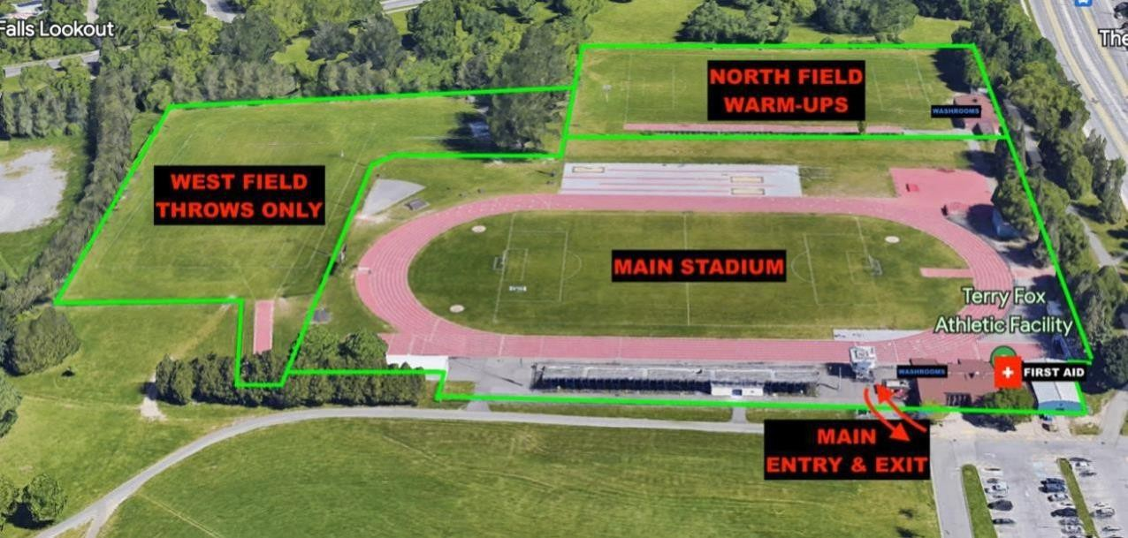

COMPETITION AREAS
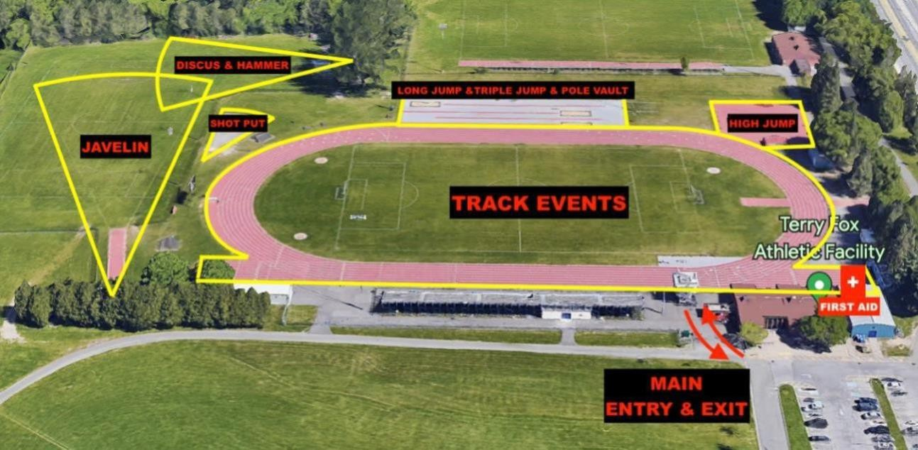

EMERGENCY ACTION PLAN:
There will be a First Aid Team located on site for the duration of the weekend. The First-Aid station will be located just east of the grandstands. This team is not responsible for RMT or PT but a first response in case of injury or need to call EMS.

A defibrillator is in the main building of the Terry Fox Athletic Facility.

If EMS is required at the Terry Fox Athletic Facility, the address is 2960 Riverside Dr. Ottawa Ontario K1V 8N4 (Inside Mooneys Bay Park). The best point of access is from the intersection of Riverside Dr. and Ridgewood Avenue, they should take an immediate right once inside Mooneys Bay Park. An alternative point of entry would be arriving from Hogs Back Rd, turning into the Mooneys Bay Boat launch entrance, and pulling up to the West Field.

Under a severe weather warning or arrival of a thunder/lightning storm there are very few locations for shelter. While there are a few change rooms and locations for shelter. We ask that athletes, officials and volunteers who drive to the venue take shelter in their respective vehicles until the storm subsides. Please do not welcome others you did not travel with into your vehicle.







