Contents:
- Note From the Race Directors
- Backyard Ultra Race Philosophy and Rules
- Summary: Do’s, Don’ts, Options
- Event Schedule
- Race Format
- Location/Parking/Access
- Course
- Support Crew and Shelters
- Required Equipment
- Race Courtesy
- Safety
- Food/Hydration
- Race Results, Tracking, Social Media and Awards

Welcome Note from the Race Directors
Whether you are a seasoned veteran of backyard ultramarathons, a returning runner from the 2025 Layers of Pain race, or you’re a first-timer to your new favourite sufferfest, we’re overjoyed to welcome you to the 2026 Layers of Pain Backyard Ultramarathon!
The backyard ultramarathon format is simple: run the designated 6.7-km loop every hour, on the hour, for as many or as few loops as you can or want to do. Challenge yourself to “go long” and set a new personal record, or just enjoy a fun trail run with friends – the choice is yours! But beware, once you start, the temptation to run “just one more lap” will be strong, and you might end up setting a new PR whether you plan to or not
Layers of Pain is a runners’ event organised by fellow runners and volunteers. Runners are expected to be self-supporting, with the assistance of a crew if they choose. We will provide some water and basic snacks for the event. We would like to thank our many sponsors (including Supplement King, Unbound Gear and Apparel, Safeway, Trigo’s, Misty River Books, Wild Bike, Ascent Coffee, The Fix, and Atlantis Taekwondo) for supporting for the event. We would also like to extend a special thanks to the Snow Valley Nordic Ski Club for allowing us to use the Onion Lake Ski Trails, and for brushing the trails prior to the race. This trail network is a fantastic location for recreation year-round, and the perfect venue for Layers of Pain. We must also thank Brett Casey, the founder of the Layers of Pain backyard ultra, for coming up with the idea and turning it into a reality in 2025 before his big move to Whitehorse. Finally, a big thank you to all runners and volunteers for being a part of this year's Layers of Pain backyard ultra!
Elaine Kennedy and Sarah Poole
Race Directors

Backyard Ultra Race Philosophy and Rules
The Backyard Ultra is a race designed to encourage self-sufficiency and resilience. At the center of the race philosophy are two points: moving beyond your perceived abilities and building camaraderie between runners.
Backyard ultra runners are required to complete a 6.7-km loop each hour, on the hour, until they fail to complete a loop within the hour or voluntarily withdraw. Most runners aim to set their own personal best distances, while seasoned ultra-runners will vie to be the last person standing.
A winner is declared when the last person completes a solo loop. Should no one complete a solo loop then we will not have a winner for that year.
BACKYARD ULTRA RULES
1. COURSE
● 6.7-km loop (see map)
● course will be flagged throughout and marshalled at main intersections to direct runners
2. STARTING CORRAL
● Corral will be marked with flagging or cones and stays the same throughout the event
● Warning must be given 3, 2, and 1 minutes prior to start at each hour (via whistle)
● Participants must be in the starting corral at the one-minute whistle
● All competitors must start at the bell—no late starts!
3. LOOPS
● Each loop must be completed within an hour to be counted, including the final loop
● Except for volunteers, no non-competitors on the course (including eliminated runners)
● No artificial aids (e.g., trekking poles)
● Slower runners must allow passes
4. TIMING
● Timing of the loops is optional
5. WINNER/RESULTS
● The winner is the last person to complete a solo loop
● All others are technically DNF (Did Not Finish)
● Results of each runner in terms of distance covered are to be given after the race
● If no runner can complete one more loop than anyone else, there is no winner
6. CAP
● Race will be limited to 24 hours (final loop will start at 8:00am Sunday, June 21)
Rules will be enforced by the Race Directors without exception. We ask that if the Race Coordinator or their delegate advises that you have breached the rules and you are designated as disqualified (DSQ) or did not finish (DNF), you gracefully accept the decision that your Backyard Ultra is over for this year.

Summary: Do’s, Don’ts, Options
DO:
● Come prepared to be completely self-sufficient, including drinks, food, and be prepared for any kind of weather.
● Make sure you are in the starting corral before the start bell rings on the hour or your race will be over.
● Attempt to complete your loop in under an hour.
● Pick your wristband up at the start of each loop, keep it with you while running, and turn it in as directed at the end of each loop.
● Ensure you have a light source, cell phone and reflective marking of some kind for the night loops.
● Be respectful of other trail users; although signage will be posted requesting members of the public stay off the course, you might still come across some non-racers such as volunteers.
● Allow faster runners to pass.
● Let the officials at the Registration Tent know when you are finished before heading home.
● Cheer on your fellow competitors!
DON’T:
● Do not bring any aids with you onto the course. This includes trekking poles, pacers, fans, or support crew. They must remain in the base area.
● Do not wear headphones that impede your hearing while on the course; you must be aware of your surroundings.
● Do not litter on the trail or Base Camp.
● Do not leave the course or take a short cut during any loops (you will be disqualified).
● Do not ignore someone on the course who is in distress and needs assistance, you will DNF.
● Do not make excessive noise at base camp, or on the course.
Options:
● Bear spray is strongly recommended, especially at night.
● You may pitch a tent or have a canopy in the Base Camp area. There will be a communal “Runners Lounge” in the ski lodge which may suffice for those who don’t intend on “going long”.
● Bring a support crew that can help you between loops. Further details provided in the sections that follow.

Event Schedule
June 20, 2026
06:00-08:45 — Runner & Support Crew set up
07:30-08:30 — Runner Check-in
08:45 — Mandatory pre-race meeting in starting corral
09:00 — Race begins
*** If you want to set up some items or check out the location on the evening of June 20th you are welcome to come out. Race organizers will be setting up from 6-8pm. There will be designated camping/tent locations flagged out. There will not be anyone on site overnight; anything you leave will be at your own risk.

Race Format
The race will start at 9:00am and loops will continue each hour, on the hour, until only one person completes a solo loop or no one starts the subsequent loop. In the event that no competitor completes a solo loop, the race will not have a winner. If you complete the loop and return to the base area in less than an hour, you have the remainder of the hour to rest, rehydrate, refuel, socialize, etc.
We will signal 3-minute, 2-minute, and 1-minute warnings via whistle before the start of each loop. You must be in the starting corral when the loop starts or you are DNF. Unfortunately, the rules do not allow for any exceptions.
Should you not complete a loop in the allocated hour or decide to voluntarily withdraw, go to the registration desk to return your wristband and collect your DNF token.
Eliminated runners are no longer permitted on the course.
For safety and accounting for all runners please DO NOT leave without informing the registration desk that you have finished your race and have returned your wristband.

Location/Parking/Access
The race course is located at Onion Lake Ski Trails, about 30 km from Terrace towards Kitimat (Figure 1). There is parking near the ski lodge, but no vehicles will be allowed in the base camp during the race. Car-pooling is encouraged. The base camp area will include the starting corral, medical tent, outhouses, Runner’s Lounge, and participants’ canopies/tents/hangouts will be set up in the large clearing by the warming hut and ski lodge area. You could use your vehicle as a staging area for your extra kit and supplies.

Course
The course is a single 6.7-km loop, run clockwise (Figure 2). It will begin and end in the base camp starting corral, connecting several of the trails at Onion Lake. The first half of the loop is rolling terrain with a few small climbs and descents. It then drops downhill through some unmaintained trail followed by a steep climb to Onion Lake. The course will be clearly flagged, and there will be marshalling for the first few loops while participants become familiar with the course.

Support Crew and Shelters
Runners may set up a tent/shelter (~10 ft x 10 ft) and may camp overnight in designated camping areas if desired. Organizers may make adjustments to ensure the space is used efficiently to accommodate everyone.
It is common for participants to stage chair(s), cooler, food, water, kit changes and other supplies in their personal shelter, or share a shelter with fellow runner(s). Whether you bring a support crew or not is a personal decision. We do recommend you have at least one support crew and shelter if you are intending to “go long”.
Spectators and crew are requested to stay off the course and can under no circumstances provide assistance on the course, e.g. hand the runner food or drinks. “The course” is designated as any area after passing the start line and until crossing the finish line on the same loop. Support and assistance are only to be provided in the time between finishing one loop and starting the next.
There will be limited power on site in the ski lodge. The race organizers may use a generator to run the timing clock and other electronics but, to avoid excessive noise, personal generators are not allowed. Please take all your trash with you to ensure there is an opportunity to use the site in future years.

Required Equipment
The only mandatory equipment will be for the night loops. Starting on the 12th loop (9:00 pm) and continuing until the 20th loop, all runners will need to carry:
● a headlamp (or flashlight);
● a cell phone; and
● some form of reflective clothing or accessory.
There could be animals on the course including bears. Bear spray is not required but strongly recommended, especially during night loops. No headphones of any kind are permitted on course during night loops.

Race Courtesy
To ensure everyone has an enjoyable run experience we appreciate all runners observing the following race courtesies:
● Always give way to and be courteous to other park and trail users.
● On narrow trails allow faster runners to pass – a passing runner should announce their presence (in a pleasant manner) and pass to the left of the runner being overtaken.
● Do not play audio from speakers of any kind (not everyone may appreciate your taste in music or literature).
● Always provide aid to any runner in distress, if you do not provide aid you will be DNF.

Safety
June weather in the northwest can be anything from warm to freezing, so dress accordingly. Be prepared for both hot and cold weather, and the possibility of rain or even snow. A benefit of a backyard ultra is you can bring along all your different running outfits and change them as often as you like.
This is a rain, snow, hail, or shine run so it is unlikely to be discontinued or cancelled. The exceptions to this would be lightning in the vicinity, excessively strong winds, wildfire, problem wildlife, or any other circumstance which put participants, their crew or organisers in danger.
The course is in a wilderness area, for your safety and so you can be aware of your surroundings, including runners and wildlife, you should not wear devices that impede your hearing.
For anyone running at night it is mandatory for safety reasons for you to carry the required equipment previously mentioned: light source, cell phone, and reflective markings.
Basic first aid support will be available on site.
Runners should also come prepared to manage their own basic medical needs. A basic runner’s first aid kit of Band-Aids, blister plasters, Vaseline, etc. are recommended.
The race organizers reserve the right to withdraw runners from the event for safety reasons.

Race Day Emergency Numbers
Medical Emergency: Dial 911 then alert Race Directors and Medical Team
Race Director: Elaine Kennedy, 250-641-4236
Race Deputy: Gianna Tetz, 250-641-1441

Food/Hydration
There will be water and some basic snacks available for participants at Base Camp, you are encouraged to bring your own food and drinks to support your participation in the event. Runners should ensure they bring sufficient fueling and hydration for the time they expect to run.

Race Results, Tracking, Social Media, and Awards
Updates will be posted on the Facebook page during the event so family and friends can follow the progress. Final results will be available at BC Sport and Facebook as soon as we can manage it. We will also email a copy to the participants.
In keeping with Backyard ultra tradition, unless you are the last person standing, your result is DNF and your number of loops is recorded. A DNF token will be awarded to all runners save for the winner who will receive their own unique prize.
If you exceed your personal best, don’t forget to ring the bell when you finish that loop so everyone can celebrate your achievement!

Please reach out to the race directors if you have any questions, and enjoy the 2026 Layers of Pain Backyard Ultramarathon!

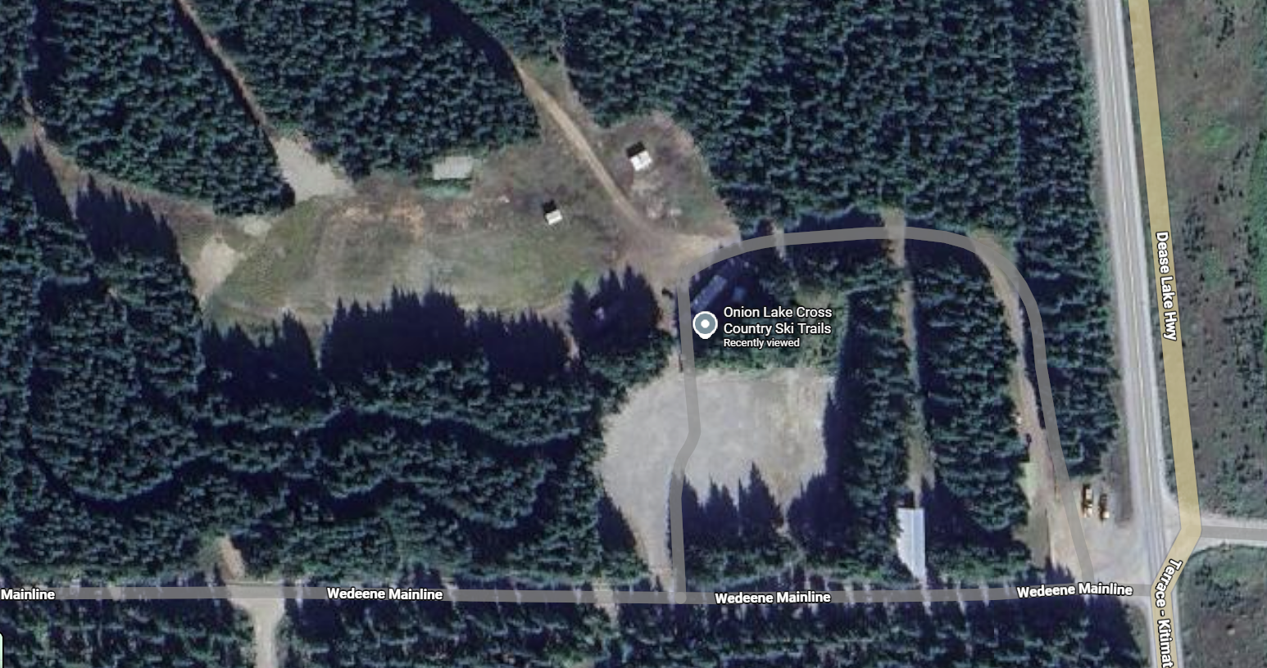
Camping area
Runner’s lounge
Parking area/muster location

Starting corral
Figure 1: Layers of Pain Backyard Ultramarathon Parking and Staging Area
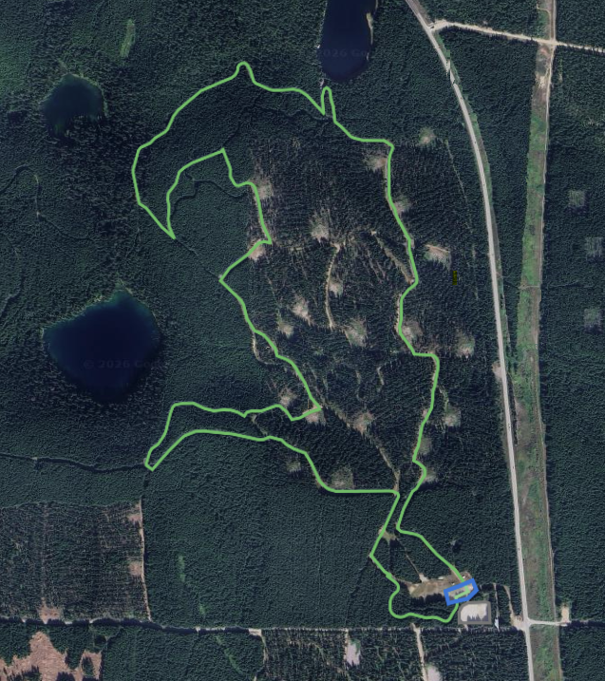
Figure 2: Layers of Pain Backyard Ultramarathon Race Course

