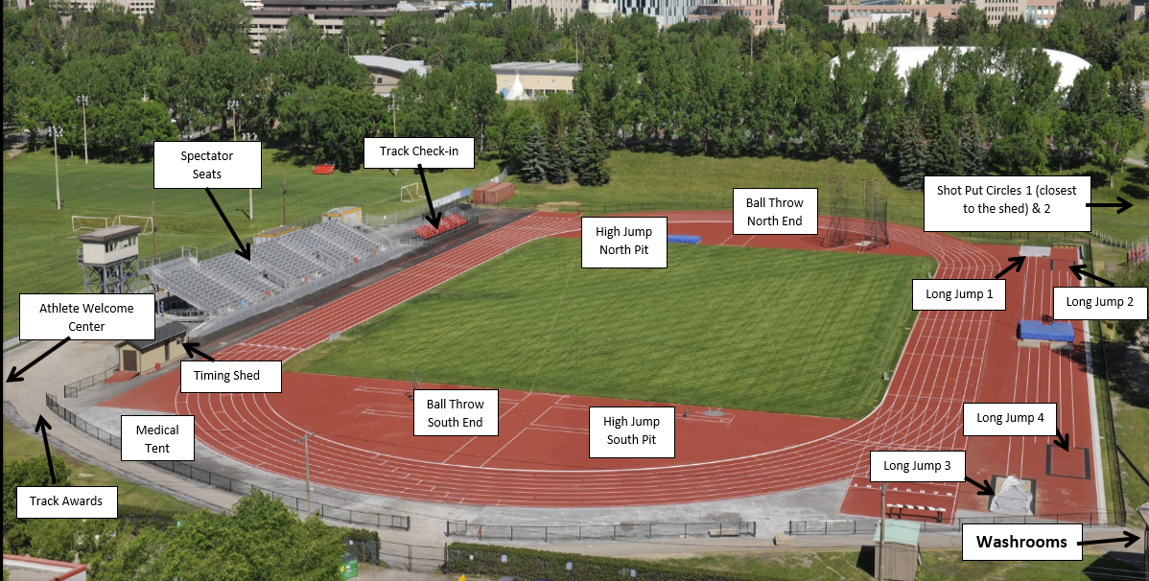
Welcome to the Elementary Track and Field Championships.
When you arrive, please check in to the athlete welcome center to understand where your events will start for the day.

TRACK CHECK IN- Please arrive 15 minutes before your race, so we can marshal you into your running events.

FIELD CHECK IN- Please arrive 15 minutes before your event starts AT THE EVENT AREA PLEASE!

