Track and Field Resources 2026

Blocks: (100m, 200m, 400m and relays)

(two and three rule)
Set your first block two steps from the start line for your front foot.
Set your second block three steps from the start line for your back foot.

Before the race begins athletes must stand behind their blocks.
Starter will voice the command: “On your marks”.
The athletes will then move forward to enter their blocks.
Once the starter sees that all runners are in their blocks with their back knee down on the track and finger tips behind the line they will voice the next command: “Set”
Runners will then rise up in their blocks to the set position with their finger tips behind the line, their front knee bent at 90 degrees and their back knee bent at 120 degrees.
The starter will then fire the starting pistol and the runners will race down the track.

Sprinting Technique - Maximizing Block Starts
3 Starting Block Drills to Become a Better Sprinter
How to Set Up Sprinting Blocks

Long Jump:

How to Volunteer & Officiate - Long Jump & Triple Jump // LAVicTV
An Introduction to the Rules of Long Jump Competition

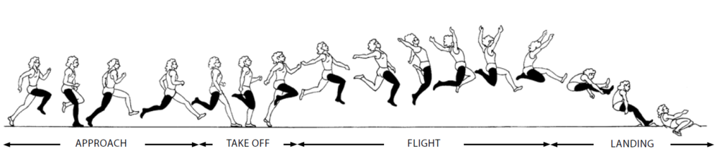

Triple Jump (Hop - Step - and then Jump).

https://www.youtube.com/watch?v=FXXbVN8l-hM
https://www.youtube.com/watch?v=HtzLad9ABic

High Jump (Technique)

High Jump Complete Technique Instruction - Brad Kearns
https://www.youtube.com/shorts/2jtCfcTENJU

Throws:

https://www.youtube.com/watch?v=OBHQZkAAJt4

Shot Put:

https://www.youtube.com/watch?v=agOBqvffXZA
https://www.youtube.com/watch?v=kpioqEOWbNY&list=PLo_-S_zovEWC9pTvBO5w0jWX57UwpQVx6

Discus:

https://www.youtube.com/watch?v=sjf5kBfk4Wc

Javelin:

https://www.youtube.com/watch?v=T1j3PrCjY78
https://www.youtube.com/watch?v=5XL_mT_SYOw

