2026 DON WRIGHT TEAM CHALLENGE
& ALL-COMERS
HEAT SHEETS AND LIVE RESULTS
HERE!

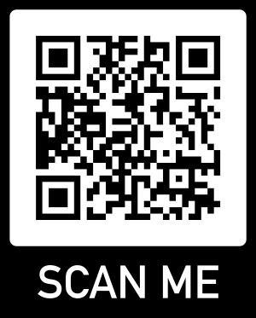

mustangstiming.com/Results/DW26/

