**ISEA Cross Country Championships 2025**

The ISEA Championships are fast approaching and we can’t wait to see you Tuesday, October, 21st at **Crescent Park**. The course is mostly flat with a short uphill, and is a mixture of grass, gravel and bark mulch pathways – please refer to maps for course routes (attached).

All students should bring their own lunches, and a full water bottle. **We will provide coffee, treats, and sandwiches for coaches/volunteers only.** Note: We will require the assistance of one volunteer from each school to assist with course spotting for the duration of the event.

Upon arriving at Crescent Park, you will see that there is no covered area on the course, so it is ***strongly recommended*** that your team bring a portable tent (or two). A volunteer will direct you where to set up tent(s). City officials have asked that tents be weighed down with sandbags not pegs. Limited public washrooms are available and can be found near the baseball diamond, and some additional porta-potties will be on site, it is recommended that an adult accompany students to/from these facilities. Athletes are advised to bring a complete change of clothing for after the race, and should be properly prepared with appropriate layers of clothing as it is an outdoor event held rain or shine.

The coaches meeting will take place at 9:40am at the start line. Scoring procedures will be reviewed at that time. **Electronic Timing will be used**, all athletes need to be pre-registered by the entry deadline on Thursday,, October 16th, 2025 (minimal late entries and changes will be accepted until 11:59 pm on Saturday, October 18th, 2025). All athletes will be **required to wear their assigned race bib and school uniform,** and have it visible to officials when crossing the finish line. Individual awards will be handed out at the finish line, and team results will take place at the end of the meet.

We will have a ‘running schedule’ to increase flow between the events, however, a break in the schedule will occur so schools can shuttle completed Grades 3/4’s and bring Grade 5-7’s.

We politely request that coaches and chaperones maintain close control over their teams, so we avoid any possible problems with interference of runners on the racecourse.

We look forward to seeing you all out running!



**Nathan Dehghan**

Junior School Cross Country Coach

West Point Grey Academy

604-222-8750, x. 4200 |[ndehghan@wpga.ca](mailto:ndehghan@wpga.ca)

4125 West 8th Avenue, Vancouver, BC, V6R 4P9

[wpga.ca](http://www.wpga.ca/) |  *Shaping lives of inquiry, action and joy*



**ISEA Cross Country Championship Details**

**Date:** Tuesday, October 21st, 2025

**Location:** Crescent Park (see attached map for details), start/finish line near baseball diamond.

**Time:** 9:00am – 12:30pm

**Grades**: 3-7

**Schools:**  Brockton Southridge

Collingwood St. George’s

Crofton House St. John’s

Fraser Academy St. Margaret’s

Glenlyon Norfolk Stratford Hall

Meadowridge UrbanAcademy

Mulgrave Vancouver Talmud Torah

Southpointe Academy West Point Grey Academy

York House

**Start Line and Meeting Area:** The start line, finish line, and tent area will be on the grass fields near the baseball diamond (see map). We will be using a **boxed start line**, to ensure distancing between schools, as well as to ensure a safe start off the line. *Schools are asked to bring their own tent with them, extra tents will not be provided.*

**Course:** Please see attached map. The course is run on grass fields and gravel/chip trails.

**Schedule of Events**: Girls and boys will run separately with girls running first. Running schedule.

9:00am – Volunteer Meeting I All Schools to Arrive 9:00-9:30am at the latest

9:40am – Coaches Meeting

10:00am – Grade 3 Girls / Boys

10:30am – Grade 4 Girls / Boys

*Break for Bus Shuttles 10:45-11:15am*

11:30am – Grade 5 Girls / Boys

12:00pm – Grade 6 Girls / Boys

12:30pm – Grade 7 Girls / Boys

1:10pm – Team Awards

**Distances:**

Grade 3: 1.2km (1x Blue Loop)

Grade 4: 1.5km (1x Green Loop)

* Athletes will be running the same route as grade 3’s but will have an extended turnaround point.

Grade 5 and 6: 2.4km (1x Red Loop - short)

Grade 7: 3.0km (1x Blue Loop + 1x Red Loop - extended)

**Transportation:**

The meet is held at Crescent Park, with the start/finish line located on the grass fields near 132nd street off 24th Ave in South Surrey. Please park either in designated parking lots and/or along 132nd. All Bus Parking should be along 132nd Street, as parking lots are small, and offer little turn around room.

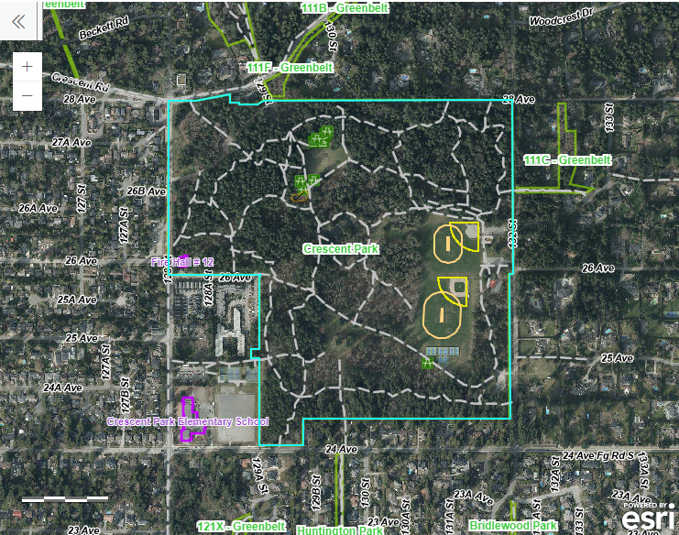

**Awards:**

There will be ISEA medals for 1st - 3rd and ISEA ribbons for the 4th to 16th, in the finish line chute of the event.

Team Aggregate Awards, Top 3 teams/division/gender, as well as overall girls and boys team titles will be awarded at the end of the meet.

**Registration, Volunteers & Fees:**

All teams must register in advance of the meet. All entries must be submitted on trackie.regunder the event, ‘2025 ISEA Cross Country Championships’ Thursday, October 16th, 2025 by 4:00pm. Late entries/scratches will be accepted until Saturday, October 18th, 2025 at 11:59pm.

**Each school is responsible for paying a fee to cover the costs of park rental and awards,** (to be included in the Term 1 ISEA Athletic Fees)**.**

In addition, we require one staff volunteer per school to help at the event, as a course marshall. Please send an email to [mwong@wpga.ca](mailto:mwong@wpga.ca) with the name of the designated individual from your school.

**Additional questions:**

Please email Nathan Dehghan [ndehghan@wpga.ca](mailto:ndehghan@wpga.ca) or Mark Wong [mwong@wpga.ca](mailto:mwong@wpga.ca) call 604-222-8750 x 4200.

**ISEA Cross Country Championships**

Course Map 2025

