**Race details**

We sincerely appreciate you joining us at this very special event in memory of Rowan Dean. 100% of proceeds raised will go directly to the ***Rowan Dean Passion for Sports Scholarship***. We hope you have a wonderful time and thank you for attending.

**Date:** Saturday, October 11, 2025

**Check in time:** 9-9:45 am. There will be a table where you will pick up your BIB and receive a bracelet in honor of Rowan.

**Events:** 1) 5 km **competitive** timed race

2) 5 km **leisure run and walk**

3) 2 km fun run

*\*\* If your child is under 10 and will be running the 5km, we kindly ask that a parent/accompanying adult always be near them on the course.*

**Start Location:** St Michael High School Soccer pitch adjacent to the Ferguson Forest Centre.

**Link to Google Maps:**

<https://www.google.com/maps/search/google+maps+ferguson+forest+north+grenville/@45.0296102,-75.6591952,1081m/data=!3m1!1e3?entry=ttu&g_ep=EgoyMDI1MDkxNS4wIKXMDSoASAFQAw%3D%3D>

**Start Times:** Approximately 10 am after opening remarks

Grouped sections at start line:

1st event: 5 km competitive (timed)

2nd event: 5 km leisure (runners at front, walkers nearer to back,

stroller are allowed)

3rd event: 2 km fun run

**5km competitive race and leisure walk/run ROUTE**

Starts and finishes at the soccer pitch in a large loop that uses grass, gravel road surface, fields and forest trails. No paved surfaces. **See map below.** Route will be clearly marked, and volunteers posted throughout route at key turn points. Start and finish flags will be visible.

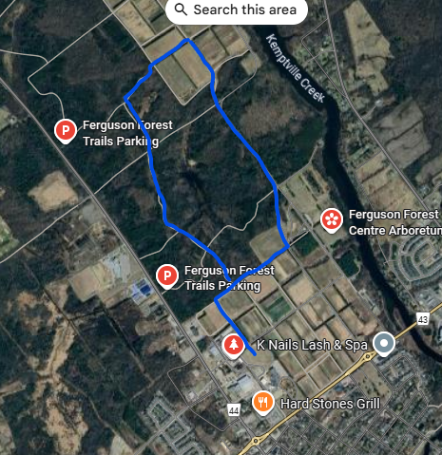

**2 km fun run ROUTE**:

Starts and finishes at soccer pitch in a small loop that uses grass and gravel road surface. **See map below.** Route will be clearly marked, and volunteers posted throughout route at key turn points. Start and finish flags will be visible.

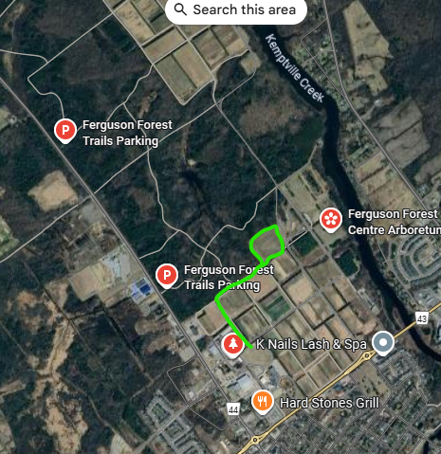

**Toilets:** Porta potties on site and indoor washrooms available at Municipal Centre (another event is taking place at Municipal centre so those washrooms may be very busy)

**First Aid:** Volunteer Fire Fighters on site, call 911 if there is an emergency

**Water:** We encourage everyone to bring a reusable water bottle. Filling station available at Municipal Centre

**Food:** Rowan’s favourite treats will be offered as you cross the finish line.

**NB:** 1) There are no water stations on the race route

2) After-run clean up and route check: As the run/walk comes to conclusion, the route will be checked for any remaining participants. Please help us keep the run/walk routes and soccer pitch clean by using garbage and recycling bins available on site or bring waste home.