|  |  |  |
| --- | --- | --- |
|  | 2019 Gryphon Open Cross Country Meet  Friday, September 26th  Mooneys Bay, Ottawa, ON |  |

Details regarding the race layout are below.

This years race course will be taking place over the original Capital XC courses that start down by Canada’s biggest playground and finish on the track.

**ENTRIES**

* DEADLINE – Wednesday, September 24th at 11:59PM EDT
* All entries are to be completed online through Trackie at the links provided below.
* Coaches/School Admins are responsible for registering their themselves or teams together.
* Cheques are to be made payable to Glebe Collegiate Institute.
* Teams/Schools paying by cheque must present fee before receiving team package on site.
* If you have any registration issues please contact kirk.dillabaugh@ocdsb.ca
* [REGISTRATION LINK](https://www.trackie.com/event/GyphonXCHSOpen)
  + Junior Varsity Athletes – Grade 9 & 10
  + Varsity Athletes – Grade 11 & 12
  + Coaches of each high school are to register their athletes.
  + $10.00 individual entry
  + $250.00 max fee (entry across all divisions/genders)

**RESULTS/AWARDS**

* Results will be available on <https://www.cstiming.com/events>

**SCHEDULE**

**FRIDAY, SEPTEMBER 26th – Gryphon High School XC Open**

|  |  |  |
| --- | --- | --- |
| RACE TIME | ACE DIVISION | DISTANCE |
| 1:30pm | Junior Varsity Girls | 4km |
| 2:00pm | Junior Varsity Boys | 4km |
| 2:30pm | Varsity Girls | 5km |
| 3:00pm | Varsity Boys | 5km |

*\*The posted schedule will be finalized after the entry deadline and announcements will be made for athletes to assemble at the start line on the event day (events will not switch days).*

*\*The organizers reserve the right to merge both men and women’s events into one race should the entry numbers allow for a safe event.*

**CONFIRMED ENTRIES CAN BE VIEWED ON THE TRACKIE REGISTRAION PAGES.**

**PERFORMANCE LISTS WILL BE POSTED THURSDAY, SEPTEMBER 25th.**

**DETAILS**

* **Athlete check in/Bib pick up:** Athletes can pick up their race bib at the registration tent located at the Terry Fox Athletic Facility no later than 30min before their respective race (plan a head of time as lines may form).
* **Facility:** Washrooms are available in the Terry Fox Athletic Facility.
  + 2 Portable toilets will be open closer to the park playground and in the beach pavilion.
* **Parking:** Limited pay and display for car parking at Mooneys Bay Park and at the Terry Fox Athletic Facility.
* **Team Tents**: May be arranged near the park playground and starting area.
* **Spectators:** Are free to watch and cheer the races on throughout the park and stadium.
* **The Course:** The course includes is runs on grass, the beach, woodchip trails and concludes on 300m of Mondo inside the Terry Fox Athletic Facility. All courses will include at least one major climb up the Mooney’s Bay hill and briefly cross a few gravel/paved paths.
  + The entire course will be clearly marked with a line of paint, flags and tape.
  + All course loops will be posted by registration tent with a QR code link.

**MAPS**

4km Course – Start/Green + 2xRed + Orange + Yellow/Finish

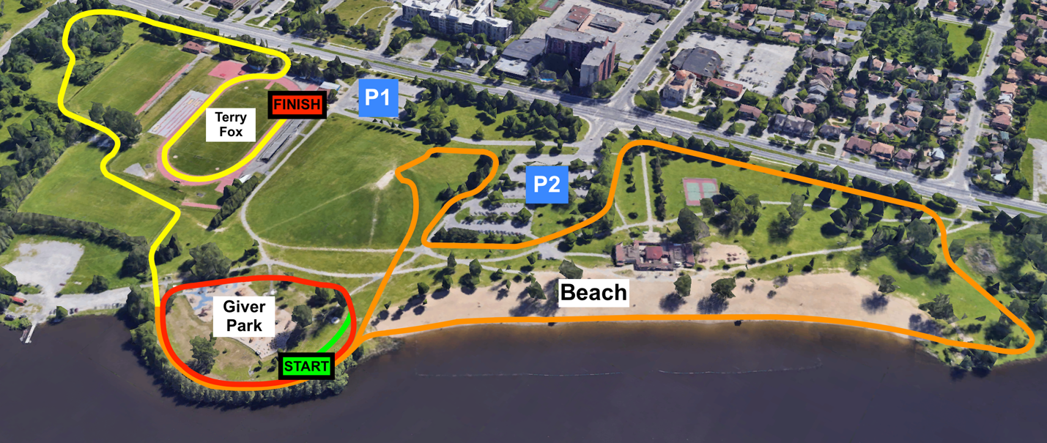

5km Course – Start/Green + 2xOrange + Red + Yellow/Finish

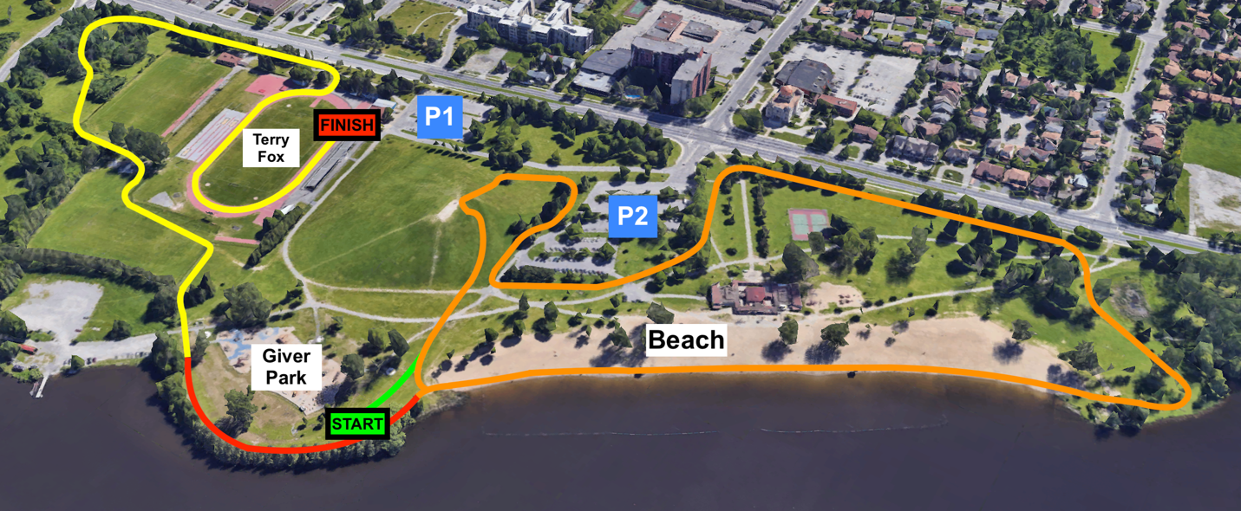

**EMERGENCY ACTION PLAN**

There will be a First Aid Team located on site for the duration of the weekend. The First-Aid station will be located just east of the grand stands. This team is not responsible for Massage Therapy or Physio Therapy but a first response in case of injury or need to call EMS.

A defibrillator is located in the main building of the Terry Fox Athletic Facility.

If EMS is required at the Terry Fox Athletic Facility, the address is 2960 Riverside Dr. Ottawa Ontario K1V 8N4 (Inside Mooneys Bay Park). The best point of access is from the intersection of Riverside Dr. and Ridgewood Avenue, they should take an immediate right once inside Mooneys Bay Park. An alternative point of entry would be arriving from Hogs Back Rd, turning into the Mooneys Bay Boat launch entrance and pulling up to the West Field.

Under a severe weather warning or arrival of a thunder/lightning storm there are very few locations for shelter. While there are a few change rooms and locations for shelter, they will be limited in space as a 2m physical distancing rule will apply while indoors (along with wearing masks). We ask that athletes, officials and volunteers who drive to the venue take shelter in their respective vehicles until the storm subsides. Please do not welcome others you did not travel with into your vehicle