

**PEACE HILLS Classic XC**

***Saturday September 20, 2025***

***Hosts: GO ATHLETICS (Edmonton)***

***Please note: Should there be a labor disruption in the schools this meet will STILL be held!***

*GO Athletics* Track Club is pleased to invite clubs, schools, and athletes to compete in the 26th annual Peace Hills Cross Country Classic.

**LOCATION**

Peace Hills Park, Wetaskiwin, Alberta T0C 1Z0

**Directions**: Township Road 464 west of Highway 2A -- go past the golf course, over the hill, and turn north at the bottom of the hill.

**COST**

$20.00 per entry (includes the $1.43 processing fee). Fee to be paid to Trackie at time of registration.

**ENTRY DEADLINE**

All entries are due by Tuesday, September 16 by 11:59 p.m. Late entries will cost $40.00 each.

**REGISTERING**

All entries and payments must be done through Trackie. Enter by going to:

<https://www.trackie.com/event/peace-hills-classic/1000738/?admin=1>

**TIMING**

We are pleased to announce that again this year our timing will be handled by **Ellis Timing.**

**FACILITIES & PARKING**

Parking is limited. Please respect "No Parking" signs on Range Road 243. First Aid and Portable toilets are available onsite; no change facilities or shelters. A concession will be available to purchase lunch and snacks from.

**SCHOOL VS CLUB ENTRIES**

* For all Elementary and Junior High races, you may enter under your Club or your School (check with your coach.) – Individual entries welcome!
* **As per ASAA rules, we will have High School aged athletes compete in one (the same) event but their results will be separated for all placings and awards.**
  + **For the High School age races, you must enter under EITHER your Club or School.** Club and High School athletes will run in separate races, but under the same event, and will be separated for their respective results & awards (EG: Grade 10 girls will run at the same time with Club U16 Women, but will be competing in 2 separate races – this satisfies ASAA competition guidelines). There will be medals and Top 4 T-shirts for each race. **Please ensure your coach enters you under the correct category (Club or School).**
  + All High School categories have an age limit, as of September 1, 2025: under 16 for Junior (Grade 10), under 17 for Intermediate (Grade 11), and under 18 for Senior (Grade 12).
  + Club Age Categories are: U16 (born 2010/2011), U18 (2008/2009) and U20 (2006/2007).
* For Homeschool athletes, please enter the board you are registered with (EG: Roots) as your School and compete under the appropriate grade category **for your age.**

**AWARDS and RIBBONS**

|  |  |
| --- | --- |
| * Race T-shirts for the Top 6 in Elementary & Jr High Races, Top 4 T-shirts for High School and Club races. | * Medals for 1st, 2nd, and 3rd finishers in each race category. |
| * Ribbons for 4th-10th & participants | * Team ribbons for 1st to 3rd & trophy for school for 1st |

All individual and team awards will be given, as much as possible, 15 minutes after each race.

**For more information please contact the Meet Directors:**

Pete Wright at 780-479-1860 or 780-619-9690 or **peacehills.xcountry@gmail.com**

Lois Greidanus at 780-203-5336 or **loisgrei@gmail.com**

**Race Distances & Schedule**

(Some races may begin before others are completed)

**9:00 Walk Through – Elementary and Jr. High**

09:25 Grade 1 Boys – 1 km

09:35 Grade 1 Girls – 1 km

09:45 Grade 2 & 3 Boys – 1 km

9:55 Grade 2 & 3 Girls – 1 km

10:05 Grade 4 & 5 Boys – 2 km

10:15 Grade 4 & 5 Girls – 2 km

10:30 Grade 6 & 7 Boys – 3 km

10:50 Grade 6 & 7 Girls – 3 km

**10:51 Walk Through – High School & U16 & older Only – NO Junior High**

11:10 Grade 8 & 9 Boys – 4 km

11:50 Grade 8 & 9 Girls – 3 km

12:10 HS Grade 10 Men & Club U16 Men – 4 km

12:25 Grade 10 Women & Club U16 Women – 4 km

12:50 HS Grade 11 Men & Club U18 Men – 5 km

1:15 HS Grade 11 Women & Club U18 Women – 5 km

1:15 HS Grade 12 Women & Club U20 Women – 5 km

1:15 Open Women (ages 20+) – 5 km

1:40 HS Grade 12 Men & Club U20 Men – 6 km

1:40 Open Men (20+) – 6 km

**2nd Year!**

2:15 pm

No early entry required – Enter day of meet! – No cost!

**Mixed Open 4 X 2km XC Relay – 2 ladies & 2 men! Any order**

Run @ same time but separate school & Club entries

**COURSE MAP**

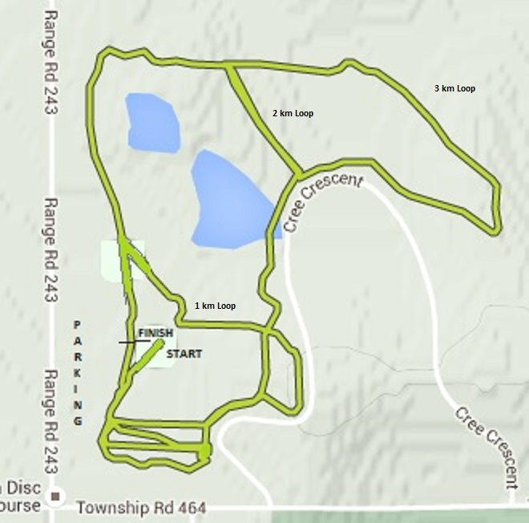

The course features several large hills and a combination of running on dirt trails, some hard packed gravel, and grass. Spikes are recommended but certainly not necessary.

All the Grade 1 and Grade 2/3 races will be led by a runner. Other races will have the trails clearly marked, with marshals stationed at key points to ensure no one gets lost.