Windsor Night Flight
Windsor Waterfront Pole Vault

Presented by
University of Windsor Athletics Club
& Athletics Ontario

Friday, July 25 / Saturday, July 26

Event Site The event will take place on the Riverfront in the downtown city center of Windsor, Ontario.

Directions Use “Viale Udine rd” as a destination in your map direction searches.

Entries Entries will be processed at:

https://www.trackie.com/event/windsor-night-flight/1030656/

Entry Fee Regular entry fee: $40
Late entry fee: $60

Deadline Regular: Wednesday, July 23 by 11:59pm
Late: Saturday, July 26 (on-site)

It is encouraged to process your entry on time so you can be placed in to the proper competition level.

Additional Information
Kevin DiNardo (519) 996-8095
kevin.dinardo@hotmail.com

Schedule

Elite men and elite women’s competition will take place on the Friday evening. All other competition levels will be organized on the morning/afternoon of Friday and all day on Saturday. Competition officials will be flexible with the start times if such circumstances are required.
Final schedule will be made available on Trackie soon.



Warmup Area

The warmup area is located at Dieppe Park and along the riverfront. There will be a suitable amount of parkland available for warmup jogs, runs, sprints, stretching and drills.

Poles

Poles can be dropped off at the competition area when athletes arrive. They will be securely stored overnight if required.

Parking

Pay parking is available all along the waterfront where the warmup and competition area is located. There are also parking garage options. It is encouraged to drop off poles first.

Qualification Standards

Athletes will be placed in to the competition that matches their season best performances. Elite entries are by invitation only.

Height Increments

Will be determined based on the entry pool of athletes, and will accommodate a timely competition. Input from participating coaches will be taken in to consideration.

Changes to Competition Setup

If required, will be noted on the Trackie website and will be made to accommodate a better athlete experience and for a more exciting competition.

Prize Money

Prize money will be made available for the top performers in the Elite fields.



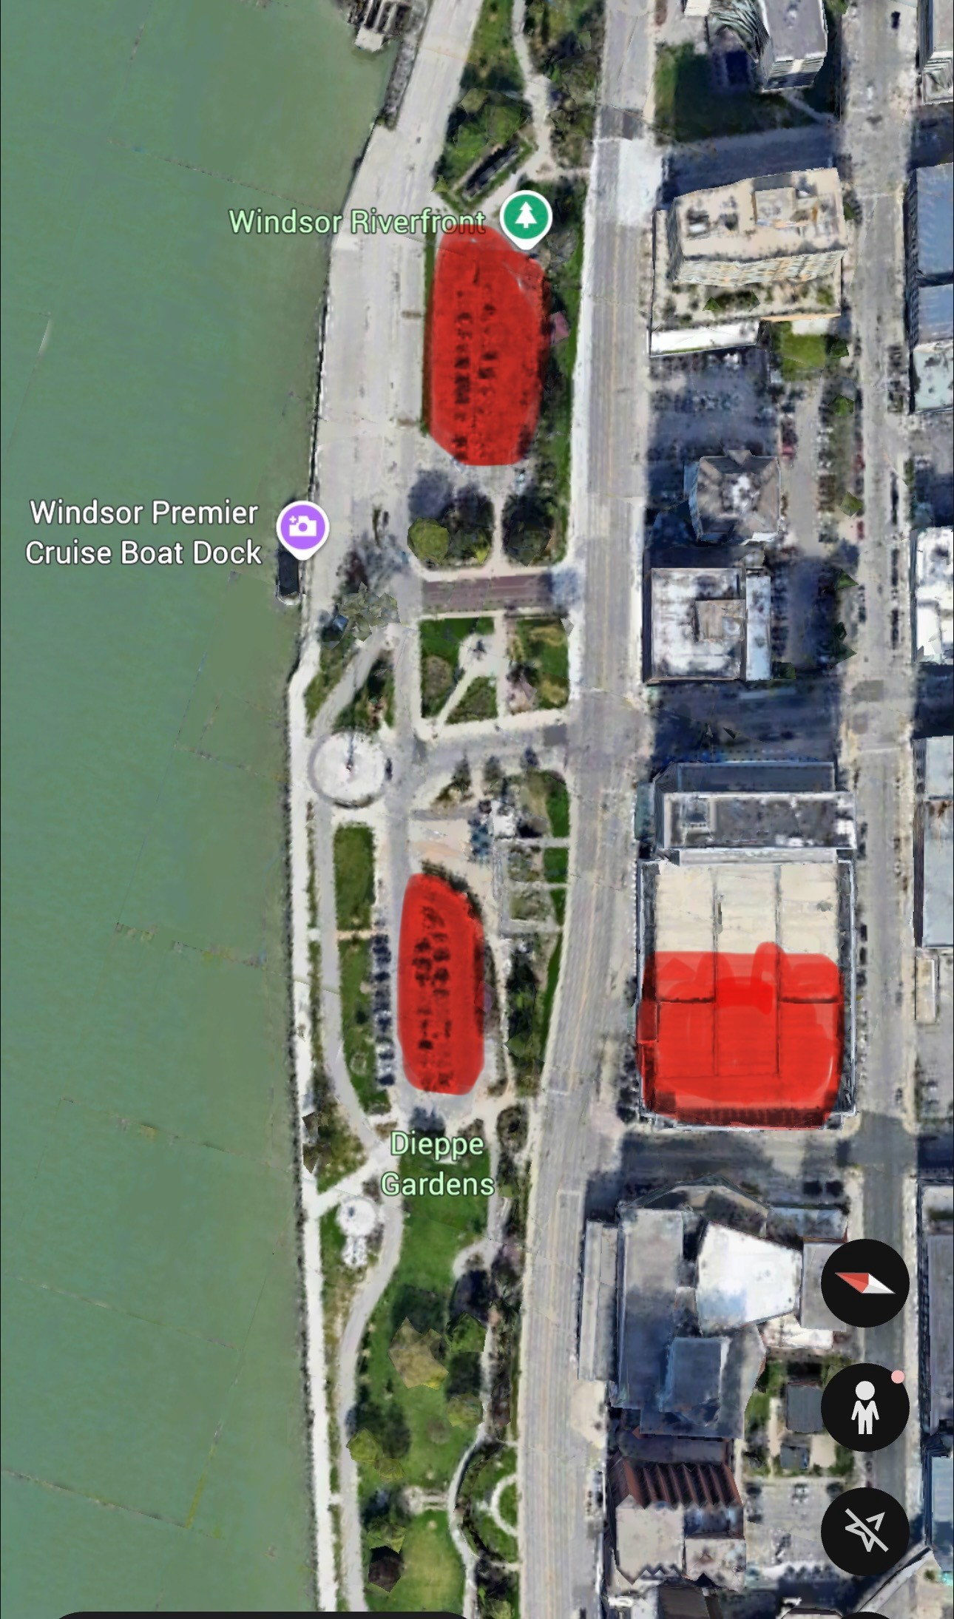
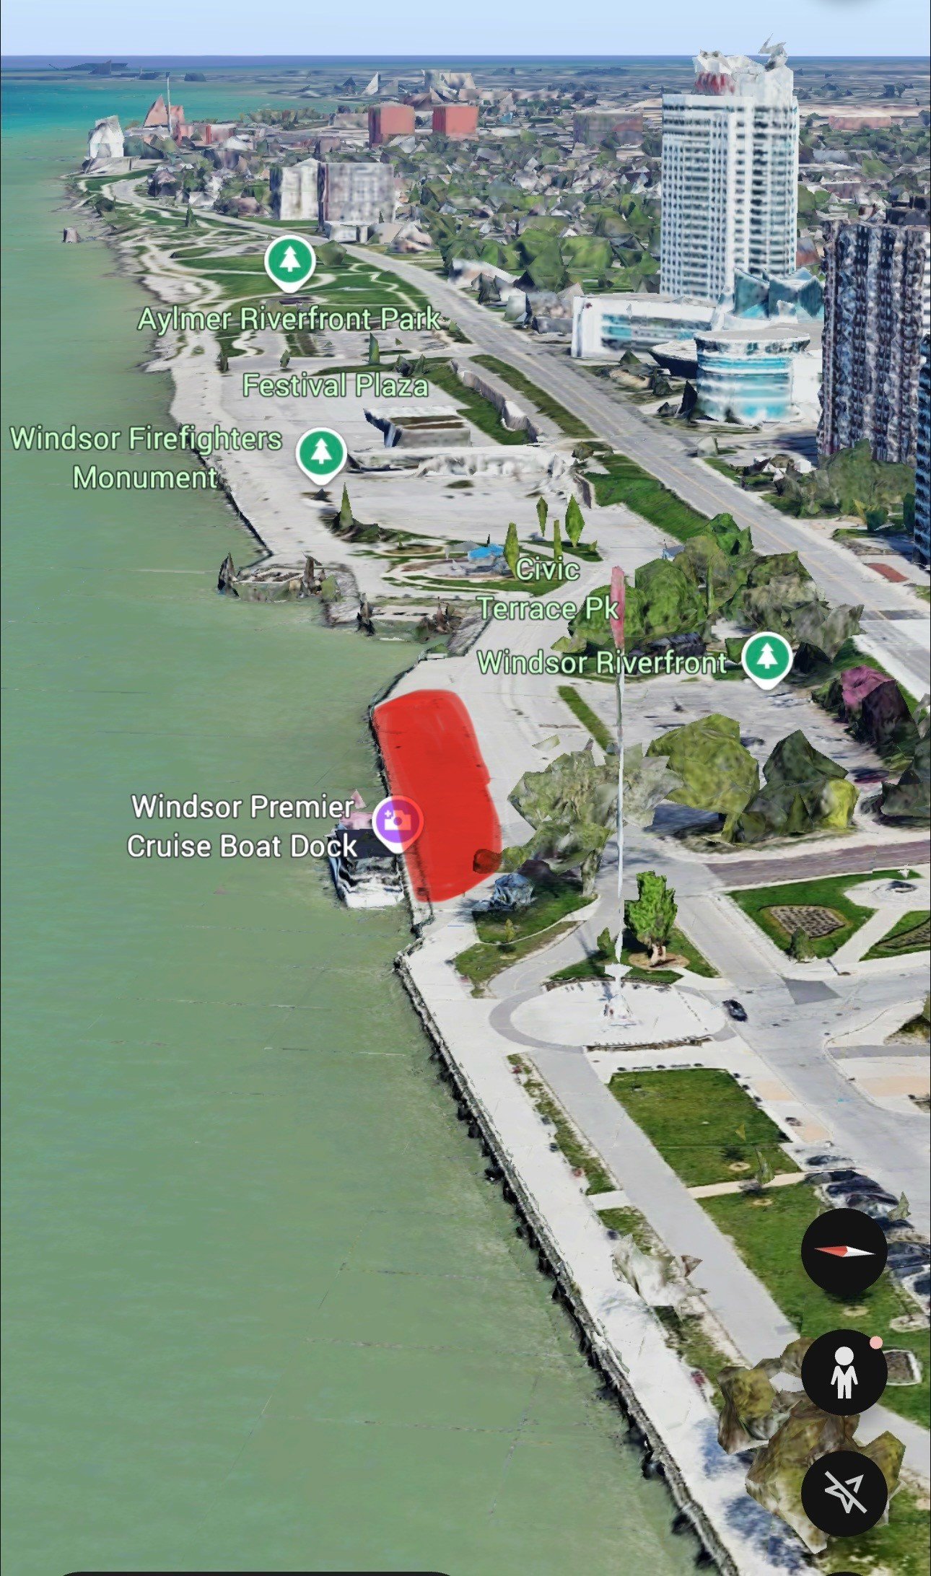
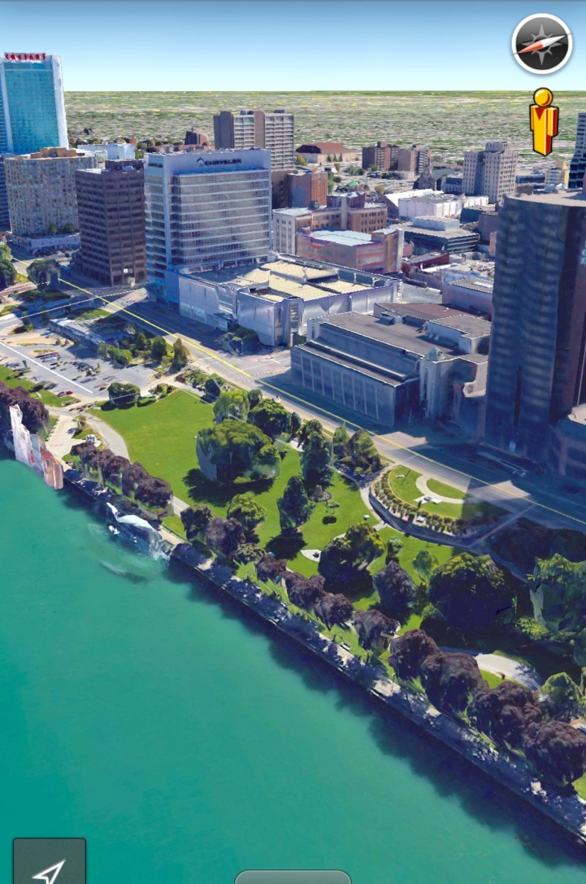
Left: Sitemap of the pay parking options in red. Includes sites on the water and a parking garage.

Bottom Left: Sitemap of a warmup area at Dieppe Park along the waterfront.

Bottom Right: Overall view of the competition area in red and the warmup area along the riverfront

