

**Hosted by the Vernon Amateur Athletics Association**

**Sanctioned by BC Athletics**

**“We acknowledge that we are on the traditional, ancestral, and unceded land of the Syilx / Okanagan people who have resided here since time immemorial.”**

**Saturday October 18, 2025**

**Meet Director:**

* Adrienne Mills: email – [vaaatrack@gmail.com](mailto:vaaatrack@gmail.com)

**Location:**

* Department of National Defense Grounds, Falaise Drive, Vernon, BC,

**Course Maps:**

* See Map Below

**Registration:**

* Online registration:
* closes midnight October 16, 2025

**Age Categories:**

* Track Rascals – age 1 – 8
* U-16
* 16 - 99

**Entry Fees:**

* Track Rascals - $1.00
* U-16 - $8
* 16 – 99 - $15
* Additional $5 if you require “Day of Event” BC Athletics Membership

**Package Pick-up:**

* Friday October 17, 2025, 1Pm – 7pm at ‘The Starting Block’, 3100 29th Ave Vernon B.C.
* **Day of Race:**
  + Department of National Defense Grounds, must sign in no later than 1 hour prior to scheduled race start

**Tentative Schedule of Events:**

|  |  |  |  |
| --- | --- | --- | --- |
| **RACE** | **TIME** | **AGE GROUP** | **DISTANCE** |
| 1 | 09:00:00 AM | Community Race | 5.0km |
| 2 | 09:45:00 AM | Track Rascals | 1.0km |
|  | 10:00:00 AM | Community Race Awards |  |
| 3 | 11:00:00AM | U10 Boys and Girls | 1.5km |
| 4 | 11:15:00AM | U11 Boys and Girls | 2.0km |
| 5 | 11:35:00AM | U12 Boys and Girls | 2.0km |
| 6 | 11:55:00AM | U20, Senior & Masters Women, Masters 70+ Women | U20 & Masters 8K, Senior 10K (Masters 70 plus 6K) |
| 7 | 01:00:00PM | U20, Senior & Masters Men, Masters 70+ Men | U20 & Masters 8K, Senior 10K (Masters 70 plus 6K) |
| 8 | 2:05:00PM | U13 Boys and Girls | 3.0km |
| 9 | 2:30:00PM | U14 Boys and Girls | 3.0km |
| 10 | 2:55:00PM | U16 Girls | 4.0km |
| 11 | 3:20:00PM | U16 Boys | 4.0km |
| 12 | 3:40:00PM | U18 Girls | 6.0km |
| 13 | 4:10:00PM | U18 Boys | 6.0km |

**EVENT TIMING:**

Timing will be provided by **Startline Timing**

**To all coaches and athletes, if you have scratches or will scratch from the race, you MUST hand in your bib to the timing table before your race time. Do not leave unused bibs in your backpack or pockets, then walk around the course or close to the finish line. This creates delays in getting verified results out on time.**

To athletes racing: Do not stop your watch at the first timing mat finish line, crossing your arm over your bib and chip timer. The camera cannot see your bib number, and this interferes with the timing chip and verifying placement. Stop your watch after the second backup timing mat. If you stop your watch at the first timing mat, your official time will be 2 seconds slower, as the official time will be taken at the second backup timer mat.

**Awards:**

* **Will be presented at the podium at 10:00am**

**Individual Awards 5km**

* **U-16: Prizes to** 1st, 2nd, 3rd and 4th place finishers (boys and girls).
* **16 – 99:** Prizes to 1st, 2nd, 3rd and 4th place finishers (boys and girls).

**Results:**

* Available on line at:
  + VAAA Website - <https://www.vernontrackandfield.org/>

**Competitors Numbers:**

* Must be worn on the front and be visible at the finish line

**Medical:**

* First aid will be available on site.

**Food and Beverage:**

* Available on site, there will be a variety of food trucks on site
* There will be post race snacks and drinks available for racers at the finish line

**Tents**

* Team and individual tents are welcome. There will be a designated area to set up tents, see map.
* Tents can **NOT** be staked into the ground. They must be tied to a weight of some kind ie: sandbag, brick, etc.

**ACCOMODATIONS**

Please note that this will be a busy weekend in Vernon and hotels will fill up fast. Clubs, Athletes and Coaches are please asked to book accommodations ASAP.

**Host Hotels: Prestige Hotels and Resorts,** [www.prestigehotelsandresorts.com](http://www.prestigehotelsandresorts.com/)

Online Promo Code: **XRUN**

If calling directly ask for the **BCXC Championships in October**

**Prestige Vernon Lodge and Conference Centre**, 2.4km from competition site (approximately 6min.) 250-545-3385

**Prestige Hotel Vernon**, 3km from Competition site (approximately 7min.) 250-558-5991

* Rate: Standard Rooms starting at $139.95/night (Oct. 16-19,2025)
* Complimentary: Parking & WIFI and access to the fitness center

**Host Restaurant:**

* **Silverstar Brewing Company, 2933a 30th Ave, Vernon**

**COURSE MAP**

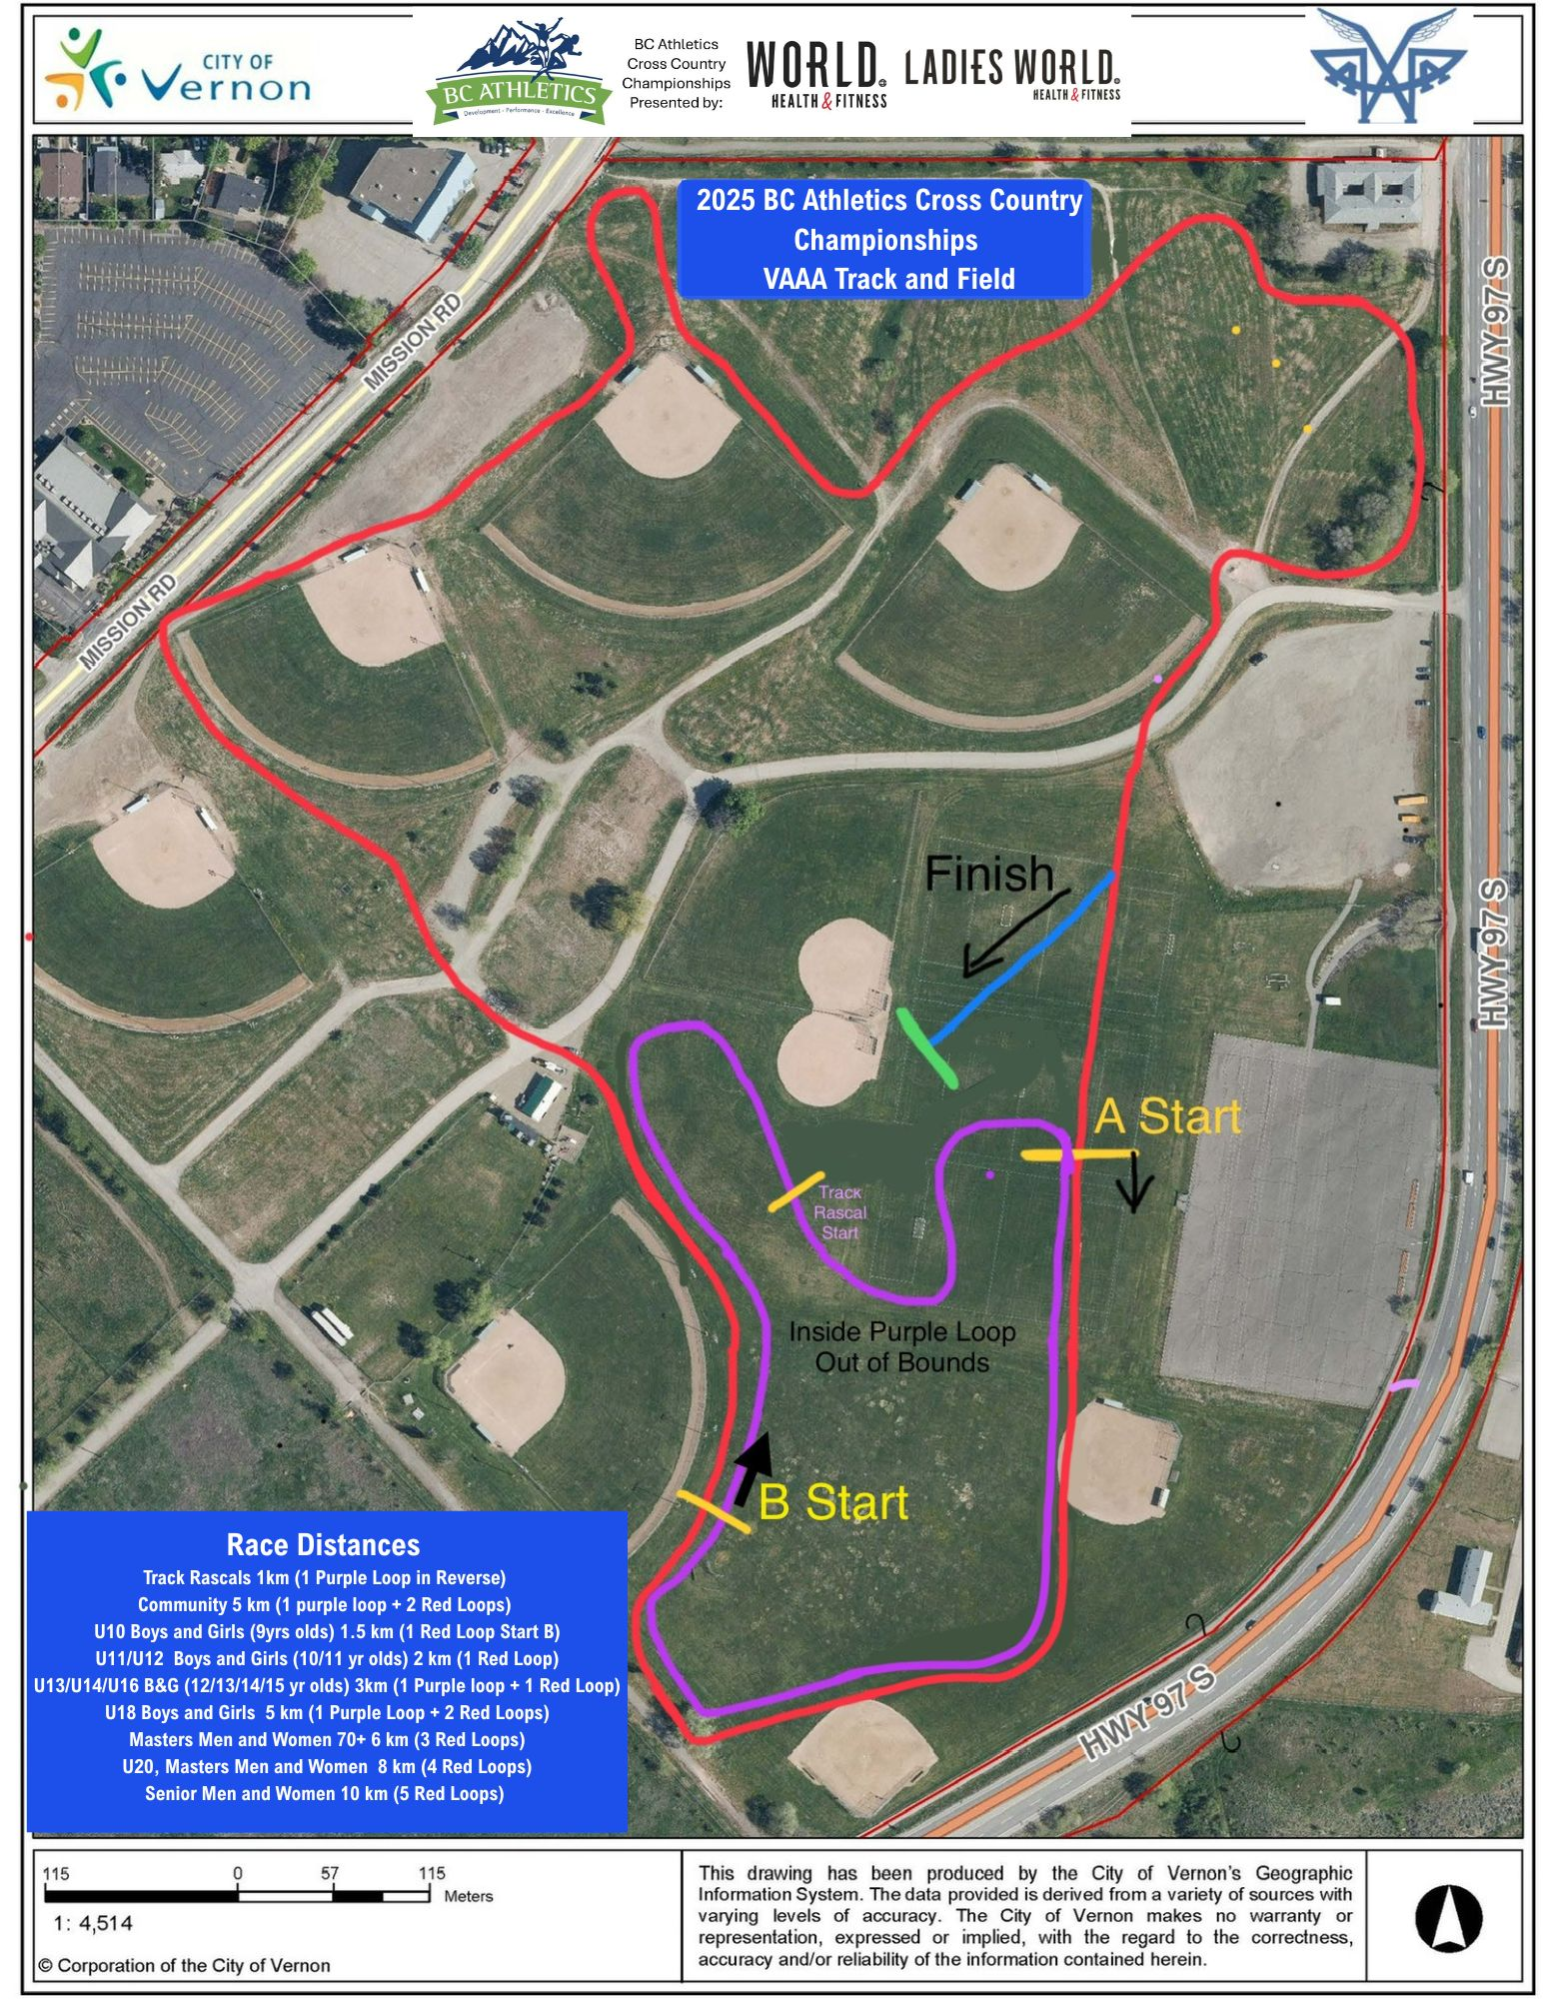

**FACILITIES AND PARKING MAP**

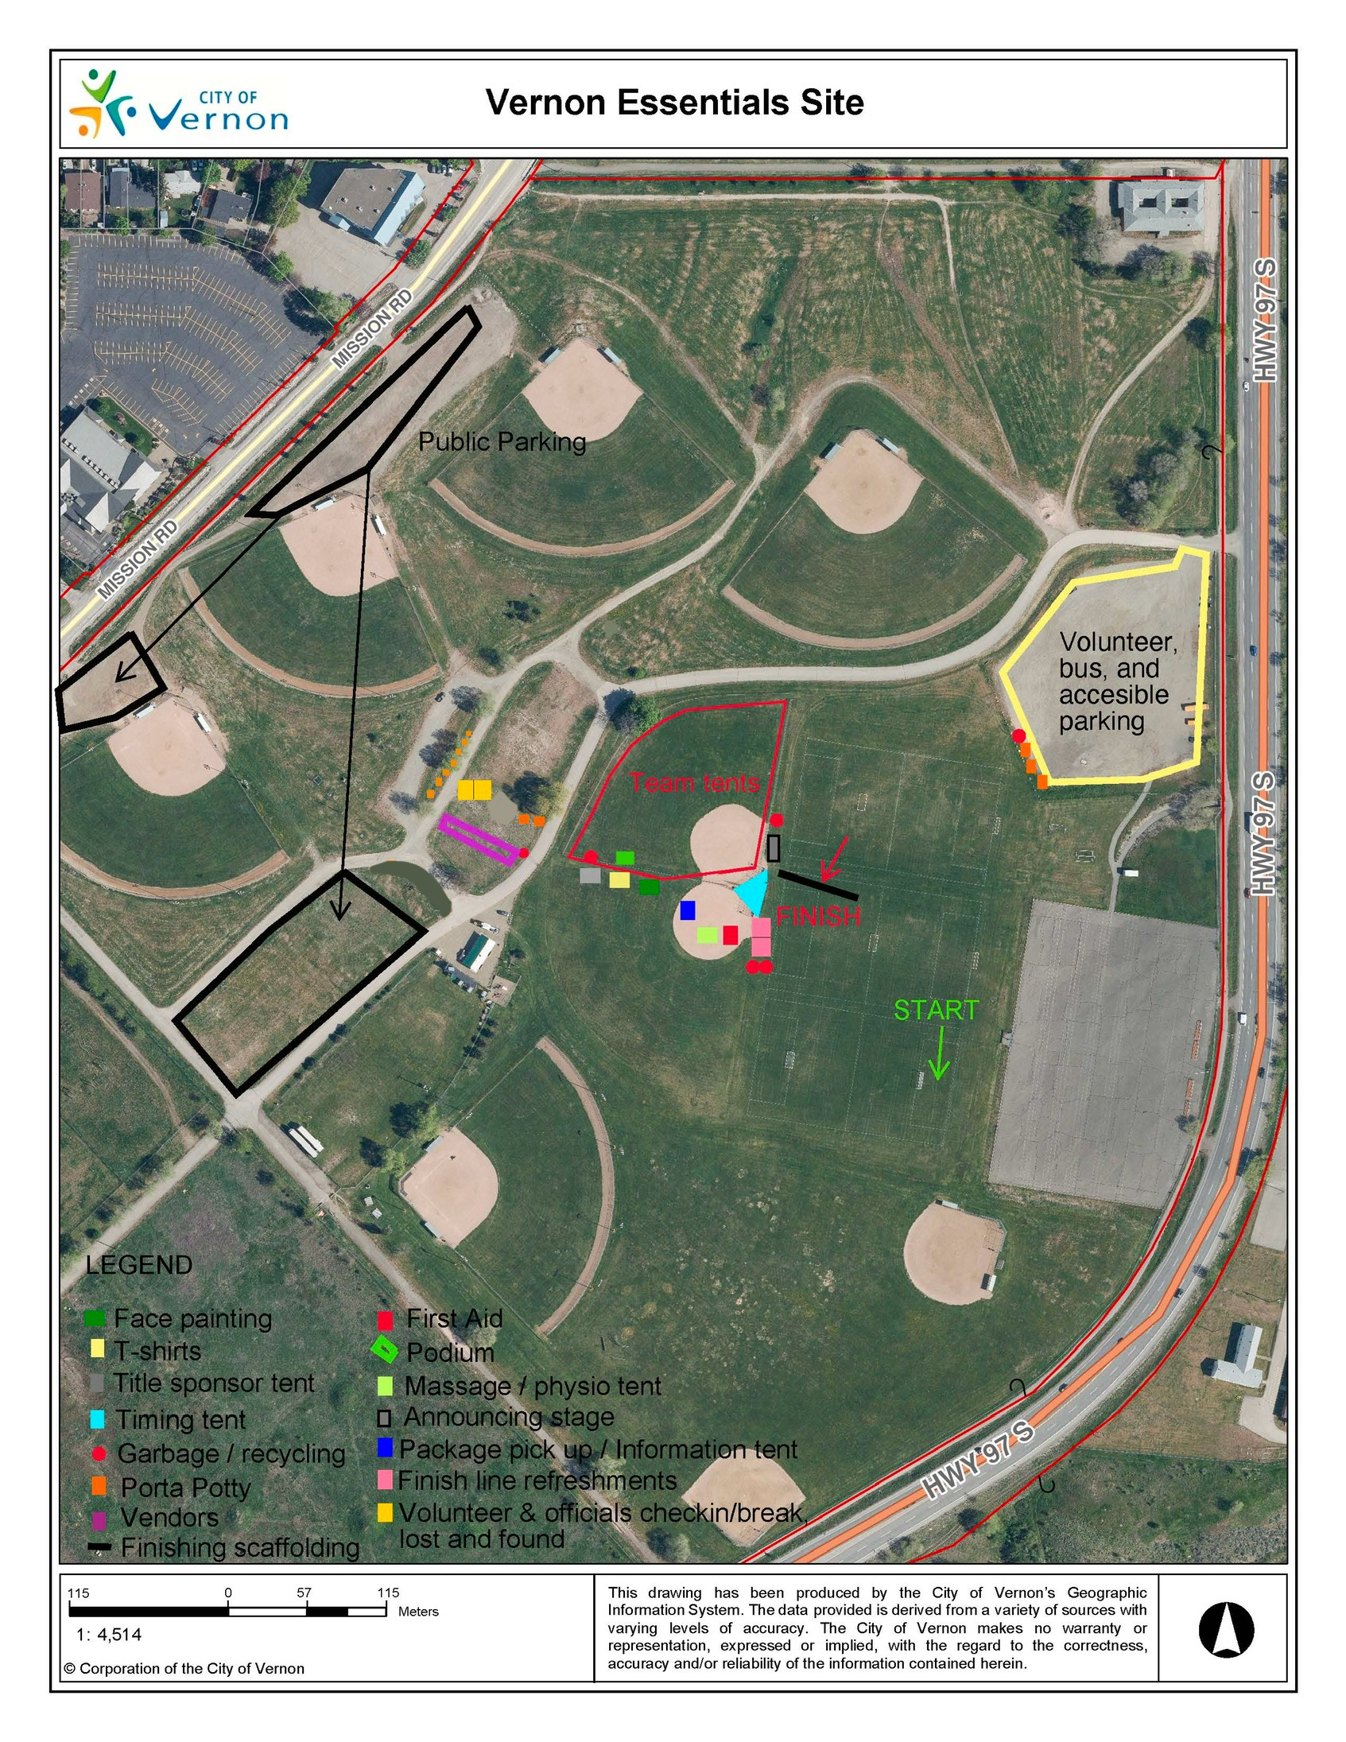

**Elevation Map 2km Loop**

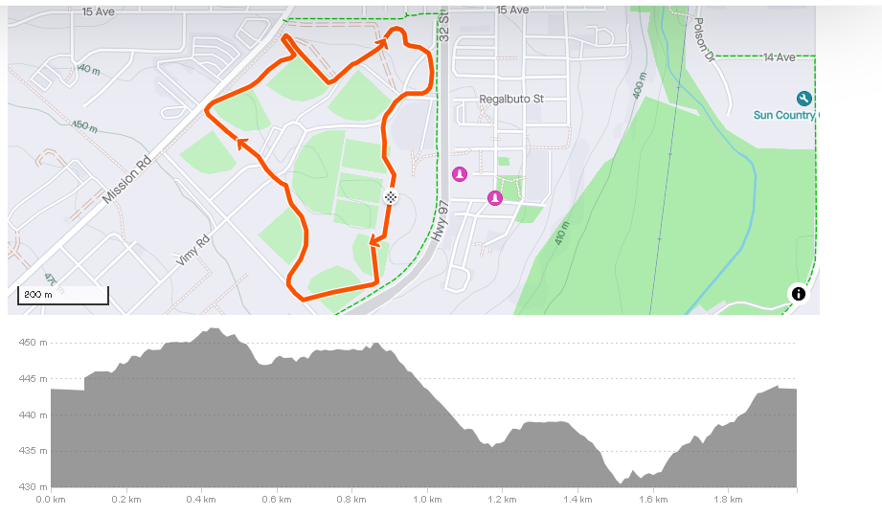

**Elevation Map 1km Loop**

