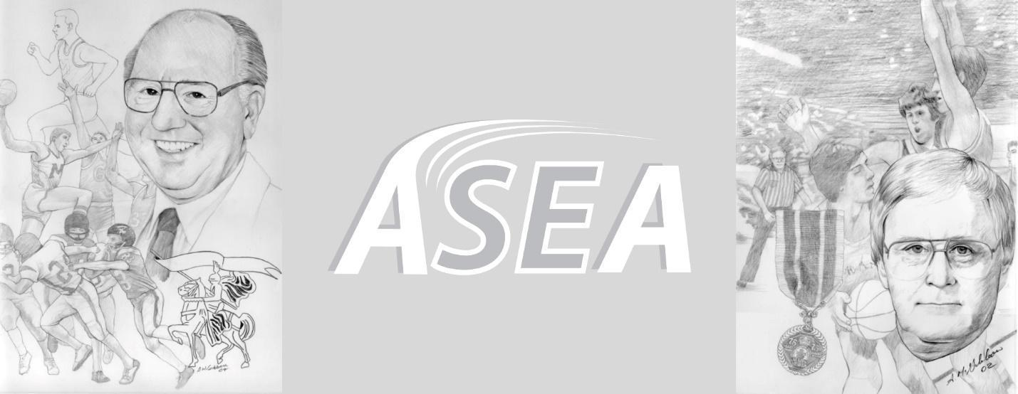

\\\

**Skiffington / Grant Challenge**

**Date:** Saturday, May 21st, 2022

**Time:** 9:30am - 5:30pm

**Classification:** Outdoor Track and Field Meet

**Location:** Croix-Bleue Medavie Stadium, Moncton, NB

**Primary Contact:** Peter Stuart (stuart@nbnet.nb.ca)

**Organized by:** Athlétisme Sud-Est / South-East Athletics (ASEA)

Ed Skiffington (Moncton High School) and Don Grant (Harrison Trimble High School) each

**Skiffington / Grant Challenge**

Organized by : ASEA

Primary Contact : Peter Stuart , [stuart@nbnet.nb.ca](mailto:stuart@nbnet.nb.ca)

Co-Host : Riverview High School

Date : Saturday May 24

Time: 8:30am - 5:30 pm

Location : Medavie Blue Cross Stadium

Classification: Outdoor Track and Field Meet

.

Events : 80m, 100m, 150m, 200m,300m, 400m, 800m, 1200m, 1500m, 1500ms/c, 2000ms/c, 3000ms/c, 80mh, 100mh, 110mh, 200mh, 300mh, 400mh, Long Jump, Triple Jump, High Jump, Shot Put, Discus, Javelin, Hammer

Registration: First event $25.00. Second event $15.00. All other events are $10.00 each. All athletes should be registered by Wednesday May 21 at 11:59pm. There will be no onsite registration.

Organized by Athlétisme Sud-Est / SouthEast Athletics (ASEA).

Sanctioned by Athletics New Brunswick ( ANB ) and the New Brunswick Interscholastic Association ( NBIAA).

All events will be divided into NBIAA sections & non-NBIAA sections.



**Défi Skiffington / Grant**

Organise par : ASEA

Contact primaire: Peter Stuart , stuart@nbnet.nb.ca

Date: Samedi le 24 mai

Quand: 8:30am - 5:30 pm

Location: Stade Medavie Croix Bleu

Classification: Outdoor Track and Field Meet

.

Evenements: 80m, 100m, 150m, 200m, 400m, 800m, 1200m, 1500m, 1500ms/c, 2000ms/c,3000ms/c , 80mh, 100mh, 110mh, 200mh, 300mh, 400mh, LJ, TJ, HJ, SP, Dis, Jav, Ham

Inscriptions: La premiere evement est 25.00$. Deuxieme evenements est 15.00$. Les evenements additionale est 10.00$ Tous les athletes doivent etre inscris par le 21 mai at 23h59. Aucune athlete voit etre accepter apres.

Chaque participant doit accepter de ce conformer a tout les reglements de ANB et AC.

Organisé en conjonction avec athlétisme nouveau brunswick et le ASINB.  
  
Les évènements auront être séparé par organe directeur (ASINB ou ANB).

**Tentative Track Schedule (Horaire tentative du piste)**

( female before male, younger age groups to older )

( groups might be combined depending on entries)

8:30am

2000m - U14/U16 Female & Male

3000m - U18/ U20. Senior/ Masters

200mh - U14/U16 Female & Male

300m hurdles - U14/U16 Female

400m hurdles - U18/U20/ senior Female

300m hurdles - U14/ U16 Male

400m Hurdles - U18/U20/ Senior Male

80m heats - U12/U14 female

80m heats - U12/U14 Male

100m heats - U16/U18/U20/open/ Masters female

100m heats - U16/U18/U20/open/ Masters male

800m - U16 and older female

800m - U16 and older male

80m finals - U14 female U14 Male

100m finals - U16/U18/U20/open/ Masters female

100m finals - U16/U18/U20/open/ Masters male

**Featured Events**

1000ms/c- U14 male & Female

1500ms/c - U16 Female & Male

2000ms/c - U18 Female

2000ms/c - U18 Male

3000ms/c - U20 and older Female

3000ms/c - U20 and older Male

**Break ( approx 1:00-1:30pm )**

150m timed final - U14

200m timed final - U16/U18/U20/open/ Masters female

200m timed final - U16/U18/U20/open/ Masters male

80m hurdles finals - U14/ U16 Female; U16 Female, Masters,

100m hurdles finals - U16 male, U18/U20/Open female, Masters

110m hurdles finals - U18/U20/Open male, Masters

1200m - U14/ U16 female

1200m - U14/ U16 male

1500m - U18 and older female

1500m - U18 and older male

300m timed final - U16 female

300m timed final - U16 male

400m timed final - U18 and older female

400m timed final - U18 and older male

**Tentative Field Schedule (Horaire tentative)**

9:00am - Female Shot Put

9:00am - Male Discus

9:30am -Male Long Jump

11:00am -Female triple ( after male long jump )

10:15am - Male discus

11:00am - Female Shot put

**After Break ( should be at approx 12:00 )**

12:00 - All High Jump

12:00- Female Javelin

12:00 - Female long jump

1:30pm - Male Triple jump ( after female long jump)

1:30pm - Male Javelin

**3:00pm -** Female & Male Hammer **Featured Event**

  