
INFORMATION PACKAGE
Saturday 10th May 2025
19th Annual - Eagles Classic Track & Field Meet
Maple Ridge Secondary School, Maple Ridge, BC
21911 122 Avenue Maple Ridge, BC, Canada V2X 3X2
We are very pleased to invite the track & field community to the 19th Annual Eagle Classic Track & Field Meet to be held on Saturday, May 10th, 2025, in Maple Ridge. This year’s meet will include events in sprints, distance, jumps, and throws, with a few events being offered for adult competitors including Masters Sprint events. The historic mile will again be our feature distance race. Keeper trophies will be awarded to the top three finishers in each JD event category and special Eagle Classic ribbons will be awarded for places fourth to eighth. In keeping with the tradition of our meet, beautiful perpetual trophies will again be presented to the top JD milers of the day; the top JD thrower; the most outstanding individual meet performance, and the top school or club team.
There will again be professional electronic photo finish timing, professional announcing, and officiating by BC Athletics.
We hope to see you and your athletes at this year’s meet!
GOLDEN EARS ATHLETICS
Phil Pitzey PRESIDENT, GEA
goldenearsathletics@gmail.com or Tel: 604-396-4856
For meet updates visit www.golden-ears.org

Entry Deadline: Register by WED., May 7th, 2025 – 11:59pm
Entry Fee: $10 / per event for each athlete (Relay events - $15 per team)
Late Entries:
At meet / $15 / per event (Relay events - $20 per team). Deadline for all late entries will be 2 hours before the event. (Absolutely no exceptions. Entries will be managed on an individual basis however GEA reserves the right to decline entry based upon availability).

Registration/Entry Procedures: Trackie.com Enter as an individual or as a team at www.trackie.com.

Track Schedule: (Schedules are approximate/ events can run 30min. ahead of schedule)
9:00 AM - Coaches Meeting and Track Brief
9:30 AM - Sprint Hurdles (9-13 year olds U10-U14 Oldest to Youngest)
10:45 AM - 800m Timed Finals (12-13 year olds U14-U14)
11:00 AM - 600m Timed Finals (9-11 year olds U10-U12)
11:30 PM - Masters 200 (35 & over)
11:35 PM - Open 200(14 & Over)
11:50 PM - 60m Timed Finals (9-10 year olds U10-U11)
12:20 PM - 100m Heats (11-13 year olds U12-U14)
11:50 PM - Lollipop Run
1:00 PM - OFFICIALS BREAK
1:30 PM - Mile Timed Finals (Open & Masters)
1:45 PM - Mile Timed Finals (13 year olds U14)
2:00 PM - 1200m Timed Finals (12 year olds U13)
2:15 PM - 1000m Timed Finals (9-11 year olds U10-U12)
2:35 PM - Masters 400 m (35 & over)
2:40 PM - Open 400 m (14 & over)
2:45 PM - 200m Timed Finals (11-13 year olds U12-U14)
3:35 PM - 100m Timed Finals (9-10 year olds U10-U11)
4:35 PM - 100m Finals (Masters, Open, 11-13 year olds U12-U14)
5:00 PM - 4 x 100m Relay (9-13 U10-U14) & Open/Masters

Field Schedule
10-May-25
Time | Field Schedule
 | High Jump |  | High Jump |  | Long Jump |  | Long Jump |  | Javelin |  |  | Shot Put | Shot Put |  | Discus
 | Pitt # 1 |  | Pitt # 2 |  | Pitt # 1 |  | Pitt # 2 |  |  |  |  | Circle # 1 | Circle # 2 |  | Cage
9:30 AM | 13 Boys (U14) |  | 9 Girls(U10) |  |  |  |  |  |  |  |  | 10 Girls (U11) |  |  | 10 (U11) &(U12) Boys
10:00 AM |  |  |  |  |  |  |  |  | 12 Boys (U13) |  |  | 9 Girls (U10)
10:30 AM |  |  | 13 Girls(U14) |  | 12 Girls (U13) |  | 11 Boys (U12) |  |  |  |  |  | 9 Boys (U10) |  | 10 (U11)& 11(U12) Girls
11:00 AM | 9 Boys (U10) |  |  |  |  |  |  |  | 13 Girls (U14) |  |  | 12 Boys (U13) | 10 Boys (U11)
11:30 AM |  |  |  |  | 11 girls(U12) |  | 13 Boys (U14) |  |  |  |  | 11 Girls (U12) | 11 Boys (U12) |  | 12 Girls(U13)
12:00 PM | 10 Boys (U11) |  | 12 Girls(U13)
12:30 PM |  |  |  |  |  |  |  |  |  |  |  |  |  |  | 13 Girls(U14)
1:00 PM |  |  |  |  | 9 Boys (U10) |  | 10 Girls (U11) |  | 12 Girls (U13) |  |  | 13 Boys (U14)
1:30 PM | 11 boys (U12) |  | 10 Girls(U11) |  |  |  |  |  |  |  |  | 13 Girls (U14) |  |  | 12 Boys(U13)
2:00 PM |  |  |  |  | 10 Boys(U11) |  | 12 Boys(U13) |  | 13 Boys (U14) |  |  | 12 Girls (U13)
2:45 PM | 12 boys (U13) |  | 11 girls(U12) |  | 9 girls(U10) |  | 13 girls(U14) |  | Men and Women OPEN |  |  |  |  |  | 13 Boys(U14)

Location: Maple Ridge Secondary School - 21911 122 Ave, Maple Ridge, B.C. V2X 3X2
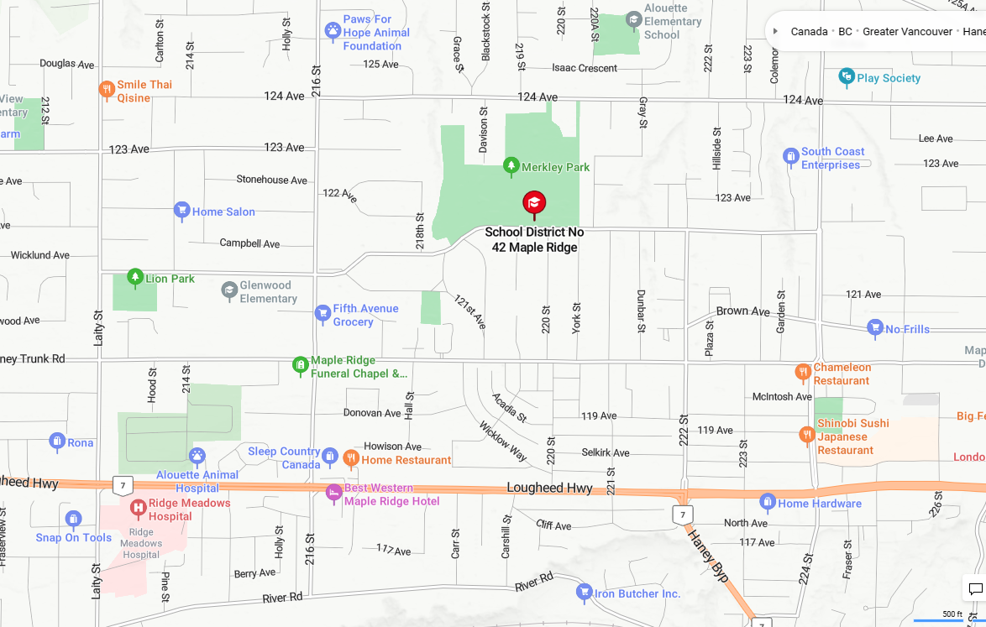

Parking:
There is a parking lot at the MRSS track; however, space is limited. Parking is also available on the street on 123rd Avenue and in the school parking lot just a few hundred meters away.
Medical/First Aid: There will be a First Aid attendant on site.

Concession / Food & Beverages:
There will be a concession in operation throughout the day serving a variety of food and drinks including hot dogs, hamburgers, chips, pop, water, donuts etc. There are also many restaurants and grocery stores just minutes away on Dewdney Trunk Road and in downtown.
Maple Ridge.
Contact Information: Phil Pitzey goldenearsathletics@gmail.com
Meet Director: Norm Tinkham goldenearsathletics@gmail.com
Meet Info: www.golden-ears.org
Sanctioned by: BC Athletics
Meet Management: Meet Pro Timing: Electronic Timing
(Finish Lynx System)
Eligibility: Athletes must possess a current BC Athletics Membership (Day of meet membership is available at the meet) Non-BC Athletics Members: add $3.00 / per athlete.
Entries: Due to time constraints, we reserve the right to limit entries to certain track and field events for all divisions to ensure schedules are maintained.
Age Divisions for Competition: Athletes may only enter events in their age category
9 year old boys (Boys born in 2016 U10) (Other than relay events)
9 year old girls (Girls born in 2016 U10)
10 year old boys (Boys born in 2015 U11)
10 year old girls (Girls born in 2015 U11)
11 year old boys (Boys born in 2014 U12)
11 year old girls (Girls born in 2014 U12)
12 year old boys (Boys born in 2013 U13)
12 year old girls (Girls born in 2013 U13)
13 year old boys (Boys born in 2012 U14)
13 year old girls (Girls born in 2012 U14)
All-Comers (born in 2011 or earlier)
Awards:
1st – 3rd Place trophies: individual events JD only
4th – 8th place ribbons: individual events JD only
All Relays - Ribbons to all runners on team
* No awards for All-Comers or Masters events
* Will be Available 30 minutes after posting

Special Perpetual Awards:
- Andrew Lenton & Cindy Foley: Golden Ears Mile Awards top male & female mile run performances.
- Ed Collinson Throwers Award: Top male & female throwing performances.
- Outstanding Team Award- perpetual trophy to top school or club, based.
on points for top 8 in each event (10,8,6,5,4,3,2,1) Elementary division (9–13-year-old age group)
- Herb Gee: Outstanding Meet Performance Award- perpetual trophy for
single event performance judged to be most outstanding, relative to
age/gender

Age for Distance Races:
The 600m and 1000m are available for those born 2014 to 2016, the 800m is available for those born in 2012 and 2013, the 1200m is available for those born in 2013, and the mile is available to athletes born in 2012 and earlier.

Event Order:
All track events will be run in the order of oldest to youngest. This allows the younger athletes to learn race procedures from the older athletes prior to being marshalled. Girls will go before boys in each age group track event.

100m Finals:
Heat winners and next fastest times will advance to the final. (9 &10 year olds U10-U11 will run timed section finals)

Relays:
Relay teams are encouraged to be made up of athletes from the same school or club. An athlete may compete for an older age class in a relay but may not compete in more than one relay race of each kind or more than once in the same race. If a school enters a relay team, club athletes will run for their school. Clubs may enter relay teams of athletes whose schools are not entered.

Event Check-in:
Athletes in track events will be marshalled at the west side of the track behind the 100m start when the event is called. Athletes should report to their field event 20 minutes prior to the start.

Registration:
Registration packages, including athletes’ numbers, will be available for pick up at the check-in table by coaches at 8:30 a.m. on Saturday. Numbers must be worn for all events. Athletes using another athlete’s number will be disqualified from participating in the rest of the meet.
Event Schedule:
Events may run up to 30 minutes ahead of schedule. Any scheduling changes will be announced. All changes to posted results will be made in consultation with the Track or Field Referee and Meet Director.

Additional Rules:
EACH SCHOOL OR CLUB IS RESPONSIBLE FOR THE SUPERVISION AND CONDUCT OF THEIR ATHLETES. ON YOUR REGISTRATION FORM, PLEASE DESIGNATE THE ADULT OR COACH RESPONSIBLE FOR YOUR TEAM. ·

MARSHALLING:
Only athletes will be allowed in the marshalling areas. After the athlete has entered the marshalling area, parents and coaches are required to leave. Athletes should warm up ahead of marshalling and keep warm clothing on until the start of the event. ·
• Coaches, athletes, and spectators are not allowed on the infield. All coaches and spectators must stay out of the areas designated as competition areas. Coaching must take place in an area designated by the chief official. Athletes who are competing must stay within the competition area with the other competitors.
• IF TWO EVENTS OCCUR AT THE SAME TIME FOR AN ATHLETE the athlete or the parent/coach, should notify the field event organizer and the track event marshal of the situation at the time that each event is marshalled. A short time before the track event is run the athlete must notify the field event officials and go to the race. The parent/coach must realize that COMPETITION WILL NOT BE SUSPENDED UNTIL ATHLETES RETURN (IAAF and JD rules.) The athlete will enter the competition at
the point that it has reached when they return. Sometimes athletes may decide to miss one of the events in order to do well in one of their choices. This situation is a common occurrence at track and field meets.

• FIELD EVENTS: For safety reasons, athletes who cannot jump safely into the pit from a 1m takeoff board when competing in long jump should not be entered in this event. Also for safety reasons shot put contestants must put the shot correctly and not throw it.
o long jump: 3 jumps each
o High Jump: 3 attempts at each height. 5 cm increments until two athletes are left, then the athletes can choose.
o Shot put: 3 throws each.
o Javelin: 3 throws each for JD, 6 throws for All Comers
o Discuss: 3 throws each
Do Not Cross the Track, Discus, High Jump or Shot-Put Area Except Under the Direction of an Official.
This Meet will be run in accordance with IAAF and BC Junior Development rules. Failure to comply with meet rules may result in the disqualification of an athlete, team, or coach from the competition.

