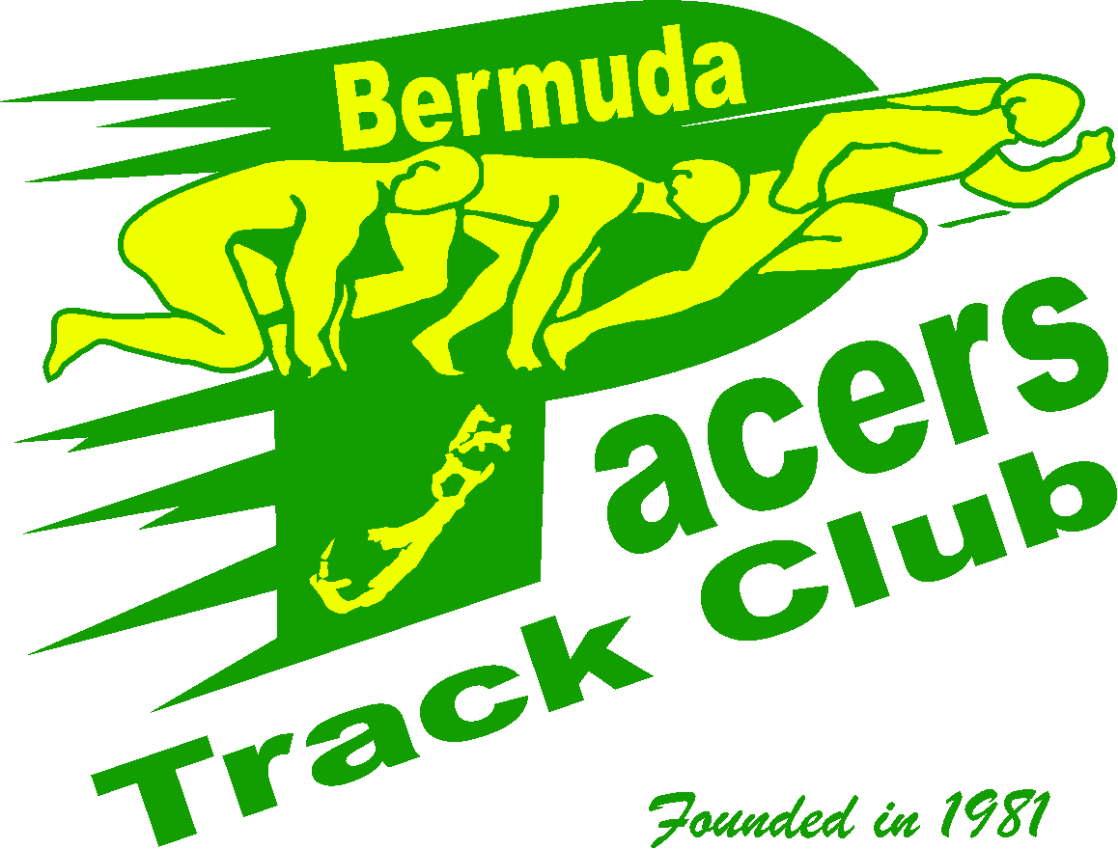

April 22, 2025

Greeting Physical Education Teacher(s),

The Bermuda Pacers Track Club is pleased to inform you that ten primary schools, seven middle schools and four senior high schools have confirmed their interest to compete in the 16th Annual School Relay Classic. The event will be held on Friday, May 2, 2025, at the Flora Duffy National Sport Centre starting at 5.30pm. Below are some of the rules and regulations for the event.

* Primary and Middle Schools can enter a maximum of two (2) teams in each race category.
* Senior High schools can enter a maximum of three (3) teams in each race category.
* ***However, only one relay team from your school in the finals will receive the allotted points.***Teachers, please identify your A, B or C teams when registering.
* Should there not be enough teams during the semi-final rounds; the events will be a straight final. (**See track meet schedule**)

Your team’s package with athlete numbers and updated track meet schedule will be available for collection between 4.30 pm and 6.30 pm on the night of the event in the press box on the upper level of the Sports Centre.

The event will consist of two relay events. The 4 x100 metres and 4 x 400-metres relays. Schools are required to enter their best teams in both the girls’ and boys’ categories. With support from our sponsors, we will have cash awards for the Physical Education Departments of the top three schools at each school level.

To facilitate this event, we have provided you with a complete registration package that consists of the event schedule, rules, and regulations for the track meet. To register go to [www.trackie.com/event](http://www.trackie.com/event) bermuda-pacers-school-relay-classic-hosted-by-pacers/1019437/?admin=1

For assistance with registration please contact Mr. Wayne Raynor at [wmr041255@gmail.com](mailto:wmr041255@gmail.com) or call 337-0088.

***\*\*The registration fee is $30 per team and payable online or by check payable to the Bermuda Pacers Track Club. If you are paying by check, please give the check to the Pacer official in the press box when collecting your registration package. They will provide you with a receipt. Registration deadline is Wednesday, April 30th , 2025.***

In closing, we look forward to seeing your school compete in this exciting event. Should you have any questions regarding the event, please call: Cal Simons at 337-0237 or email me at [ckpacers@gmail.com](mailto:ckpacers@gmail.com).

Sincerely,

Wayne Raynor

Co-Meet Director



Bermuda Pacers Track Club Schools’ Relay Classic

Friday, May 2, 2025

Registration Entry Fee $30.00 per relay team

Relay Schedule

4 X 100 Metre Relays (preliminary rounds)

The top two teams in each heat and the next four fastest times qualify for the finals.

5:30 pm 4x 100m Relay Primary School Girls Heat 1/2

5:50 pm 4 x100m Relay Primary School Boys Heat 1/2

6:00 pm 4 x 100m Relay Middle School Girls Heat 1/2 (if required )

6:20 pm 4 x 100m Relay Middle School Boys Heat 1/2 (if required )

***Special Events***

6:15 pm Football Club Relay events

4 X 400 Metre Relays Time Finals

7:00pm 4 x 400m Relays Primary School Girls Heat 1 followed by Heat 2

7:10 pm 4 x 400m Relays Primary School Boys Heat 1followed by Heat 2

7:20 pm 4 x 400 m Relays Middle School Girls

7:30pm 4 x 400m Relays Middle School Boys

7:40pm 4x 400m Relays High School Girls

7:50 pm 4 x 400m Relays High School Boys

4 X 100 Metre Relays Finals

8:00 pm 4x 100m Relay Primary School Girls

8:10 pm 4 x 100m Relay Primary School Boys

8:20pm 4 x 100 m Relay Middle School Girls

8:30 pm 4 x 100m Relay Middle School Boys

8:40pm 4x 100m Relays High School Girls

8:50 pm 4 x 100m Relays High School Boys

***\*\* All times are subject to change: Depending on the Number of Teams competing in each event.***

**Registration packages will be available for collection between 4. 30 pm and 6. 30 pm on Friday, May 2nd, 2025.**

In the press box on the outer level of the sports centre.

**Teams must be available one (1) hour before the scheduled time of the event. Teams will check-in**

**30 minutes before the start of each race**. All team members must check in together.

Medal presentation will take place at the conclusion of each final race.

***Registration deadline is Wednesday, April 30 st,2025.***



Rules and Regulations for the Meet

1. Athletes must compete in their school running attire or PE uniform.
2. Athletes must attend the competing school.
3. Athletes must use the batons provided by meet organizers.
4. Athletes can compete in both relay events for their school.
5. All athletes must check in as a team.
6. Athletes must present their relay team check-in form to meet officials.
7. Coaches or teachers will not be allowed in the check-in area.
8. All schools must pre-register for the event by Wednesday, April 30st ,2025
9. Team registration is $30 per relay team (six athletes) For example, 4 teams cost $120.00
10. Online registration [www.trackie.com](http://www.trackie.com). Schools may pay by credit card or check. See payment process. **
11. Medals will be presented to the top three teams after the final race.
12. All protests must be in writing and presented 15 minutes after the particular event to meet directors. The Meet Directors and Chief Track Referee decisions are final.

**Team Awards**

The schools with the most combined points at the conclusion of the relay in each year category will receive an award of $500.00, the second-place team will receive $300.00 the third-place team will receive $200.00. In addition, $100.00 will also be presented to the top male and female team in each category. The only condition for presenting the awards is that there must be at least three (3) schools competing in the senior high school event, three (3) schools in the middle School event and five (5) schools in the primary school events. The awards will be presented to the Physical Education Department of that school to assist in the development of their PE programs.

**Scoring of Points**

First place team 10 points, second place team 8 points, third place team 6 points, fourth place team 4 points and fifth place team 2 points. All other positions will receive (1) one point. These points will be added after each final event and awarded to the respective schools. However, should you have more than one relay team in the finals, only your top place team will receive the allotted points.

The school with the largest number of points at the end of the meet will be crowned Champion.

Should there be a tie-on point, the teams with the lowest total combined race times will be declared the winner.

***Teams will be disqualified from the meet if they are found to be demonstrating unsportsmanlike conduct on or off the track.***

***Registration Deadline Wednesday, April 30th, 2025***

**BERMUDA PACERS TRACK CLUB**

**A GREAT TRACK AND FIELD EXPERIENCE**

**FOUNDED IN 1981**

**Official Relay Team Registration Process**

The meet will run under World Athletics rules and regulations according to specific ages groups .

**Instructions**

* Please complete online registration for each relay team competing from your school on [www.trackie.com](http://www.trackie.com).

* Relays will be in the following age divisions: Primary School, Middle School, Senior High School.
* List the top four athletes as the starting relay team members. Two additional alternates may be listed as part of that relay team. (See relay team check in form)
* Once the meet starts only the registered starting and alternate relay team members will be permitted to compete in the race.
* If you must make changes to your team due to an athlete being injured, please contact the Meet Directors prior to checking in to get their approval. Failure to do this will result in a disqualification.
* All relay team members must be from the same school and same school division.
* Each member of the relay team must wear a matching school PE uniform or running outfit.
* Each relay team member must wear his/her own bib number. Switching of bib numbers will result in disqualification.
* All four members of the relay team must check-in **30 minutes** prior to the start of the event or on the first call.
* Teams must present the relay team check-in form to officials. (New)
* Each relay team will be provided with a regulation baton.

***Please make copies of this form and have the athletes present it to the check-in officials in the call room.***

***-------------------------------------------------------------------------------------------------------------***

***Bermuda Pacers Track Club***

***Relay Team Check-in Form 2025***

***Athletes must present this form to check-in officials.***

**School Name: _________________________________ Event: *4 X100 or 4 x 400 (circle one)***

**Male or Female (circle one) School Division: Primary, Middle, Senior School (circle one)**

**Coach’s Signature: ________________________ Contact Numbers___________________________**

**Relay Team Members Please circle A, B, or C team.**

**Starting Team Alternates**

**1.________________________________ 1. ________________________________**

**2.________________________________ 2 _________________________________**

**3. _______________________________**

**4. _______________________________**

**--------------------------------------------------------------------------------------------------------------------------------------------------------**

***Bermuda Pacers Track Club***

***Relay Team Check-in Form 2025***

***Athletes must present this form to check-in officials.***

**School Name: _________________________________ Event: *4 X100 or 4 x 400 (circle one)***

**Male or Female (circle one) School Division: Primary, Middle, Senior School (circle one)**

**Coach’s Signature: ________________________ Contact Numbers___________________________**

**Relay Team Members Please circle A, B, or C team.**

**Starting Team Alternates**

**1.________________________________ 1. ________________________________**

**2.________________________________ 2 _________________________________**

**3. _______________________________**

**4. _______________________________**