Using Trackie:

<https://www.trackie.com/>

Click on “Find Event”

Type in “Westman”

Click on the link

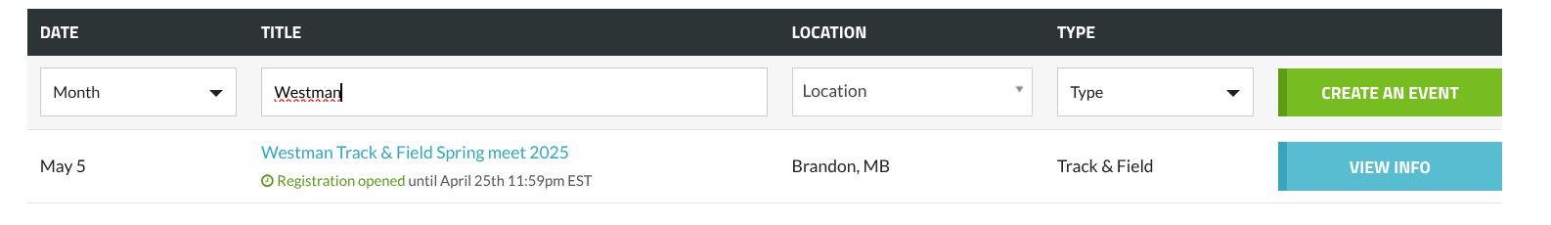

You will have to create a team using the MHSAA T & F codes. If your school is present and does not in include the MHSAA code **please** create a new team using the code. **You will find your code in the attached document. Enter your school name exactly the way it is on the document.**

Thanks

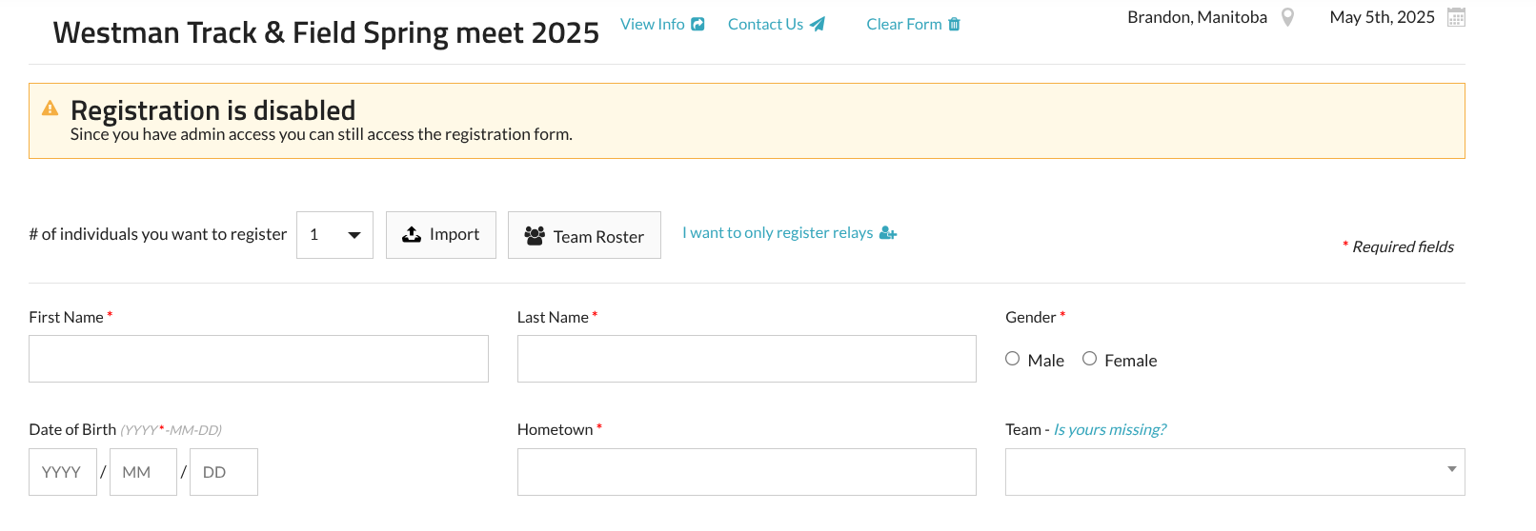

You probably want to create a team roster, making it easier to do entries in the future. You can download the file for import and create your roster that way. **Do not enter events** on this file, just the athlete information. {**Name, gender, DOB, Team} For hometown put in your school name. I am not sure if this field is necessary but adding it in right away can save you some grief if it is required.**

For the date of Birth just enter the year, then 01/01 for month & day. 2008/01/01.

Once you create your roster you can import from the team roster, then click on each athlete and enter their events. Please make sure you enter the correct category (JV or Var)

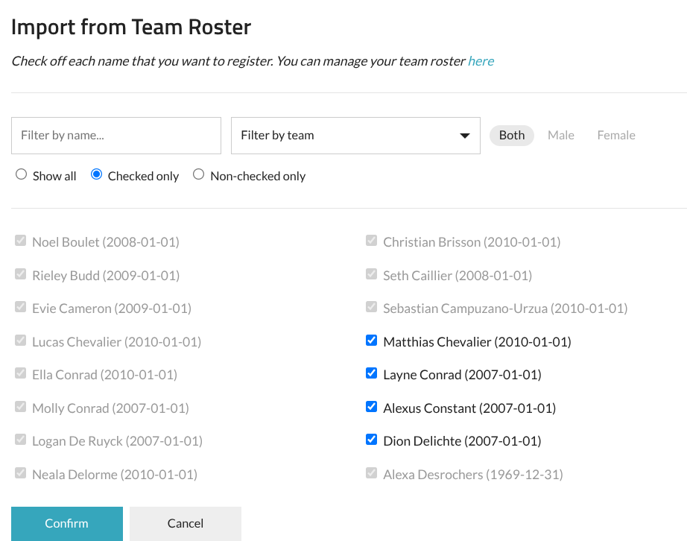

The entries page will look like this: Where you can click on each athlete & fill in the events.

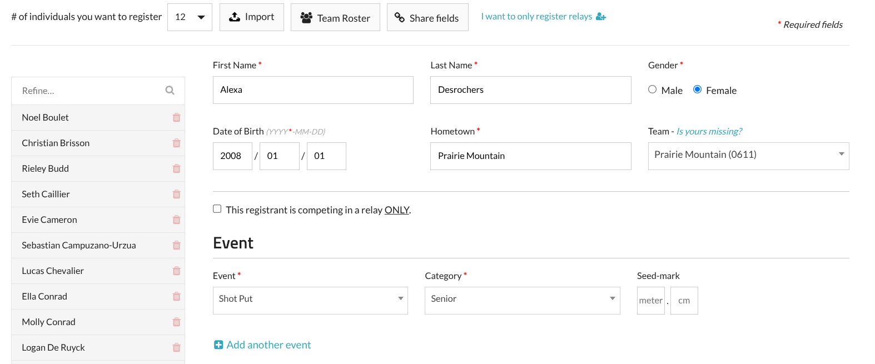

Since you have to pay the entry fee online I would suggest that you save your registrations & complete later when you are 100% sure of your registrations. I assume there would be a processing fee on your credit card each time you would alter your registrations.

**Entry fee is $5 per registrant plus processing fees from Trackie.**