2025 Forest City Mustang Invitational | 
Thursday April 24th, 2025 @ Alumni Stadium Western University

2025 FOREST CITY/MUSTANG INVITATIONAL
TRACK AND FIELD MEET
Thursday April 24th @ Alumni Stadium, Western University - London, ON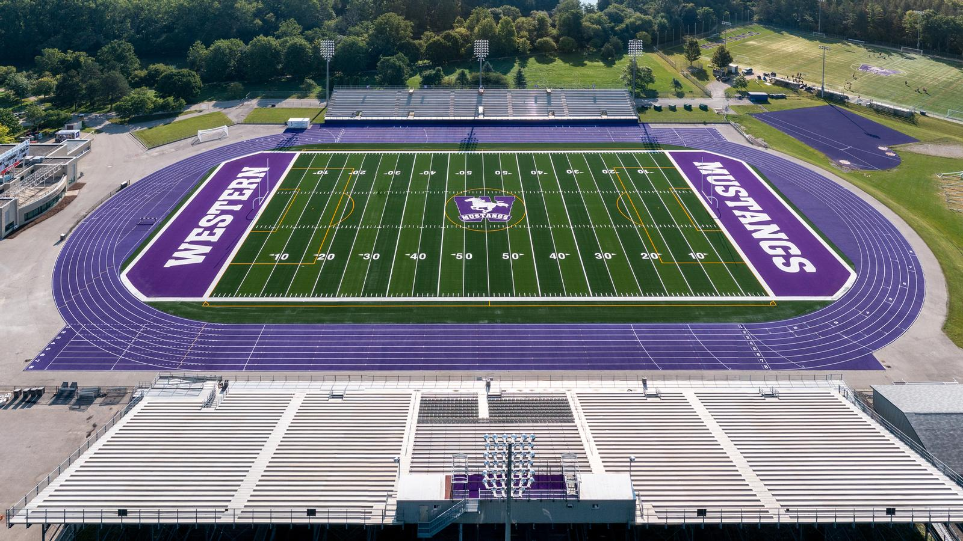
Dear Coach:
Western’s Men’s and Women’s Track & Field teams and the London-Western Track and Field Club invite your school to participate in this year’s meet. The meet is on the Donald J. Wright Track at Alumni Stadium which was resurfaced in 2021 and is home of the 2024 OFSAA Track & Field Championships

  www.westernmustangs.ca |   www.londonwesterntfc.com
Meet Directors
Taylor Ehrhardt
Taylorehrhardt10@gmail.com
Scott MacDonald
scottmaclwtfc@gmail.com

ENTRIES: Entries can be done at: 2025 Forest City | Mustang Invitational
Deadline: Friday April 18th 2025 @ 11:59pm

Entry Fee: $20 per athlete or a maximum of $550 per school. Cheques can be made out to:
“Western University”, If you are paying online, there will be an admin fee that will be on-top of the team cap

Max Entries: A limit of 3 athletes per event, per age category, per school. Each athlete is also limited to total
of 2 events.

Track Check-in: Last check in for track events will be 20min before the start of the race, at the start line of the
event. All athletes that miss last check-in will be scratched from the race with NO EXCEPTIONS.

Field Check-in: Check-in for field events at the event site 30min before start time

Schedule: Final Schedule will be sent out once entries are closed.

TIMED SECTIONS: All track events will be run as a timed section final. Sections will be organized based on seed times and will run the fastest to slowest. Unseeded athletes will be placed at the bottom of the start list, in the slower sections. We know that this will be the first meet for most schools but please try and make a guess about the seed times.

FIELD EVENTS: In horizontal jumps and all throws, each competitor will be given 3 attempts.

1st Legal attempt will be measured, all remaining attempts must surpass a minimum distance to be measured.

POLE VAULT: Novice and Junior males/females with seed performances of 3.20m/2.80m or higher, respectively, will compete with senior age category.

POLE VAULT LOCATION: Pole Vault will take place at the outdoor track, if weather is bad/raining pole vault will be moved to the indoor track.

ELIGIBILITY: All athletes competing in this meet must be registered through their respective schools. School uniform must be worn in competition.

FIRST AID: Headquarters will be in the change room 1, inside main building.

2024 FOREST CITY/MUSTANG INVITATIONAL
TENTATIVE TRACK SCHEDULE
TRACK EVENTS – Track events will be run from FAST to SLOW
*In the interest of time, we will run ahead of schedule whenever possible*
Event Start Time | Event | Divison
9:30am | 110mh | Senior Boys 36”
TBD | 100mh | Junior Boys 36”
TBD | 100mh | Novice Boys 33”
TBD | 100mh | Senior Girls 30”
TBD | 80mh | Junior Girls 30”
TBD | 80mh | Novice Girls 30”
TBD | 800m | Novice Girls
TBD | 800m | Junior Girls
TBD | 800m | Senior Girls
TBD | 800m | Novice Boys
TBD | 800m | Junior Boys
TBD | 800m | Senior Boys
TBD | 100m | Novice Girls
TBD | 100m | Junior Girls
TBD | 100m | Senior Girls
Track Break | Track Break | Track Break
TBD | 100m | Novice Boys
TBD | 100m | Junior Boys
TBD | 100m | Senior Boys
TBD | 400m | Novice Girls
TBD | 400m | Junior Girls
TBD | 400m | Senior Girls
TBD | 400m | Novice Boys
TBD | 400m | Junior Boys
TBD | 400m | Senior Boys
TBD | 1500m | Novice Girls
TBD | 1500m | Junior Girls
TBD | 1500m | Senior Girls
TBD | 1500m | Novice Boys
TBD | 1500m | Junior Boys
TBD | 1500m | Senior Boys

FINAL FIELD SCHEDULE
Time | Event | Divison
11:00 | High Jump | Junior Girls
TBD | High Jump | Novice Girls
TBD | High Jump | Senior Girls
TBD | High Jump | Junior Boys
TBD | High Jump | Novice Boys
TBD | High Jump | Senior Boys
High Jump Starting Heights
Novice/Junior Boys - starting ht./increments 1.40 + 10cm to 1.50 + 5cm
Senior Boys - starting ht./increments 1.51 + 10cm to 1.61 + 5cm
Novice/Junior Girls - starting ht./increments 1.20 + 10cm to 1.40 + 5cm
Senior Girls - starting ht./increments 1.33 + 10cm to 1.43 + 5cm

Time | Event | Divison
11:00 | Long Jump (Upper Pit) | Senior Boys
11:00 | Long Jump (Lower Pit) | Senior Girls
TBD | Long Jump (Upper Pit) | Novice Boys
TBD | Long Jump (Lower Pit) | Novice Girls
TBD | Long Jump (Upper Pit) | Junior Boys
TBD | Long Jump (Lower Pit) | Junior Girls

Time | Event | Divison
12:00 | Pole Vault | Novice/Junior Girls
1:30 | Pole Vault | Senior Girls
3:00 | Pole Vault | Novice/Junior Boys
4:30 | Pole Vault | Senior Boys

Time | Event | Divison
11:00am | Shot Put | Novice Girls
12:15am | Shot Put | Junior Girls
1:30pm | Shot Put | Senior Girls
3:00pm | Shot Put | Novice Boys
4:15pm | Shot Put | Junior Boys
5:30pm | Shot Put | Senior Boys

Time | Event | Divison
11:00am | Discus | Senior Boys
1:00pm | Discus | Junior Boys
2:30pm | Discus | Novice Boys
3:30pm | Discus | Senior Girls
4:30pm | Discus | Novice Girls
5:45pm | Discus | Junior Girls

Time | Event | Divison
11:00am | Javelin | Junior Boys
12:30pm | Javelin | Novice Boys
1:45pm | Javelin | Senior Boys
3:30pm | Javelin | Junior Girls
5:00pm | Javelin | Novice Girls
6:00pm | Javelin | Senior Girls

