EDMONTON YUDANSHAKAI

JUDO SOCIETY

[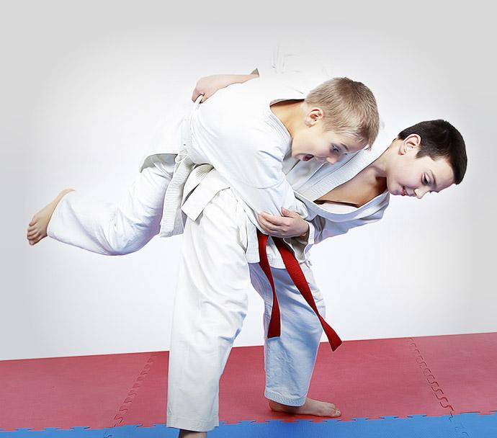](http://www.google.ca/url?sa=i&rct=j&q=&esrc=s&source=images&cd=&cad=rja&uact=8&ved=0ahUKEwiRotWpzrDPAhXn6oMKHUV_By8QjRwIBw&url=http://w2wma.com/&psig=AFQjCNGXzxWib9KM4xbR_T_R-HIuzMiB3Q&ust=1475102228924023)

**Yellow to Green Belt Tournament**

**&**

**Open Kata Demonstration**

Nov 2, 2024

Hosted by EYJS Member Clubs

Dow Centennial Centre

8700-84 Street  
Fort Saskatchewan

Subject to change based on facility availability/conflicting date

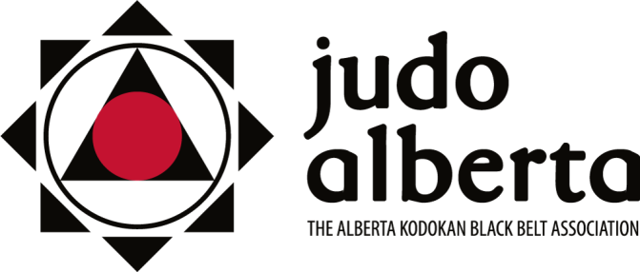

Judo Alberta Sanctioned

January 18, 2025 & Sanction #2025-2

**EYJS Monthly Tournament Package**

**Shiai**

**Who: Shiai:** 7 years to Adult - born 2018 or earlier (age as of December 31, 2025)

**Kata** – 13 years to Adult

**Where:** Dow Centennial Centre

8700-84 Street

Fort Saskatchewan, AB

**When:** February 8, 2025 all Subject to change based on facility availability/conflicting dates. Kata only on November 2, January 18 & February 8

**Time:** Tournament setup 10:30 am /competitor organization – all athletes must be checked in by 11:00 am. Shiai Competition starts at 11:30. Kata follows in the afternoon. Kata participants please check in by 2 pm with Gord Okamura

**Registration Link:** Registrations must be done at [https://registration.judocanada.org/event/2025-EYJSMonthlyFeb8](https://registration.judocanada.org/event/eyjs-monthly-tournament-kata-competition-february-8-2025/1001068/?admin=1)

**NO REGISTRATIONS WILL BE DONE AT THE TOURNAMENT.**

**Cost:** $10/participant (processing fee will be applied at check out).

$7/Kata participant (processing fee will be applied at check out)

**Purpose:** Developmental - to expose lower belt levels to a tournament environment. These tournaments are also training grounds for referees, timekeepers, draw keepers, set-up, etc. The kata demonstration is a developmental opportunity as well for competitors and judges.

**Tournament Directors:**

Mark Hicks/ Wesley Enns / Teresa Yamada

Gord Okamura – Kata Demonstration (gyokamura@gmail.com)

Mark Hicks (780) 782-3669

Email: mhicks@sherwoodford.ca

**Shiai**

**NOTE: All competitors must wear a white gi. White gi is required for first name called, blue judogi is optional for second name called. Females are required to wear a plain white t-shirt.**

**A pre-tournament training will be offered, this training is open to everyone and will run from 10:15 am to 11:00 am.**

**Divisions:** Determined by size and gender of the participants. However, two distinct groupings are defined, ‘‘under 16’’, and ‘‘16 and over’’ to ensure that physical variances evident with age are not present in the competitors and that competitors are of similar physical and mental development.

**Weigh Ins:** No weigh-ins required as athletes are reviewed on site, however athletes are required to provide their actual weight on the Trackie registration. If a weight discrepancy is suspected, the athlete’s weight will be checked by tournament organizers in judogi pants and t-shirt.

**Draws:** Format determined once athletes are grouped (at the discretion of the Tournament Director).

2 competitors – Best 2 out of 3

3-5 competitors – Round Robin

6 or more competitors – Double knock out.

IJF Rules apply. Judo Alberta & Judo Canada Tournament Sanction Policies will be in effect.

<https://judoalberta.com/wp-content/uploads/2013/04/2-05-Tournament-Sanction-Policy2.pdf>

<https://static.judocanada.org/wp-content/uploads/2024/05/Tournament-Sanctioning-Policy_EN_Sept_30_V3b.pdf>

**Kata**

This event is for demonstration purposes for kata competitors of any age (minimum yellow belt) and for judges. Each member of a kata team is to register on Trackie in the Kata category and indicate name of partner. Medals will not be awarded. After the presentations, the certified judges and experienced kata experts will offer feedback to the teams.  (**PLEASE NOTE THESE BELOW CATEGORIES & MINIMUM BELT REQIREMENTS ARE NOT FOLLOWED FOR THIS DEMONSTATION EVENT)**

We hope to see more and more kata participants practice kata, not only for black belt gradings but for competitions like 2025 Edmonton International, Provincials and Nationals (Calgary). The formal tournament categories are as follows:

|  |  |  |
| --- | --- | --- |
| **Age** | **Kata offered** | **Belt minimum** |
| U16 | Nage (3 or 5 set) / Katame / Ju no / Goshin | Orange |
| U23 | Nage/ Katame/ Ju no / Goshin/ Kime no kata | Green |
| Senior | Nage/ Katame/ Ju no / Goshin/ Kime no kata | Brown |

Category determined by oldest partner.

IJF Kata Competition rules apply. For further kata instructions, see the Judo Alberta website:

https://judoalberta.com/index.php/kata/