EDMONTON YUDANSHAKAI

JUDO SOCIETY

[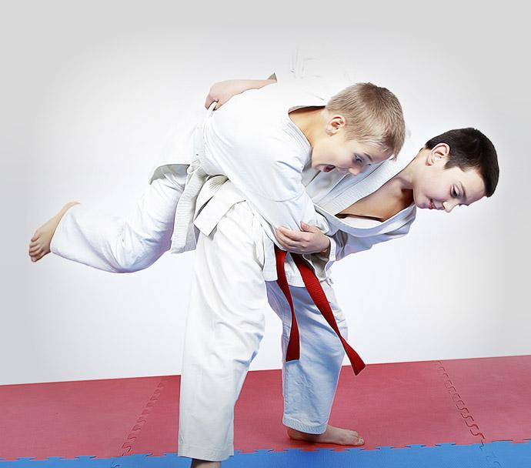](http://www.google.ca/url?sa=i&rct=j&q=&esrc=s&source=images&cd=&cad=rja&uact=8&ved=0ahUKEwiRotWpzrDPAhXn6oMKHUV_By8QjRwIBw&url=http://w2wma.com/&psig=AFQjCNGXzxWib9KM4xbR_T_R-HIuzMiB3Q&ust=1475102228924023)

**Yellow to Green Belt Tournament**

Hosted by EYJS Member Clubs

Dow Centennial Centre

8700-84 Street  
Fort Saskatchewan

Subject to change based on facility availability/conflicting date



Judo Alberta Sanctioned

November 30th,2024, Sanction #2024-12

**EYJS Monthly Tournament Package**

**Who: Shiai:** 7 years to Adult - born 2018 or earlier (age as of December 31, 2025)

**Where:** Dow Centennial Centre

8700-84 Street

Fort Saskatchewan, AB

**When:** November 30, 2024 all Subject to change based on facility availability/conflicting dates.

**Time:** Tournament setup 10:30 am /competitor organization – all athletes must be checked in by 11:00 am. Shiai Competition starts at 11:30. Kata follows in the afternoon. Kata competitors please check in by 2 pm with Gord Okamura

**Registration Link:** Registrations must be done at: [https://registration.judocanada.org/event/EYJSMonthlyNov30](https://registration.judocanada.org/event/eyjs-monthly-tournament-november-30-2024/1001069/?admin=1)

**NO REGISTRATIONS WILL BE DONE AT THE TOURNAMENT.**

**Cost:** $10/participant (processing fee will be applied at check out).

**Purpose:** Developmental - to expose lower belt levels to a tournament environment. These tournaments are also training grounds for referees, timekeepers, draw keepers, set-up, etc.

**Tournament Directors:**

Mark Hicks/ Wesley Enns / Teresa Yamad

Phone: (780) 782-3669

Email: mhicks@sherwoodford.ca

**Shiai**

**NOTE: All competitors must wear a white gi. White gi is required for first name called, blue judogi is optional for second name called. Females are required to wear a plain white t-shirt.**

**A pre-tournament training will be offered, this training is open to everyone and will run from 10:15am to 11:00 am.**

**Divisions:** Determined by size and gender of the participants. However, two distinct groupings are defined, ‘‘under 16’’, and ‘‘16 and over’’ to ensure that physical variances evident with age are not present in the competitors and that competitors are of similar physical and mental development.

**Weigh Ins:** No weigh-ins required as athletes are reviewed on site, however athletes are required to provide their actual weight on the Trackie registration. If a weight discrepancy is suspected, the athlete’s weight will be checked by tournament organizers in judogi pants and t-shirt.

**Draws:** Format determined once athletes are grouped (at the discretion of the Tournament Director).

2 competitors – Best 2 out of 3

3-5 competitors – Round Robin

6 or more competitors – Double knock out.

**For these tournaments to be successful all participating clubs will be required to provide volunteers: tournament set up & take down, scorekeeping, timekeeping, marshalling and referring**

IJF Rules apply. Judo Alberta & Judo Canada Tournament Sanction Policies will be in effect. <https://judoalberta.com/wp-content/uploads/2013/04/2-05-Tournament-Sanction-Policy2.pdf>

<https://static.judocanada.org/wp-content/uploads/2024/05/Tournament-Sanctioning-Policy_EN_Sept_30_V3b.pdf>