

**SSNS Northumberland Regional Cross Country Meet**

**Wednesday, October 16th, 2024**

**Host School:** Dr. John Hugh Gillis

**Parking:** Parking is available at the Antigonish Mall. Parking on Campus is by Parking Pass Only!

**Washrooms**: Bloomfield Centre, St.FX

**Start Line:** Centre of Grass Soccer Field

**Student Eligibility:** SSNS recognizes grade level (and NOT AGE) for each class Junior: Grade 7 and 8

Intermediate: Grade 9 and 10

Senior: Grade 11 and 12

Para: Grade 7 to 12

1. **km** ::: 1 x 3k loop
2. **km** ::: 2 x 2k loop

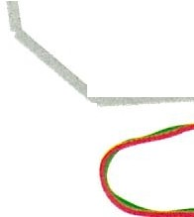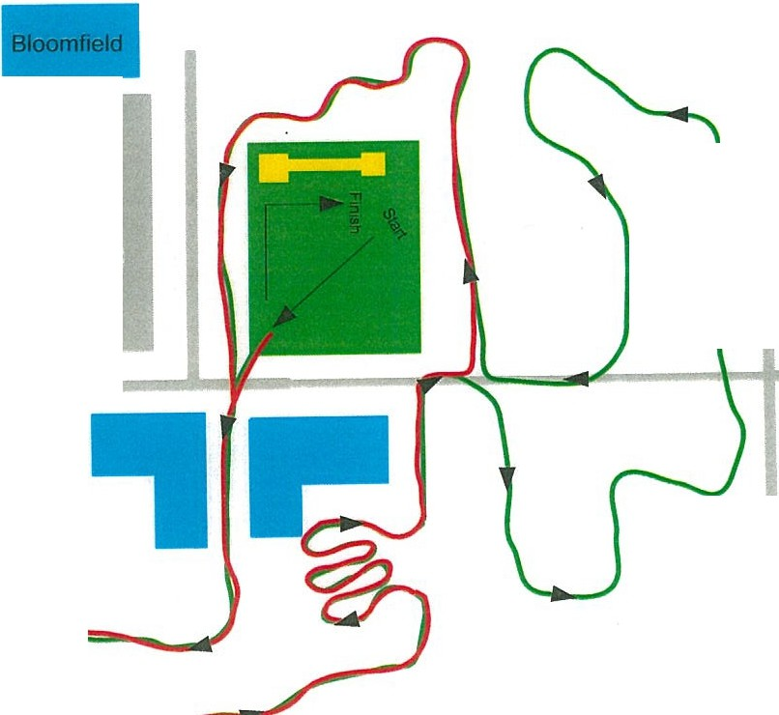

**5 km** ::: 1 x 3k loop + 1 x 2k loop

i

(')

*::T*

Cg.

I

**Parking**

**Mall** I

**TRACK**

■

()

*::T*

C

<;.

*<fl*

i

0*::T*

1il

!B

**StFX**

**Parking**

i

---.---==--TT\Tn1<4 **Trunlc4i---:::IIII .. _**