
SSNS Northumberland Regional Cross Country Meet

Wednesday, October 16th, 2024

Host School: Dr. John Hugh Gillis

Parking: Parking is available at the Antigonish Mall. Parking on Campus is by Parking Pass Only!

Washrooms: Bloomfield Centre, St.FX

Start Line: Centre of Grass Soccer Field

Student Eligibility: SSNS recognizes grade level (and NOT AGE) for each class Junior: Grade 7 and 8
Intermediate: Grade 9 and 10
Senior: Grade 11 and 12
Para: Grade 7 to 12

- km ::: 1 x 3k loop




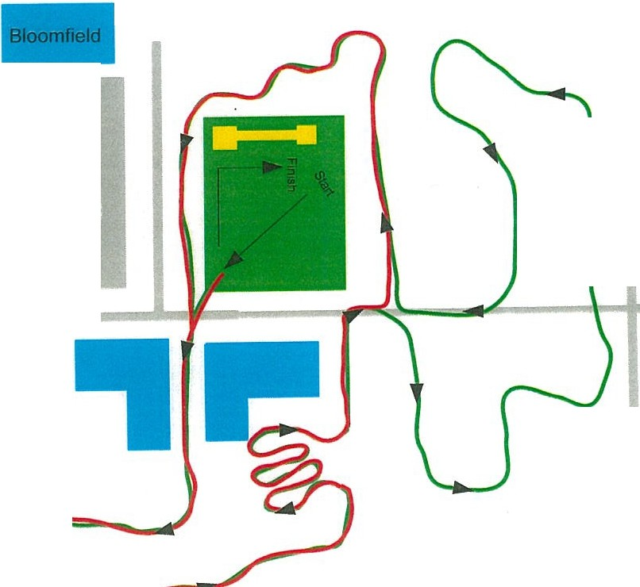
- km ::: 2 x 2k loop
5 km ::: 1 x 3k loop + 1 x 2k loop
i
(')
::T
Cg.
I
Parking
Mall I
TRACK
■
()
::T
C
<;.
<fl
i
0::T
1il
!B

StFX
Parking

i

---.---==--TT\Tn1<4 Trunlc4i---:::IIII .. _

