B

[www.sportnb.com/judonb](http://www.sport.nb.ca/judonb)

3rd

coupe “BUSHIDO” cup

clair, nb

**Date: Saturday, October 26th, 2024**

**Location: Centre d’Apprentissage du Haut Madawaska, 323 Boul. Long, Clair, NB**

**(Right at Home Hardware, first street on right Approx ¾ km)**

**Éligibilité: U8 (2018 and younger), U10 (2016-2017), U12 (2014-2015), U14 (2012-2013) and U16 (2010-2011). The format of the tournament is to promote judo for kids in a safe and fun environment and to do so, the competitors will be match with other competitors with the same belt division, same year of birth and weight class as much as possible. All competitors must be member of their provincial association.**

**Fees: $40.00 add $10.00 for a second category payable on Trackie when registering.**

**PRE-REGISTRATION AND PAYMENT MUST BE RECEIVED BY: by Oct. 20 2024** –

All competitors must register through Trackie. ***Online registrations will begin October 1st***

[***https://registration.judocanada.org/event/bushido-cup-2024/1000911/***](https://registration.judocanada.org/event/bushido-cup-2024/1000911/)

No registrations will be accepted after **midnight Oct. 20** as the draw sheets will be completed in advance of the tournament.

Fees are non-refundable.

**The competition will start at 10h00.**

**Tournament: Fights that involve a white belt and U8 – ne waza (ground)**

**Colored belts, U10, U12, U14 and U16 – tachi waza (standing)**

**Tachi waza : 3 min of timed fight with regular points system**

**- No grabbing around the neck or under the belt**

**- No drop on the knees and no sacrifice technique.**

**Ne waza (Modified rules): 2 min of actual fight**

* **Need 3 ippon (30 points) to win or most points after time is over.**
* **No grabbing the neck.**
* **Turn over are 5 point.**

**Host: Bushido Judo Club, Clair, NB**

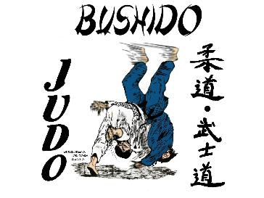

**Information: Daniel Ouellet, Tel : 506-992-9820** [**senseidanju@yahoo.fr**](mailto:senseidanju@yahoo.fr)

**Cell : 506-733-7481**

Accomodations:

**Comfort Inn Best Western Edmundston**

**5 Avenue Bateman 280 Boulevard Hébert**

**Edmundston Edmundston**

**739-8361 739-0000**

**www.edmundstoncomfort inn.com Indoor pool**

**Many thanks to our sponsor TUAC 501**