**2nd ANNUAL**

**KNIGHT TIME INVITATIONAL**

Friday, September 27th, 2024

North Grenville District High School – Intermediate Division

Dear coach,

Thank you for committing to our 2nd annual Knight Time invitational Cross Country meet. Our course is unique, challenging, and includes various types of terrain (small rolling grassland hills, asphalt, uneven terrain, a gravel path, and a covered 0.7km forest loop with a steep incline). This course, for Intermediate students, is cross country at its finest.

**ORDER OF RACES**

1:00 pm – Grade 7 girls – 3.2 km

1:25 pm – Grade 7 boys – 3.2 km

1:50 pm – Grade 8 girls – 3.2 km

2:15 pm – Grade 8 boys – 3.2 km

**AWARDS**

The top 3 runners in each event will receive a medal at the end of their race.

**ENTRIES**

Please use [www.trackie.com](http://www.trackie.com) to register your athletes. It will be live as of Friday, September 13th. There is no limit, however, athletes can only race in one event according to their grade. The entry deadline is *Tuesday, September 24th 2024 at 11:59pm.* Please direct any questions you may have to: christina.lobasso@ucdsb.on.ca or you can text me at (613) 866-7440.

**ENTRY FEE**

$5.00 per runner / late entries $10.00 per runner. If paying by cheque, please make it payable to: *North Grenville District High School*. A receipt will be issued to you on the day of the meet. A max of $200 per team – the equivalent to 40 athletes).

**RESULTS**

Full meet results (position only) will be e-mailed to coaches following the meet. We will **NOT** be timing the race. It will be a position-only race.

**ON THE DAY OF THE MEET**

* Entry fees must be paid at the Registration desk at the back of the track, beginning at 12 pm. At that time, you will receive your team package, including runner bibs, pins, the course map, and a garbage bag.
* All team tents are being asked to be set up **on the grass near the 300m mark on the track** (see attached drawing). Please ensure that athletes do not use the track to warm-up as it is being used as a portion of the race.
* A canteen will be made available for athletes and spectators. Items will range between $1 and $3.
* *Washrooms*: Athletes can access one area for washrooms inside the school (through our back doors), There will be signs. If an athlete NEEDS to use it, there will be signage and volunteer students to help guide them inside. **Please remind your athletes that the school day is still going on for our high school students in that hallway. They are to respect the noise level and not wander around the halls.**

**REMINDERS**

* Runners must wear their numbers on the **front** of their singlets/t-shirts. PLEASE REMND STUDENTS TO NOT PIN THE TEAR-OFF section, as we are using these for our results.
* Please use the garbage bag given to you in your team package to help keep our field clean. This is very much appreciated.
* Rain or shine, the meet will be a go. The only way the meet would be rescheduled is if lighting is a guarantee.

**THINGS TO CONSIDER**

* The 0.7 loop within the forest is relatively tight, fitting no more than 2 athletes side-by-side. Please ensure you mention to your runners to be cautious, as it’s a natural path with normal vegetation and branches. It has been groomed, but we are still reminding athletes to be aware of their surroundings. There will be student volunteers positioned within the forested area to guide runners. They will have bright vests on.
* Please ask your bus drivers to **drop off your team in the bus loop but they cannot stay parked there**. If they can then move their busses out of the loop until our dismissal of busses at 2;20pm, that would be appreciated. The parking lot will be somewhat packed with cars. Once busses have been cleared for dismissal, they can use the bus loop to wait for your team.
* Please ensure that each runner gets the bib that is assigned to them.
* The start of the race begins on the infield near the track finish line (it will be properly marked off). The end of the race is in the end zone on the grass closest to the school (tall flags will be very visible). Please ensure your runners do not run onto the infield.

**COURSE SATELITE MAP**

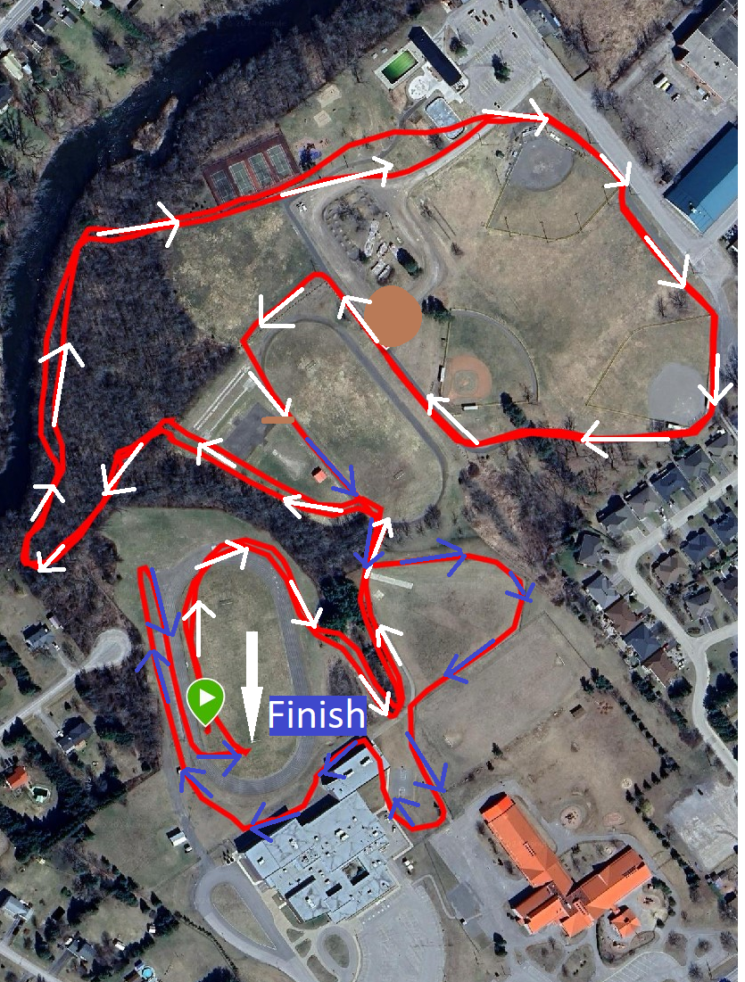

**MAP OF SCHOOL / FIELD**

