LONDON WESTERN TWILIGHT SERIES

MEET #2

PERFPORMANCE LISTS/HEAT SHEETS AND

LIVE RESULTS HERE!

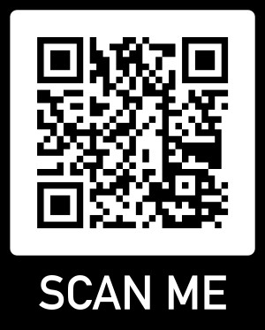

[mustangstiming.com/Results/LWT224/](http://mustangstiming.com/Results/PW22/)