
OTTAWA TWILIGHT #2

DATE: Wednesday, June 12th, 2024
LOCATION: Terry Fox Athletic Facility, 2960 Riverside Dr. Ottawa, ON K1V 8N4
SANCTIONED BY: World Athletics, World Para Athletics & Athletics Ontario
AGE CATEGORIES: OPEN
MEET ENTRY DEADLINE: Tuesday, June 11th 11:59pm
ENTRY PAGE: https://www.trackie.com/event/2024ottawatwilight2
FEES: Online - $25.00
IMPLEMENTS: Athletes are asked to bring their own. A limited number of implements may be available but requests must be made with plenty of time. Ottawa Lion members receive priority.
CHECK IN: Athletes are asked to marshal at the start line of their event no later than 10min prior to the start. Distance runners will be required to pick up a hip/chest number at the Ottawa Lions tent located under the timing tower.
PARKING: Limited parking will be available at the venue. Pay and display parking in the
Mooneys Bay lot will also be available. With the Mooneys Bay park attractions the lots will fill up quickly.
LIVE RESULTS: liveresults.ottawalions.com
SCHEDULE OF EVENTS: Will be run men before women (unless indicated otherwise). Seeded/fast sections will be run first. Events may be combined if entries are low.
Para: Ambulatory events are integrated and wheelchair events assigned dedicated hea

TRACK EVENTS:
5:45pm Youth 80m Dash
100m Heats
200mH
300mH
400mH
1500m
100m Final
300m
400m
Combined 5000m
4x100m Relay
FIELD EVENTS:
6:15pm Combined Pole Vault
Combined Hammer Throw
Womens Long Jump
7:15pm Combined Shot Put
7:30pm Mens Long Jump

FACILITY LAYOUT
STADIUM AREAS
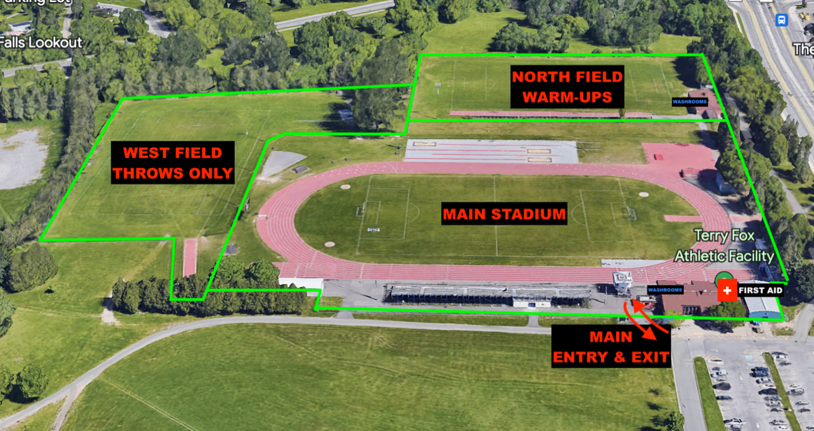

COMPETITION AREAS
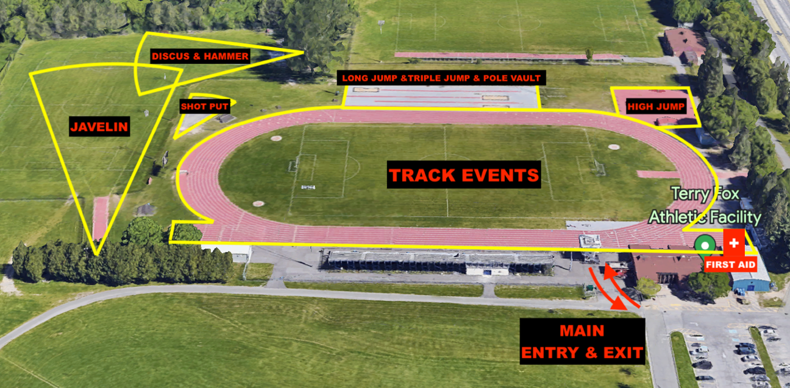

EMERGENCY ACTION PLAN:
There will be a First Aid Team located on site for the duration of the weekend. The First-Aid station will be located just east of the grandstands. This team is not responsible for RMT or PT but a first response in case of injury or need to call EMS.

A defibrillator is in the main building of the Terry Fox Athletic Facility.

If EMS is required at the Terry Fox Athletic Facility, the address is 2960 Riverside Dr. Ottawa Ontario K1V 8N4 (Inside Mooneys Bay Park). The best point of access is from the intersection of Riverside Dr. and Ridgewood Avenue, they should take an immediate right once inside Mooneys Bay Park. An alternative point of entry would be arriving from Hogs Back Rd, turning into the Mooneys Bay Boat launch entrance, and pulling up to the West Field.

Under a severe weather warning or arrival of a thunder/lightning storm there are very few locations for shelter. While there are a few change rooms and locations for shelter, they will be limited in space as a 2m physical distancing rule will apply while indoors (along with wearing masks). We ask that athletes, officials and volunteers who drive to the venue take shelter in their respective vehicles until the storm subsides. Please do not welcome others you did not travel with into your vehicle.

Special recognition to Athletics Ontario, Athletics Canada and the Ontario Cerebral Palsy Sports Association for their support of Athletics in Canada Day – Ottawa, a project made possible in part by the Government of Canada.



