GRIT Athletics Track and Field
Friday Night Flights- Meet #1
Friday June 14th
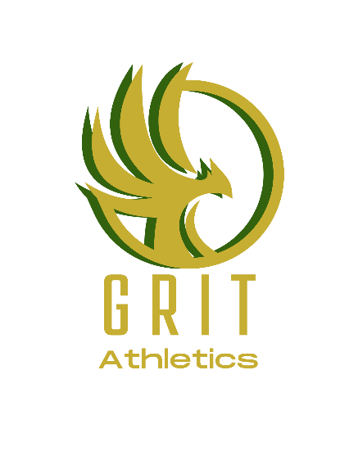
Event Site: Beazley Field, Dartmouth, NS
- Eight lane track on the oval with a polyurethane surface.
- Maximum spike length is 7mm
- Gender neutral washrooms on-site.

Categories:
All age categories will be offered.

Events:
Triple jump and long jump.

Registration:
Please visit Trackie to register. Registration deadline is Thursday, June 13, 2024, at 8:00pm.

Schedule:
Men and Women’s triple jump- 6:00pm
Men and Women’s long jump- 7:00pm

Registration:
Entries must be received by 7:59p.m. Thursday, June 13th, 2024
One event: $15
Two Events: $25 total for both
Entry fees must be paid before an athlete can compete in the meet.

Come fly with us!!!



