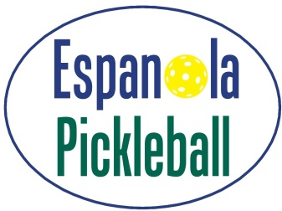
Adopted July 8, 2022
Code of Conduct
The Espanola Pickleball Club (the “Club”) is dedicated to promoting the growth of the sport of Pickleball in Espanola, Ontario and the surrounding area through education, training, social events, and other amateur sports competitions.
The Club will conduct itself with integrity, honesty, and respect for others. The Club strives to help make pickleball in Espanola an experience that is friendly, safe, and fun, while still encouraging competitive play. We want to promote an atmosphere where all players are treated equally, sportsmanship is more important than winning, competition is strong, but not relentless and where mutual respect is more important than the game.
Given the above, the following outlines the conduct required of its members.
- I will not engage in unsportsmanlike conduct or encourage others to do so.
- I will not engage in any behaviour that would endanger the health, safety, or wellbeing of others.
- I will not engage in the use of obscene language or gestures.
- I will treat others with respect.
- I will exhibit fairness and honesty in my dealings with others.
- I will support the Club policies, procedures, plans and initiatives.
- I will accept responsibility for my own actions.
- I will exemplify the highest standard in ethical behaviour and fair play.
- I will engage in conduct that is free from fear, discrimination, abuse, and harassment.

