Dear Coach, March 8, 2023

We are writing to invite your school to participate in the 23rd Annual Pirate Relays
on Friday, April 19, 2024.

If your school wishes to enter the 23nd Annual Pirate Relays, please send a confirmation email with form to randy.givogue@ucdsb.on.ca. Only the first 15 teams to send their confirmation of entry by email will be accepted. Confirmed schools will be notified by email. The schedule of events will be sent out as soon as the schedule is finalized based on field conditions.
Entry Fee
The entry for each school is $8.00 per relay and $6.00 per individual event up to a maximum of $300.00 which is payable to “Thousand Islands SS”. ALL ENTRIES WILL BE DONE ON TRACKIE.COM - go to Trackie.com and enter Pirate Relays under FIND AN EVENT.

Entries for the meet are due by Tuesday, April 16 at 5:00 pm. Late entries will not be accepted.

Ribbons to the top 3 teams in ALL relays. Field event athletes, Steeplechase, and Hurdles will receive individual awards for top 3. **FIELD EVENTS WILL BE ALL RUN BASED ON FIELD CONDITIONS. Some events may be cancelled if fields not suitable for competition.

Please keep in mind that our track requires ¼ inch pyramid spikes for all events.
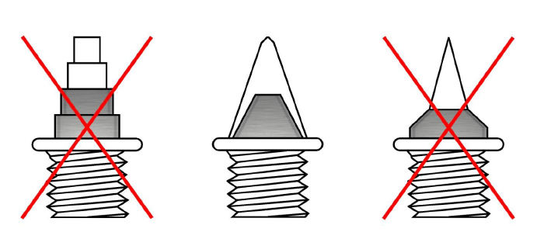

We are looking forward to hearing from you.

Sincerely,

TISS TF Coaches

23rd Annual Pirate Relays

Pirate Relays 2024
Confirmation of Entry

School Name- ___________________________________________________________

School Address- __________________________________________________________
__________________________ Postal Code -____________________
School Phone - (_____) _______-__________ School Fax - (_____) _______-___________

Coaches Names Home Phone e-mail address
__________________________ (____) _____-________ ____________________________
__________________________ (____) _____-________ ___________________________

Approx. No. of Athletes
Girls- ______ Boys - ____

All schools attending must be willing to provide at least ONE ADULT OFFICIAL (if requested). TISS will do their best to fill as many events as possible. If there is an event your school would like to run- please email us. If not- can you please type in what would be the 2 events that you would be most comfortable with as an official if needed.

Event #1- ___________________________________
Event #2-___________________________________

Email this form. We will accept the first 15 schools that send payment/confirm.

Email to: randy.givogue@ucdsb.on.ca

23rd Annual TISS PIRATES RELAYS
Friday, April 19th, 2024

Order of Track Events

11:20 am Steeplechase (OB followed by OG)

11:50 am Sprint Hurdles (TIMED SECTIONS)
MG 80m., JG 80m., SG 100m., MB 100m., JB 110m., SB 110m.

12:50 pm Co-ed 800-400-400-800 Metre Relay (Novice, Junior & Senior) (2B, 2G or 1B, 3G, or 4G)

1:30 pm Sprint Medley Relay (400m.- 200m. - 200m. - 800m.) ( TIMED SECTIONS )
MG, JG, SG, MB, JB, SB

2:10 pm Co-ed 4 x 200m. Relay (2 boys, 2 girls)
Mid., Jun., Sen.

2:40 pm Co-ed Open Distance Medley (1200, 400, 800, 1600) *coaches eligible (2B, 2G)

3:00 pm 4 x 100m Relays (TIMED SECTIONS)
MG, JG, SG, MB, JB, SB

4:00 pm 4 x 400m. Relay (TIMED SECTIONS)
Open Girls, Open Boys

Order of Field Events (*Only 1 of LJ or TJ may be offered due to loss of Runway)

Time | High Jump | Pole Vault | Long Jump* | Triple Jump* | Shot Put | Javelin
12:00 noon | M,J,S Girls | All Vaulters  start at 1.75 | M,J,S Girls |  | MG/MB | SG/SB
1:00 pm | M,J,S Boys |  | M,J,S Boys |  | SG/SB | JG/JB
2:00 pm |  |  |  | M,J,S Girls | JG/JB | MG/MB
3:00 pm |  |  |  | M,J,S Boys | 3:00 pm

* In all throws events boys will follow girls.

