Date: Saturday January 6th, 2024

Location: Bruce Kidd Field House,
University of Toronto Athletic Centre
55 Harbord Street, Toronto M5S 2W6

Start Time: Saturday 8:00 am
Sanctioned by: Ontario University Association (OUA) World Athletics sanctioned
Hosted By: Faculty of Kinesiology & Physical Education
University of Toronto

Meet Director: Jill Mallon jill.mallon@utoronto.ca

Eligibility: University, College, and AO athletes

Entries: Must be submitted on-line by Thursday Jan 4th, 2024 (noon)

http://www.trackie.com/online-registration/
Facility: 200m flat Mondo - rubber 5-lane track with 8 sprint lanes. All runways Mondo - rubber; shot put circle concrete.
Spikes: MAXIMUM 6mm.
Timing: Fully electric timing.
Changing facility: Locker rooms are available for men and women. Please bring your own locks and towels.
Entry Fee: $25.00 per athlete per event
Cost limit $500 per team
Late Entry: Late entries will be accepted at $50.00 per athletes per events.
Entries will not be accepted after 6:00PM the night before the meet.
SCRATCHES: Please make all scratches online or upon arrival to the Field House registration desk (top of the stairs).

SPIKES

- All spikes must be presented to be checked at the spike check in table (where you receive your hip numbers)
- Athletes will not be allowed to compete without having their spikes
checked and cleared .
- Acceptable spikes: 6mm pyramids / cones – same size
- Any athletes competing with longer than 7mm spikes will be disqualified.
- Water is the only permitted drink allowed on the track facility.

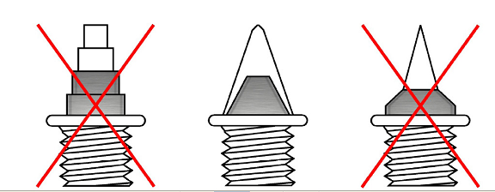

How to get the University of Toronto Athletic Centre: - 55 Harbord St. Toronto, Ontario, Canada, M5S 2W6

The Athletic Centre is located on the west side of U of T’s St. George campus at the intersection of Harbord St. and
Spadina Ave. It is easily accessible from the Spadina subway station and by streetcar.

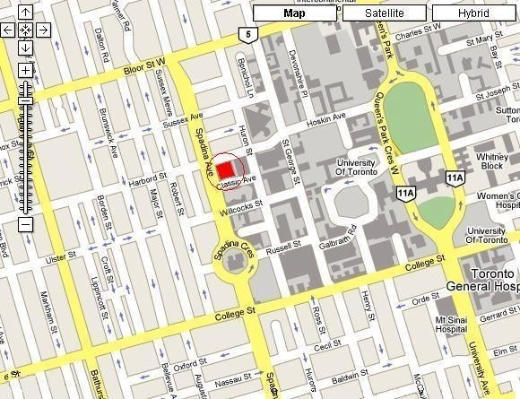

From theGardinerExpressway:
Gardiner Expressway to Spadina Ave. Turn left (go north) on Spadina Ave. Turn Right onto Harbord St and enter through first set of doors.

From 401 (East of DVP): 401 West to Don Valley Pkwy. Don Valley Pkwy South to Bloor St. West on Bloor St. to
Spadina Ave.. Turn Left onto Spadina Ave. Turn Left on Harbord St and enter through first set of doors.

From 401 (West of Allen Road): 401 East to Allen Road. Allen Road South to end (Eglinton). Turn left (go east) onto Eglinton. Turn right (go south) onto Bathurst St. Turn left (go east) onto Harbord St. Enter through first set of doors.

Athletic Centre Entry:
For the safety and security of everyone, all students and members must enter and exit the Athletic Centre through the main entrances only* (on Harbord St. and Classic Ave.)

