CWOSSA Cross Country Championship
Thursday, October 26, 2023
Greens at Renton Golf Course
Hosted by AABHN
(Last Updated October 10, 2023)
Convenor: Aimee Ernst, Paris District High School
E-mail: aimee.ernst@granderie.ca
Location: Greens at Renton Golf Course 969 Concession 14 Townsend, Simcoe, Ontario N3Y 4K3
It is very exciting to be holding a cross country championship! This is a cross country course that includes smooth golf course terrain and rolling hills with limited elevation changes. The terrain includes grass sections and some trail running on gravel pathways with a small amount of pavement where runners may cross golf cart paths. Please prepare your athletes accordingly.
The Greens at Renton has exceptional dining and they have agreed to leave open their clubhouse restaurant as well as their Oasis which will have BBQ hotdogs, hamburgers, etc. available. Athletes and spectators are welcome to bring their own food to the course, however the management has asked that this be consumed in the tent area and not in their dining room and that all garbage be cleaned up prior to your departure. Thanks for respecting their wishes.
ENTRY FEE: $12 per athlete. Payment may be made on Trackie after completing the online registration by credit card or a cheque may be mailed to Paris District High School. The school address is 231 Grand River St. N., Paris ON N3L 2N6. Please ensure that your cheques are mailed in time to arrive by October 23 so that there is time to generate receipts. Alternatively, you may bring your school cheque with you to the meet and a receipt will also be provided on site. However, schools who do not pay for their athlete’s entry fees on or before race day will not be permitted to race. Thanks for your understanding.
REGISTRATION: The link to the registration on Trackie for all athletes is https://www.trackie.com/event/cwossa-xc-2023/1001015
REGISTRATION DEADLINE: Tuesday, October 24th by 8pm

CWOSSA – Forms click here forms due 24 hours prior to competitions
Make sure that all OFSAA Hub forms have been completed and sent to aimee.ernst@granderie.ca a minimum of 24 hours prior to the CWOSSA championship.
MERCHANDISE: The CWOSSA online store is available for pre-sales!!!! Order your CWOSSA t-shirts ($20), long sleeve t-shirts ($25) and hoodies ($40) and pick up your order at the meet. There will be some merchandise for sale on site the day of the meet as well but ordering early guarantees your selection and size. Here is the link to the online store:
https://cwossacrosscountry2023.itemorder.com/

Start lines: Mass start, though a box start is likely, where each team has one place on the start line. Runners would line up with the fastest runner at the front of the start line and their teammates behind them. Coaches will be notified of the type of start prior to the meet.
Order of Events:
9:00 am – Course opens
10:00 am – Coaches meeting
10:30 am – Novice Girls – 4000m
11:00 am – Novice Boys – 4000m
11:30 am – Para Race – 4000m
12:15 pm – Junior Girls – 5000m
1:00 pm – Junior Boys – 5000m
1:40 pm – Senior Girls – 6000m
2:30 pm – Senior Boys – 6000m
3:30 pm – Awards and clean up
Course Map– In order to fit the required distances onto the areas of the course we were permitted to use, there are three different course sections. The 1km loop is indicated in orange, the 2 km loop is indicated in white, and the 4km section is indicated in pink. Novices and Para athletes will only run the 4km pink section. Juniors will run the 1km loop followed by the 4km section. Seniors will run the 2km white section followed by the 4km pink section. See the attached map.
CWOSSA routes + other information - https://www.google.com/maps/d/u/0/edit?mid=1hN90AV2kEdbvlbf0M3OV2Ws1lEN-Q-k&usp=sharing

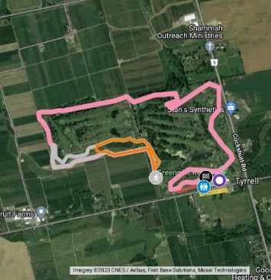 | CWOSSA 2023 at the Greens at Renton - Google My Maps  Race Routes: - 4K: pink - 5K: 1k orange loop + 4k pink - 6K: 2k white loop + 4k pink  www.google.com
Overflow Parking for Buses-There is not a lot of parking at the Greens at Renton for buses. We encourage you to have your drivers drop you off at the course and then proceed to the overflow parking in the old Zellers parking lot in Simcoe across from the Walmart.
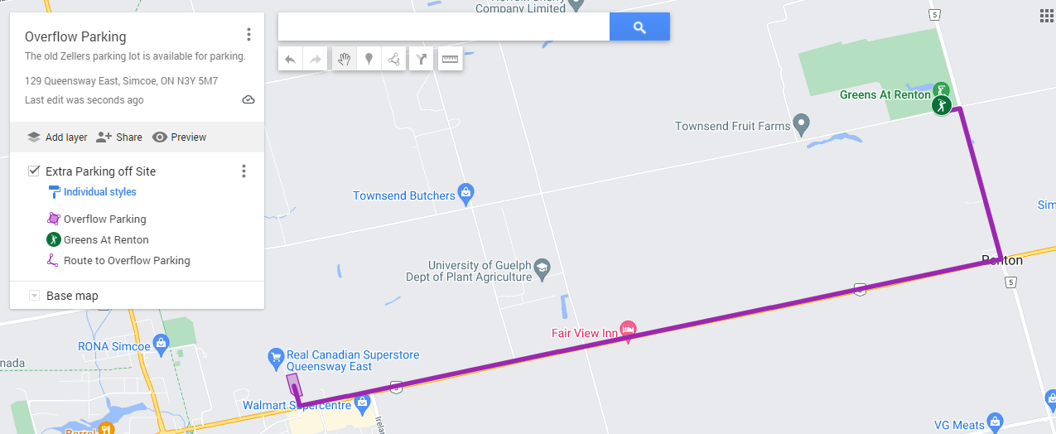

Live google map -> https://www.google.com/maps/d/u/0/edit?mid=164GlHxNRZZUGPWMhv9JQwuJUvpQ1vn0&usp=sharing
Tent City- IMPORTANT-If there is frost on the ground, schools are asked to wait until after 9am to set up tents or place any blankets, etc. on to the ground as it will damage the grass on the fairway!! Each school will have their own area to put up their tent and will be asked that athletes not visit in other school’s areas. It is the responsibility of each school to use the garbage bag provided at registration to clean up all messes.
Spectators are encouraged to attend the championship. If they do attend the spectators should remain off the greens and maintain the OFSAA spectator code of conduct. Spectators are not allowed near the athletes’/school’s tent city. Be aware that the golf course will have 9 holes open for their golfing community, so please stay to the areas shown on the course map.
Results: Speed River Timing https://www.speedrivertiming.com/
Awards: Ribbons will be given to the top 6 in each age category and top three teams. If your school has one of the team plaques, please bring it with you to the championship and turn it into the registration table. Thank you.
OFSAA Qualifiers: The top 5 athletes from each division and the top two teams from each division will advance to the OFSAA championships.
OFSAA Championship -Saturday, Nov 4th, 2023, at Centennial Park 256 Centennial Park Rd, Etobicoke, ON M9C 5N3
***IMPORTANT*** Coaches of OFSAA qualifying individuals and teams must confirm with the OFSAA registration desk prior to leaving the CWOSSA championship and pay for their athletes.
NEW THIS YEAR- ALL OFSAA SUPERVISION FORMS MUST BE TURNED INTO THE CWOSSA CONVENOR SO THAT THEY CAN BE COURIERED TO THE OFSAA CO-CONVENORS IMMEDIATELY AFTER THE CWOSSA MEET! I would upload these to the HUB as well if you are able in advance of the meet just as an extra precaution. Supervision forms will be required in order to pick up any of your OFSAA packages, so please DO NOT FORGET! You will be responsible to courier it yourself if you do.
All OFSAA XC Championship registration paperwork is to be signed and uploaded by individual teams to the OFSAA HUB no later than Tuesday, October 31 @ midnight.” Follow the link to get all the forms off the OFSAA page. https://www.ofsaa.on.ca/championship/cross-country-running/for-coaches/
Fees for OFSAA: $20 per athlete ($15 entry fee and $5 OFSAA participant fee).
Please pay by cash or cheque at the registration table prior to leaving the CWOSSA event. Make all cheques payable to Paris District High School.
NOTE: for coaches of Para athletes, you must indicate the classification when registering your athlete at the OFSAA registration desk at the CWOSSA championship.
OFSAA Para athlete registration form OFSAA-Para-XC-Registration-Form-4-1
OPHEA safety guidelines, OFSAA, Athletics Ontario and Ontario guidelines have been read and will be followed throughout the championship.

