B

[www.sportnb.com/judonb](http://www.sport.nb.ca/judonb)

2nd

coupe “BUSHIDO” cup

clair, nb

**Date: Saturday, October 28th, 2023**

**Location: Centre d’Apprentissage du Haut Madawaska, 323 Boul. Long, Clair, NB**

**(Right at Home Hardware, first street on right Approx ¾ km)**

**Éligibilité: U6, U8, U10, U12, U14 and U16. The format of the tournament is to promote judo for kids in a safe and fun environment and to do so, the competitors will be match with other competitors with the same belt division, same year of birth and weight class as much as possible. All competitors must be member of their provincial association. The age on the day of the tournament will be used.**

**REGISTRATIONS are with Trackie. Limit to register is October 26th at midnight.**

**The competition will start at 11h00.**

**Registration fee: $ 30 will be collected before 10h00 the morning of the tournament. $10 extra to fight in two divisions.**

**Tournament: Fights that involve a white belt and U6 and U8 – ne waza (ground)**

**Colored belts, U10, U12, U14 and U16 – tachi waza (standing)**

**Tachi waza : 3 min of timed fight with regular points system**

**- No grabbing around the neck or under the belt**

**- No drop on the knees and no sacrifice technique.**

**Ne waza (Modified rules): 2 min of actual fight**

* **Need 3 ippon (30 points) to win or most points after time is over.**
* **No grabbing the neck.**
* **Turn over are 5 point.**

**Host: Bushido Judo Club, Clair, NB**

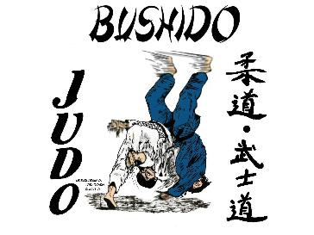

**Information: Daniel Ouellet, Tel : 506-992-9820** [**senseidanju@yahoo.fr**](mailto:senseidanju@yahoo.fr)

**Cell : 506-733-7481**

Accomodations:

**Newly Renovated Comfort Inn Best Western Edmundston**

**5 Avenue Bateman 280 Boulevard Hébert**

**Edmundston Edmundston**

**739-8361 739-0000**

**www.edmundstoncomfort inn.com Indoor pool**

**Many thanks to our sponsor TUAC**