

2023/2024 FALL & WINTER TRAINING & FEE SCHEDULE
- SENIOR POWER/SPEED & MIDDLE DISTANCE –

Registration for this season will be online at: www.trackiereg.com/OACS-Fall-Winter2024
Registration opens: Friday, September 1st, 2023

Our Full Power/Speed Track & Field Program will begin on Monday, September 18th, and run until Wednesday, March 6th (Middle Distance begins in January).

-Training Locations-
All Fall Track & Field practices are held at the Apple Bowl (September 18th – October 30th)
All Winter Track & Field practices are held at the Capital News Centre (November 1st – March 6th)
Please note that if the weather is mild, we may remain at the Apple Bowl into November and delay moving indoors to the CNC.
Supplemental Training begins Thursday, September 28th.

-Training Days & Times-
Group | Monday | Wednesday | Thursday | Saturday
Power/Speed | 5:30 – 7:30pm | 5:30-7:30pm | - | 10:00am -12:00pm
Supplemental Training | - | - | 5:30 – 7:00pm | -
Middle Distance | 5:30 – 7:00pm | 5:30 – 7:00pm | N/A | *10:00-11:30  (Depending on coach availability)  *Emailed workout will be provided if a coach is not available

-Season Dates-
Full Power/Speed Track & Field Program (Fall & Winter): Monday, September 18th - Wednesday, March 6th
Supplemental Training: Thursday, September 28th – Thursday, March 7th
Full Middle Distance Track & Field Program (Winter): Monday, January 8th - Wednesday, March 6th

There are no practices on the following days:
Monday, October 9th - Thanksgiving
Monday, November 13th – Remembrance Day
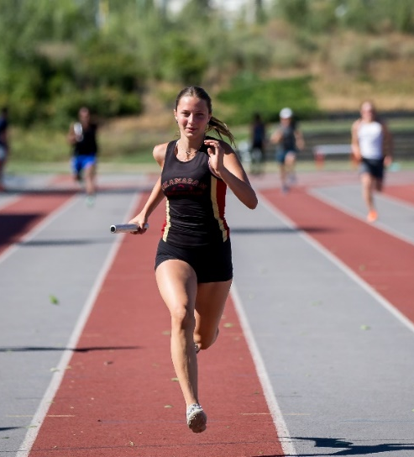
Last Practice before Winter Break - Wednesday, December 20th First Practice after Winter Break - Wednesday, January 10th
Monday, February 19th - Family Day

-Track Meets-
OAC Fall Twilight Meet – Thursday, October 12th, 2023
Gary Reed Indoor Classic – February 2024 – Kamloops (exact dates TBC)
Van Ryswyk Indoor meet – February 2024 – Kamloops (exact dates TBC)

Entry fees for competitions are additional to the program fees listed below. Athletes are responsible for their own travel expenses to competitions and accommodation costs as applicable. Registration information for competitions will be sent via email by the club manager 1-2 weeks before the registration deadline.

Program Fees: Power/Speed Athletes | FALL ONLY | Sept 18th – Oct 30th (6 weeks)
Age on Dec 31st, 2024 | Group | *BCA Fee  Fees will increase Oct 1st 2023 | Training Fee | Raffle Tickets | Total Fees
13  (2011) | JD Athletes training with the Senior Power/Speed Group  (by invitation only) | $60.00  Competitive | $285.00 | $50.00 | $395.00
13  (2011) |  | $15.75  Training only | $285.00 | $50.00 | $350.75
14  (2010) | U16 | $70.00  Competitive | $285.00 | $50.00 | $405.00
14  (2010) | U16 | $15.75  Training only | $285.00 | $50.00 | $350.75
15  (2009)  18-22  (2004-2002) | U16  *Post Secondary  (Proof of registration at a recognized post-secondary institution required) | $73.50  Competitive | $285.00 | $50.00 | $408.50
15  (2009)  18-22  (2004-2002) |  | $15.75  Training only | $285.00 | $50.00 | $350.75
16+  (2008-1990) | U18/U20/Senior | $94.50  Competitive | $285.00 | $50.00 | $429.50
16+  (2008-1990) | U18/U20/Senior | $15.75  Training only | $285.00 | $50.00 | $350.75
35+  (1989-) | Master | $63.00  Competitive | $285.00 | $50.00 | $348.00
35+  (1989-) | Master | $15.75  Training only | $285.00 | $50.00 | $350.75
Supplemental Training |  |  |  |  | $75.00

Program Fees: Power/Speed Athletes | FULL | Sept 18th – Mar 6th (21 weeks)
Age on Dec 31st, 2024 | Group | BCA Fee  Fees will increase Oct 1st 2023 | Training Fee | Raffle Tickets | Total Fees
13  (2010) | JD Athletes training with the Senior Power/Speed Group  (by invitation only) | $60.00  Competitive | $625.00 | $150.00 | $835.00
13  (2010) |  | $15.75  Training only | $625.00 | $150.00 | $790.75
14  (2009) | U16 | $70.00  Competitive | $625.00 | $150.00 | $845.00
14  (2009) | U16 | $15.75  Training only | $625.00 | $150.00 | $790.75
15  (2008)  18-22  (2005 – 2001) | U16  *Post-Secondary  (Proof of registration at a recognized post-secondary institution required) | $73.50  Competitive | $625.00 | $150.00 | $848.50
15  (2008)  18-22  (2005 – 2001) |  | $15.75  Training only | $625.00 | $150.00 | $790.75
16/17 (2007/2006)  18/19  (2005/2004)  20-34  (2003 – 1989) | U18  U20  Senior | $94.50  Competitive | $625.00 | $150.00 | $869.50
16/17 (2007/2006)  18/19  (2005/2004)  20-34  (2003 – 1989) | U18  U20  Senior | $15.75  Training only | $625.00 | $150.00 | $790.75
35+  (1988 - ) | Masters | $63.00  Competitive | $625.00 | $150.00 | $838.00
35+  (1988 - ) | Masters | $15.75  Training only | $625.00 | $150.00 | $790.75
Supplemental Training |  |  |  |  | $215.00

**Program Fees: Power/Speed | PARTIAL SEASON | Nov 1st – Mar 6th (15 weeks)
Age on Dec 31st, 2024 | Group | BCA fee  Fees will increase Oct 1st 2023 | Training Fee | Raffle Tickets | Total Fees
13  (2010) | JD Athletes training with the Senior Power/Speed Group  (by invitation only) | $60.00  Competitive | $485.00 | $100.00 | $645.00
13  (2010) |  | $15.75  Training only | $485.00 | $100.00 | $600.75
14  (2009) | U16 | $70.00  Competitive | $485.00 | $100.00 | $655.00
14  (2009) | U16 | $15.75  Training only | $485.00 | $100.00 | $600.75
15  (2008)  18-22  (2005 – 2001) | U16  Post-Secondary  (Proof of registration at a recognized post-secondary institution required) | $73.50  Competitive | $485.00 | $100.00 | $658.50
15  (2008)  18-22  (2005 – 2001) |  | $15.75  Training only | $485.00 | $100.00 | $600.75
16/17 (2007/2006)  18/19  (2005/2004)  20-34  (2003 – 1989) | U18  U20  Senior | $94.50  Competitive | $485.00 | $100.00 | $679.50
16/17 (2007/2006)  18/19  (2005/2004)  20-34  (2003 – 1989) | U18  U20  Senior | $15.75  Training only | $485.00 | $100.00 | $600.75
35+ (1988 - ) | Masters | $63.00  Competitive | $485.00 | $100.00 | $648.00
35+ (1988 - ) | Masters | $15.75  Training only | $485.00 | $100.00 | $600.75
Supplemental Training |  |  |  |  | $175.00
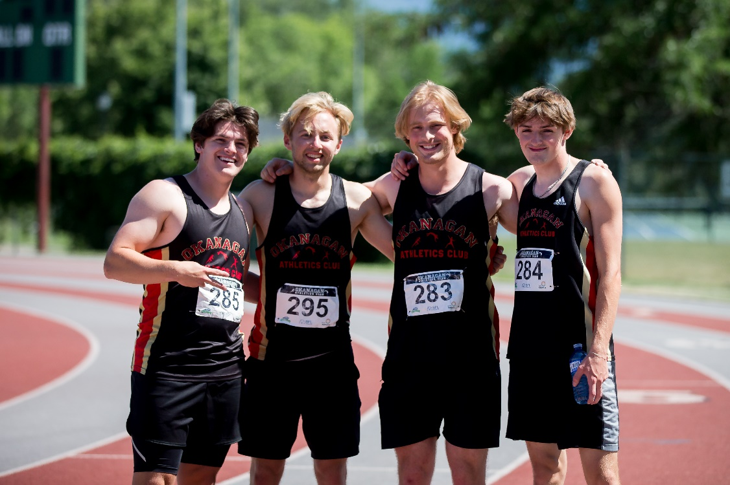

**Program Fees: Power/Speed | PARTIAL SEASON | Jan 10th – Mar 6th (8 weeks)
Age on Dec 31st, 2024 | Group | BCA fee  Fees will increase Oct 1st 2023 | Training Fee | Raffle Tickets | Total Fees
13  (2010) | JD Athletes training with the Senior Power/Speed Group  (by invitation only) | $60.00  Competitive | $295.00 | $50.00 | $405.00
13  (2010) |  | $15.75  Training only | $295.00 | $50.00 | $360.75
14  (2009) | U16 | $70.00  Competitive | $295.00 | $50.00 | $415.00
14  (2009) | U16 | $15.75  Training only | $295.00 | $50.00 | $360.75
15  (2008)  18-22  (2005 – 2001) | U16  Post-Secondary  (Proof of registration at a recognized post-secondary institution required) | $73.50  Competitive | $295.00 | $50.00 | $418.50
15  (2008)  18-22  (2005 – 2001) |  | $15.75  Training only | $295.00 | $50.00 | $360.75
16/17 (2007/2006)  18/19  (2005/2004)  20-34  (2003 – 1989) | U18  U20  Senior | $94.50  Competitive | $295.00 | $50.00 | $439.50
16/17 (2007/2006)  18/19  (2005/2004)  20-34  (2003 – 1989) | U18  U20  Senior | $15.75  Training only | $295.00 | $50.00 | $360.75
35+  (1988 - ) | Masters | $63.00  Competitive | $295.00 | $50.00 | $408.00
35+  (1988 - ) | Masters | $15.75  Training only | $295.00 | $50.00 | $360.75
Supplemental Training |  |  |  |  | $75.00
** As spaces for the indoor programs are limited, partial season registration will not be open until October 15th, once we have confirmed numbers for the Full Season Program, (September to March).
Senior athletes who wish to participate in both Cross Country & Track & Field Programs will join the Track & Field Program on Monday, October 30th. They cannot participate in both programs simultaneously. Athletes who wish to do both programs should contact Karen: manager@okac.ca

Program Fees – Middle Distance Program | FULL| Jan 10th – Mar 6th )
Age on Dec 31st, 2024 | Group | BCA fee  Fees will increase Oct 1st 2023 | Training Fee | Raffle Tickets | Total Fees
13  (2010) | JD Athletes training with the Senior middle distance Group  (by invitation only) | $60.00  Competitive | $285.00 | $50.00 | $395.00
13  (2010) |  | $15.75  Training only | $285.00 | $50.00 | $350.75
14  (2009) | U16 | $70.00  Competitive | $285.00 | $50.00 | $405.00
14  (2009) | U16 | $15.75  Training only | $285.00 | $50.00 | $350.75
15  (2008)  18-22  (2005 – 2001) | U16  Post-Secondary  (Proof of registration at a recognized post-secondary institution required) | $73.50  Competitive | $285.00 | $50.00 | $408.50
15  (2008)  18-22  (2005 – 2001) |  | $15.75  Training only | $285.00 | $50.00 | $350.75
16/17 (2007/2006)  18/19  (2005/2004)  20-34  (2003 – 1989) | U18  U20  Senior | $94.50  Competitive | $285.00 | $50.00 | $429.50
16/17 (2007/2006)  18/19  (2005/2004)  20-34  (2003 – 1989) | U18  U20  Senior | $15.75  Training only | $285.00 | $50.00 | $350.75
35+  (1988 - ) | Masters | $63.00  Competitive | $285.00 | $50.00 | $398.00
35+  (1988 - ) | Masters | $15.75  Training only | $285.00 | $50.00 | $350.75

-Methods of Payment-
1. Online at trackiereg.com with a credit card (there is a small processing fee for payment by this method)
2. By e-transfer to Brad Heinzman at president@okac.ca
3. By monthly installment (6 equal payments; September – February inclusive) via e-transfer to Brad (see #2) The first e-transfer must be received on or before the first practice of the program or by 6 postdated cheques which must be handed in at the first practice.

*** NEW*** For those who choose to pay in installments, a payment agreement must be signed on or before the first practice.

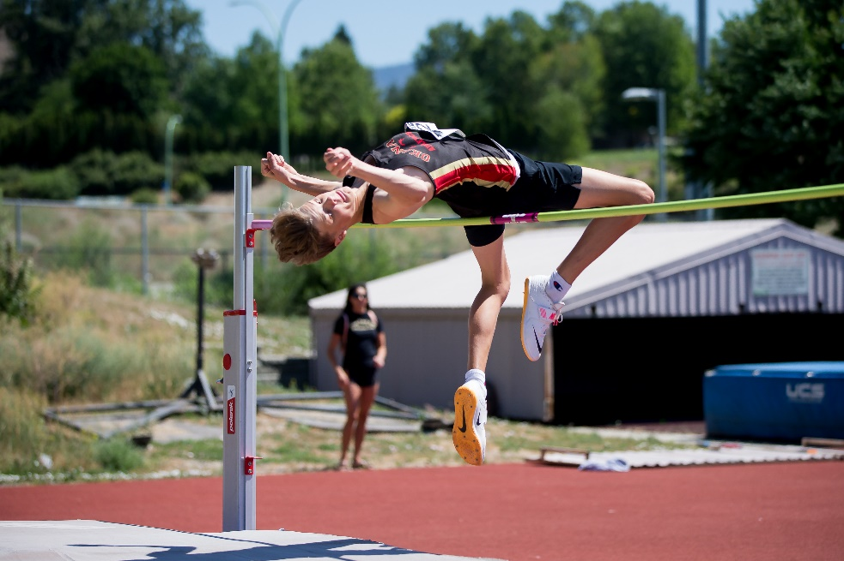
-Sibling Discount-
There is a 10% discount for a 2nd sibling and 15% for 3rd + from the OAC training fee. This will be applied automatically on registration.

-Annual BC Athletics Fee-
BC Athletics membership fees are valid until December 31st, 2024 for new and renewing members registering on or after September 1st . In order to compete in track meets, athletes require a Competitive Membership. A Training Membership can be upgraded for an additional fee of $44.75 + a $5.00 admin fee (total $49.75).
Please note: BC Athletics memberships will be increasing in 2024, therefore, if you are fairly certain you/your child will compete in 2024, we would recommend opting for the Competitive Membership now. The fee increase takes place October 1st, 2023.

-Training Shirt-
As part of registration, each athlete who registers by September 6th, 2023, will receive an OAC training shirt to keep. It is important to indicate your size at registration, or we cannot guarantee that we will have your size available for you. Athletes are encouraged to wear them to practices but it is not mandatory. Those who register late are not guaranteed a training shirt and will receive one only if stocks allow.
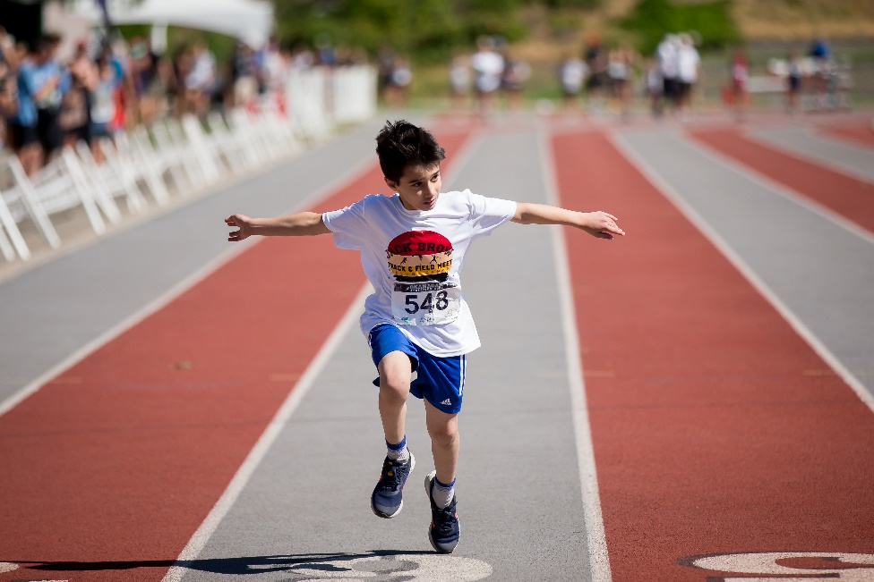
-Refunds-
As the number of athletes and funding is used to determine coaching requirements and funding, the Club does not provide refunds as a matter of policy. However, in the case of medical circumstance, some level of refund of the OAC Training Fee will be considered at the discretion of the Club Executive. However, the BC Athletics Fee portion of the membership fees is non-refundable.

-Practice Cancellations-
We practice rain or shine. In the event of inclement weather such as thunderstorms or heavy smoke, we will contact athletes by email and social media to notify you if practice is cancelled. Cancelled practices due to mother nature are not refunded.

Athletes are asked to arrive for practice on time. If for any reason you will be late or cannot attend a practice, please inform your coach ahead of time. Parents must pick up your athletes on time at the end of each practice.

Please note: OAC has adopted a “No Pay, No Play” policy, whereby OAC fees that have not been paid in full (or whereby a pre-approved payment plan is not in place) by the athlete’s first training session of the season, then that athlete will NOT be permitted to train and/or compete in OAC meets. Additionally, any athlete with outstanding fees from any previous season(s) will not be permitted to train and/or compete in OAC meets unless a payment plan is in place.

For all other information, please refer to our
2023/2024 OFFICIAL OAC HANDBOOK,
which can be found on our website www.okac.ca

As always please do not hesitate to contact me if you have any questions.
Karen Hatch
Okanagan Athletics Club Manager
www.okac.ca
manager@okac.ca
250 862 6039
