2023 FALL TRAINING & FEE SCHEDULE
- CROSS COUNTRY –

Registration for all our fall and winter programs will be online at: www.trackiereg.com/OACS-Fall-Winter2024
Registration opens: Friday, September 1st, 2023

Our Fall Cross Country programs will begin on Monday, September 11th, 2023.

-Locations-
Most practices will be held at Mission Creek Greenway, however, efforts will be made to change the Monday locations for variety and to preview and train the weekly High School race courses.

-Training Days & Times-
Group | Monday | Friday | Saturday
Junior Development – Cross Country | 4:00-5:00pm | 4:00-5:00pm | ---
Senior Cross Country (age 14+) | 5:00-6:30pm | 5:00-6:30pm | *10:30-11:30  (Depending on coach availability)  *Emailed workout will be provided if a coach is not available

-Season Dates-
Junior Development Cross Country: Monday, September 11th – Monday, October 23rd
Senior Cross Country: Monday, September 11th – Monday, October 30th

There are no practices on the following days:
Monday, October 10th - Thanksgiving
Friday, October 13th – travel to BC Cross Country Championships
Saturday, October 14th – BC Cross Country Championships

-Track Meets-
OAC Fall Twilight Meet – Thursday, October 12th, 2023
BC Athletics Cross Country Championships (South Surrey) – Saturday, October 14th, 2023
BC High School Cross Country Championships (South Surrey) – Saturday, November 4th, 2023
Canadian Cross Country Championships (Ottawa, Ontario) – Saturday, November 25th, 2023

Entry fees for competitions are additional to the program fees listed below. Athletes are responsible for their own travel expenses to competitions and accommodation costs as applicable. Registration information for competitions will be sent via email by the club manager 1-2 weeks before the registration deadline.

JD athletes who wish to participate in both cross country & track & field programs will join the track & field program on Monday, October 30th. They cannot participate in both programs simultaneously. Athletes who wish to do both programs should contact Karen: manager@okac.ca

-Program Fees - Junior Development (JD) Athletes-
Age on Dec 31st, 2024 | Membership Type | Training Group | *BCA  Fees will increase Oct 1st, 2023 | Training Fee | Raffle Tickets | Total Fees
*9-13  (2015- 2011) |  | Junior Development Cross Country | $60.00  competitive | $155.00 | $50.00 | $265.00
 |  |  | $15.75  training |  |  | $220.75
* BC Athletics membership fee will be for the remainder of 2023 and valid until December 31st 2024

-Program Fees – Senior Athletes-
Age on Dec 31st, 2024 | Membership Type | Training Group | *BCA  Fees will increase from Oct 1st 2023 | Training Fee | Raffle Tickets | Total Fees
13 (2011) | U14 | JD Athletes training with the senior cross country group  (by invitation only) | $60.00  competitive | $205.00 | $50.00 | $315.00
 |  |  | $15.75  training |  |  | $270.75
14 (2010) | U16 | Senior Cross Country | $70.00  competitive | $205.00 | $50.00 | $325.00
 |  |  | $15.75  training |  |  | $270.75
15 (2009)  18-22 (2004-2002) | U16  Post Secondary | Senior Cross Country | $73.50  competitive | $205.00 | $50.00 | $328.50
 |  |  | $15.75  training |  |  | $270.75
16+  (2008-1990) | U18/U20/Senior | Senior Cross Country | $94.50  competitive | $205.00 | $50.00 | $349.50
 |  |  | $15.75  training |  |  | $270.75
35+  (1989-) | Master | Senior Cross Country | $63.00  competitive | $205.00 | $50.00 | $318.00
 |  |  | $15.75  training |  |  | $270.75
* BC Athletics membership fee - will be for the remainder of 2023 and valid until December 31st 2024.

-Methods of Payment-
1. Online at trackiereg.com with a credit card (there is a small processing fee for payment by this method)
2. By e-transfer to Brad Heinzman at president@okac.ca
3. By monthly installment (2 equal payments; September & October.) via e-transfer to Brad - (see #2). The first e-transfer must be received on or before September 11th or by 2 postdated cheques which must be handed in at the first practice.

***NEW*** For those who choose to pay in installments, a payment agreement must be signed on or before the first practice.
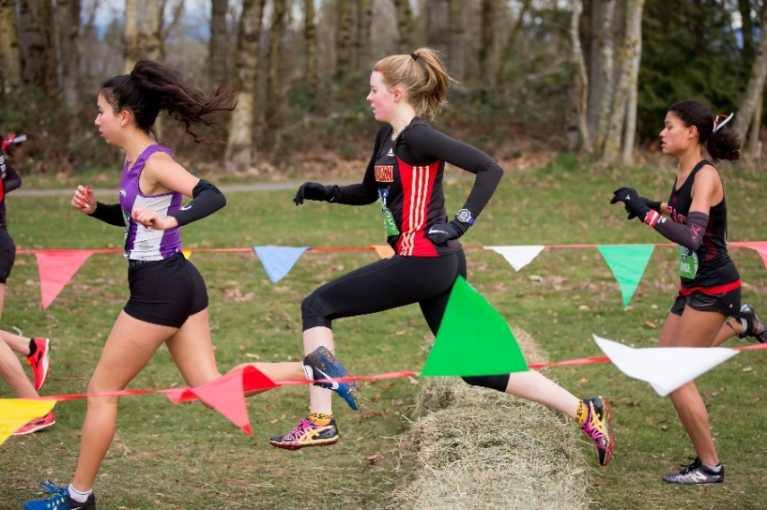
-Sibling Discount-
There is a 10% discount for a 2nd sibling and 15% for 3rd + from the OAC training fee. This will be applied automatically on registration.

-Annual BC Athletics Fee-
BC Athletics membership fees are valid until December 31st, 2024, for new and renewing members registering on or after September 1st . To compete in the BC Athletics Cross Country Championships (and track & field meets in 2024), athletes require a Competitive Membership. A training membership can be upgraded for an additional fee of $44.75 + a $5.00 admin fee (total $49.75). If you initially opt for a training only membership and wish to upgrade to a Competitive Membership, please contact the club manager: manager@okac.ca. You will need to have the Competitive Membership upgrade completed before you can register for any BC Athletics sanctioned competitions. Please note: BC Athletics memberships will be increasing in 2024, therefore, if you are fairly certain you/your child will compete in 2024, we would recommend opting for the Competitive Membership now. The fee increase takes place October 1st, 2023.

-Training Shirt-
As part of registration, each athlete who registers by September 6th, 2023, will receive an OAC training shirt to keep. It is important to indicate your size at registration, or we cannot guarantee that we will have your size available for you. Athletes are encouraged to wear them to practices but it is not mandatory. Those who register late are not guaranteed a training shirt and will receive one only if stocks allow.

-Refunds-
As the number of athletes and funding is used to determine coaching requirements and funding, the Club does not provide refunds as a matter of policy. However, in the case of medical circumstance, some level of refund of the OAC Training Fee will be considered at the discretion of the Club Executive. However, the BC Athletics Fee portion of the membership fees is non-refundable.

-Practice Cancellations-
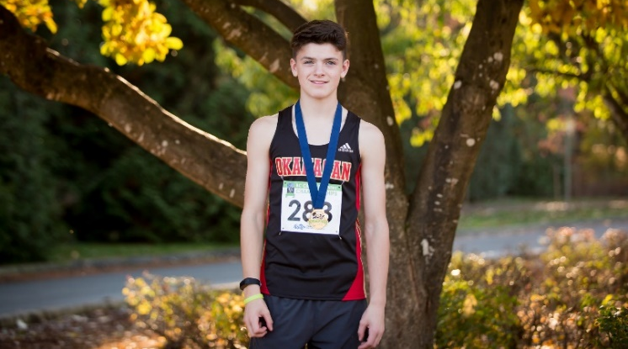
We practice rain or shine. In the event of inclement weather such as thunderstorms or heavy smoke, we will contact athletes by email and social media to notify you if practice is cancelled. Cancelled practices due to mother nature are not refunded.

Athletes are asked to arrive for practice on time. If for any reason you will be late or cannot attend a practice, please inform your coach ahead of time. Parents must pick up your athletes on time at the end of each practice.

Please note: OAC has adopted a “No Pay, No Play” policy, whereby OAC fees that have not been paid in full (or whereby a pre-approved payment plan is not in place) by the athlete’s first training session of the season, then that athlete will NOT be permitted to train and/or compete in OAC meets. Additionally, any athlete with outstanding fees from any previous season(s) will not be permitted to train and/or compete in OAC meets unless a payment plan is in place.
For all other information, please refer to our
2023/2024 OFFICIAL OAC HANDBOOK,
which can be found on our website www.okac.ca

As always please do not hesitate to contact me if you have any questions.
Karen Hatch
Okanagan Athletics Club Manager
www.okac.ca
manager@okac.ca
250 862 6039

