Royal City Track and Field
Pole Vault Twilight Meet #1
Thursday 20 July 2023
Mercer Stadium 900 Sixth Street New Westminster BC email questions to ian@royalcitytrack.ca
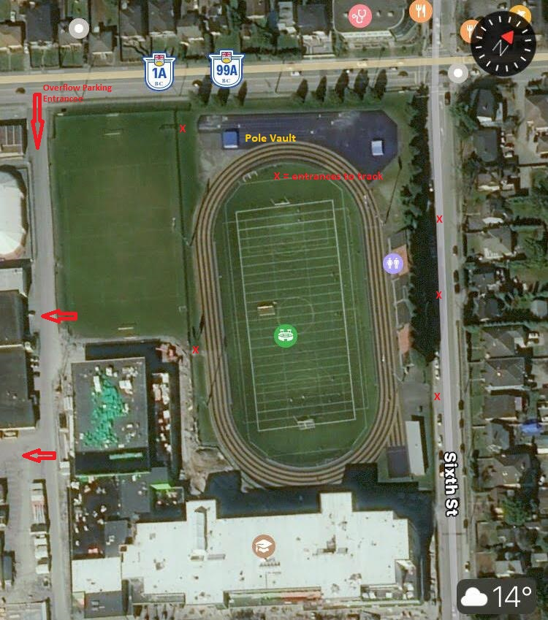
X = Entrance Gate
We have a new school on this site, impacting access and parking. There is no parking on 10th Avenue, and the east side of 6th Street is by permit only. If you are unable to park on the stadium side of 6th Street, there is ample parking around the old NWSS and the Pearson Centre, accessed from 10th Avenue between 6th and 8th Street. Please note you cannot turn left onto 6th Street if travelling west on 10th Avenue, you may however turn left into the parking lot. Some GPS and internet map services have an old address on 8th Avenue for Mercer Stadium; this will take you to the arena and Massey Theater and you can drive past the new school to park.
Access to the upper west gate is from the grass field or from beside the new school, not from the 10th Avenue sidewalk. Please respect any field sports being played.
If you experience difficulties call Ian 778 789 0338 for real-time directions.
Open to all AC Competitive Members
- Time subject to advancement based on entries
4:30 Athlete Check In
4:45 Warm Up Vaults
6:00 First Flights
Single event meet, decision of the officials is final, disputes to be addressed to Sean Dixon or delegate within 30 minutes of the occurrence.

