2023 Forest City Mustang Invitational
Wednesday April 26th, 2023 @ Alumni Stadium Western University

2023 FOREST CITY/MUSTANG INVITATIONAL
TRACK AND FIELD MEET
Wednesday April 26th @ Alumni Stadium, Western University - London, ON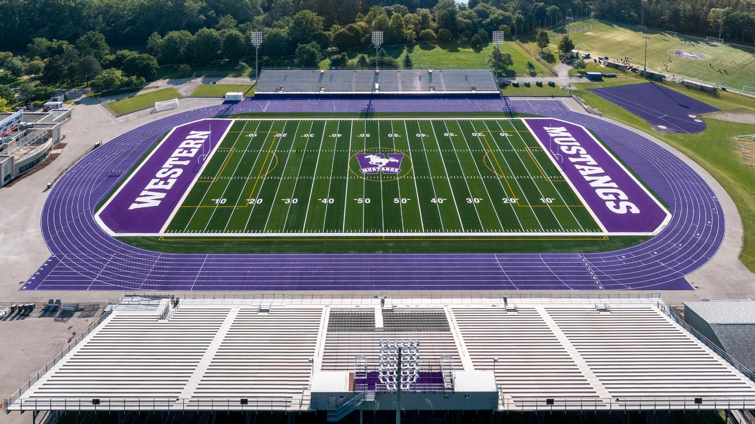
Dear Coach:
Western’s Men’s and Women’s Track & Field teams and the London-Western Track and Field Club invite your school to participate in this year’s meet. The meet is on the Donald J. Wright Track at Alumni Stadium which was resurfaced in 2021 and is home of the 2024 OFSAA Track & Field Championships

www.westernmustangs.ca | www.londonwesterntfc.com
Meet Director – Taylor Ehrhardt
Taylorehrhardt10@gmail.com
519-639-0496

ENTRIES: Entries can be done at: http://www.trackiereg.com/ForestCityMustang2023
Deadline: Friday April 21st 2023 @ 11:59pm

Entry Fee: $15 per athlete or a maximum of $550 per school. Cheques can be made out to:
“Western University”

Max Entries: A limit of 6 athletes per event, per age category, per school. Each athlete is also limited to total
of 2 events.

Track Check-in: Last check in for track events will be 45min before the start of the race, for re-seeding to take
place. All athletes that miss last check-in will be scratched from the race with NO EXCEPTIONS.
Athletes then return to start line 15min before race time to receive heat and lane.

Field Check-in: Check-in for field events at the event site 30min before start time

Schedule: Final Schedule will be sent out once entries are closed.
Results will be posted during the meet at: mustangstiming.com/Results/FCMI23

TIMED SECTIONS: All track events will be run as a timed section final. Sections will be organized based on seed times and will run the fastest to slowest. Accurate seed times are critical. Unseeded athletes will be placed at the bottom of the start list, in the slower sections.

FIELD EVENTS: In horizontal jumps and all throws, each competitor will be given 3 attempts.

1st Legal attempt will be measured, all remaining attempts must surpass a minimum distance (Bronze Standard) in order to be measured.

POLE VAULT: Novice and Junior males/females with seed performances of 3.20m/2.80m or higher, respectively, will compete with senior age category.
POLE VAULT LOCATION: Due to facilities Pole Vault will take place at the indoor track (Thompson Arena), please park at Alumni Stadium, and enter through loading dock. Directions below:

ELIGIBILITY: All athletes competing in this meet must be registered through their respective schools. School uniform must be worn in competition.

AWARDS: Awards: t-shirt for 1st place, ribbons for standards achieved

FIRST AID: Headquarters will be in the change room 1, inside main building.

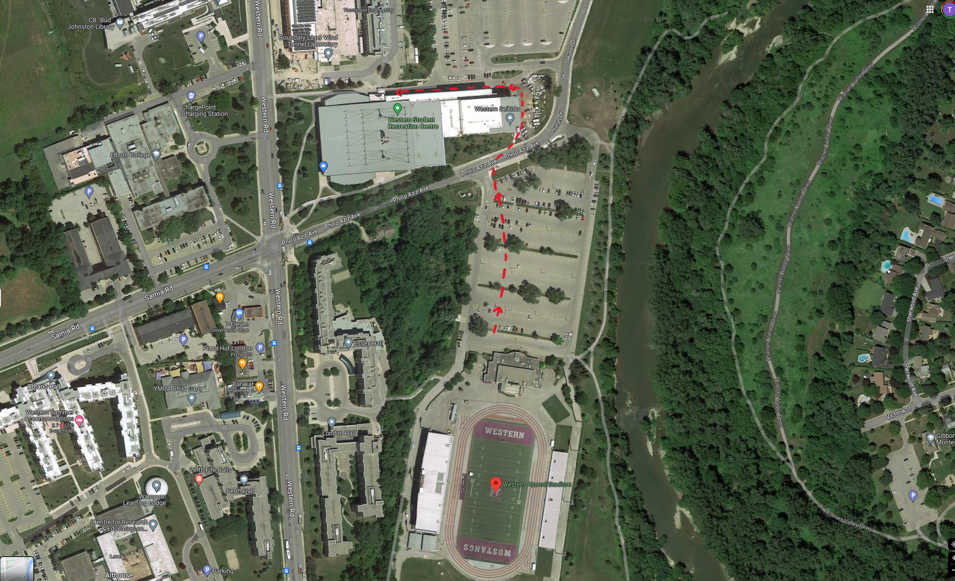
Pole Vault:

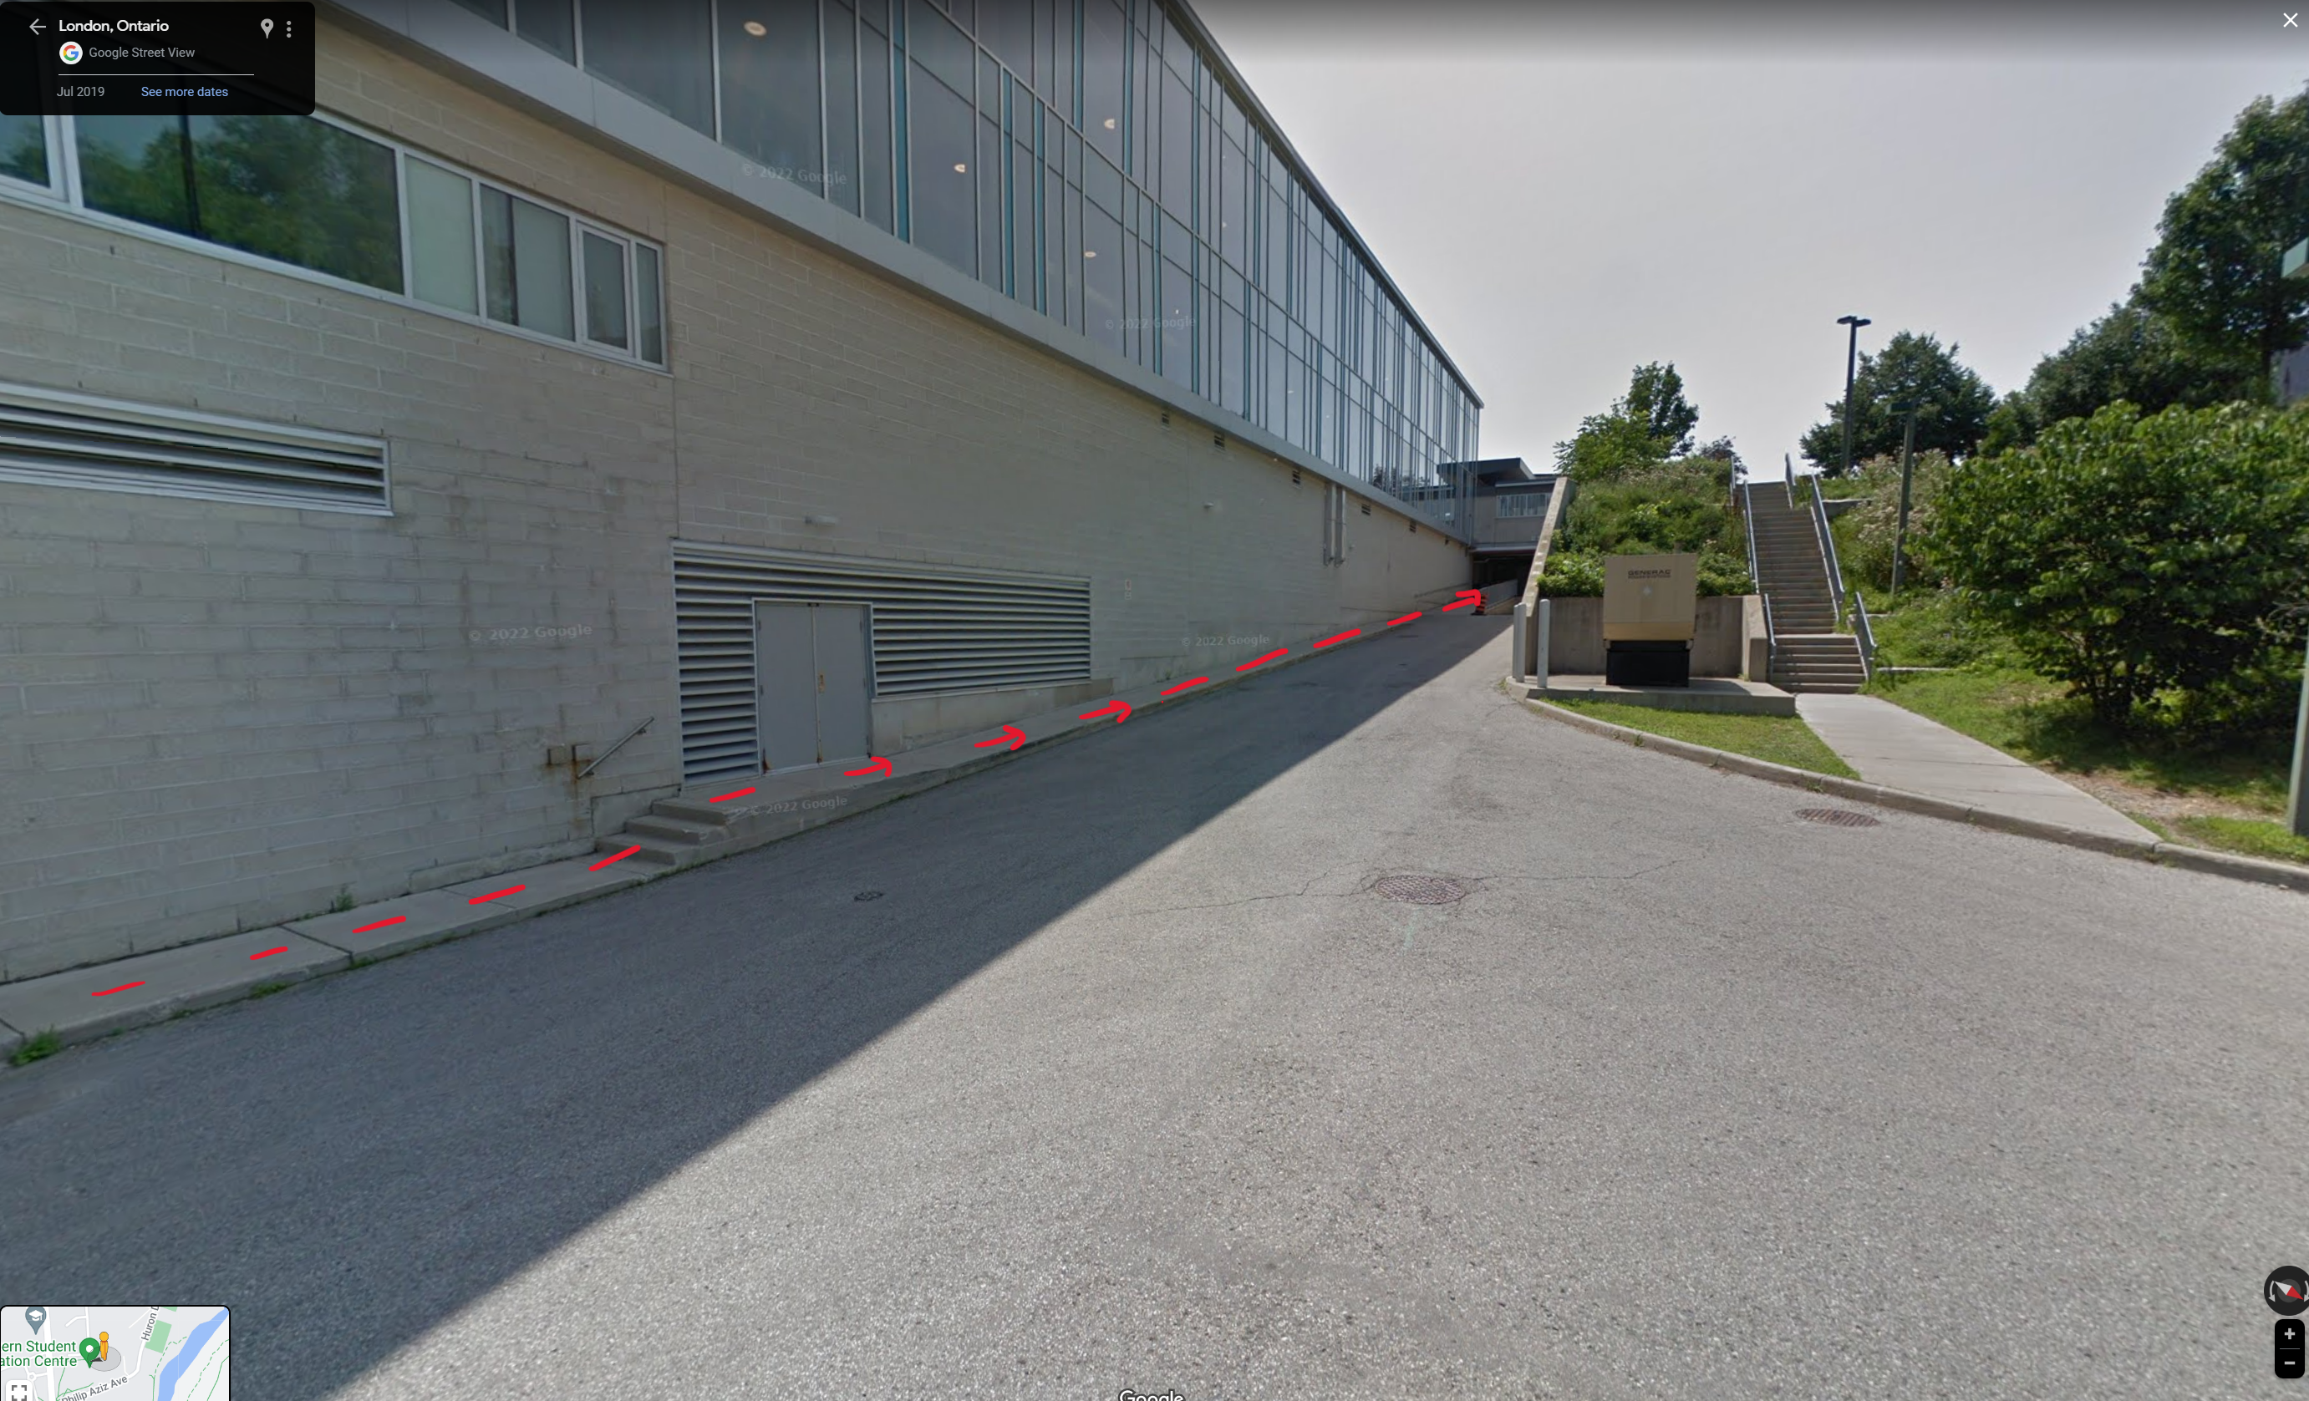
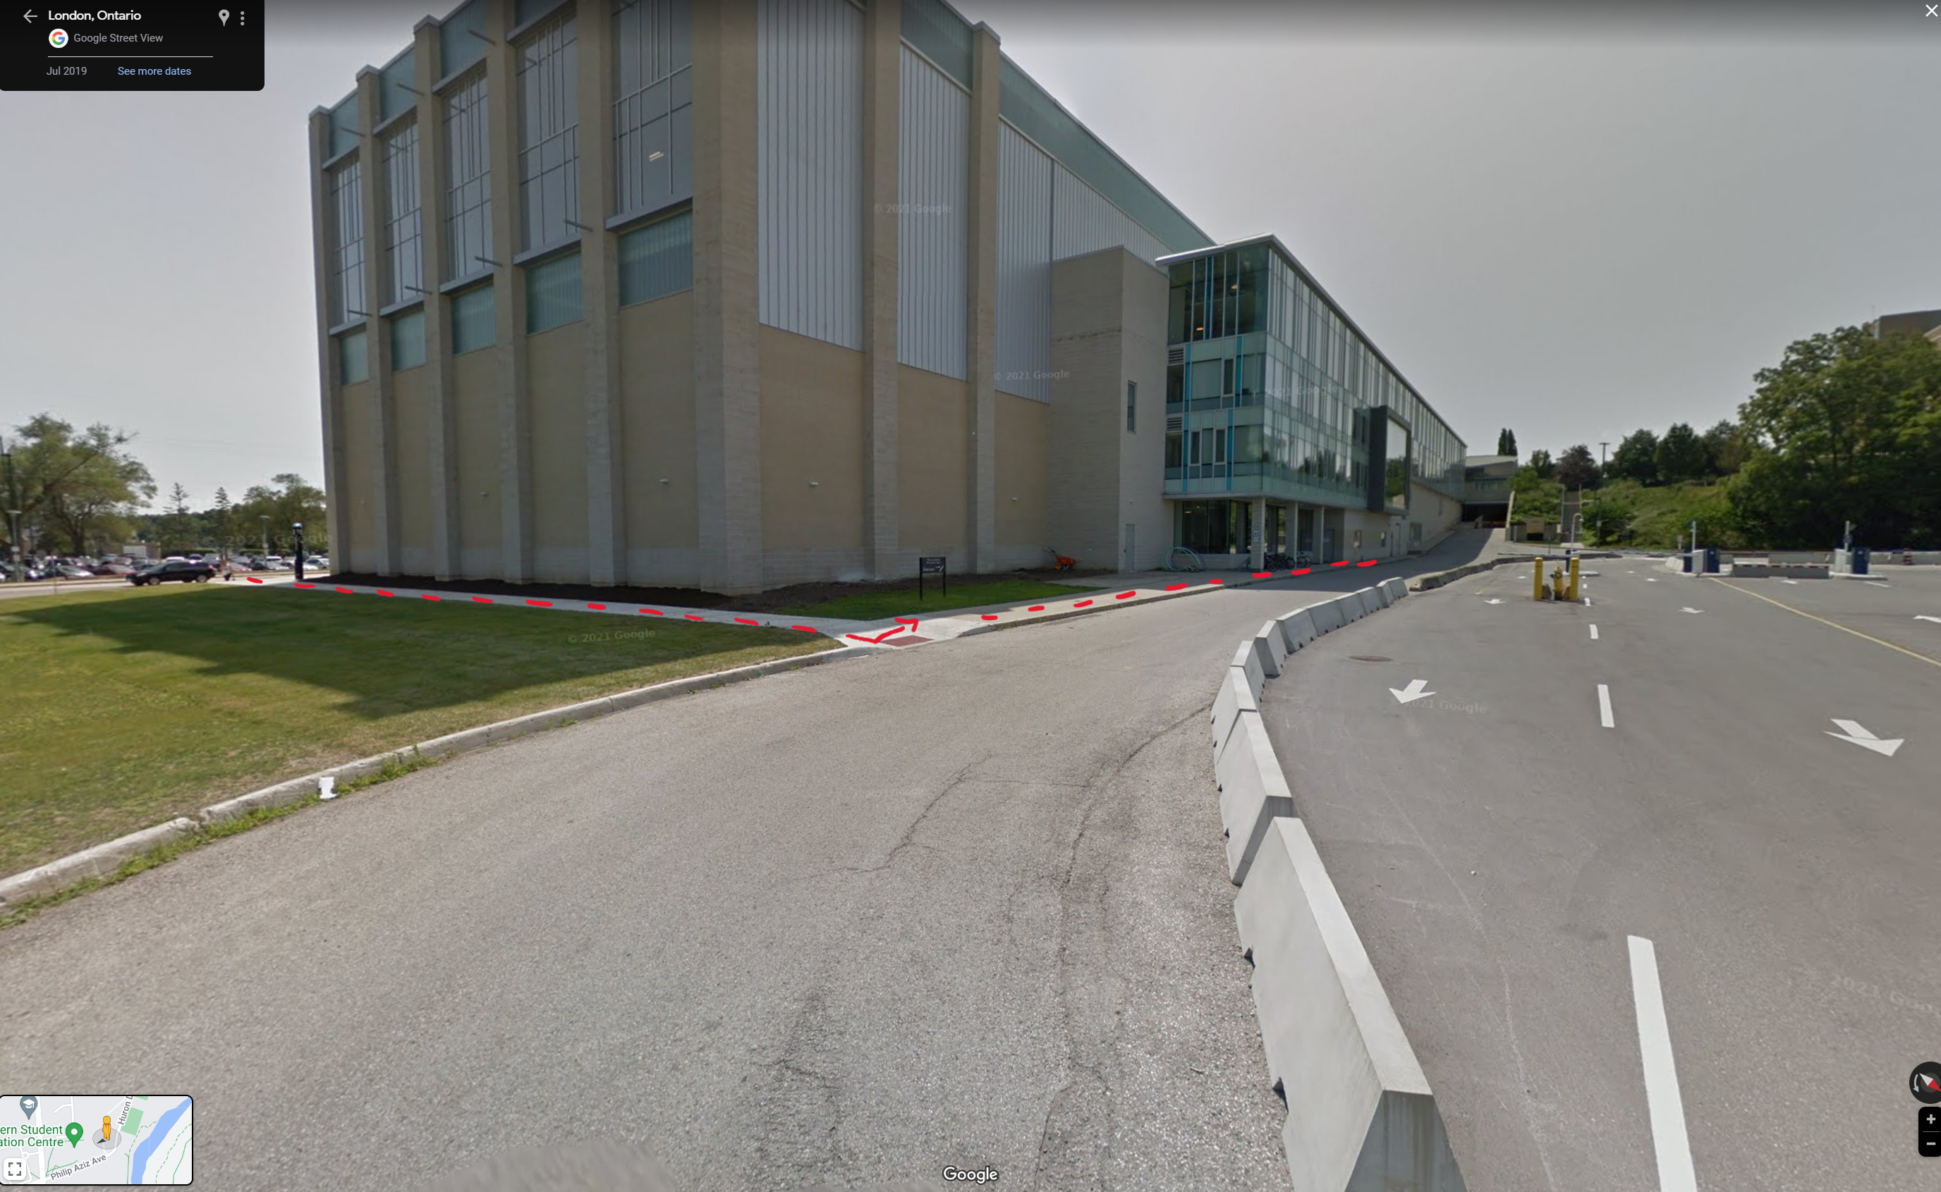

2023 FOREST CITY/MUSTANG INVITATIONAL
FINAL TRACK SCHEDULE
TRACK EVENTS – Track events will be run from FAST to SLOW
*In the interest of time, we will run ahead of schedule whenever possible*
Event Start Time | Event | Divison | Check-in Open | Check-in Closes
10:30am | 110mh | Senior Boys 36” | 9:15am | 9:45am
10:45am | 100mh | Junior Boys 36” | 9:15am | 10:00am
10:55am | 100mh | Novice Boys 33” | 9:15am | 10:05am
11:00am | 100mh | Senior Girls 30” | 9:45am | 10:15am
11:15am | 80mh | Junior Girls 30” | 9:45am | 10:30am
11:30am | 80mh | Novice Girls 30” | 9:45am | 10:45am
11:40pm | 800m | Novice Girls | 10:25am | 10:55am
12:00pm | 800m | Junior Girls | 10:25am | 11:15am
12:10pm | 800m | Senior Girls | 10:25am | 11:25am
12:35pm | 800m | Novice Boys | 11:20am | 11:50am
12:50pm | 800m | Junior Boys | 11:20am | 12:05pm
1:05pm | 800m | Senior Boys | 11:20am | 12:20pm
1:20pm | 100m | Novice Girls | 12:05pm | 12:35pm
2:00pm | 100m | Junior Girls | 12:05pm | 1:15pm
2:30pm | 100m | Senior Girls | 12:05pm | 1:45pm
2:55pm | 100m | Novice Boys | 1:40pm | 2:10pm
3:25pm | 100m | Junior Boys | 1:40pm | 2:40pm
3:45pm | 100m | Senior Boys | 1:40pm | 3:00pm
4:20pm | 400m | Novice Girls | 3:05pm | 3:35pm
4:35pm | 400m | Junior Girls | 3:05pm | 3:50pm
4:50pm | 400m | Senior Girls | 3:05pm | 4:05pm
5:05pm | 400m | Novice Boys | 3:50pm | 4:20pm
5:20pm | 400m | Junior Boys | 3:50pm | 4:35pm
5:35pm | 400m | Senior Boys | 3:50pm | 4:50pm
Track Break | Track Break | Track Break | Track Break | Track Break
6:20pm | 1500m | Novice Girls | 5:05pm | 5:35pm
6:35pm | 1500m | Junior Girls | 5:05pm | 5:50pm
6:50pm | 1500m | Senior Girls | 5:05pm | 6:05pm
7:10pm | 1500m | Novice Boys | 5:55pm | 6:25pm
7:30pm | 1500m | Junior Boys | 5:55pm | 6:45pm
7:45pm | 1500m | Senior Boys | 5:55pm | 7:00pm
8:00pm | 200m | Novice Girls | 6:45pm | 7:15pm
8:15pm | 200m | Junior Girls | 6:45pm | 7:30pm
8:30pm | 200m | Senior Girls | 6:45pm | 7:45pm
8:45pm | 200m | Novice Boys | 6:45pm | 8:00pm
9:00pm | 200m | Junior Boys | 6:45pm | 8:15pm
9:15pm | 200m | Senior Boys | 6:45pm | 8:30pm
**200m Races have been cancelled**
RESULTS: mustangstiming.com/Results/FCMI23
FINAL FIELD SCHEDULE
Time | Event | Divison
11:00 | High Jump | Novice/Junior Girls
1:30 | High Jump | Senior Girls
3:00 | High Jump | Novice/Junior Boys
5:30 | High Jump | Senior Boys
High Jump Starting Heights
Novice/Junior Boys - starting ht./increments 1.40 + 10cm to 1.50 + 5cm
Senior Boys - starting ht./increments 1.51 + 10cm to 1.61 + 5cm
Novice/Junior Girls - starting ht./increments 1.20 + 10cm to 1.40 + 5cm
Senior Girls - starting ht./increments 1.33 + 10cm to 1.43 + 5cm

Time | Event | Divison
11:00 | Long Jump (South Pit) | Novice Girls - Flight 1  (Last name A - J)
11:00 | Long Jump (Lower Pit) | Junior Girls - Flight 1  (Last name A - J)
11:00 | Long Jump (North Pit) | Senior Girls - Flight 1  (Last name A - J)
12:30 | Long Jump (South Pit) | Novice Girls - Flight 2  (Last name K - Z)
12:30 | Long Jump (Lower Pit) | Junior Girls - Flight 2  (Last name K - Z)
12:30 | Long Jump (North Pit) | Senior Girls - Flight 2  (Last name K - Z)
2:00 | Long Jump (South Pit) | Novice Boys - Flight 1  (Last name A - M)
2:00 | Long Jump (Lower Pit) | Junior Boys - Flight 1  (Last name A - K)
2:00 | Long Jump (North Pit) | Senior Boys - Flight 1  (Last name A - L)
3:30 | Long Jump (South Pit) | Novice Boys - Flight 2  (Last name N - Z)
3:30 | Long Jump (Lower Pit) | Junior Boys - Flight 2  (Last name L - Z)
3:30 | Long Jump (North Pit) | Senior Boys - Flight 2  (Last name M - Z)
Horizontal Pits:
South - 300m Start Line
North - 200m Start Line
Lower - Lower level past finish line

Time | Event | Divison
12:00 | Pole Vault | Novice/Junior Girls
1:30 | Pole Vault | Senior Girls
3:00 | Pole Vault | Novice/Junior Boys
4:30 | Pole Vault | Senior Boys

Time | Event | Divison
5:00 | Triple Jump (South Pit) | Novice Girls
5:00 | Triple Jump (Lower Pit) | Junior Girls
5:00 | Triple Jump (North Pit) | Senior Girls
6:30 | Triple Jump (South Pit) | Novice Boys
6:30 | Triple Jump (Lower Pit) | Junior Boys
6:30 | Triple Jump (North Pit) | Senior Boys

Time | Event | Divison
11:00am | Shot Put | Novice Girls
12:15am | Shot Put | Junior Girls
1:30pm | Shot Put | Senior Girls
3:00pm | Shot Put | Novice Boys
4:15pm | Shot Put | Junior Boys
5:30pm | Shot Put | Senior Boys

Time | Event | Divison
11:00am | Discus | Senior Boys
1:00pm | Discus | Junior Boys
2:30pm | Discus | Novice Boys
3:30pm | Discus | Senior Girls
4:30pm | Discus | Novice Girls
5:45pm | Discus | Junior Girls

Time | Event | Divison
11:00am | Javelin | Junior Boys
12:30pm | Javelin | Novice Boys
1:45pm | Javelin | Senior Boys
3:30pm | Javelin | Junior Girls
5:00pm | Javelin | Novice Girls
6:00pm | Javelin | Senior Girls

RESULTS: mustangstiming.com/Results/FCMI23

