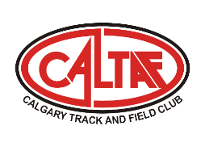
Caltaf Summer Camp
The Caltaf Summer Camp is designed to introduce athletes between the ages of 7 and 14 to the sport of track and field while at the same time developing fundamentals of the sport and a general foundational level of fitness that will benefit these young athletes in all aspects of their lives. Athletes will work through half-day sessions that will provide an exciting mix of technical practice, games, and other fun activities. The focus will be on learning the fundamentals of running, jumping, and throwing as well as developing speed and agility using age-appropriate progressions.
WEEK 1  Date: Daily from Monday to Friday  July 10-14, 2023  Time: 12:00 pm to 3:00 pm  Location: Glenmore Athletic Park  Cost: $199.00  Note: *We may adjust the end time due to weather conditions or Air Quality |  | WEEK 2  Date: Daily from Monday to Friday  August 14-18, 2023  Time: 12:00 pm to 3:00 pm  Location: Airdrie Genesis Place  Cost: $199.00  Note: *We may adjust the end time due to weather conditions or Air Quality
REGISTRATION

To register, please click on the following link:
http://www.trackiereg.com/caltafweek1
http://www.trackiereg.com/caltafweek2

For both weeks for those 10 and younger, please select U10. For those 11 and under please select U12. For those 13 and under, please select U14.

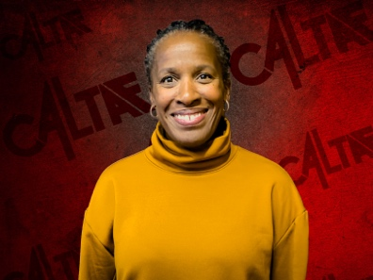 | Head Coach - Samantha Read  Samantha competed for Caltaf in the sprints and middle distance events and as a member of the U of C Dinos (1988-1993). She was a member of the 1991 National Championship team, earning All Canadian status that year. Sam then moved to the United States and competed for the Nike Farm Team (1996-2001) in the middle-distance events. While living in the United States she was the Head Track and Field and Cross Country Coach at Mountain View High School in Mountain View, California (1996-2006). In her time there, she was named the Santa Clara Valley Athletic League Honor Coach in 2001 (Girls Cross Country), 2005 (Girls Cross Country) and 2006 (Girls & Boys Track and Field).  Samantha is the Head Coach for our Junior Development Group and the Head Coach for our Senior Distance Group. In 2015 and 2016 Sam was named Grassroots Coach of the Year by Athletics Alberta. In 2016 & 2018 Sam was named the Zone 3 Head Coach for the Alberta Summer Games Team. She was the Head Coach for the 2017 & 2018 Western Canadian Tri-Province Team, 2017 & 2018 Team Alberta Royal Canadian Legion Team, 2019 Western Canada Summer Games Team Distance Coach and was named to the 2022 Canada Games Coach coaching staff as the Distance Coach. Sam continues with her coach’s education and is months away from her Level 3. She is also pursuing her master’s degree in Sport Management with a concentration in Coaching Theory and Strategy.

