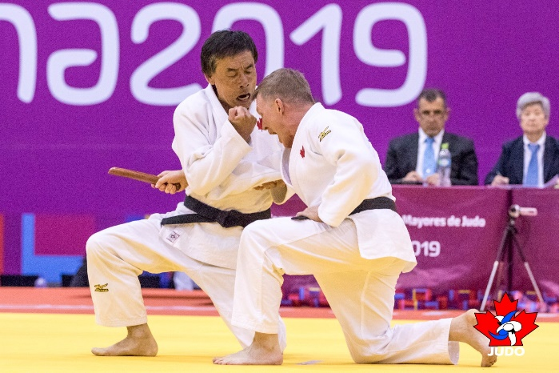
Kata Clinic – March 4-5, 2023
Hosted by Raymond Judo Club
The Judo Alberta Grading Board is pleased to announce that Gordon Okamura (National Kata Coach) will be leading a series of kata clinics for participants to sample various kata for interest. Key points and principles will be covered in each kata but the entire kata may not necessarily be shown. Questions will be addressed and critique will be provided. Weapons will be provided.
These sessions are open to all interested judoka!
Time: Saturday March 4 10 am – 1 pm Nage no Kata
1-2 pm - Lunch
2 pm – 5 pm Kodokan Goshin Jutsu

Sunday March 5 9am – 12pm Katame no Kata
12 – 1 pm - Lunch
1 pm – 4 pm Kime no Kata

Location: Victoria Sports Park 350E 100N, Raymond, Alberta T0K2S0
Registration: $35 Registration is through trackie: www.TrackieReg.com/raymondkataclinc
If you have any questions, please contact Gord Okamura at gyokamura@gmail.com

