EDMONTON YUDANSHAKAI
JUDO SOCIETY
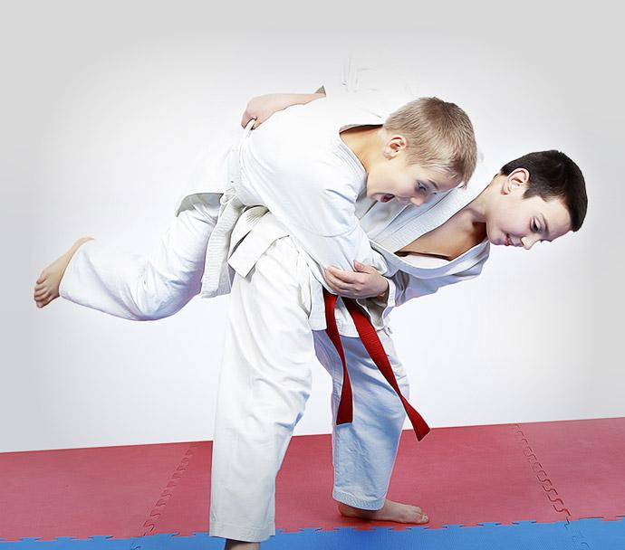

Yellow to Green Belt Tournament

Hosted by EYJS Member Clubs
Dow Centennial Centre
8700-84 Street
Fort Saskatchewan
Subject to change based on facility availability/conflicting date

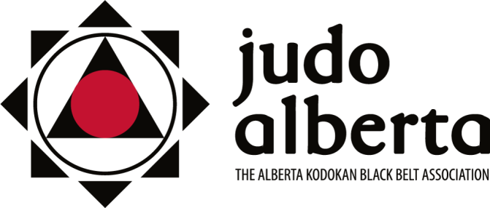

Judo Alberta Sanctioned
December 3, 2022 (2022-10)

EYJS Monthly Tournament Package

Who: 7 years to Adult - born 2016 or earlier (age as of December 31, 2023)

Where: Dow Centennial Centre

8700-84 Street

Fort Saskatchewan, AB

When: December 3, 2022 all Subject to change based on facility availability/conflicting dates.

Time: Tournament setup/competitor organization 11 AM. Competition starts at 12 noon.

Registration Link: Registrations must be done at www.TrackieReg.com/EYJSMonthlyDecember2022

NO REGISTRATIONS WILL BE DONE AT THE TOURNAMENT.

Cost: $10/participant (processing fee will be applied at check out).

Purpose: Developmental - to expose lower belt levels to a tournament environment. These tournaments are also training grounds for referees, timekeepers, draw keepers, set-up, etc.

Kids Tournament Directors:

Mark Hicks/ Wesley Enns / Teresa Yamada

Phone: (780) 782-3669

Email: mhicks@sherwoodford.ca

NOTE: All competitors must wear a white gi. White gi is required for first name called, blue judogi is optional for second name called. Females are required to wear a plain white t-shirt.

A group warm-up will take place before the competition.

Divisions: Determined by size and gender of the participants. However, two distinct groupings are defined, ‘‘under 16’’, and ‘‘16 and over’’ to ensure that physical variances evident with age are not present in the competitors and that competitors are of similar physical and mental development.

Weight Ins: No weigh-ins required as athletes are reviewed on site, however athletes are required to provide their actual weight on the Trackie registration. If a weight discrepancy is suspected, the athlete’s weight will be checked by tournament organizers in judogi pants and t-shirt.

Draws: Format determined once athletes are grouped (at the discretion of the Tournament Director).
2 competitors – Best 2 out of 3
3-5 competitors – Round Robin
6 or more competitors – Double knock out.

IJF Rules apply. Judo Alberta & Judo Canada Tournament Sanction Policies will be in effect. https://judoalberta.com/wp-content/uploads/2013/04/2-05-Tournament-Sanction-Policy2.pdf
https://judocanada.org/wp-content/uploads/2021/09/Sanctioning-Policy-and-tournament-standards-EN.pdf

