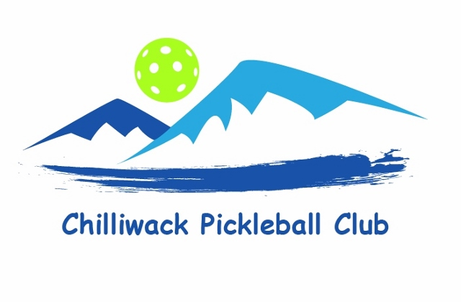

Junior Program Registration Form
Name:______________________________ DOB_______________________
Address:________________________________________________________
Phone:_____________________________
Email:__________________________________________________________

Parent’s/Legal Guardian’s Name:____________________________________
Phone:______________________________
Email;___________________________________________________________

I would like to participate in the Chilliwack Junior Pickleball Program.
______ Session 1: January 9th-Feb 13th, 2023 @ 3.30pm-5.30pm - Cost $50
______Session 2: Feb 27th-Mar 27th, 2023 @ 3.30pm -5.30pm - Cost $45

Please etransfer payment to pay@chillpb.com and put “Junior” in the comment box.
NB: All equipment will be provided and participants will be asked to wear safety glasses.
Players should wear clean indoor runners, comfortable athletic clothing and bring a water bottle.
All lessons will be held at the Landing Sports Centre: 45530 Spadina Ave, Chilliwack.

