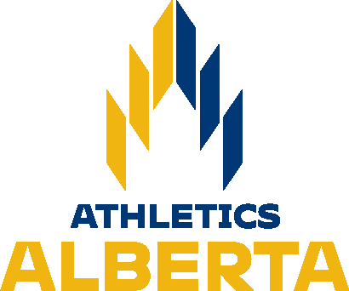

Calgary Track Council is pleased to host the

2022 Alberta Cross-Country Running Championships Saturday, November 5, 2022

Sanctioned by Athletics Alberta Location
St. Mary’s University. 14500 Bannister Road SE, Calgary, AB T2X 1Z4

Course

St. Mary’s University has a 2km loop Athletics Alberta has the privilege to use with a wide starting area and separate finish line. There are wide straights, a few turns, challenging hills, a few fast downhill sections, and one road crossing that will be covered with mats on race day.

Course map is below:

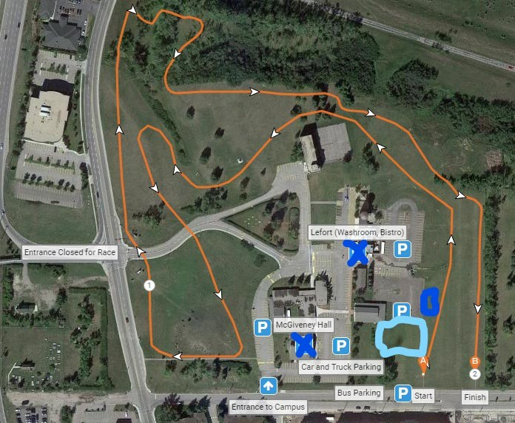

Light blue indicates dedicated spectating area. Dark blue indicates location of Porta-Potties.

There will be a lead cyclist for the U10/U12/U14 races showing them where the course breaks are for their race distances. It will also be marked on the race course and marshaled.

On-Site
- First Aid
- Bib Pick up – AT STARTLINE/Registration Table
- Portable toilets
- Parking: Please respect "No Parking" – various spots on St. Mary’s University, see map.

Spectators
There will be a roped off section for spectators and coaches to observe the races, it will be between the start/finish lines of every race.

Bibs
- Pick up at startline from Race Director/Registration Table

Results and Team Scoring
- Calgary Track Council website: https://calgarytrackcouncil.com/
- Cochrane Endurance Project's Facebook: https://www.facebook.com/pages/category/Sports- Club/Cochrane-Endurance-Project-310899062830184/
- Trackie.ca

Athletics Alberta Membership
All competitors must be members of Athletics Alberta or equivalent Athletics Canada Branch Membership. No exceptions -- please see https://www.athleticsalberta.com/aa-membership/ . (Note: "Day of Meet" memberships are no longer available. Membership must be registered before the meet entry deadline of October 28, 2019.)

Entries
Due: 6:00 p.m. on Tuesday, November 1, 2022, NO LATE ETRIES ALLOWED Please submit all entries using TrackieReg (https://www.trackie.com/online- registration/event/2022-alberta-cross-country-championships/482888/#.Yzuqe3bMLIU ) For seed time, please indicate the estimated time for the athlete (which will allow the organizers to determine if schedule adjustments will be required).

Entry Fee
$28.00 per participant (includes Alberta Championship fee and Trackie fee). All entry fees need to be paid on Trackie at time of registration.

CONTACTS
Meet Director: Travis Cummings (traviscummings10km@gmail.com, cochraeenduranceproject@gmail.com)
Meet Co-Director: Pamela Moores (pammoores@gmail.com )
Entries/Results: competitions@athleticsalberta.com, traviscummings10km@gmail.com

Events
(Times to be updated if needed no later than Nov 2):

Age Category | Year of Birth | Race Distance | Start Time
Open Women | 1987-2002 | 8000m | 11:00 am
Master Women | Born before 1987 | 8000m | 11:00 am
U20 Women | 2003-2004 | 6000m | 11:00 am
Open Men | 1987-2002 | 8000m | 12:00 pm
Master Men | Born before 1987 | 8000m | 12:00 pm
U20 Men | 2003-2004 | 8000m | 12:00 pm
U10 Girls | 2013 or later | 1000m | 1:00 pm
U10 Boys | 2013 or later | 1000m | 1:15 pm
U12 Girls | 2011 – 2012 | 1200m | 1:30 pm
U12 Boys | 2011 – 2012 | 1200m | 1:50 pm
U14 Girls | 2009 – 2010 | 2000m | 2:10 pm
U14 Boys | 2009 – 2010 | 2000m | 2:30 pm
U16 Girls | 2007 – 2008 | 4000m | 2:50 pm
U16 Boys | 2007 – 2008 | 4000m | 3:15 pm
U18 Girls | 2005 – 2006 | 4000m | 3:45 pm
U18 Boys | 2005 – 2006 | 6000m | 4:15 pm

Awards
AWARDS:
- There will be an awards ceremony after each event for Top 3 finishers and Top 3 teams.
- Provincial Championship Medals to top 3 Individuals and teams (scoring members).
- Ribbons will be awarded to U10, U12, U14 places fourth(4th) to tenth(10th) Individuals.

Athletics Alberta Team Championships
Teams are 6 runners with 4 to score. If a club does not designate their team members prior to the start of the race, the first 6 athletes finishing will be considered the team.
Scoring: First place scores 1, second place 2, third 3, etc. Lowest total wins.
In accordance with Athletics Alberta policy, for runners to be considered for the end-of- year recognition as cross-country runner of the year in the Under-10 through Under-18 divisions, they must compete in their appropriate age group in this championship.

Results
Unofficial results will be posted on-site shortly after each race. Official results will be posted later by Athletics Alberta on Trackie.
Results can also be found:
- Calgary Track Council website: https://calgarytrackcouncil.com/

- Cochrane Endurance Project's Facebook: https://www.facebook.com/pages/category/Sports-Club/Cochrane-Endurance- Project-310899062830184/
- Athleticsalberta.com
- Trackie.ca

Provincial Club Cross Country Championships
A point system will be used to determine the winner of the 2022 Alberta Provincial Club Cross Country Championships. The trophy presentation will be done at the Athletics Alberta Awards Banquet.

Team Alberta Selection for AC XC
TBD by Athletics Alberta. There will be a declaration process in place prior to AC XC in Ottawa Nov 26, athletes will need to declare their intentions to be a part of Team Alberta for the Nationals race. Participation in Athletics Alberta Age Class Provincial Championships is a REQUIREMENT to be a part of Team Alberta XC 2022 (extenuating circumstances may apply for Usports/CCAA/NCAA/NAIA athletes).
Coaches traveling to AC XC will be considered Team Alberta coaches and will/may be consulted for Team Alberta selection. The team(s) will be declared minimum 1 week prior to National XC Championships.

