Cochrane Endurance Project/CALTAF XC Open 2022
Athletics Alberta XC Race Series #2

- Date – Saturday, Sept 24th, 2022

- Venue – Confederation Park (Rosemont Community Association), 2807 10th St NW, Calgary AB, T2K1H2

- Schedule –

  - U10 Girls – 11am – 1000m
  - U10 Boys – 1115am – 1000m
  - U12 Girls – 1130am – 1200m
  - U12 Boys – 1200pm – 1200m
  - U14 Girls – 1220pm – 2000m
  - U14 Boys – 1240pm – 2000m
  - HS Open (U16/U18) Mixed Relays (3x 2km loops) – 100pm
  - HS Women’s – 5km – 130pm
  - HS Men’s – 5km – 200pm
  - Open Women – 6km – 230pm
  - Open Men – 6km – 315pm

- Course Map

2km Loop
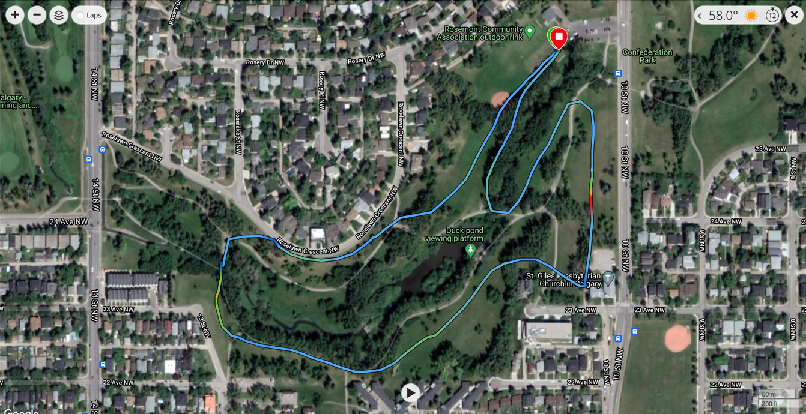
1200m Loop

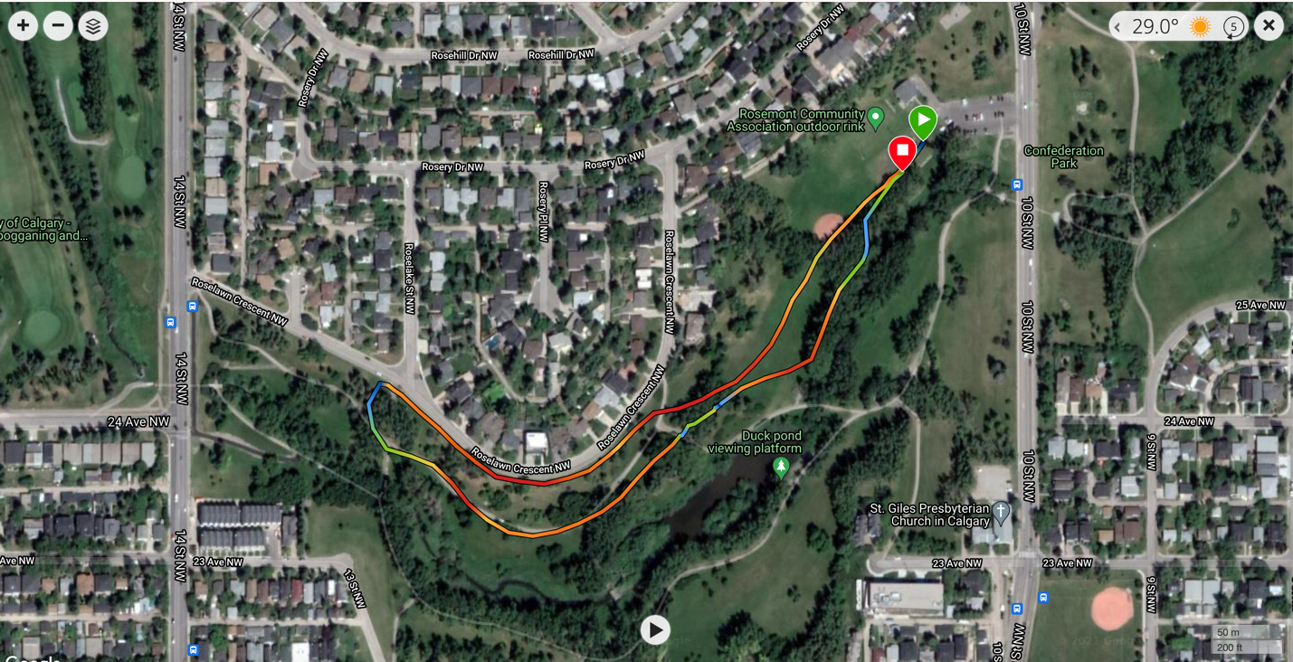

1000m Loop

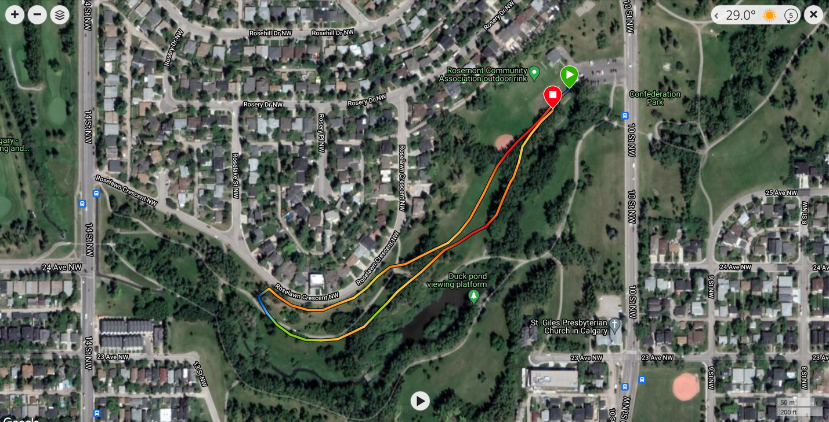

- Entries –

  - Due – 6pm TUESDAY SEPTEMBER 20th
  - Please submit all entries using TrackieReg (https://www.trackie.com/online-registration/)
  - For seed time, please indicate the estimated time for the athlete (which will allow the organizers to determine if schedule adjustments will be required).

- Entry Fee –
  - To be paid to Trackie at time of registration
  - $18.00 – includes Trackie fee plus new $1.50 Contribution to Athletics Alberta XC High Performance fund (to fund, subsidize athletes representing Alberta in International Competition, or subsidize athletes participating at AC XC Championships requiring travel – to be spent at the discretion of Athletics Alberta)

- Contact – Meet Director – Travis Cummings – traviscummings10km@gmail.com

- Results – Electronic Timing Completed by the Calgary Track Council, results to be posted on the CTC website and on Trackie within 24h of competition conclusion.

- AWARDS – Swag/prizes to be given to winners of races courtesy of Strides Running Store/New Balance Canada if available at time of meet

- Athletics Alberta Membership - All competitors must be members of Athletics Alberta. No exceptions -- please see https://www.athleticsalberta.com/aa-membership/ . (Note: "Day of Meet" memberships are no longer available. Membership must be registered before the meet entry)

- COVID Protocols – emailed upon registration closing if required

